

BUSINESS REQUIREMENTS DOCUMENT
Push Notification
Customer journey alerts in the Super App — Credit Card, Personal Loan and CASA
V1.0 / 28 September 2026
Prepared for Reem Bank
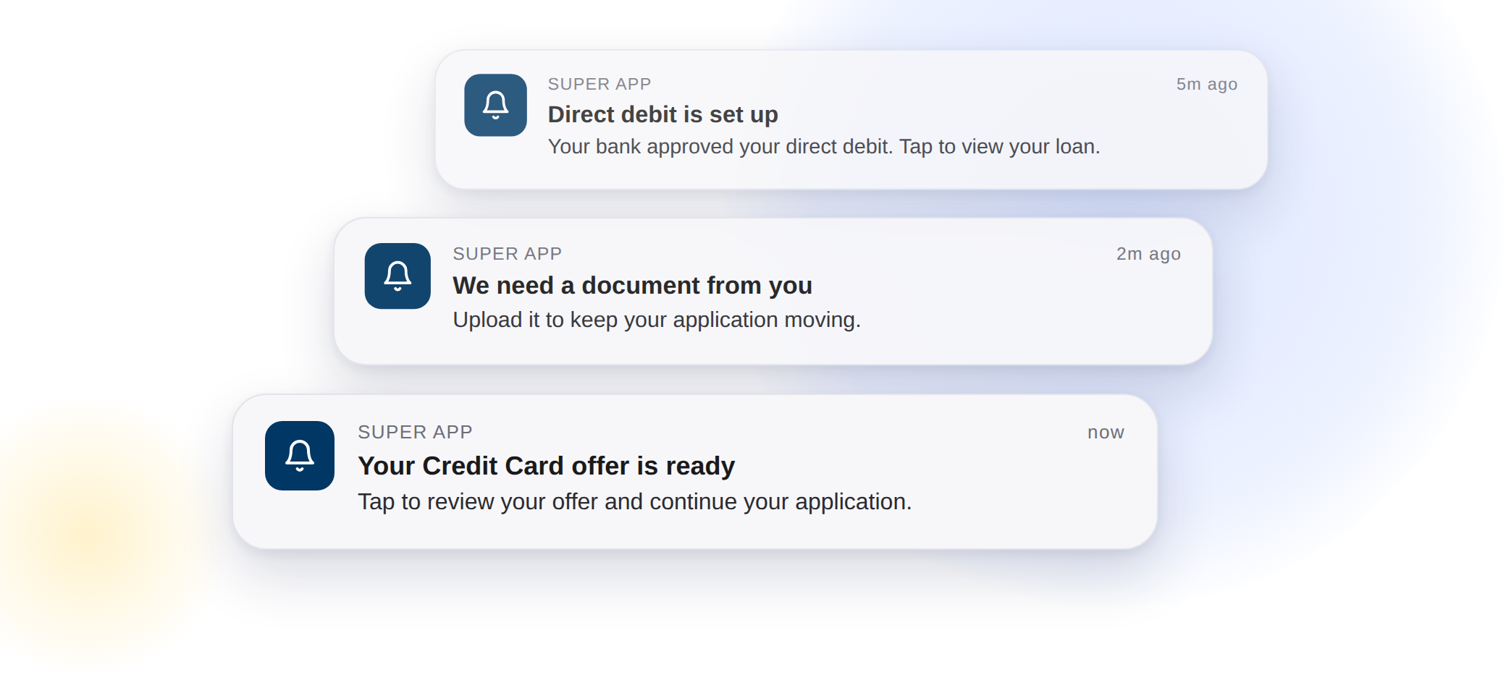

Appro Onboarding Solutions FZ-LLC · Customer Journey
This is not a legally binding document. Highly confidential not to be shared without written consent.
Based on the Reem Bank middleware Push Notifications specification v0.1 (Avanza, 25 September 2026). Items awaiting confirmation are listed in section 10.
appro.ae · 105, Arjaan Office Towers, Dubai Media City, UAE
VERSION HISTORY
Date | Version | Author | Change Description
28-09-2026 | 1.0 | Hailey, Appro | Created BRD

TABLE OF CONTENTS
1. FEATURE OVERVIEW AND KEY COVERED AREAS 3
2. SCOPE 4
3. TRIGGER POINTS AND PUSH CONTENT 5
4. PUSH NOTIFICATION API INTEGRATION 7
5. RESPONSE HANDLING AND RETRY 9
6. DUPLICATE AND REMINDER CONTROL 9
7. AUDIT TRAIL 10
8. BUSINESS RULES 10
9. IMPACT ANALYSIS 11
10. OPEN QUESTIONS 12
APPENDIX 1: SUMMARY OF CHANGES 13
APPENDIX 2: WORKFLOW 13
APPENDIX 3: API REFERENCE 14
APPENDIX 4: GLOSSARY 14

1. FEATURE OVERVIEW AND KEY COVERED AREAS
This document describes the requirements for Push Notification in the Reem Bank customer journey for Credit Card, Personal Loan and CASA, on iOS and Android.
Today the customer learns about decisions and required actions on an application — a credit decision, a Direct Debit Authority response, the end of the cooling-off period — by email and in-app notification only. When the customer is outside the Super App, nothing reaches the device, and the application waits until the customer returns.
Push Notification adds a device-level alert at each agreed trigger event. The Appro platform sends the push request to the Reem Bank middleware Push API, following the same integration pattern as the existing SMS and email integration. When the customer taps the notification, the Appro journey opens at the screen where the application continues.
This BRD covers the following areas:
- Trigger events and push content — eleven notifications, each with its title, body and the screen it opens
- Language — English or Arabic, following the customer’s current language
- Middleware integration — the Push API request, headers and response
- Response handling and automatic retry
- Duplicate and reminder control
- Audit trail — one new step per push
- Business rules — personal data and excluded templates
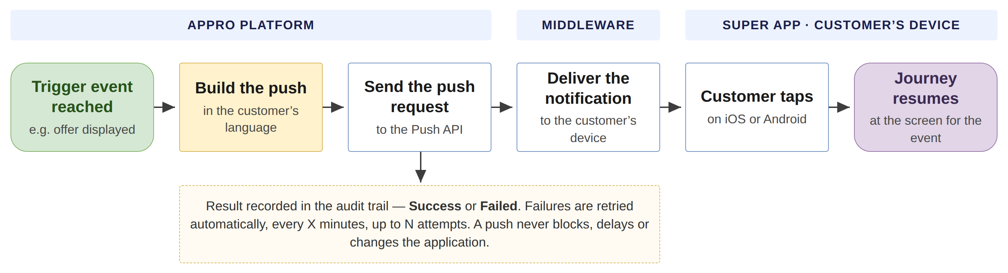
Figure 1 — How a push reaches the customer (green = start, amber = system action, blue = step, purple = end)
Key steps
- A trigger event is reached on the application, for example an offer is displayed or a document is requested.
- The system builds one push for the event: the Push ID, the title and the body, in the customer’s current language.
- The system sends the push request to the Reem Bank middleware Push API.
- The middleware delivers the notification to the customer’s device through the Super App.
- The customer taps the notification, and the Appro journey opens at the screen for that event.
- The result is recorded in the application audit trail. A failed push is retried automatically and never blocks the application.
Note: Push content is fixed per notification and is not configurable in Super Portal in this release. Customer actions on a notification (open, dismiss, ignore) are not tracked. Existing email and in-app notifications are unchanged.

2. SCOPE

2.1 Product scope
Credit Card, Personal Loan and CASA, on iOS and Android. Each notification applies only to the products listed against it in section 3.

2.2 In-scope notifications
- P01 — Offer ready (Credit Card, Personal Loan)
- P01 (CASA) — Account approved in principle (CASA)
- P02 — Offer expiry reminder, once per day for 15 days (all products)
- P03 — Offer expired (all products)
- P04 — Update on the application after a rejection (all products)
- P05 — Document requested from the customer (all products)
- P06 — Application active again after the cooling-off period (Credit Card, Personal Loan)
- P08 — Direct debit set up (Personal Loan)
- P09 — Direct debit rejected by the customer’s bank (Personal Loan)
- P10 — Loan on its way after disbursement (Personal Loan)
- P11 — Product ready: card issued (Credit Card, CASA) or loan approved (Personal Loan)

2.3 Not in scope
- OTP messages — never sent as push (BR3).
- Bank and internal-user notifications — never sent as push (BR4).
- Configuring push content in Super Portal — content is fixed per notification in this release.
- Tracking customer actions on a notification — open, dismiss or ignore.
- Changes to the existing email and in-app notifications — they remain unchanged (BR1).

3. TRIGGER POINTS AND PUSH CONTENT

3.1 Trigger events
A push is fired at the same trigger point as the existing email and in-app notification templates listed under Source templates. Existing email and in-app notifications remain unchanged.
Push ID | Priority | Applies to | Trigger event | Source templates
P01 | P0 | CC · PL | AIP given (at least one offer displayed), or Credit Queue approves / overrides the application | ET15/NT06 · ET9
P01 (CASA) | P0 | CASA | Account application approved in principle | ET15/NT06 (CASA)
P02 | P0 | CC · PL · CASA | Scheduled reminder once per day for 15 days, starting after the first offer is displayed | ET13 · NT02
P05 | P0 | CC · PL · CASA | Credit or Sales team returns the case requesting documents from the customer | NT12
P06 | P0 | CC · PL | Cooling-off end date reached (start + 5 days, configurable) with no customer action; application returns to Approved In Principle | ET55/NT24
P09 | P0 | PL | Customer’s bank rejects the Direct Debit Authority | ET41/NT17
P04 | P1 | CC · PL · CASA | Queue user rejects (Credit, Sale, Risk or Compliance), Rule Engine filtration fails, or minimum income not met | ET22/NT10 · ET8/NT11 · ET12 · ET19/NT07/NT08 · ET21/NT19
P08 | P1 | PL | Customer’s bank accepts the Direct Debit Authority | ET40/NT21
P10 | P1 | PL | Disbursement Checker approves and releases the disbursement | ET42/NT18
P11 | P1 | CC · PL · CASA | Card issued (CC, CASA) or loan approved (PL) | ET37 · ET38 · NT13
P03 | P2 | CC · PL · CASA | Offer validity (30 days) elapses with no acceptance | ET14/NT03
Source templates: ET = email template, NT = in-app notification template, as configured in Communication Setup. Priority: P0 highest.

3.2 Push content
Push ID | Title (EN, max 40 characters) | Body (EN, max 100 characters) | Opens at (deep-link screen)
P01 | Your %%PRODUCT_TYPE%%  offer is ready | Tap to review your offer and continue your application. | Offer selection
P01 (CASA) | Your account is approved | Tap to continue and complete your account opening. | Resume application
P02 | Your offer expires in  %%COUNTING_DOWN%% days | Complete your application before your approval expires. | Offer selection
P05 | We need a document from you | Upload it to keep your application moving. | Document upload
P06 | Your application is active again | Your cooling-off period has ended. Tap to continue or cancel. | Application Ready to Continue screen, then KFS
P09 | Action needed on your direct debit | Your bank didn’t accept the authority. Tap to see next steps. | DDA screen / next steps
P04 | Update on your application | Tap to view the status of your  %%PRODUCT_TYPE%% application. | Application status
P08 | Direct debit is set up | Your bank approved your direct debit. Tap to view your loan. | Loan details
P10 | Your loan is on its way | Funds will reach your account shortly. Tap for details. | Loan details
P11 | Your %%PRODUCT_TYPE%%  is ready | Tap to see what happens next. | Product screen (card / loan / account)
P03 | Your offer has expired | You can reapply whenever you’re ready. | SDK start (new application)
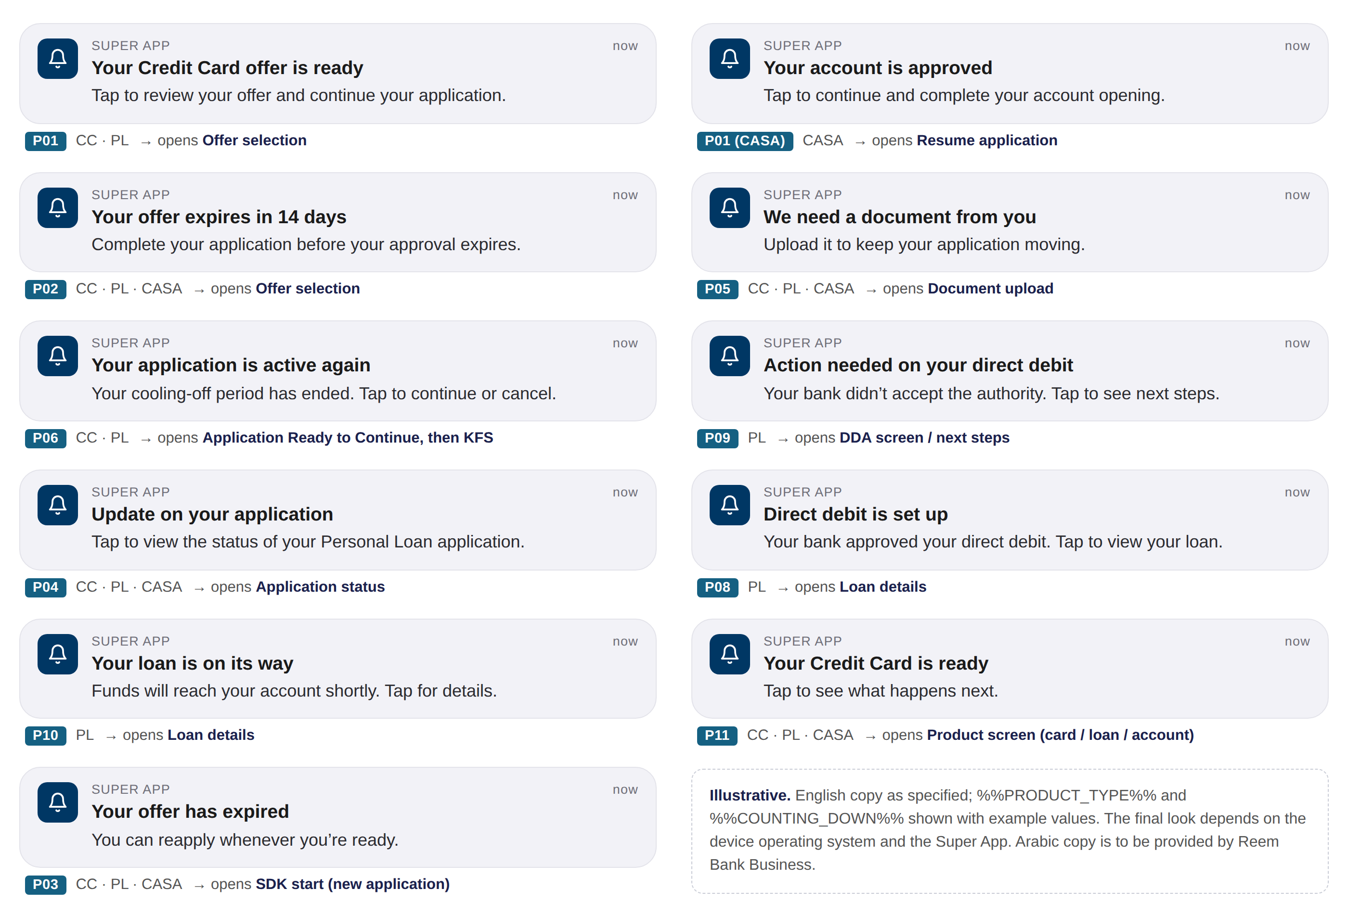
Figure 2 — The eleven notifications as the customer sees them (illustrative)

3.3 Content rules
- When the application reaches a trigger event and the product matches Applies to, the system must build one push request for that application.
- [%%PRODUCT_TYPE%%] and [%%COUNTING_DOWN%%] must be replaced with actual values before sending. No placeholder is ever shown to the customer.
- The title must not exceed 40 characters and the body 100 characters, after replacement.
- Content is fixed per Push ID and is not configurable in Super Portal in this release.

3.4 Language
- The push is sent in English or Arabic, following the language the customer is currently using.
- ⚠ TBC by Reem Bank Business: Arabic title and body for every notification.

4. PUSH NOTIFICATION API INTEGRATION
The integration follows the Reem Bank middleware specification Reem Payments API — Push Notifications v0.1 (Avanza, 25-09-2026). Items the specification does not yet answer are flagged ⚠ TBC by Avanza and tracked in section 10.

4.1 Request details
Item | Value
Method | POST
Endpoint | http://<MW URL>/api/notifications/push  ⚠ TBC by Avanza: MW URL per environment (SIT, UAT, PROD) and HTTPS
Authentication | Bearer token  ⚠ TBC by Avanza: how the token is issued (endpoint, grant, expiry)

4.2 Header parameters
Parameter | Type | Required? (Y/N) | Description | Values / Data Source
stan | String | Y | Unique system audit trace number in each request | Generated by Appro, unique per request.  ⚠ TBC by Avanza: format and length
Authorization | String | Y | Authorization header | Bearer <token>
Content-Type | String | Y | Request format | application/json
channel_id | String | Y | Channel id of the calling system | ⚠ TBC by Avanza: value assigned to Appro

4.3 Request parameters
Parameter | Type | Required? (Y/N) | Description | Values / Data Source
requestId | String | Y | Unique message id | Generated by Appro, unique per push.  ⚠ TBC by Avanza: same or new id on retry
timestamp | String | Y | Request date-time | ISO 8601 UTC with milliseconds, e.g. 2026-09-28T06:49:02.366Z
type | String | Y | Notification type | Fixed: APPRO_NOTIFICATION
action.id | String | Y | Push identifier | Push ID from section 3, e.g. P01. P01 (CASA) is sent as P01 with action.value = CASA
action.type | String | Y | NONE / POPUP / APPRO_JOURNEY | APPRO_JOURNEY for every Push ID, so a tap opens the Appro journey.  ⚠ TBC by Avanza: behaviour of NONE / POPUP, and how the Super App hands action.id and action.value to the Appro journey
action.value | String | Y | Product | CREDIT_CARD / PERSONAL_LOAN / CASA, from the application. NA is not used — every push belongs to an application
recipient.mobilePhone | String | Y | Customer mobile number | From the application.  ⚠ TBC by Avanza: format (country code, ‘+’, spaces)
recipient.customerId | String | Conditional | Customer CIF — required if ETB | ETB: customer CIF. NTB: not sent.  ⚠ TBC by Avanza: whether mobilePhone alone reaches an NTB customer
recipient.email | String | N | Customer email | Not sent.  ⚠ TBC by Avanza: purpose
content.title | String | Y | Push title | Per section 3.2, in the customer’s current language
content.body | String | Y | Push body | Per section 3.2, in the customer’s current language
content.message | String | N | Notification message | Sent empty ("").  ⚠ TBC by Avanza: purpose versus body
content.language | String | Y | Language — en / ar | Customer’s current language.  ⚠ TBC by Avanza: case (en vs EN in the sample) and type (listed as Date Timestamp)

4.4 Response parameters
Parameter | Type | Description | Values / Handling
messageId | String | Message id returned by the middleware | Recorded in the audit trail
error.code | String | Result code | "000" = Processed Ok  ⚠ TBC by Avanza: full code list, and which codes are retryable
error.message | String | Result description | Recorded in the audit trail with error.code
A sample request and response are in Appendix 3.

5. RESPONSE HANDLING AND RETRY
- If the HTTP code is 20x and [error.code] = "000" (Processed Ok) → the push is sent → audit trail Step Status = Success → the journey proceeds.
- Else → the system retries automatically after X minutes, up to N attempts. X and N are configurable.
  - “Else” covers a timeout, any non-20x HTTP code and any [error.code] other than "000".
  - ⚠ TBC by Avanza: the full error-code list, and any code that should not be retried.
- If the push is still not successful after the last attempt → audit trail Step Status = Failed → the journey proceeds. A push failure must not block, delay or change the application status.
- The system tracks the API delivery result only. Customer actions on the notification (open, dismiss, ignore) are not tracked.
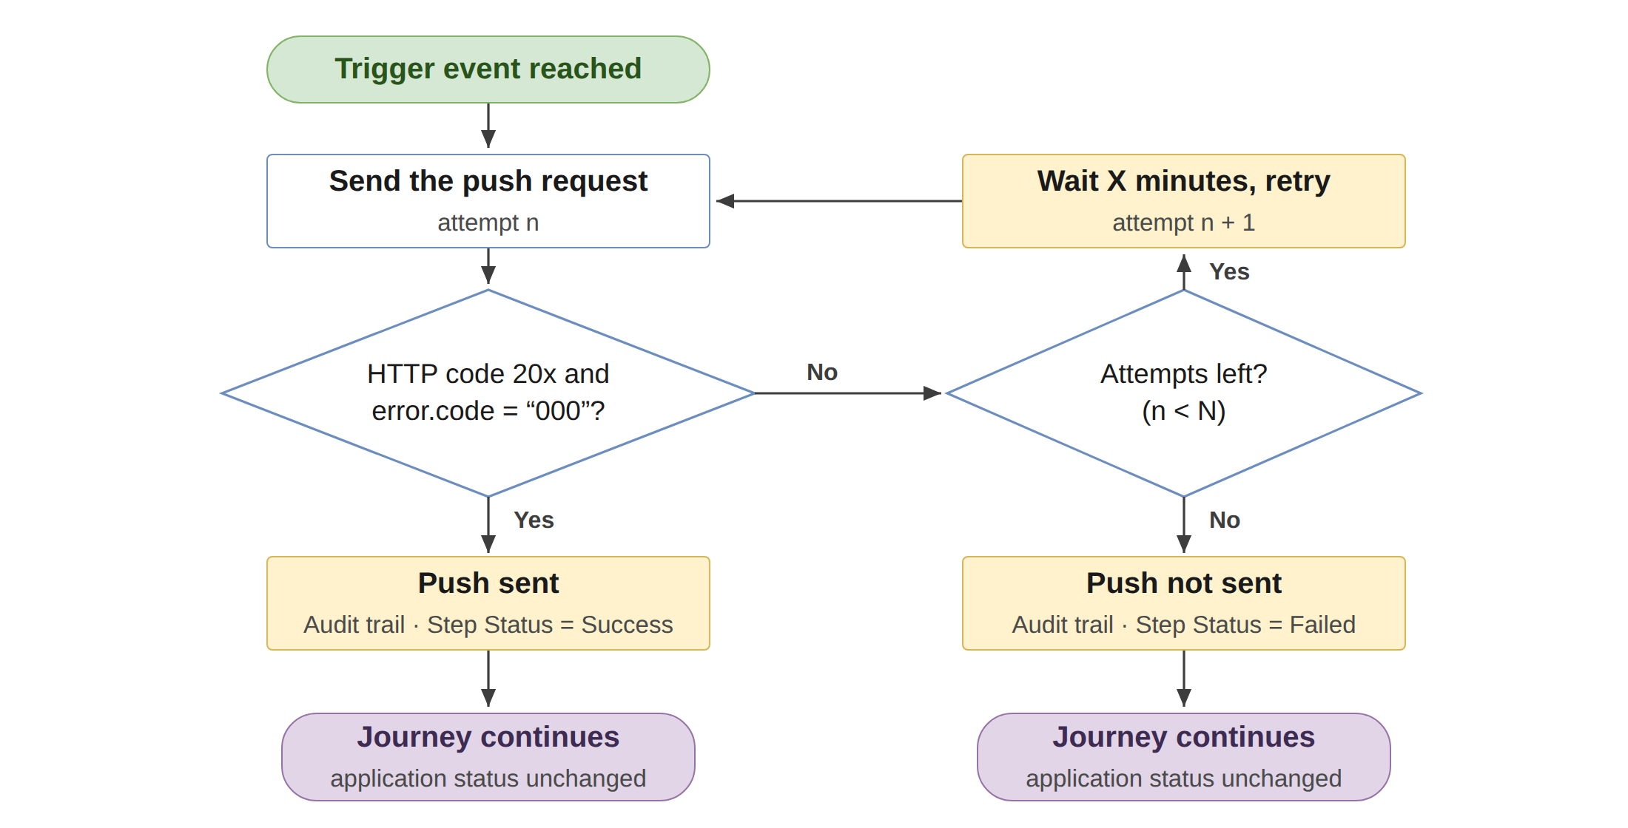
Figure 3 — Response handling and automatic retry (X and N configurable)

6. DUPLICATE AND REMINDER CONTROL
- The system must send at most one push per Push ID per trigger occurrence per application. Consolidated templates (for example P04) must not generate more than one push for the same decision.
- P02 is sent once per day for 15 days from the first offer display, and stops immediately once the customer selects an offer or the application is expired, cancelled or rejected.
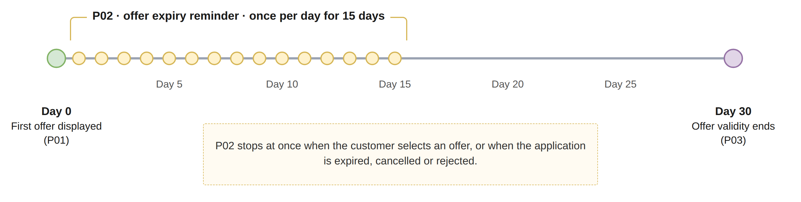
Figure 4 — The P02 offer expiry reminder

7. AUDIT TRAIL
Every push writes one entry to the application audit trail, visible in Application Enquiry. The application status is not changed.
Field | Value
[Application ID] | Current Application ID
[Step] | Push Notification
[Step Details] | Send Push <Push ID> · stan · requestId · messageId — or error.code and error.message when the push is not sent
[Start Time] | Date-time the request is sent
[End Time] | Date-time of the response, or of the last timeout
[Attempt No.] | n of N
[Step Status] | Success / Failed
[Action by] | System
The Audit Trail screen has no attempt column, so the attempt is shown in Step Details, as in Figure 5.
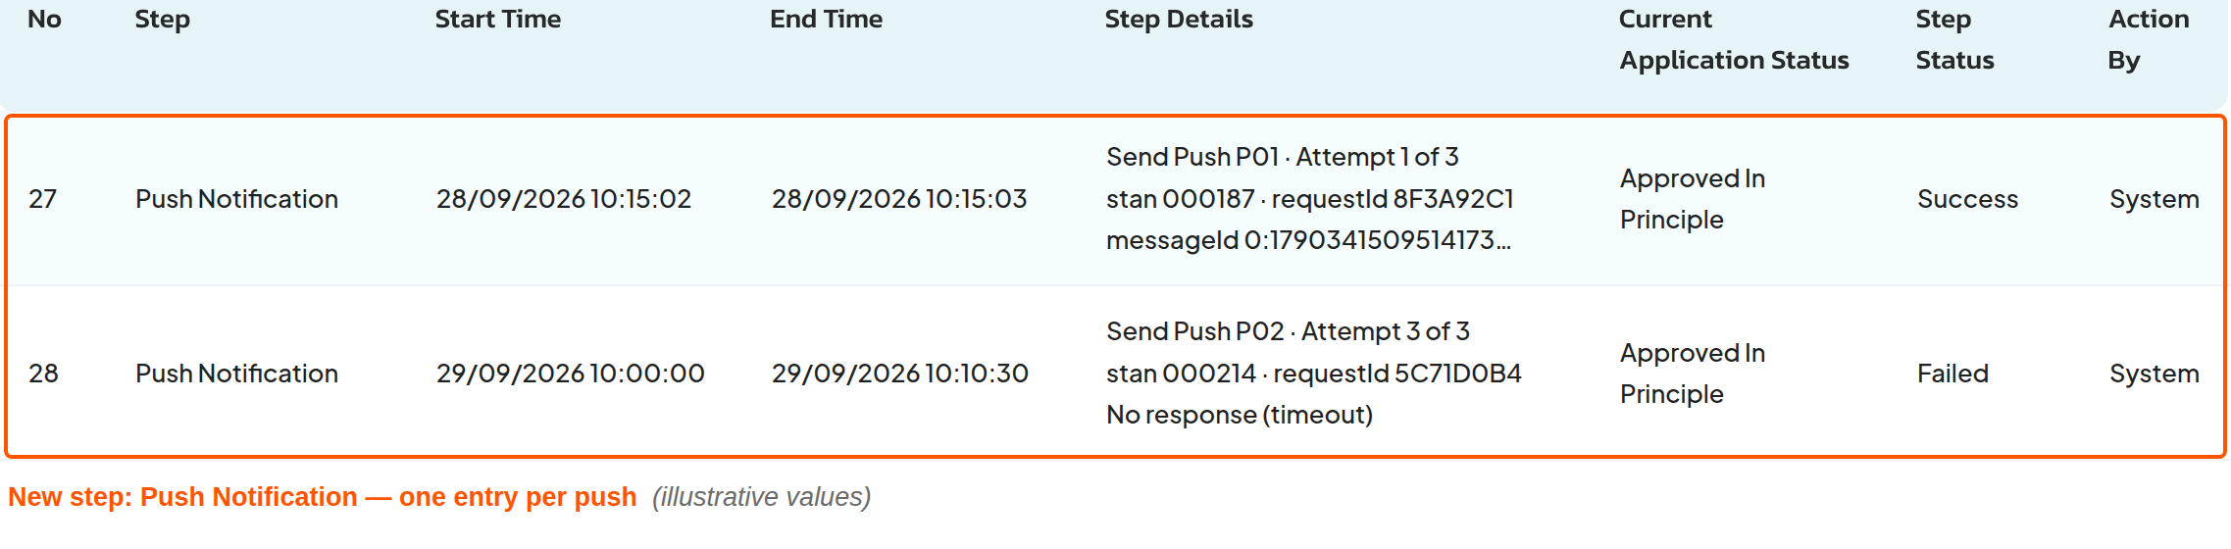
Figure 5 — Application Enquiry › Audit Trail — the new Push Notification step (composite over the UAT screen, illustrative values)

8. BUSINESS RULES
No. | Rule
BR1 | Push is additional; existing email and in-app notifications are unchanged.
BR2 | No personal data in the title or body: no name, Application ID, IBAN or amounts.
BR3 | OTP content (ET17, ET18, ET35, NT04, NT05) is never sent as push.
BR4 | Bank and internal-user templates are never sent as push.

9. IMPACT ANALYSIS
Area | Impact | Screen
Customer journey (Super App) | A device notification at eleven trigger events. A tap opens the Appro journey at the screen for that event; existing journey screens are reused as the destinations. | 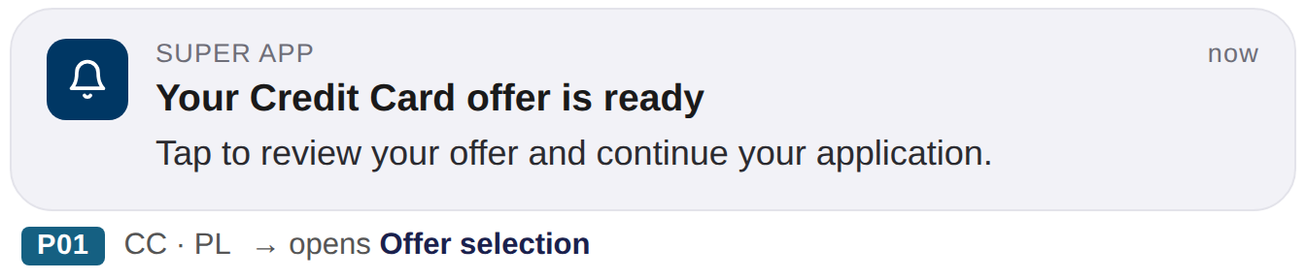
Middleware integration | New outbound call from the Appro platform to the Reem Bank middleware Push API, following the SMS and email integration pattern. Endpoint, credentials and channel id per environment: see section 10. | 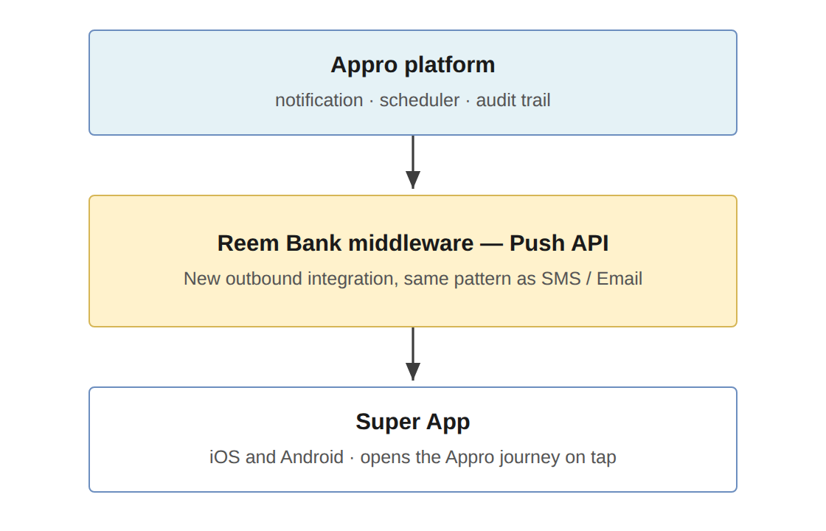
Communication Setup | No change. Existing email and in-app templates keep working as today and remain the trigger reference for each push. Push content is fixed per notification in this release and is not added to Communication Setup. | 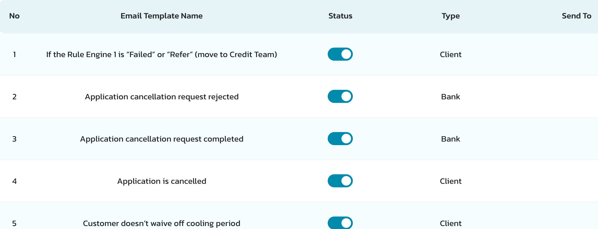
Audit trail | One new step, Push Notification, per push — with Success or Failed, the attempt count and the middleware references for tracing. | 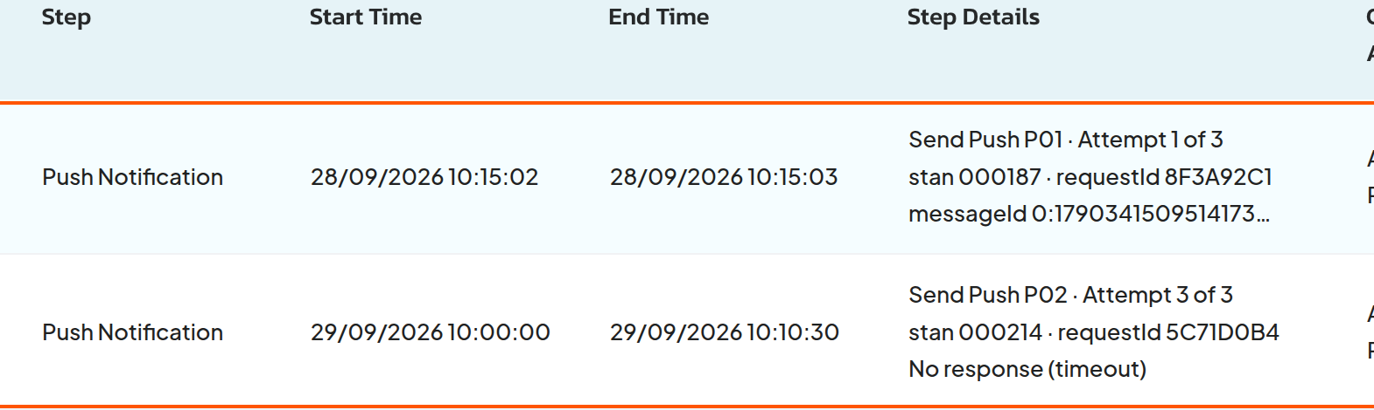
Application status | No change. A push — sent or not — never changes, blocks or delays the application. | 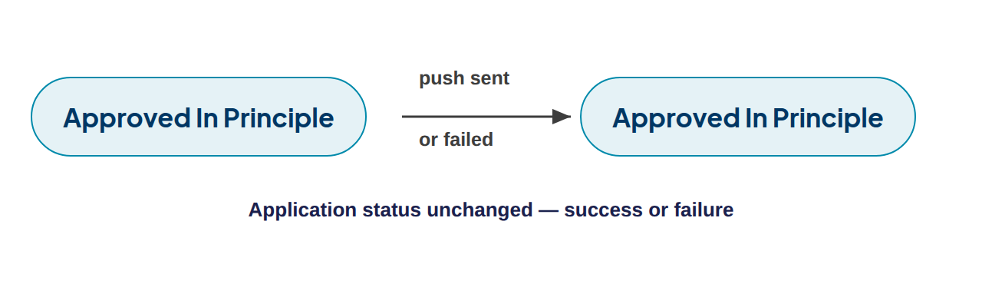
Scheduling | A daily run sends the P02 reminder for 15 days and stops as soon as the offer is selected or the application is expired, cancelled or rejected. | 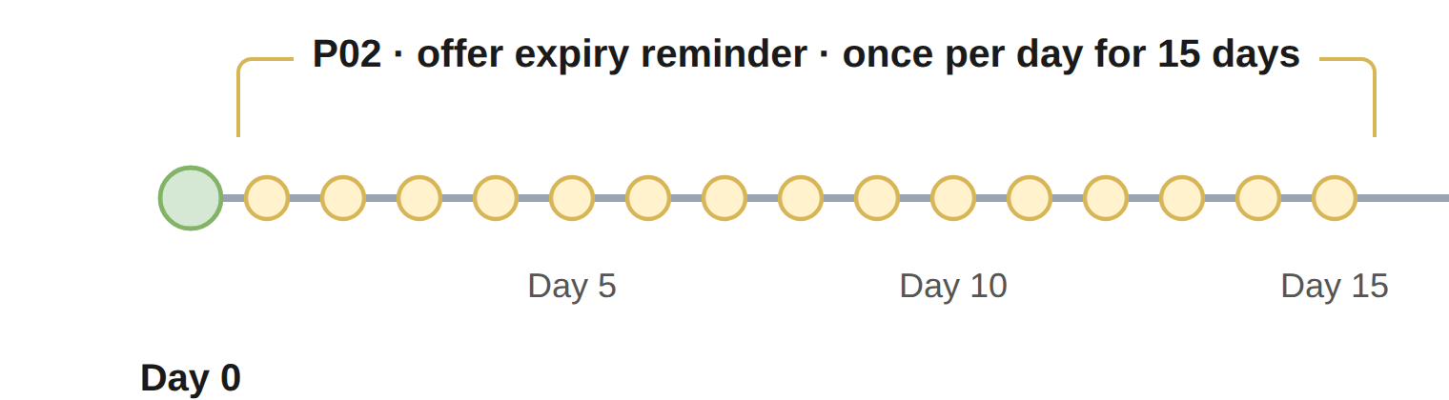
Reporting | The API delivery result is tracked. Customer actions on a notification (open, dismiss, ignore) are not tracked. | No screen change

10. OPEN QUESTIONS
Each item carries Appro’s proposal. Confirming the proposal is enough to proceed.
# | Question | Owner | Appro proposal
1 | MW URL for SIT, UAT and PROD. The specification shows http:// — confirm the endpoint is served over HTTPS. | Avanza | HTTPS in all environments
2 | How Appro obtains the Bearer token: token endpoint, grant type, expiry and refresh; UAT credentials. | Avanza | Please advise
3 | stan: format, length and uniqueness scope. | Avanza | Generated by Appro, unique per request, including each retry
4 | channel_id value assigned to Appro, per environment. | Avanza | Please assign
5 | requestId: format and length; on a retry, resend the same requestId so the middleware can de-duplicate? | Avanza | Same requestId on every retry of the same push
6 | action.type: behaviour of NONE, POPUP and APPRO_JOURNEY; how action.id and action.value reach the Appro journey on tap; when NA applies. | Avanza | APPRO_JOURNEY for every push; NA not used
7 | recipient.mobilePhone format: country code, ‘+’, spaces (the sample value has a trailing space). | Avanza | 971XXXXXXXXX — country code, digits only
8 | NTB customers have no CIF: is mobilePhone alone enough to reach them; omit customerId or send it empty? | Avanza | Omit customerId for NTB
9 | Purpose of recipient.email and of content.message versus body. | Avanza | email not sent; message sent empty
10 | Maximum title and body length supported by the Super App. | Avanza | Title 40, body 100 characters
11 | content.language type (listed as Date Timestamp) and case (en / EN); timestamp format and time zone. | Avanza | String, lower case en / ar; ISO 8601 UTC with milliseconds
12 | Full error.code list and messages, the HTTP codes returned, and any code that should not be retried. | Avanza | Success = HTTP 20x with "000"; anything else retried up to N
13 | Does "000 Processed Ok" mean accepted for delivery, or delivered to the device? | Avanza | Recorded as sent, not delivered
14 | Recommended request timeout and any rate limit (P02 runs daily). | Avanza | Please advise
15 | Arabic title and body for every notification. | Reem Bank Business | To be provided

APPENDIX 1: SUMMARY OF CHANGES
Areas | Previous Behaviour | New Behaviour
Customer alerts | Email and in-app notification only | Email, in-app notification and push notification
Customer outside the Super App | No device-level alert; the application waits for the customer to return | A device notification at eleven trigger events
Resuming the journey | The customer opens the Super App and navigates to the application | A tap opens the Appro journey at the screen for the event
Offer expiry reminder | Email and in-app reminders (ET13, NT02) | Plus a daily push (P02) for 15 days, stopping on selection, expiry, cancellation or rejection
Audit trail | No push entries | One Push Notification entry per push, with the result and the middleware references

APPENDIX 2: WORKFLOW
- The application reaches a trigger event listed in section 3.1, and the product matches Applies to.
- The system builds one push: Push ID, title and body in the customer’s current language, with placeholders replaced.
- Duplicate control applies: at most one push per Push ID per trigger occurrence per application.
- The system sends the request to the middleware Push API (attempt 1).
- If the HTTP code is 20x and [error.code] = "000" → the push is sent; the audit trail records Success.
- Otherwise the system waits X minutes and retries, up to N attempts.
- After the last unsuccessful attempt, the audit trail records Failed.
- In every case the journey continues and the application status is unchanged.
- The middleware delivers the notification; on tap, the Super App opens the Appro journey at the deep-link screen.
The end-to-end flow is shown in Figure 1 and the retry logic in Figure 3.

APPENDIX 3: API REFERENCE

Sample request
{
"requestId": "<unique id>",
"timestamp": "2026-09-28T06:49:02.366Z",
"type": "APPRO_NOTIFICATION",
"action": { "id": "P01", "type": "APPRO_JOURNEY", "value": "CREDIT_CARD" },
"recipient": { "mobilePhone": "9715XXXXXXXX", "customerId": "<CIF, if ETB>" },
"content": {
"title": "Your Credit Card offer is ready",
"body": "Tap to review your offer and continue your application.",
"message": "",
"language": "en"
}
}

Sample response
{
"messageId": "0:1790341509514173%d5881a7ad5881a7a",
"error": { "code": "000", "message": "Processed Ok" }
}

Product mapping
Product on the application | action.value
Credit Card | CREDIT_CARD
Personal Loan | PERSONAL_LOAN
CASA | CASA

APPENDIX 4: GLOSSARY
Term | Meaning
AIP | Approval In Principle — at least one offer is displayed to the customer
Appro journey | The Appro onboarding journey (SDK) that runs inside the Super App
CIF | The bank’s customer identification number
DDA | Direct Debit Authority
ETB / NTB | Existing-to-Bank / New-to-Bank customer
KFS | Key Fact Statement
Middleware (MW) | The Reem Bank integration layer, provided by Avanza
Push ID | The identifier of each notification, P01 to P11
stan | System audit trace number, unique per request
Super App | The Reem Bank mobile app on iOS and Android
THANK YOU
Appro Onboarding Solutions FZ-LLC
Customer Journey

