[COMPANY LOGO]
Appro Admin Portal
Billing & Subscription Management
Business Requirements Document
Version V1.9
This is not a legally binding document. Highly confidential not to be shared without written consent.

Version History
Date | Version | Author | Change Description
13-06-2026 | 1.5 | Appro BRD Team | Baseline — Billing & Subscription Management.
30-06-2026 | 1.6 | Appro BRD Team | Added Request-for-Price flow.
31-07-2026 | 1.7 | Hailey — Senior System Analyst Added Request-for-Price flow diagram; removed the Failed status; pricing locked while a subscription is active. | Unified Billing "Pricing" tab; tenant pricing chips (In effect / Pending / Closed) + Show history; Edit-only pricing rows; Subscription Management sub-tabs, tab-aware status filter and coloured KPIs; operational Approve / Reject / Cancel / Un-schedule; "Cancelling" dropped; plan descriptor by pricing type; customize→Pending; Customize→Approval return workflow; default-price sourcing rule.
05-08-2026 | 1.8 | Appro BRD Team | Corrected the approval model — approval grants an "eligible" interim (Approved · ready to subscribe), NOT direct-to-Active; the tenant completes the Confirm wizard to reach Active. Added the 30-day eligibility expiry and the billing/metering-starts-at-Active rule. Relaxed the reject / cancel reason to optional free-text (sanitised). Added §10 — per-user-story decisions log from the grooming pass (GAS-163, 171–180, 256, 257). Amendment A (05-08-2026): Approve is gated on a resolvable price — an unpriced product routes the administrator to "Set up pricing" (BILLING permission) instead of offering a generic package; the 30-day expiry now applies to Pending requests as well as Approved · eligible ones, both settling as "Expired".
10-08-2026 | 1.9 | Huyen — Product Owner | Added the Tenant Portal — Subscriptions & Billing view (read-only Overview): scope and RBAC gate, screen composition, per-month invoice export, consumption & billing parameters table; no payment-method section on the tenant side. New section 11.

Table of Contents
1. Feature Overview and Key Covered Areas
2. Summary of Changes (V1.7 & V1.8)
3. Status Change & Status Mapping
4. Billing Management — Pricing
4.1 Catalogue scope (global pricing)
4.2 By-tenant scope (per-tenant pricing)
4.3 Show history
4.4 Edit / Customize tenant price
5. Subscription Management
5.1 List, sub-tabs, status filter & KPIs
5.2 Request review — Approve / Reject
5.3 Subscription lifecycle — Cancel / Un-schedule
6. Request-for-Price Flow
7. Navigation Among Screens
8. Default Values (pricing source of truth)
9. List Sort Orders (for confirmation)
10. User Story Decisions (v1.8 grooming pass)
11. Tenant Portal — Subscriptions & Billing View (Read-only)
Appendix A — Status Mapping Quick Reference

1. Feature Overview and Key Covered Areas
This document describes the requirements for the Billing & Subscription Management area of the Appro Admin Portal. It covers how the platform administrator sets and reviews product pricing (globally and per tenant) and how the subscription lifecycle is governed. In this release the two Billing tabs are merged into a single Pricing screen; the tenant view shows a pricing-status chip read from the subscription; Subscription Management gains sub-tabs, a status filter and coloured KPIs and becomes the single home for lifecycle actions; and a Customize→Approval workflow lets the administrator set a tenant price mid-approval and return to finish it.
This BRD covers:
- Billing — unified Pricing tab with a Catalogue ↔ By-tenant scope switch.
- Global (catalogue) pricing and per-tenant pricing with tenant overrides.
- Tenant pricing chips (In effect / Pending / Closed) and history handling.
- Subscription Management sub-tabs, status filter, coloured KPIs and lifecycle actions (Approve / Reject / Cancel / Un-schedule).
- The Customize → Approval cross-screen workflow and navigation.
- Default-price sourcing (catalogue vs. prior tenant setup) and list sort orders.
Note: Pricing is owned by the Billing module. Subscription Management references a tenant price (priceRef) and never edits the amount. Usage metering, invoicing and tax are out of scope.

2. Summary of Changes (V1.7 & V1.8)
All changes are highlighted in purple throughout this document.
V1.8 (05-08-2026) — corrections from grooming: (a) approval grants an eligible interim, not direct-to-Active — the earlier "provisioned directly to Active / no eligible interim" callout is reversed; (b) an approved/eligible request expires after 30 days (configurable) back to "Request for Price"; (c) billing / metering starts at Active (on provisioning success), never at approval; (d) the reject and cancel reason are optional free-text (still sanitised); (e) §10 adds a per-user-story decisions log capturing the grooming Q&A and PO rulings.
V1.8 Amendment A (05-08-2026): (f) the request drawer resolves a pricing predicate before Approve is offered — where no catalogue package and no tenant override exist, Approve is disabled and the administrator is routed to Set up pricing (or told to contact a Billing administrator when they lack the BILLING permission), replacing the former generic "On request" package fallback; (g) the 30-day expiry applies to Pending as well as Approved · eligible — both settle as Expired and return the card to "Request for Price".
# | Area | Previous Behaviour | New Behaviour (v1.7)
1 | Billing navigation | Two tabs: "Catalogue pricing" and "Tenant pricing". | One "Pricing" tab with a Catalogue ↔ By-tenant scope switch.
2 | Catalogue scope | Product list. | All products in the original catalogue table structure.
3 | Tenant pricing status | Raw subscription "Status" column. | "Pricing" chip read from the subscription: In effect / Pending / Closed.
4 | History | All rows always visible. | Show history toggle; Closed (cancelled / rejected) rows hidden by default. Turned OFF automatically while editing.
5 | Tenant pricing actions | Approve/Reject/Cancel/Remove on the row. | Edit only (opens the tenant price editor). Lifecycle actions moved to Subscription Management.
6 | Plan descriptor | Overflow label only. | Reflects pricing type: "Committed volume · <overflow>", "Tiered pricing", or "Pay-as-you-go".
7 | Customize result | Custom price stayed "In effect". | Saving a custom (overridden) tenant price sets the status to Pending (awaiting activation).
8 | SM views | Single combined list. | Sub-tabs: All / Pending request / Active requests.
9 | SM search | Free-text tenant search. | Removed; replaced by a status filter whose options adapt to the active tab.
10 | SM KPIs / header | Plain KPI tiles + role chip. | Coloured KPI tiles (amber/green/amber); role chip removed.
11 | SM lifecycle | Approve/Reject disabled; Cancel button on the list. | Approve / Reject / Cancel / Un-schedule operational in the drawer; no inline Cancel; Retry and the Failed status removed. "Cancelling" transient state dropped.
12 | Customize → Approval | One-way (stranded in Billing after save). | A "Return to approval" bar lets the admin customize several packages, then return to re-open the request and finish approval.
13 | Pricing on an active subscription | Editable at any time. | Locked while active — Customize / Edit disabled once the price is In effect.
14 | Failed status | "Failed" provisioning state + Retry action. | Removed — no Failed status, KPI tile, filter option or sort position.

3. Status Change & Status Mapping
One object, one status. The subscription (tenant × product) owns a single lifecycle status in Subscription Management; the Billing Pricing chip is a read of that status.

3.1 Subscription lifecycle statuses
Status | Meaning | Billable?
Pending | Request submitted, awaiting review. | No
Approved · eligible | Approved by the admin; the tenant may now subscribe. Not provisioned. Expires after 30 days (configurable) → returns to "Request for Price". | No
Active | Provisioned and live — reached only after the tenant confirms. Billing / metering starts here. | Yes
Scheduled to cancel | Active with a future cancellation date. | Yes (until date)
Cancelled | Ended and de-provisioned. | No
Rejected | Request declined. | No
Expired | Lapsed with no decision (Pending, 30 days from submission) or no tenant confirmation (Approved · eligible, 30 days from approval). Settled and retained for audit; the card returns to "Request for Price" and the tenant may re-request immediately. | No
Removed: [CHANGE] the transient "Cancelling" state is dropped — a cancel goes Active / Scheduled → Cancelled directly.
Clarified: Approval grants an Approved · eligible interim — it does not provision to Active. The tenant completes the Confirm wizard (§6) to reach Active; an eligible request expires after 30 days (configurable), returning the card to "Request for Price". Billing / metering starts only at Active. NEW v1.8
Expiry: both open states are time-bounded by the same configurable TTL (default 30 days). A Pending request expires 30 days after submission if no administrator decides it; an Approved · eligible request expires 30 days after approval if the tenant does not confirm. Either way the request settles as Expired, the tenant is notified, an audit entry is written (actor: system), and the catalogue card returns to "Request for Price" — so no request can block a tenant indefinitely under BR1. NEW v1.8

3.2 Allowed transitions
- Pending → Approved · eligible (Approve) or Rejected (Reject). NEW v1.7 · corrected v1.8
Pending → Expired — no administrator decision within 30 days of submission (configurable). The card returns to "Request for Price". NEW v1.8
Approved · eligible → Active (tenant completes the Confirm wizard → provisioning succeeds) or Expired (no tenant confirmation within 30 days of approval; the card returns to "Request for Price"). Approval does not provision; billing / metering starts at Active. NEW v1.8
- Active → Scheduled to cancel (schedule) or Cancelled (cancel now). NEW v1.7
- Scheduled to cancel → Active (un-schedule) or Cancelled (cancel now / date reached). NEW v1.7

3.3 Pricing chip mapping (Billing ▸ By tenant)
Subscription status | Pricing chip (Billing) | Shown by default?
Active | In effect | Yes
Pending | Pending | Yes
Scheduled to cancel | In effect (· ends <date>) | Yes
Cancelled | Closed | No — under Show history
Rejected | Closed | No — under Show history
Expired | Closed | No — under Show history
Ordering: rows are listed In effect → Pending → Closed; Closed rows appear only when Show history is on.

4. Billing Management — Pricing
The Billing ▸ Pricing tab replaces the former "Catalogue pricing" and "Tenant pricing" tabs with one tab and a Catalogue ↔ By-tenant scope switch. The tenant selector and Show-history appear only in By-tenant scope.

4.1 Catalogue scope (global pricing)
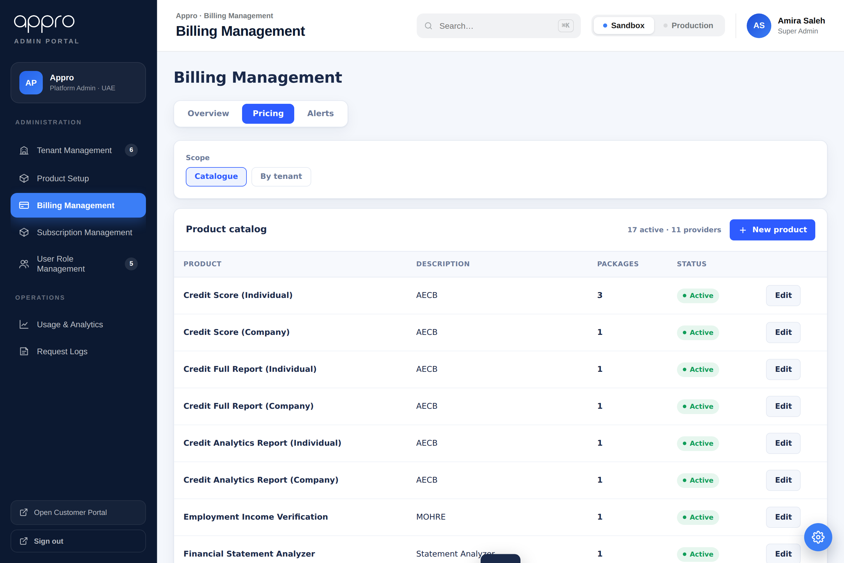
Billing ▸ Pricing ▸ Catalogue — every product in the master catalogue.
The Catalogue scope is the global (master) price list and lists every product. It is the default source of pricing for every tenant until a per-tenant override is set (see §8).
Component | Type | Editable | Mandatory | Default | Description
Scope switch | Toggle | Yes | Yes | Catalogue | Catalogue (global) ↔ By-tenant.
Product | Text | No | — | — | Product name and provider.
Packages | Number | No | — | — | Count of packages configured.
Status | Chip | No | — | Active | Active / Inactive.
Edit | Button | Yes | — | — | Opens the product / package editor.
New product | Button | Yes | — | — | Creates a new catalogue product.

4.2 By-tenant scope (per-tenant pricing)
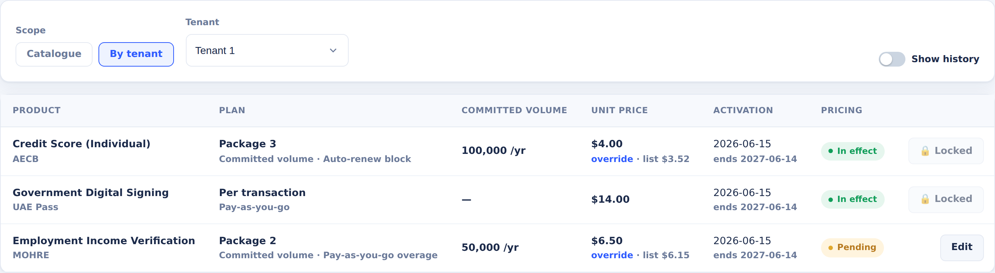
Billing ▸ Pricing ▸ By tenant — effective prices with the Pricing chip (In effect / Pending); In-effect rows are 🔒 Locked, Pending rows keep Edit.
By-tenant scope shows a tenant’s products at their effective price — the catalogue list price unless a tenant override is set ("override · list $x"). Each row exposes Edit only. The Plan descriptor reflects the actual pricing type (Committed volume / Tiered / Pay-as-you-go).
Edit is locked while the price is In effect (Active). A live subscription’s price is read-only — the row shows a 🔒 Locked marker instead of Edit. Pricing is set during the request / approval stage; only Pending rows (and history) stay editable. NEW v1.7
Component | Type | Editable | Mandatory | Default | Description
Tenant | Dropdown | Yes | Yes | First tenant | Shown only in By-tenant scope.
Product / Plan | Text | No | — | — | Product, package and pricing-type descriptor.
Committed volume | Number | No | — | — | Committed txns/yr (committed-volume plans).
Unit price | Money | No | — | Catalogue list | Effective price; shows override vs. list.
Pricing | Chip | No | — | — | In effect / Pending / Closed — read from status.
Show history | Toggle | Yes | — | Off | Reveals Closed rows; off automatically on Edit.
Edit | Button | Yes | — | — | Opens the tenant price editor (Customize).

4.3 Show history
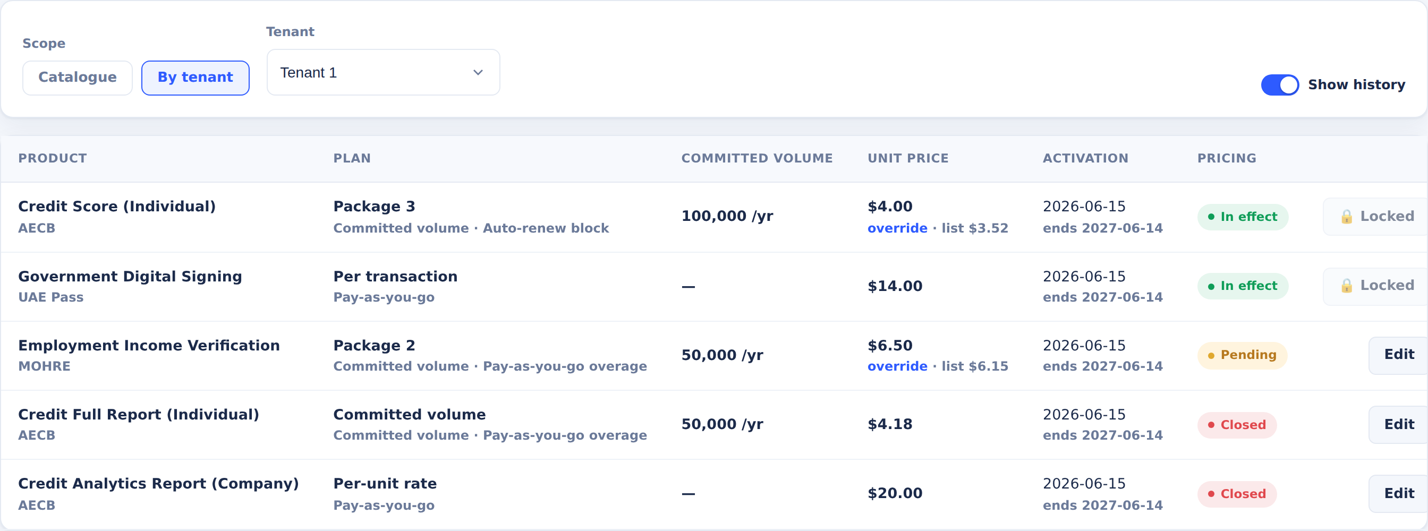
Show history on — the Pricing column shows In effect / Pending / Closed; Closed (cancelled / rejected) rows are revealed at the bottom.
Show history is off by default. When on, Closed rows are revealed after In-effect and Pending rows. Opening Edit turns Show history off for a cleaner edit context.

4.4 Edit / Customize tenant price
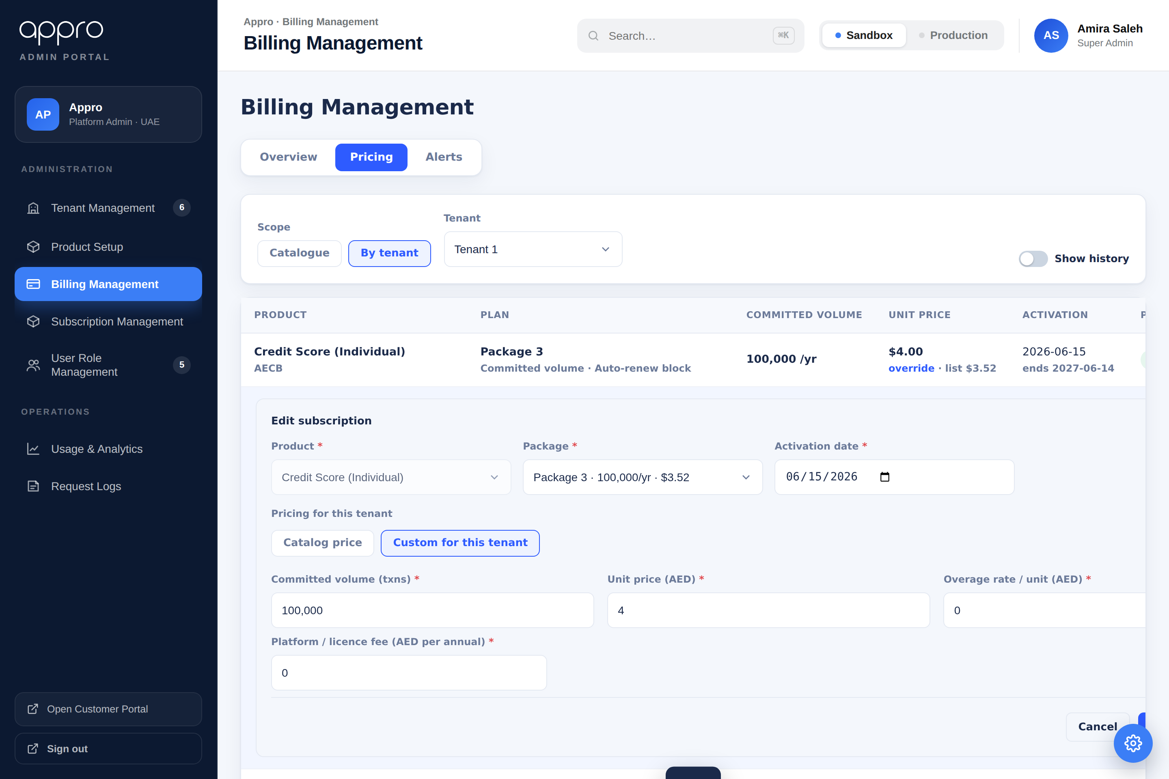
Edit subscription — Catalog price vs. Custom for this tenant; fields default from the catalogue.
Editing a row opens the Edit subscription form. Under Pricing for this tenant:
- Catalog price — the tenant follows the global catalogue price (the default).
- Custom for this tenant — a tenant override for unit price, committed volume, overage rate and platform / licence fee.
Saving a custom (overridden) price sets the pricing status to Pending [CHANGE] — the new price is awaiting activation and shows as Pending until then. Saving "Catalog price" keeps the current status.

5. Subscription Management
Subscription Management governs the subscription lifecycle and outbound data exposure. It references the Billing price (priceRef) read-only.

5.1 List, sub-tabs, status filter & KPIs
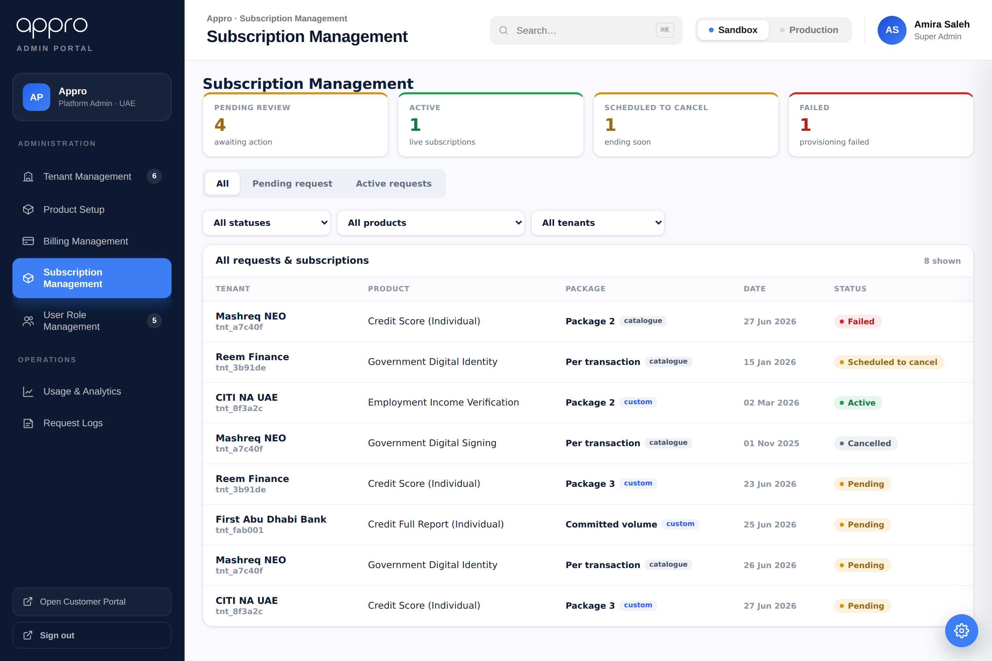
Subscription Management — coloured KPIs, sub-tabs, a status filter, and the combined list.
The screen provides:
- Coloured KPI tiles [CHANGE] — Pending review (amber), Active (green), Scheduled to cancel (amber). The role chip is removed.
- Sub-tabs [CHANGE] — All / Pending request / Active requests.
- A status filter whose options adapt to the active tab (All → every status; Pending → Pending; Active → Active / Scheduled to cancel), plus product and tenant filters. The free-text search is removed.
The two secondary tabs are shown below.
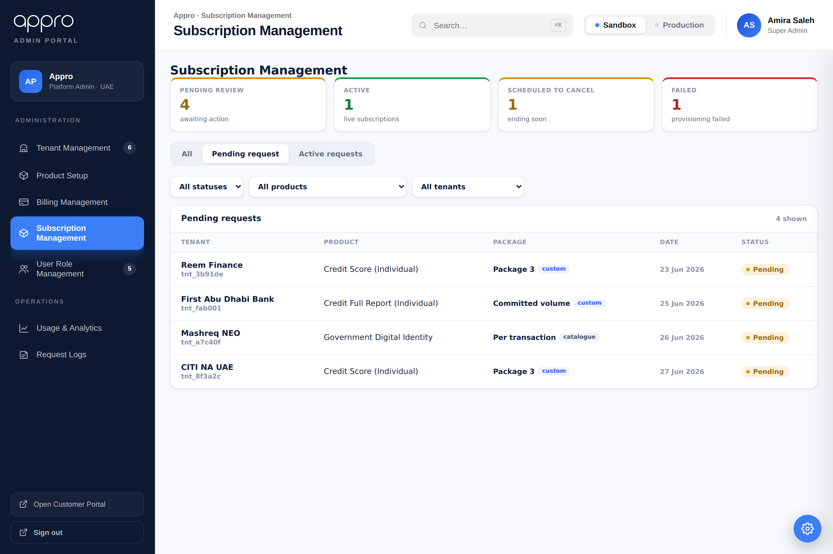
Pending request tab — only pending items; status filter limited to Pending.
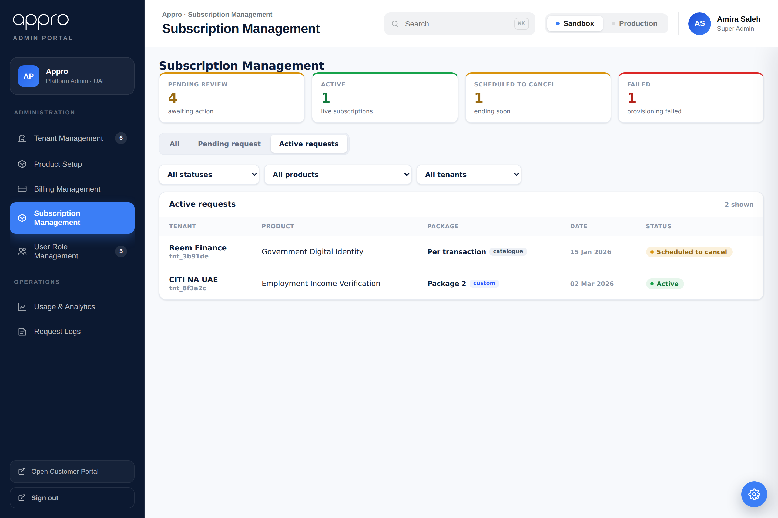
Active requests tab — live subscriptions, Scheduled to cancel listed before Active.

5.2 Request review — Approve / Reject
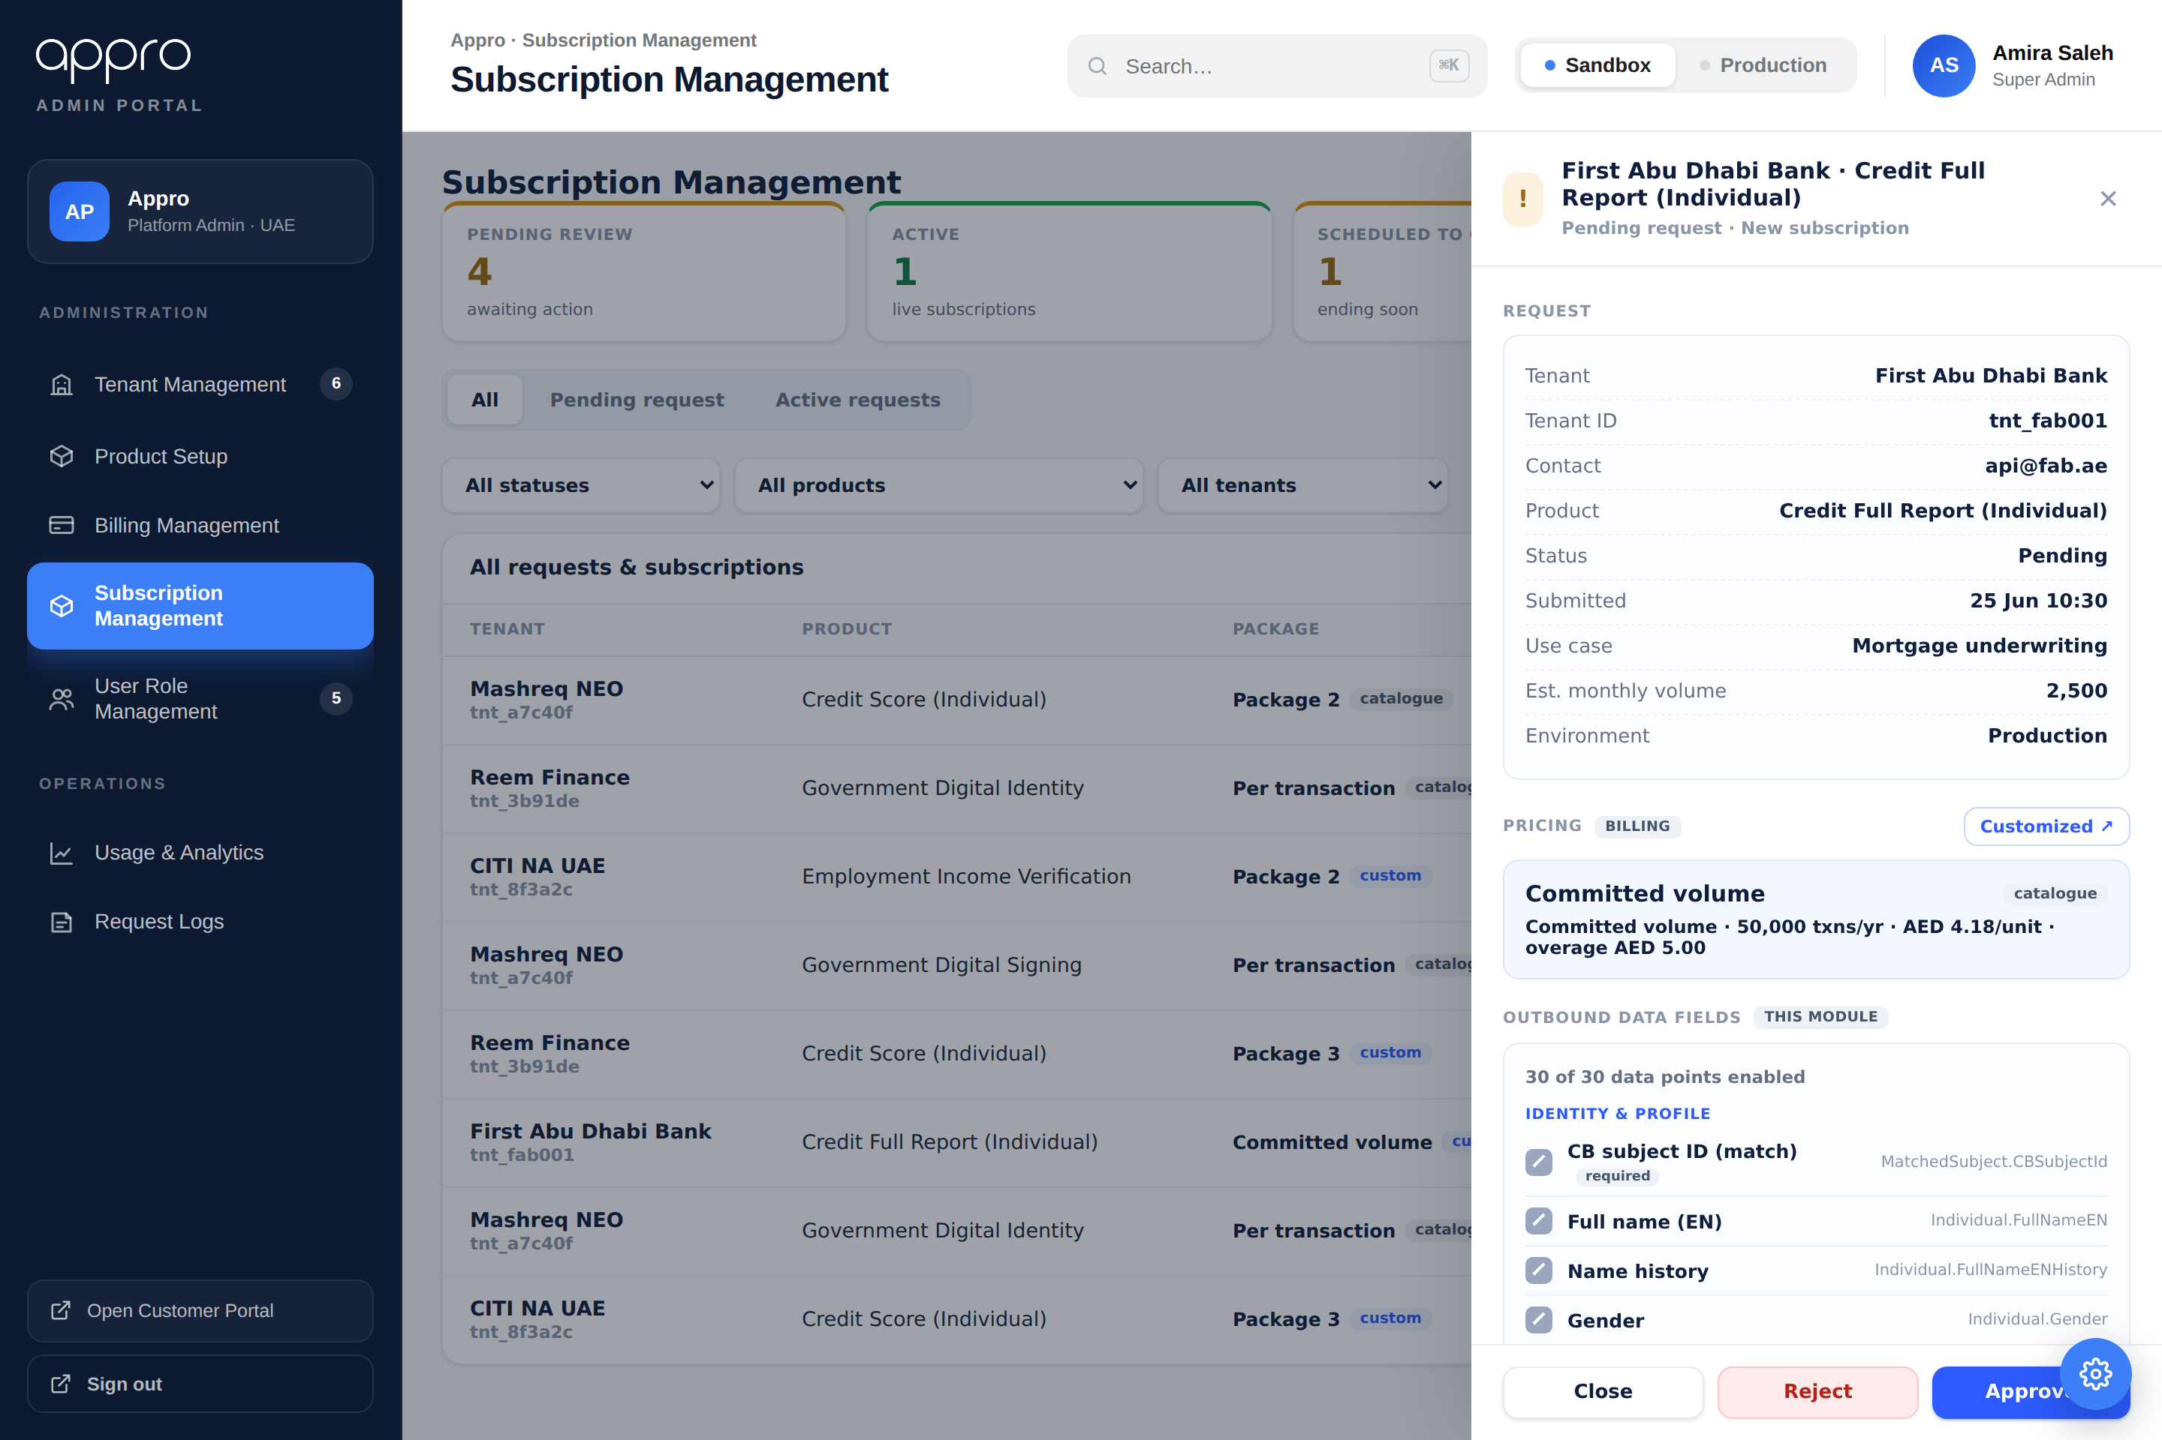
Request drawer — Approve / Reject, the read-only Billing price block, and the Customized ↗ link.
Opening a Pending request shows its details and a read-only pricing block (owned by Billing). The footer exposes:
- Approve [CHANGE] — grants eligibility (→ Approved · ready to subscribe); it does NOT provision. The tenant then completes the Confirm wizard (§6) to reach Active. Clears the request from the pending queue. Available only once a price resolves (see the pricing gate below). corrected v1.8
- Reject [CHANGE] — records a reason (optional free-text, shown to the tenant when provided; sanitised) and sets the request to Rejected. corrected v1.8
The Customized ↗ link cross-navigates to Billing to set the tenant price (see §6–§7).
Pricing gate — Approve requires a resolvable price. Opening a Pending request resolves one predicate: does a price exist for this tenant × product — either a Billing catalogue package for the product, or a per-tenant override already saved for this tenant? An on-request product has no catalogue price by definition, so for the Request-for-Price flow the override is normally the only source. Where neither exists the subscription could reach Active with nothing to bill, so Approve is disabled and the drawer routes the administrator forward instead of presenting a generic package. Reject stays available in every state — declining never needs a price. NEW v1.8
Drawer state | When | Pricing block and action | Approve
Priced | A catalogue package or a per-tenant override exists — priceRef resolves. | Read-only price + Customized ↗ (unchanged behaviour). | Enabled
No pricing · BILLING admin | No catalogue package and no override; the administrator holds the BILLING permission. | "No pricing configured for this product." + Set up pricing ↗ — opens Billing ▸ Pricing ▸ Catalogue for that product with the Return to approval bar. | Disabled
No pricing · other admin | No catalogue package and no override; the administrator does not hold BILLING. | "No pricing configured for this product. Contact a Billing administrator to set up pricing before this request can be approved." No Set up pricing action is offered. | Disabled
On return from Set up pricing the drawer re-resolves the predicate: the price now exists, Customized ↗ replaces the setup prompt, and Approve becomes available. Creating a catalogue package does not change how the product is advertised — a browsing tenant's card still reads "Request for Price", because card resolution follows the product's pricing type, not the existence of a package. NEW v1.8

5.3 Subscription lifecycle — Cancel / Un-schedule
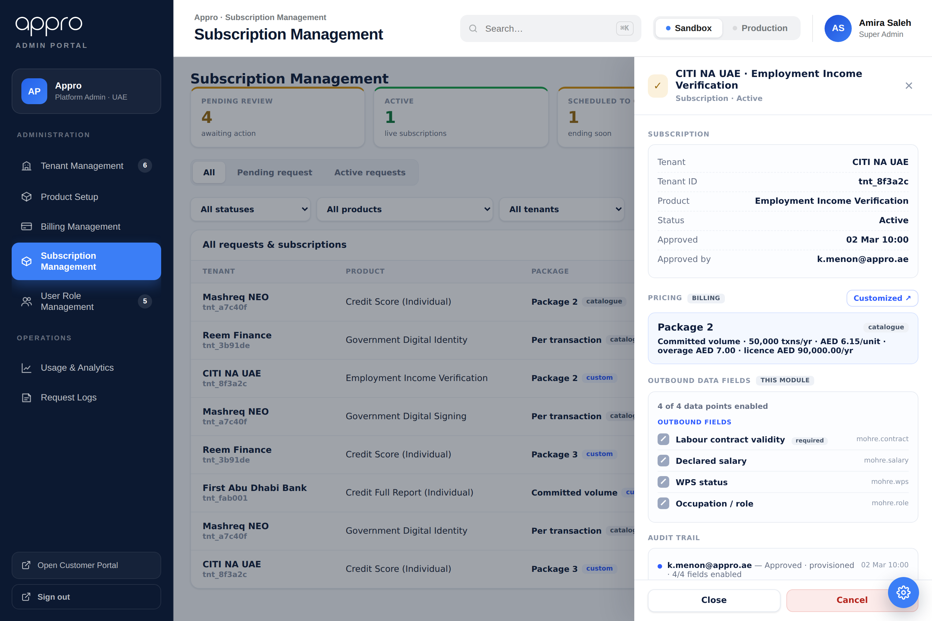
Subscription drawer — Cancel is in the drawer; the pricing block is read-only (“Locked while active”) for an active subscription.
The subscription drawer exposes lifecycle actions per status:
- Active → Cancel (cancel now or schedule a date). Cancel is in the drawer only — the inline list button is removed. NEW v1.7
- Scheduled to cancel → Un-schedule or Cancel now. NEW v1.7
- The Failed status and its Retry action are removed entirely. NEW v1.7
Pricing is locked while active — once a subscription is Active the drawer shows “Locked while active” in place of Customized ↗; Customize / Edit is available only while the price is still a Pending request. NEW v1.7
A cancel goes straight to Cancelled (no transient state); the drawer refreshes in place.

6. Request-for-Price Flow
This is the end-to-end journey from a tenant asking for a price to a live subscription. It threads three owners — the tenant (Customer Portal), Subscription Management (where the request lands and is decided), and Billing ▸ Pricing (where a tenant-specific price is set).
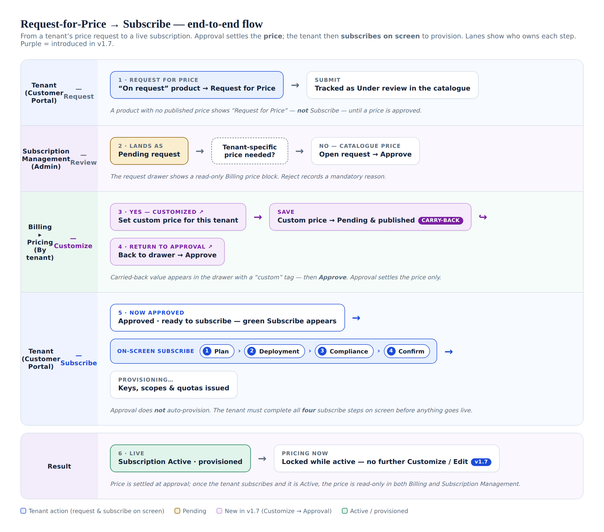
Request-for-Price — end-to-end flow across the tenant, Subscription Management and Billing.
1. Tenant requests a price. A product published as “On request” shows Request for Price instead of Subscribe; the tenant submits a subscription request, tracked as Under review in the catalogue.
2. It lands in Subscription Management as a Pending request. The reviewer opens it and sees a read-only Billing price block. A Pending request expires after 30 days (configurable) if no decision is taken, returning the card to "Request for Price".
3. Decision — is a tenant-specific price needed? No → the catalogue price applies; the admin clicks Approve (or Reject with a mandatory reason). Yes → the admin clicks Customized ↗ to cross-navigate to Billing ▸ Pricing ▸ By tenant. If the product has no pricing at all, Approve is unavailable until pricing is set up (§5.2).
4. Set the price in Billing and Save. A custom price becomes Pending and its value is published back to Subscription Management (carry-back, §6.1).
5. Return to approval — the admin approves the price. The Return to approval ↗ bar re-opens the request drawer, now showing the exact custom value with a “custom” tag. The admin clicks Approve. Approval settles the price only — it does not provision the subscription. The request becomes Approved · eligible; if the tenant does not confirm within 30 days (configurable), eligibility expires and the card returns to "Request for Price".
6. The tenant subscribes on screen. The catalogue now shows the product as “Approved · ready to subscribe” with a green Subscribe button. The tenant completes the on-screen subscribe wizard — Plan → Deployment → Compliance → Confirm (4 steps) — after which the platform provisions keys, scopes and quotas.
7. Subscription goes Active and is provisioned. Only once the tenant has completed all four subscribe steps is the subscription Active — and only then does billing / metering start. From this point the price is locked while active — Customize / Edit is disabled in both Billing (§4.2) and Subscription Management (§5.3).
Customize → Approval — detail
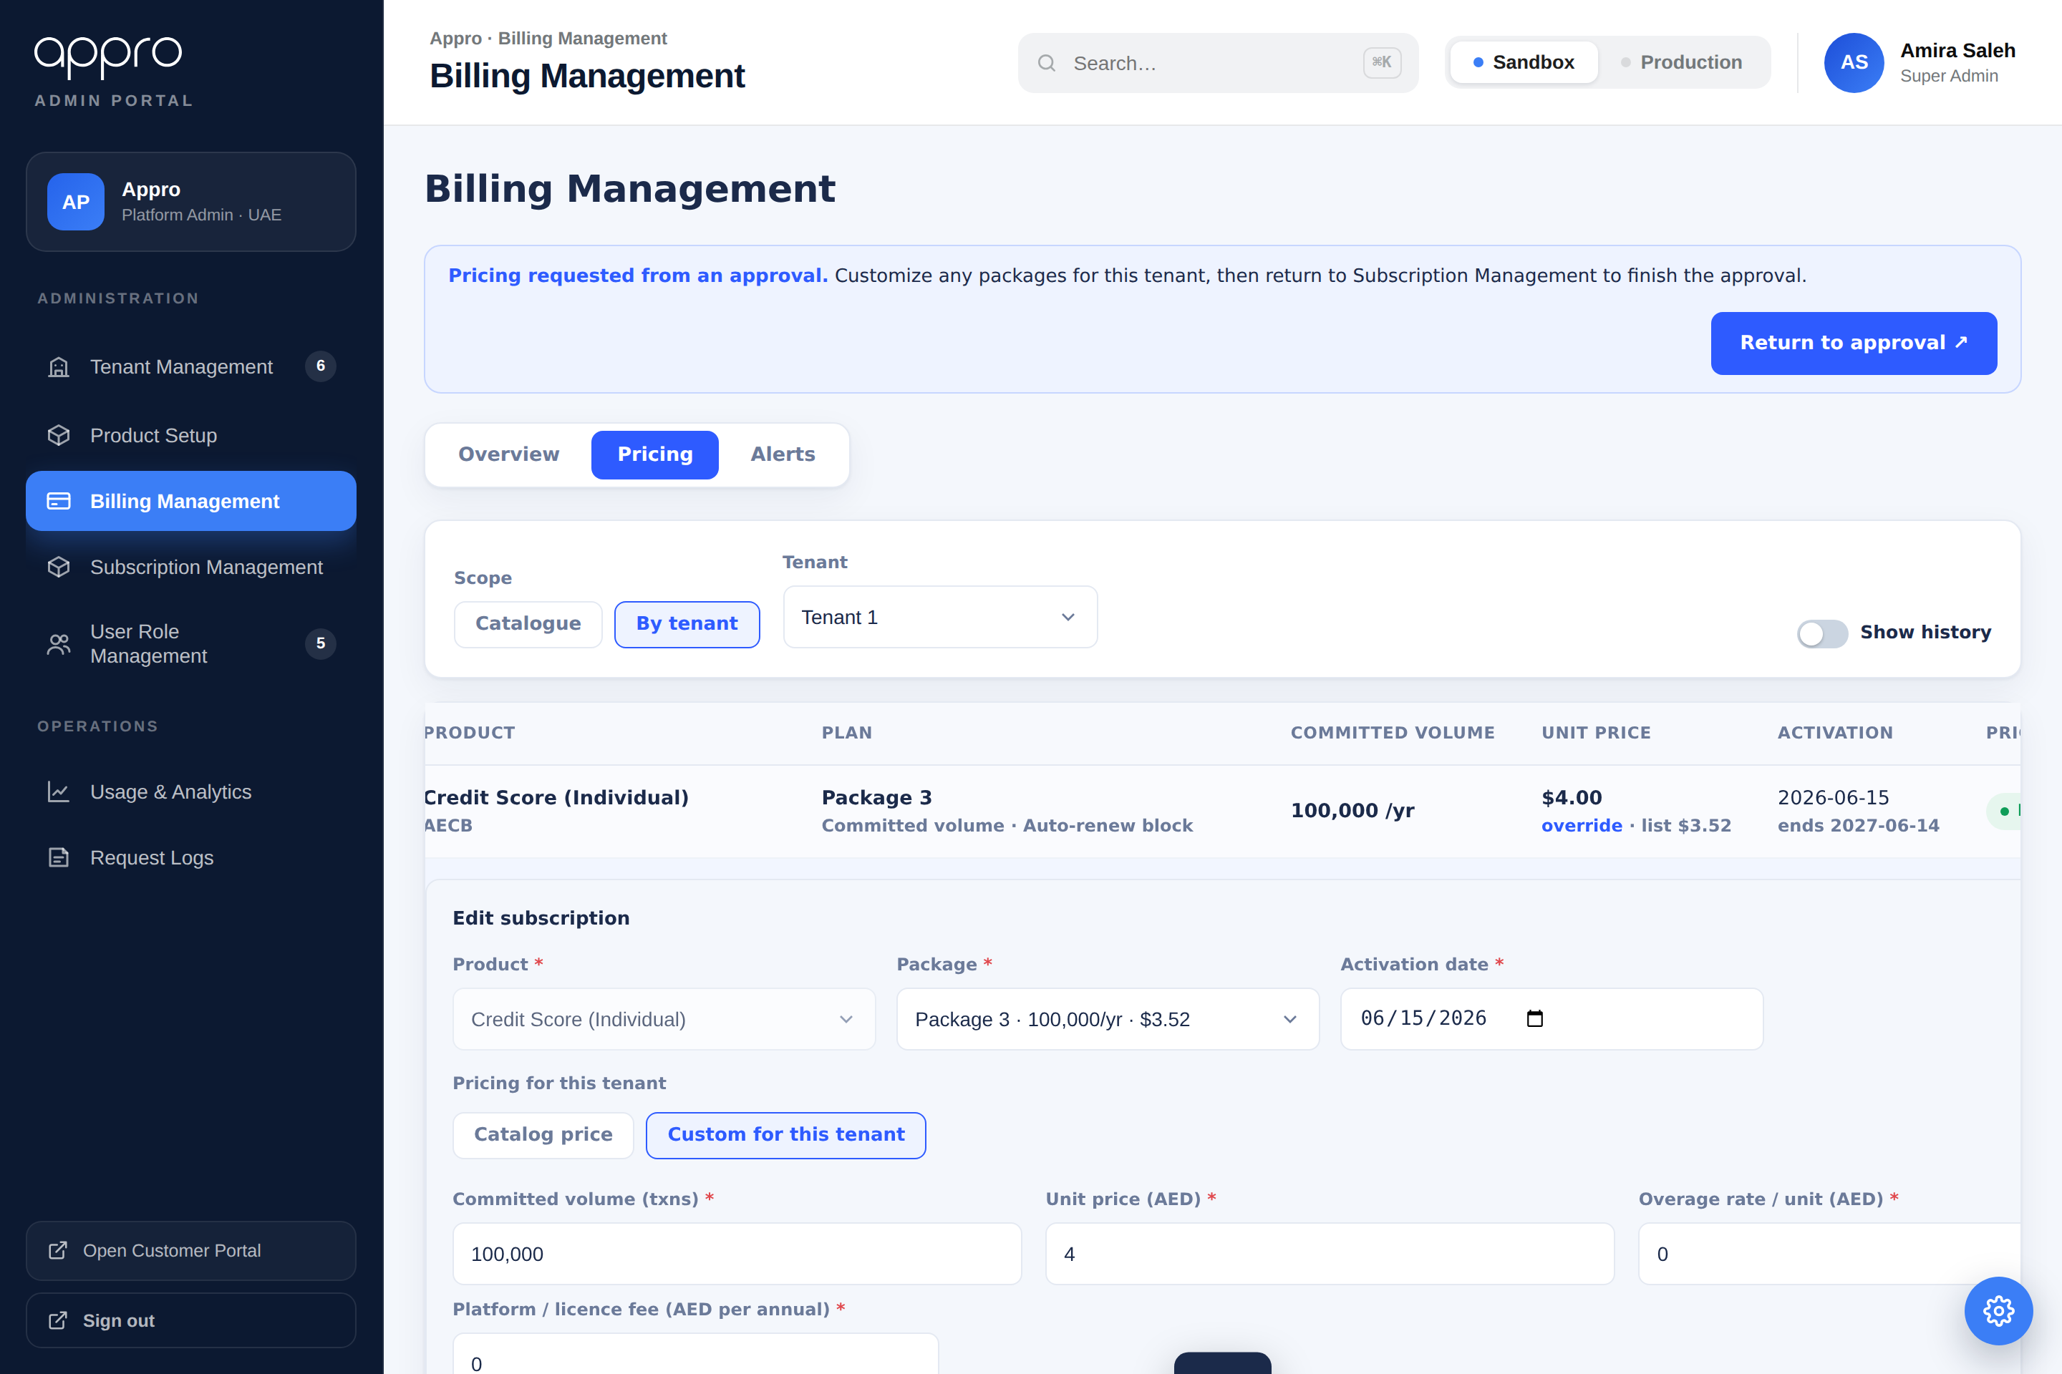
Billing shows a "Return to approval" bar after arriving from a Subscription Management approval.
When a request needs a tenant-specific price, the administrator can set it mid-approval and return to finish. The flow:
- 1. In the request drawer, click Customized ↗.
- 2. The system lands on Billing ▸ Pricing ▸ By tenant for that tenant × product, opens the Edit form, and shows a "Return to approval" bar.
- 3. The administrator may customize several packages for the tenant — each Save stays in Billing (no forced navigation).
- 4. Clicking Return to approval ↗ returns to Subscription Management and re-opens the request drawer with Reject / Approve to finish.

6.1 Price value carry-back
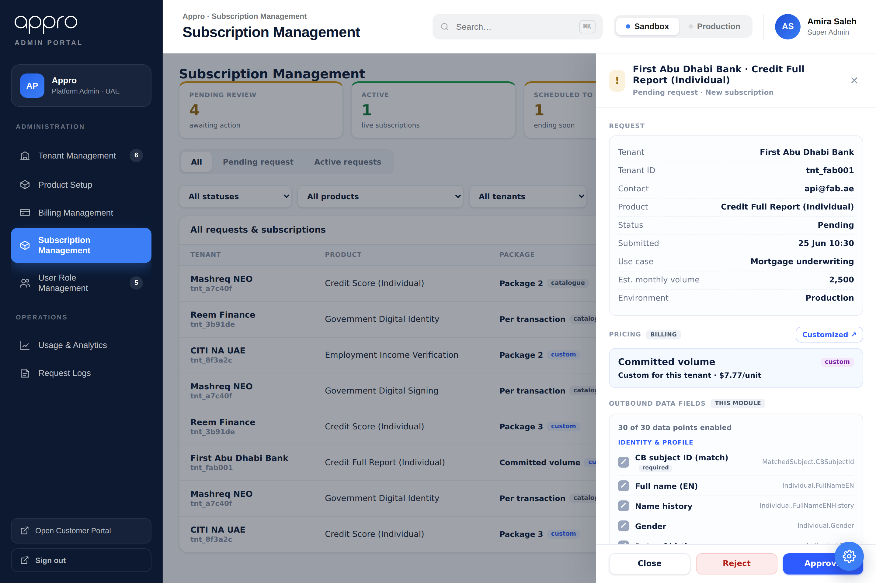
On Return to approval, the request drawer shows the exact customized value with a "custom" tag.
When the administrator saves a custom price in Billing, the value is published to a shared store keyed by tenant × product. On Return to approval, the request drawer displays that exact value with a "custom" tag — for example "Custom for this tenant · $7.77/unit" — instead of the catalogue label. In production both screens read the same backend price (priceRef); the shared store mirrors that behaviour in the prototype so the demo is faithful end-to-end.

7. Navigation Among Screens
From (screen · control) | Trigger | Lands on / Result
Subscription Mgmt · drawer · Customized ↗ | Click | Billing ▸ Pricing ▸ By tenant → Edit (Customize) form for that tenant × product, with the Return-to-approval bar.
Billing · Return to approval ↗ | Click | Back to Subscription Management; re-opens the originating request drawer to finish approval.
Billing ▸ Pricing ▸ By tenant · Edit | Click | Opens the inline Edit (Customize) form; turns Show history off.
Billing ▸ Pricing · Scope switch | Toggle | Catalogue ↔ By-tenant; tenant selector & Show-history only for By-tenant.
Billing ▸ Pricing ▸ Catalogue · Edit / New product | Click | Opens the product / package editor.
Sidebar · Billing / Subscription Management | Click | Loads the respective module.

8. Default Values (pricing source of truth)
Pricing defaults follow a clear source-of-truth rule:
- The default price for a tenant × product is picked up from the Catalogue (global pricing).
- If that product has already been set up earlier for that tenant (a per-tenant override exists in Billing ▸ Pricing ▸ By tenant), the tenant’s custom price is used instead, and the catalogue list is shown alongside for reference ("override · list $x").
- The Edit form reflects this: it opens on Catalog price when no prior tenant setup exists, or on Custom for this tenant pre-filled with the saved override when one does.
On-request products: a product published as "on request" carries no catalogue price, so the per-tenant override is normally its only price source. This is why Approve is gated on one of the two existing (§5.2) — without either, a subscription could reach Active, where billing starts, with no resolvable price. NEW v1.8
Field | Default (no prior tenant setup) | If prior tenant setup exists
Pricing mode | Catalog price selected. | Custom for this tenant selected.
Unit price | Catalogue package unit price. | Tenant override unit price.
Committed volume | Catalogue package committed volume. | Tenant override committed volume.
Overage rate / unit | Catalogue package overage rate. | Tenant override overage rate.
Platform / licence fee | Catalogue package licence fee. | Tenant override licence fee.
priceRef (Subscription Mgmt) | Points to catalogue price (tag: catalogue). | Points to tenant price (tag: custom).

9. List Sort Orders (for confirmation)
The current sort orders are listed below
List / view | Current sort order
Subscription Mgmt — All / Pending / Active | By status priority: Pending → Scheduled to cancel → Active → Cancelled → Rejected; then newest date within each group.
Billing ▸ Pricing ▸ By tenant | By pricing status: In effect → Pending → Closed (Closed only under Show history).
Billing ▸ Pricing ▸ Catalogue | By Catalogue status Catalogue Aphabetical order

Appendix A — Status Mapping Quick Reference
Subscription status | Pricing chip | History?
Active | In effect | Visible
Scheduled to cancel | In effect · ends <date> | Visible
Pending | Pending | Visible
Cancelled | Closed | Show history
Rejected | Closed | Show history
Expired | Closed | Show history

10. User Story Decisions (v1.8 grooming pass)
This section records the clarifications and Product-Owner rulings captured during the grooming of the Product Subscription Journey stories (GAS-163 and its children). It is the source of the v1.8 corrections above. Decisions are settled; Open items remain for grooming / estimation; → tech marks an engineering policy call.

GAS-163 — Product Subscription Journey (umbrella / epic)
– Note: Journey states affirmed as five: not-requested, pending, approved-eligible, rejected, active-subscribed — plus the GAS-256 cancel / scheduled-to-cancel states.
✓ Decision: Approval expiry and the metering start-point (the two questions that could reopen the state set) are resolved by the child stories below: eligibility expires after 30 days; billing / metering starts at Active.
○ Open: Still for grooming: single parent (GAS-163 story vs GAS-165 epic); the authoritative store / read path both portals project from; and who owns a real-stack SC1→SC7 journey walk.

GAS-171 — Catalogue card CTA resolution + search
✓ Decision: Q1 (blocking) — the eligible interim STAYS. Card flow of record: Request for Price → Under review → Approved · ready to subscribe (green Subscribe) → Active; a Cancelled subscription returns the card to “Request for Price”. No breaking change to FE / BFF / user-service — the shipped ELIGIBLE enum stands.
✓ Decision: Q2 — “Price on request” placement follows prototype SC1: indicator on the left, “Request for Price” on the right, same footer row; reconcile the built FE toward horizontal.
✓ Decision: Q3 — the product-detail CTA is out of scope here; standardise the on-request detail CTA to “Request for Price” and the priced case to “Subscribe” (copy-fix assigned to GAS-172).
✓ Decision: Q4 — after a Cancelled subscription the tenant may immediately re-request; BR1 blocks only one PENDING request, settled rows do not suppress the control.
✓ Decision: Q5 — GAS-171 is a v1.7-delta + regression-verification story; AC1–AC5 stand; remaining scope surfaces the two new terminal card states (Scheduled to cancel / Cancelled) and the Cancelled→re-request path.
✓ Decision: Q7 — card on-request vs priced resolution stays driven by the product-level catalogue pricingType; per-tenant pricing sets the amount only and does not flip a browsing tenant's base card.
○ Open: Q6 — whether the catalogue projection exposes a searchable “capability” field is a dependency to confirm with the catalogue-service owner; the BFF forwards q verbatim.

GAS-172 — Request-for-price modal & submit
– Note: UAT (28–29 Jul): the feature is deployed but UAT is blocked — all six UAT products return pricingType null (→ PRICED), so the Request-for-Price control never renders; unblocked by publishing one product with pricingType = ON_REQUEST. The earlier “contract gap” claim was withdrawn (measured against the wrong repo; both endpoints are documented in CustomerPortal.yaml).
○ Open: Canonical pending-state label: “Under review” (per the AC) vs “Awaiting review” (what the build renders) — still to decide.
○ Open: Also for grooming: is the user-service SubscriptionRequest + outbox write path built or to-build; the request's environment (selected vs agnostic); who may submit; post-submit modal behaviour; and how “exactly one” is enforced (DB constraint + idempotency vs app-level, and which story owns it).

GAS-173 — One-open-request rule (BR1) + reject → fresh re-request
✓ Decision: BR1 (one OPEN request per tenant×product, where open = {pending}) and reject → fresh re-request verified; a settled row (approved-then-cancelled, rejected, cancelled) does not suppress a new request. Recommend a backend dedup guard on the SubscriptionRequest write to enforce BR1 server-side.
○ Open: For grooming: behaviour when approve→provisioning fails or is in-flight (open, settled, or a third state); the full set of pending exits (withdraw / expiry); scope per (tenant, product) vs (…, plan); whether a reject also clears a tenant-level override; the guard's owning service / transaction and a partial unique constraint; and the exact 409 contract the client keys on (it must opt out of the global 409 reload-prompt).

GAS-174 — Admin review queue & request detail
✓ Decision: Approve / Reject are actioned from the Subscription Management screen (GAS-256) via the GAS-174 request-detail drawer (resolves the “which surface” question).
○ Open: For grooming: queue-LIST ownership split with GAS-256; extend the existing GAS-141 queue vs build a second; the row contract / status vocabulary under the mixed request+subscription list; the Customize button's destination; whether the data-field edit persists here or only at approve; the generic “On request” default field set; per-admin visibility scope; and the one canonical list/detail read shape (knowledge-base lesson L-10).

GAS-175 — Admin per-tenant price customization + price-value invariant
✓ Decision: priceRef is a read-only pointer to a Billing-owned price — no price scalar is stored in Subscription Management (the price-value invariant). The “No pricing configured” guard blocks approval until Billing packages exist for the product.
○ Open: For grooming: duplication vs already-baselined ACs; ownership overlap with the GAS-257 By-tenant surface; floor / ceiling / max-discount or second-approver thresholds; per-lever zero policy; price-moves-underneath handling (pin at submission vs resolve live); precision / rounding; validation enforcement point (domain vs DB CHECK → possible migration) and atomic multi-lever save; and whether the lever set varies by package type.

GAS-176 — Approve → eligibility & reject-with-reason (+ audit + notification)
✓ Decision: Q1 (blocking) — Approve grants a distinct eligible state, NOT direct-to-Active. The 02-Aug “provisions directly to Active / §3.2 removes eligible” callout overstated v1.7 and is corrected here in v1.8. GAS-256 / GAS-177 are reconciled to the same reading (the confirm wizard survives).
✓ Decision: Q2 — no metering / billing on approval alone; metering / billing starts at Active (provisioning success). The provisioning state machine + failure/retry lives in GAS-177.
✓ Decision: Q3 — the approved (eligible) state expires: configurable TTL, default 30 days; on expiry the card returns to “Request for Price”, so an unconfirmed approval never blocks the tenant forever under BR1.
✓ Decision: Q4 — the reject reason is free-text and OPTIONAL (this relaxes the earlier “validates non-empty”), shown to the tenant when provided, no structured codes, soft max 500 chars. The same rule applies to the GAS-256 cancel reason.
✓ Decision: Q5 — Approve / Reject are actioned from Subscription Management (GAS-256) via the GAS-174 request-detail drawer. Q6 — integration-level audit evidence (persisted audit/outbox row + emitted event) is accepted; GAS-191's read surface is not a prerequisite.
○ Open: → tech: Q7 actor attribution — GAS-248 (actor hard-coded “system”) must be fixed for the signed-in-admin audit entry (fold in as a prerequisite or carry principal propagation). Q8 — idempotency by decision id + a state-machine conflict check on double-submit.

GAS-177 — Confirm subscription wizard & async provisioning
✓ Decision: RETAINED, not superseded. The eligible → confirm → Active model is restored: approval grants eligible (GAS-176); the eligible request expires after 30 days; billing / metering starts at Active — all three require the tenant Confirm step this wizard owns. The 02-Aug “no confirm wizard” callout is reversed. AC1–AC4 (incl. the failure / timeout / retry path) stand.
✓ Decision: → tech (PO steer): build on the existing in-service com.appro.provisioner module — reuse its shipped GitOps / ArgoCD adapters, retry and timeout reconciler; add a subscription-provisioning job type. Do NOT revive the standalone provisioner worker.
○ Open: For grooming: the provisioning window and what the tenant is promised; the failure copy + support-contact destination + retry cap; the Confirm / retry idempotency mechanism; and environment pre-provisioned-vs-created + partial-success behaviour.

GAS-178 — Cross-portal in-session status reflection (survives reload)
✓ Decision: The v1.7 “reflects Active immediately after approval (no eligible interim)” note is reversed — the eligible interim is retained (approve → eligible → tenant confirms via GAS-177 → provisioning → Active). The subscribed card is unaffected: it renders once the subscription is Active, however Active was reached.
○ Open: For grooming: the deliverable mechanism (HTTP poll of a shared server-side store vs a browser-local store); what the reflection must survive beyond reload (different device, sign-out/in, cleared data); the acceptable staleness window; same-origin assumptions across environments; the per-surface polling budget; whether the admin portal needs in-session reflection; and whether Rejected / Cancelled are terminal.

GAS-179 — Subscribed state: sandbox + production keys, admin active-subs view & metering
✓ Decision: Keys on cancellation — revoke per effective date: Cancel-now revokes immediately; Scheduled-to-cancel keeps keys live until effectiveCancelAt, then revokes; revocation is permanent (dead, not suspended). No secret material appears on any request / review surface (GAS-180 AC5).
✓ Decision: The admin active-subscriptions view meters from Active (provisioning success); approved-but-unconfirmed items are not listed as active. Metering metric / period / latency / zero-usage / unavailable semantics are out of scope here (owned by the metering epic, GAS-169); the figures on this screen are illustrative.
○ Open: For grooming: reveal-once-and-masked vs retrievable key value; whether a Super Admin may reveal a production key; key rotation in scope for this release; and single-environment key display.

GAS-180 — Security hardening: RBAC split, 401/403/429, sanitisation, no-secret surfaces
✓ Decision: RBAC split confirmed: Approve / Reject require the SUBSCRIPTION permission; Customize (pricing) requires the BILLING permission; both within ADMIN / SUPER_ADMIN; wrong role → 403. The confirm-subscription endpoint (GAS-177) is a CUSTOMER action → authentication + tenant-ownership check, not an admin permission. Map {pending, eligible, active, scheduled-to-cancel, cancelled} onto the GAS-185 matrix.
✓ Decision: Sanitisation — the reject reason (and the GAS-256 cancel reason), now optional free-text, must still be sanitised: store-raw + escape-on-output (React escaping; no dangerouslySetInnerHTML).
○ Open: → tech: rate-limit numbers are a technical policy call — the state-mutating endpoints follow platform precedent, and the status-polling endpoint (GAS-178) needs a distinctly higher ceiling so the FE's designed cadence does not self-throttle; specify the count / window / key + Retry-After on the ticket. The limiter “must not mask BR1's benign 409 no-op”.

GAS-256 — Subscription lifecycle: Cancel / Schedule / Un-schedule (admin drawer)
✓ Decision: Cancel reason — free-text, OPTIONAL (relaxes the epic's “mandatory reason”); shown to the tenant when provided; soft max 500 chars; sanitised per GAS-180 AC3. Same contract as the GAS-176 reject reason.
✓ Decision: Cancel-now settlement — pro-rated to effectiveCancelAt; charge only up to the cancel date; no separate refund or credit note. Scheduled-to-cancel stays billable to the date, then settles pro-rata the same way.
✓ Decision: Keys on cancel — revoke per effective date (Cancel-now immediate; Scheduled at effectiveCancelAt; permanent; Un-schedule before the date keeps keys live). No transient Cancelling / Failed states.
– Note: This story's own lifecycle is unaffected by the eligible-interim correction — Cancel / Schedule / Un-schedule all act on an already-Active subscription regardless of how it reached Active.
○ Open: For grooming: de-provisioning on Cancel-now; any grace window for in-flight API calls; and settlement mechanics (timezone boundary, tick interval, multi-pod idempotency).

GAS-257 — Billing ▸ Pricing tab: scope switch, pricing chip, Show history, ordering
✓ Decision: Billing tab topology (final): three tabs — Overview · Pricing · Alerts. Pricing is this story (the Catalogue ↔ By-tenant scope switch; per-tenant overrides live under Pricing ▸ By tenant). The old standalone Subscriptions tab is retired — its route into the per-tenant override editor moves under Pricing ▸ By tenant, giving one entry point. Overview (invoice) is untouched (owned by GAS-219–222); Alerts is a separate new tab, out of scope here.
✓ Decision: Chips remain In effect / Pending / Ended (Closed), computed at read time from the subscription status (BR-B1); Billing persists no chip column and never writes lifecycle state.
○ Open: For grooming: the full status→chip mapping incl. Scheduled-to-cancel and Rejected; the lock policy for an Active tenant's price (403 vs 409, and the sanctioned mid-term renegotiation path); the By-tenant table column contract and whether selecting a tenant is mandatory; the ordering source field; and the permission mapping for the tab / scope / tenant selector / Show history / Save.
End of document.

11. Tenant Portal — Subscriptions & Billing View (Read-only)
Added in v1.9. The Customer (Tenant) Portal exposes the billing model to the tenant as a single read-only Overview screen (Operate → Subscriptions & Billing). It is the tenant-side counterpart of Billing Management: every figure is a projection of the shared billing model for the signed-in organization only. Pricing and package configuration never surface on the tenant side. Jira: GAS-531 (story), GAS-141 (epic).

11.1 Scope & access
• Single screen, no tabs and no filter — the view is always scoped to the signed-in organization (tenantId); cross-tenant data is never shown.
• Read-only: no action on the screen creates, updates or deletes data. There is no payment-method / card section and no billing-profile maintenance.
• Access is gated by the Tenant User Role Management permission "Subscriptions & Billing → View billing" (GAS-201). No write-level billing permission is exercisable on this screen.

11.2 Screen composition (Overview)
• Current cycle card — cycle label with organization, cycle close date and invoice date; KPIs: Running total (accrued charge before VAT, with % delta vs the prior cycle — down/green, up/red), Active plans (count + distinct services), Quota used (used / committed with a progress bar).
• Billing trend — bar chart of the projected period charge for the last 6 cycles; the current cycle bar is highlighted.
• Line items — Item · Usage · Unit · Amount for each active plan charge, plus rows for overflow and applied minimum charges; footer: Subtotal (before 5% VAT), VAT (5%), Total due. Totals reconcile exactly.
• Invoices — one row per month with amount and a status pill (Paid / Pending; the open cycle stays Pending until settled), listed newest first.

11.3 Consumption & billing parameters
A full-width read-only table shows, per subscription of the organization (inactive rows dimmed), the same consumption and billing parameters an administrator sees per tenant in Billing Management:
• Service (with product) · Package · Billing type (Committed volume / Usage band / Pay-as-you-go / On request / Per transaction).
• Committed volume · Success count (tagged "+over" beyond committed, "capped" at a hard cap) · Failed count (failed calls are not billed).
• Unit rate ($X/unit, tiered, or quoted) · Overage policy (with the pay-as-you-go rate where applicable) · Minimum charge · Period charge (tagged "min" where the minimum applied).

11.4 Invoice export
• Every invoice row carries an Export action that downloads that month’s invoice as a PDF matching that cycle’s line items and totals. The pre-defined PDF template and export mechanics are specified in GAS-222.

11.5 Exclusions (tenant side)
• Payment method / card display and billing-profile maintenance.
• Plan or package change requests (no self-service change flow in this release).
• Usage CSV export.
• Pricing, package and per-tenant override configuration — Super Admin Portal only (sections 4–6).

