[COMPANY LOGO]
Business Requirements Document
API Marketplace — Customer (Tenant) Portal: User Role Management
Customer (Tenant) Portal · Appro API Marketplace
Version 2.3
This is not a legally binding document. Highly confidential — not to be shared without written consent.

Version history
Date | Version | Author | Change description
20-07-2026 | 1.0 | [Author] | Initial tenant User Role Management as a Team member list with a Role-permissions drawer.
20-07-2026 | 2.0 | [Author] | Redesigned to match the Super Admin Portal User Role Management layout exactly: a tabbed module (Role Management list + Add/Edit role, User Management list + Apply Filter + Add User) with Environment (Sandbox / Production) scope. The Team screen is removed and replaced by this module. The ONLY difference from the Super Admin Portal URM is the permission function list (tenant modules: Build / Operate / Organization) and the tenant roles (Admin / Developer / Billing / Viewer). No maker-checker on the tenant side. Portal screenshots added.
29-07-2026 | 2.1 | [Author] | Made the User-list visibility scope explicit (CLR-012): the Customer Portal User Management list shows all members of the signed-in admin’s OWN organization — both Tenant Admins and regular tenant users (Developer / Billing / Viewer) — and never any other tenant’s members or any Super Admin Portal (platform) user. Documented in 2.7, reinforced NFR-1 and added NFR-6 (server-side enforcement), user story US-6 and an Impact row.
06-08-2026 | 2.2 | [Author] | Added account activation to the tenant module (CLR-013), bringing it to parity with the Super Admin Portal URM v1.4. Member creation now sends an invitation email carrying a single-use set-password / activation link (configurable expiry, 10-minute default) and lands the member on a new Activate Account screen (2.8.2) where they set a password, accept the Terms of Use and activate the account. Members are created as Invited, not Active (2.9 AC2); the three-state status is surfaced on the user list (2.7) and the Status filter (2.7.1). Added the ActivationToken entity and member credential fields (2.10), NFR-7/NFR-8, notification templates TT01–TT05 (2.12), user stories US-7/US-8 and impact rows. The dual local-password / SSO model is stated explicitly (2.8.1).
06-08-2026 | 2.3 | [Author] | Removed the Invited status (CLR-014), matching Super Admin Portal URM v1.5. Member status is TWO-state only — Active / Inactive — governed by the enable/disable control. Whether a member has established credentials is not a status: it is a property of the account, and the activation link’s validity is DERIVED from the date the link was generated. Members are created Active and cannot sign in until they set a password. The member list and Status filter revert to two states, nothing about the invitation is surfaced on the list, and no link-validity duration is shown on screen. Organization SSO sign-in is deferred to Phase 2 and is NOT in this release; template TT02 moves with it.

Table of contents

1. Feature overview and key covered areas
This document defines the requirements for User Role Management in the Customer (Tenant) Portal of the Appro API Marketplace. It replaces the earlier Team screen with a module that is structurally identical to the Super Admin Portal’s User Role Management: a tabbed workspace where a tenant administrator manages roles and their permissions (Role Management) and the organization’s users (User Management), with an Environment (Sandbox / Production) scope. The only differences from the Super Admin Portal are the permission function list — the tenant’s own Customer-portal modules (Build / Operate / Organization) — and the tenant roles (Admin / Developer / Billing / Viewer). Unlike the Super Admin Portal, the tenant side has no maker-checker control; changes apply immediately.
This BRD covers:
- Role Management — a role list (name, status, environment, per-module access) and an Add/Edit-role screen assigning permissions from the tenant permission matrix, with a per-group and per-menu “Select all”.
- User Management — a user list (name, role, environment, status, last-updated), an Apply Filter panel, and an Add/Edit-user screen.
- Environment scope — a Sandbox / Production selector at role and user level.
- Account activation — an invitation email on member creation carrying a single-use set-password / activation link, and an Activate Account screen where the member sets a password, accepts the Terms of Use and activates the account. Activation is not a status: the member is created Active and simply cannot sign in until credentials exist. [UPDATED v2.3 · CLR-014]
- The tenant permission matrix (Appendix A), data model, non-functional requirements, user stories and impact analysis.
Note: this module governs the Customer (Tenant) Portal only, and a tenant sees only its own organization. Sign-in in this release is by email + password against the shared platform user store. Organization SSO (e.g. Nuqud Pay AD) is deferred to Phase 2 and is NOT in scope this sprint. Access Requests and maker-checker are not part of this module. [UPDATED v2.3 · CLR-014]

2. Detailed requirements

2.1 Roles and access
User Role Management is available to tenant members holding the User Role Management permissions (typically the tenant Admin) only, and never exposes other tenants’ data. All create, edit, status-change and remove actions are captured in the tenant audit trail.

2.2 Concept and terminology
Term | Meaning (tenant context)
Role | A named set of permissions from the tenant matrix, plus an environment scope. Four seeded roles: Admin, Developer, Billing, Viewer. A member holds one or more roles.
Permission | A single capability on a Customer-portal module (e.g. “Create key”), grouped by Build / Operate / Organization.
Permission matrix | The tenant module → menu → permission catalogue applied across the Customer Portal to gate menus, screens and buttons (Appendix A).
Environment scope | The Sandbox / Production dimension held at role and user level (the Customer Portal is environment-aware via a global switcher).

2.3 Role Management — role list (SC1)
The Role Management tab lists all roles in a grid: role name, a Status toggle (Active / Inactive), the Environment scope, and one column per module group (Build / Operate / Organization) carrying an access indicator — Full access, Partial, or No access. A free-text search filters by role name; Add Role opens the create flow; selecting a role opens it in edit.
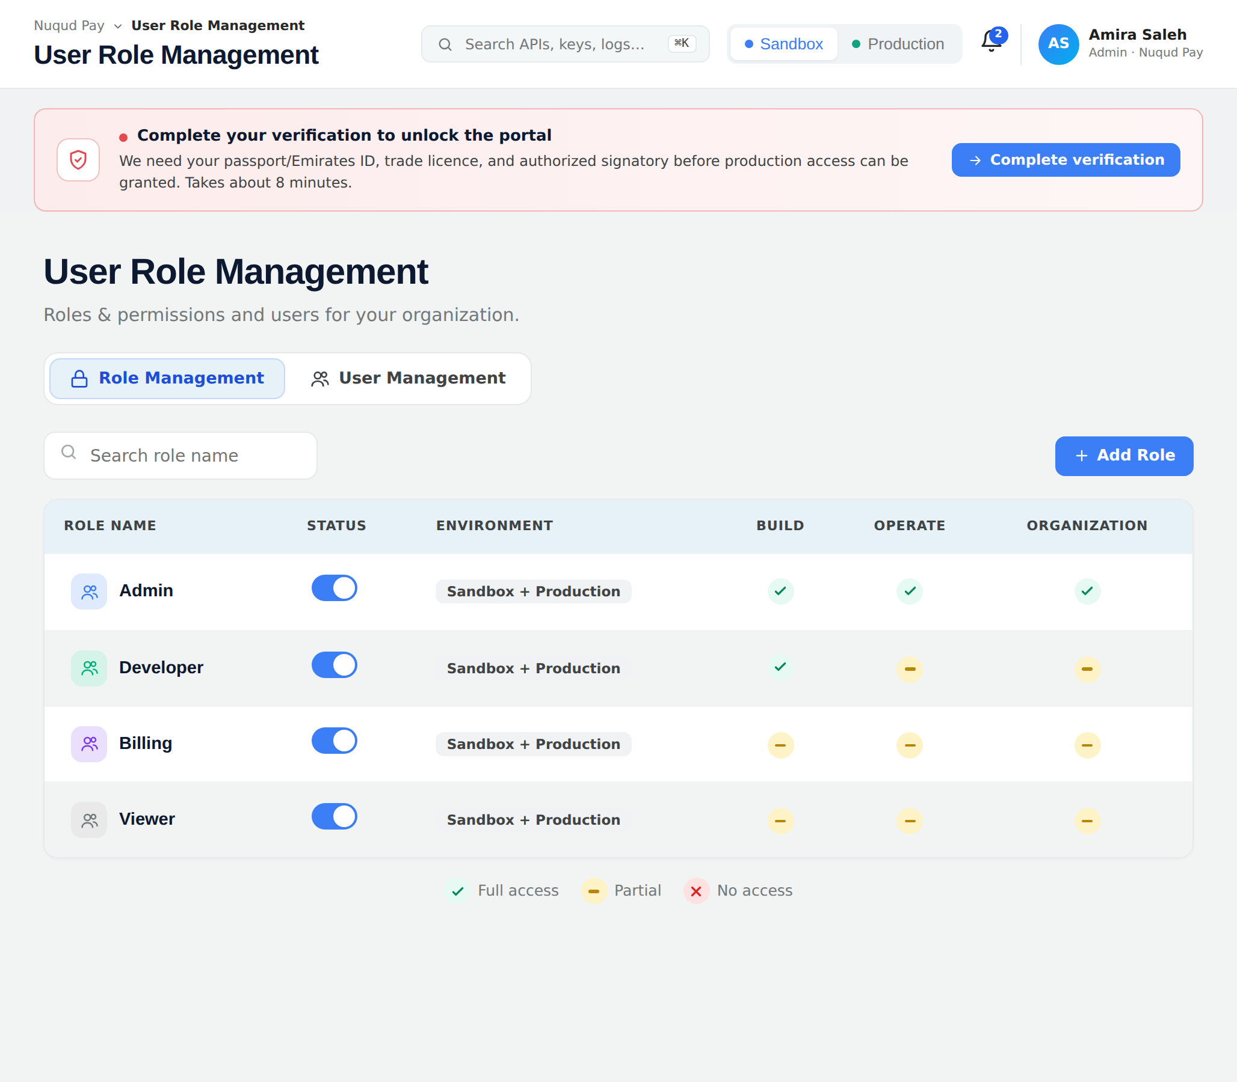
Figure 1 — Role Management: tenant roles with status, environment and per-module access (Build / Operate / Organization).

2.4 Add / Edit role (SC2)
The Add-role and Edit-role screens share one layout — a Role Information block (Role Name + Environment) followed by Permission assignment (collapsible module groups; each group carries a sub-menu rail of its menus and a per-group / per-menu “Select all”).
Component | Type | Editable | Mandatory | Default | Description
Role information
Role Name | Single line of text | Y | Y | — | Unique across Active and Inactive roles. Max 200 characters. Inline error if blank or duplicate.
Environment | Selector (Sandbox / Production / Both) | Y | Y | Both | The environment(s) this role can act in (2.6).
Permission assignment
Group Permission section | Section (collapsible) | N/A | N/A | — | Build / Operate / Organization; selections retained across collapse/expand.
Sub-menu rail | List | N/A | N/A | — | The menus in the group (e.g. Environments, Product Catalogue, API Keys …), each with its own permission set and “Select all”.
Select all | Checkbox | Y | N | Unticked | Per group and per menu; ticks/clears the permissions.
Detail permission | Checkbox | Y | N | Unticked | Gates the corresponding menu, screen or button in the Customer Portal.
Add role / Save changes; Cancel | Button | N/A | N/A | — | Validate then save (applied immediately); discard confirmation on cancel.
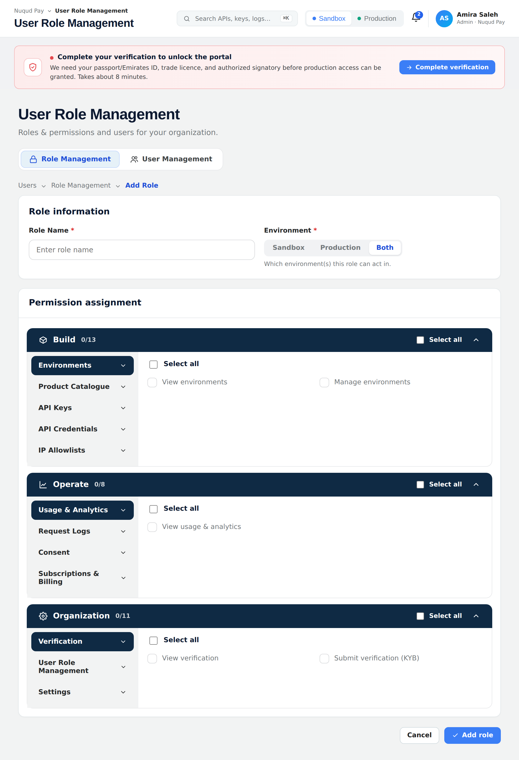
Figure 2 — Add / Edit role: Role Information and the tenant permission groups with the sub-menu rail.

2.5 Permission matrix
The Customer Portal gates every menu, screen and button on the permissions of the signed-in member’s role(s). The full tenant permission matrix is in Appendix A.

2.6 Environment scope (Sandbox / Production)
Environment is a single selector held at the role level (2.4) and the user level (2.8): a role/user scoped to Sandbox only cannot act on Production objects, and vice-versa; “Both” grants either. The effective environments for a member are the intersection of the member’s and their role’s environment scope.

2.7 User Management — user list (SC3)
The User Management tab lists the organization’s members: name and email, assigned Role(s) as chips, Environment scope, a Status pill, the Last Updated Date and the Last Updated By, with free-text search, an Apply Filter panel (2.7.1), Export, and Add User.
User-list visibility scope (CLR-012). The list shows ALL members of the signed-in admin’s own organization — both Tenant Admins and regular tenant users (Developer / Billing / Viewer, and any custom tenant roles). It never shows another tenant’s members, and never shows Super Admin Portal (platform) users. The scope is applied server-side to every read (list, search, filter, export) and follows directly from the tenant-isolation rule (NFR-1). Note: from the Super Admin Portal side, a platform administrator sees each tenant’s Tenant Admin only — not the tenant’s internal members — as specified in the Super Admin Portal User Role Management BRD (NFR-7). [UPDATED v2.1 · CLR-012]
Two-state status (CLR-013, CLR-014). Status is shown as a pill with two states — Active (green) and Inactive (grey) — and is governed solely by the enable/disable control. There is no Invited status: a member who has not yet set a password is Active but cannot sign in, because sign-in requires a credential that does not yet exist. Nothing about the invitation — neither the link nor its expiry — is surfaced on the member list. [UPDATED v2.3 · CLR-014]
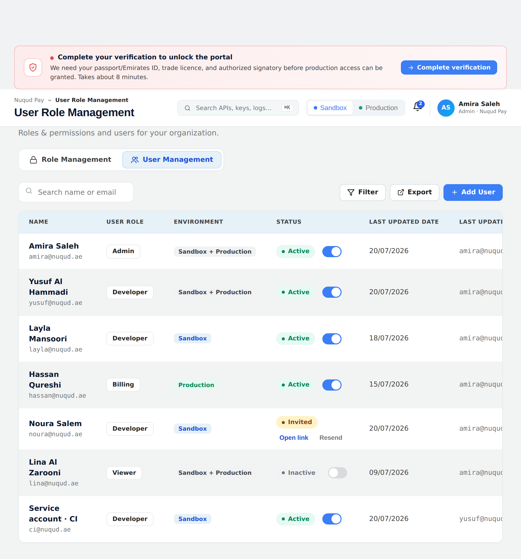
Figure 3 — User Management: members with role chips, environment and last-updated audit columns.

2.7.1 Apply Filter
The Filter action opens the Apply Filter panel, which filters the member list by Environment (All / Sandbox / Production), Status (All / Active / Inactive) and Last Updated Date (on or after). The Filter button shows an active-filter count; applied filters appear as removable chips with a Clear all shortcut. [UPDATED v2.3 · CLR-014]
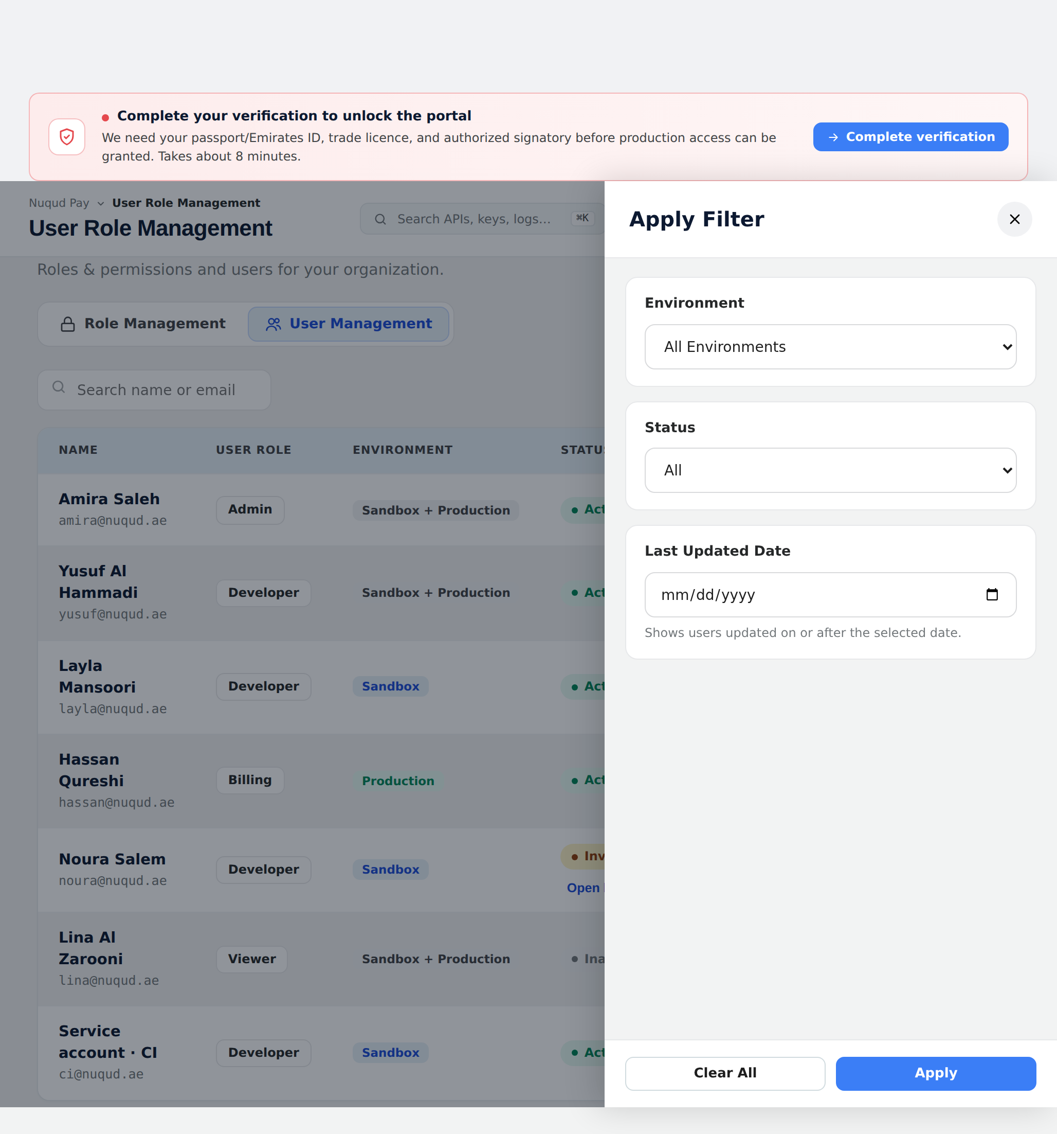
Figure 4 — Apply Filter: filter members by Environment, Status and Last Updated Date.

2.8 Add / Edit user (SC4)
Component | Type | Editable | Mandatory | Default | Description
Name | Single line of text | Y | Y | — | The member’s display name.
User Email | Single line of text | Y | Y | — | Unique within the tenant (case-insensitive, whitespace-trimmed), enforced across Active and Inactive members. Sign-in identity and notification address — the activation email is sent here (2.8.1). Max 254 characters. Editable after creation by a tenant Admin; the change is audited and, where the member has not yet activated, re-issues the activation link. [UPDATED v2.3 · CLR-014]
Mobile Number | Single line of text | Y | N | +971 | Optional contact number.
Department | Dropdown | Y | N | — | Engineering / Product / Finance / Operations / Security.
User Role | Dropdown (multi-select) | Y | Y | — | One or more of Admin / Developer / Billing / Viewer; shown as removable chips.
Environment | Checkboxes (Sandbox / Production) | Y | Y | — | The environment(s) the member may act in (2.6). At least one required.
Add user / Save changes; Cancel | Button | N/A | N/A | — | Validate then save; discard confirmation on cancel.
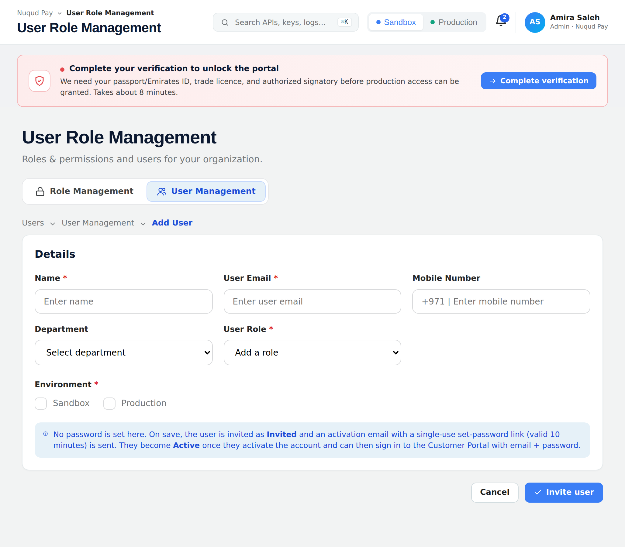
Figure 5 — Add / Edit user: role assignment and Environment (Sandbox / Production).

2.8.1 Credential establishment & invitation [NEW v2.2 · CLR-013]
A newly created member must be able to establish credentials and sign in. Creation alone does not grant access — the member is created with status Active but holds no password, so sign-in is refused until they complete the Activate Account screen. Being not-yet-activated is a property of the account, not a status. The authentication model is: [UPDATED v2.3 · CLR-014]
- Local password. On save, the backend creates the member with Status = Active and sends an activation email carrying a single-use set-password / activation link of the form …/activate?token=<token> to the User Email (template TT01). The member cannot sign in until the link is completed — access is gated by the absence of a credential, not by a status. The link expiry is a configurable per-environment setting (10-minute default; see NFR-7), and whether a given link is still usable is DERIVED by comparing the generated-link date against that setting. No link-validity duration is displayed on screen. [UPDATED v2.3 · CLR-014]
- Organization SSO — Phase 2, NOT in this release. Federated sign-in through the tenant’s identity provider is out of scope for this sprint and is deferred to Phase 2, together with notification template TT02 (access granted). Every member in this release establishes a local password through the Activate Account screen. [UPDATED v2.3 · CLR-014]
- Resend invitation. A Resend invitation action is available on the Edit-user screen for a member who has not yet activated; it issues a fresh link with a new expiry window and invalidates the previous one (template TT03), so only the most recent link works. It is deliberately NOT surfaced on the member list, which shows status only. The action requires the Invite user permission (Appendix A). [UPDATED v2.3 · CLR-014]
- Exactly one email per creation. Creation always triggers exactly one notification — the activation email (TT01). Template content is specified in 2.12; dispatch is handled by the platform notification service. [UPDATED v2.3 · CLR-014]
Parity note. This mirrors the Super Admin Portal behaviour (Super Admin Portal URM BRD v1.5, §2.8.1–2.8.2) and the tenant-onboarding activation already delivered for the tenant primary admin, so a tenant member and a platform administrator establish credentials through the same mechanism and the same token contract. [UPDATED v2.3 · CLR-014]

2.8.2 Activate Account screen (SC5) [NEW v2.2 · CLR-013]
A member activates their account from the link in the activation email (…/activate?token=<token>, template TT01). The link opens the Activate Account screen on the Customer Portal, where the member sets a password and accepts the Terms of Use. On success the account can be signed into with email and password. The screen is a three-mode state machine driven by the server-validated token: set-password (valid token), activated (success) and expired (expired / already used / not found). The screen does not state how long the link remains valid. [UPDATED v2.3 · CLR-014]
Component | Type | Editable | Mandatory | Default | Description
Identity card | Static | N/A | N | — | Shows the member’s name, email and organization resolved from the SERVER-VALIDATED token — never from raw URL parameters, so a crafted link cannot display a different organization.
New Password | Password field | Y | Y | — | The member’s chosen password. Must meet the platform password policy (length ≥ 8 and complexity); strength is indicated live as the member types. Error IEM017 if blank or below policy.
Confirm Password | Password field | Y | Y | — | Must match New Password exactly. Error IEM018 on mismatch.
I agree to the Terms of Use | Checkbox (+ link) | Y | Y | Unticked | Mandatory consent, with a link to the current Terms of Use. Must be ticked to activate; acceptance (version + timestamp) is recorded on the member (2.10). Error IEM019 if not accepted.
Link-expiry notice | Static | N/A | N | — | States how long the link remains valid, using the SERVER-SUPPLIED expiry value (e.g. "10 minutes"). It must never be hardcoded — a notice that disagrees with the real TTL sends members away after the window has closed.
Activate account | Button | N/A | N/A | — | Enabled only when the password meets policy, Confirm matches and the Terms checkbox is ticked. On click, validate the token and save (see AC below).
Email me a new link | Button | N/A | N/A | — | Shown on the expired mode only. Issues a fresh single-use token with a new expiry, invalidates the previous one, and confirms that a new link has been sent to the member’s email.
Back to sign in | Button | N/A | N/A | — | Returns to the Customer Portal sign-in.
Table — Activate Account screen components (Customer Portal).
AC1 — Token validity. The screen is reachable only with a valid, unexpired, single-use token. Validity is computed from the generated-link date against the configurable window (2.8.1 / NFR-7) — it is not read from any stored invitation state. If the token is missing, malformed, already used or expired, the form is not shown; an error state (IEM020) is displayed with guidance to request a fresh link or ask the tenant Admin to resend it (TT03). [UPDATED v2.3 · CLR-014]
AC2 — Activation. On a valid submission the backend stores the password hash against the member record (2.10), consumes the token (single-use), records Terms-of-Use acceptance (version + timestamp), stamps activatedAt, and writes a tenant audit entry. Status is unchanged by activation — the member was already Active; what changes is that a credential now exists. The member is then signed in (or redirected to sign-in). [UPDATED v2.3 · CLR-014]
AC3 — Identity is server-resolved. Every value shown on the identity card is resolved from the validated token server-side. No field on the screen is populated from a URL query parameter.
AC4 — Expiry mid-form. A token that was valid at page load but has expired by submit is rejected on submit; the member is moved to the expired mode and offered a fresh link from that screen. At a 10-minute default TTL this is a normal path, not an edge case.
AC5 — Constraints. Activation does not change the member’s roles or environment scope — those are fixed at creation (2.8). The password is never displayed, logged or emailed; the password is stored only as a hash and the activation token only as a hash (NFR-8). The full activation URL, which carries the raw token, must never be written to logs or browser console.

2.9 Validation and saving
AC1 — Validation. Mandatory fields present; [Role Name] unique across Active and Inactive roles; [User Email] unique across Active and Inactive members (case-insensitive, whitespace-trimmed); a role has ≥ 1 permission; a user has ≥ 1 role and ≥ 1 environment. The Admin role cannot be reduced below what is needed to manage the team (guard against lock-out). [UPDATED v2.3 · CLR-014]
AC2 — Saving. Persist the record with Status = Active on create. The member still cannot sign in until they establish credentials via the Activate Account screen (2.8.1–2.8.2); that is a property of the account, not a status. Preserve status on edit, stamp updated-by/date, write a tenant audit entry, and show a success toast. Changes apply immediately (no maker-checker). [UPDATED v2.3 · CLR-014]
AC3 — Credential dispatch. On successful create, dispatch the activation notification (TT01) per 2.8.1 and 2.12. The save post-condition is "the member can obtain access", not merely "record persisted". If dispatch fails, the failure is surfaced to the administrator, who can resend from the Edit-user screen. [UPDATED v2.3 · CLR-014]

2.10 Data model (key entities)
Entity | Key attributes
TenantRole | roleId, tenantId, name (unique), status (active/inactive), environmentScope[], permissionIds[], updatedBy/At
TenantPermission | permissionId, group (Build/Operate/Organization), menu, action, displayName
TenantMember | memberId, tenantId, name, email (unique in tenant, case-insensitive), passwordHash, mobile, department, roleIds[], environmentScope[], status (active | inactive), activationLinkSentAt, activatedAt, termsAcceptedVersion, termsAcceptedAt, updatedBy/At. There is no invited status and no stored invitation state — whether a member has credentials is passwordHash / activatedAt, and link validity is derived from activationLinkSentAt. [UPDATED v2.3 · CLR-014]
ActivationToken | tokenId, memberId, tenantId, tokenHash (single-use), generatedAt, expiresAt (derived: generatedAt + the configurable window, default 10 min — 2.8.1 / NFR-7), consumedAt. Issued on create and on Resend invitation; issuing a new token invalidates the previous one. Only the hash is persisted. [UPDATED v2.3 · CLR-014]

2.11 Non-functional requirements
ID | Requirement
NFR-1 | A tenant sees and manages only its own organization; cross-tenant access is impossible. The User Management list therefore returns only this tenant’s own members (Tenant Admins and tenant users) — never another tenant’s members or any Super Admin Portal user.
NFR-2 | Permission checks are enforced server-side on every Customer-portal menu, screen and action.
NFR-3 | Sign-in in this release is by email + password against the shared platform user store; 2FA is enforced. Organization SSO is Phase 2 and NOT in scope this sprint. Role/permission changes apply at next sign-in. [UPDATED v2.3 · CLR-014]
NFR-4 | All create/edit/status/remove actions are captured in the tenant audit trail.
NFR-5 | The Admin role cannot be edited into a state that locks the tenant out of team management.
NFR-6 | User-list visibility is enforced server-side: every read (list, search, filter, export) is filtered by the signed-in member’s tenantId so only own-organization members are returned. (CLR-012)
NFR-7 | Invitation / set-password (activation) links are single-use, time-limited and delivered only to the target User Email. The expiry window MUST be configurable per environment (10-minute default) and a link’s validity MUST be computed from its generated-link date against that window, never from a stored invitation status. The duration is not displayed to the member. [UPDATED v2.3 · CLR-014]
NFR-8 | Credential secrets are never exposed in-app to another member. Passwords are stored only as hashes and activation tokens only as hashes; the raw token and any URL carrying it are never logged, echoed to the browser console or included in analytics. [NEW v2.2 · CLR-013]

2.12 Notifications [NEW v2.2 · CLR-013]
The module dispatches the following notifications to tenant members. Dispatch is handled by the platform notification service; full subject and body content is aligned to the live template catalogue at build time. Codes TT01–TT05 are placeholders. All templates are sent to the member’s User Email and are tenant-branded where branding is configured.
Code | Notification | Trigger | In this release?
TT01 | Member invitation / set password | Member created in a tenant using local passwords | Yes
TT02 | Access granted (SSO) — Phase 2 | Member created in an SSO-enabled tenant | No — Phase 2
TT03 | Resend invitation | Tenant Admin resends the activation link to a member who has not yet activated, or the member requests a fresh link from the expired screen [UPDATED v2.3 · CLR-014] | Yes
TT04 | Account activated | Member completes the Activate Account screen | Yes
TT05 | Account deactivated | Member set to Inactive by a tenant Admin | Yes
Table — tenant member notification templates (2.12).

3. User stories
US-1 Define a role
As a tenant Admin, I want to create a role by selecting permissions from the tenant matrix and setting its environment scope, so that I can grant exactly the access a job function needs.
US-2 See roles at a glance
As a tenant Admin, I want a role list showing each role’s status, environment and per-module access, so that I can review who can do what.
US-3 Assign roles and environment to a member
As a tenant Admin, I want to add a member with one or more roles and an environment scope, so that they can act only where and how they are entitled.
US-4 Filter the member list
As a tenant Admin, I want to filter members by environment, status and last-updated date, so that I can quickly find the members relevant to a Sandbox or Production review.
US-5 Least privilege by default
As a tenant Admin, I want Viewer and Developer roles to be view-only where appropriate, so that only the right people can change billing and organization settings.
US-6 See only my organization’s users
As a tenant Admin, I want the User Management list to show all of my organization’s members — Tenant Admins and tenant users — and no one from any other tenant or the platform, so that I manage my own team in isolation.
US-7 Invite a member to set their own password [NEW v2.2 · CLR-013]
As a tenant Admin, I want a newly created member to receive an activation email so they set their own password, so that they can sign in for the first time without me ever handling or communicating a password. [UPDATED v2.3 · CLR-014]
US-8 Activate my account [NEW v2.2 · CLR-013]
As a newly created member, I want to open the activation link in the email I received, be taken to the Activate Account screen, set a valid password, tick "I agree to the Terms of Use" and click Activate account, so that I can sign in. Given the link is still within its validity window — derived from when it was generated — when I submit a valid password and accept the Terms, then my account is activated and I am signed in; if the link has lapsed, already been used or is not recognised, I am shown the expired state and can request a fresh link myself. [UPDATED v2.3 · CLR-014]

4. Impact analysis
Impact | Change required
Customer-portal navigation | The Team item under Organization is replaced by User Role Management; the Team screen and its drawer are removed.
RBAC enforcement | Gate every Customer-portal menu, screen and action on the tenant permission matrix, server-side. Seed the four roles.
User-list visibility scope | Scope every User Management read (list / search / filter / export) by the signed-in member’s tenantId so only own-organization members are returned — Tenant Admins and tenant users — and never another tenant’s members or a platform user (CLR-012, 2.7, NFR-1 / NFR-6).
Environment scope | Honour the Sandbox / Production scope on roles and members; intersect member × role scope.
SSO & 2FA | This release supports email + password sign-in against the shared platform user store, with 2FA enforced. Organization SSO provisioning against the tenant’s identity provider is Phase 2 and NOT in scope this sprint. [UPDATED v2.3 · CLR-014]
Audit trail | Append-only tenant trail for create / edit / status / remove.
Access Requests / Maker-Checker | Not part of this module (maker-checker is Super Admin Portal only).
Credentials & activation | Create members with status Active (there is no Invited status) and gate sign-in on the credential, not the status. Build the Activate Account screen served at …/activate?token= on the Customer Portal, reusing the tenant-onboarding token contract (SHA-256 hash, single-use). Expose the link-expiry window as a configurable per-environment setting (10-minute default) and compute validity from the generated-link date. Do not display the duration on screen. [UPDATED v2.3 · CLR-014]
Notifications | Integrate templates TT01 / TT03–TT05 with the platform notification service; exactly one email on create. Surface a dispatch failure to the administrator and offer Resend invitation from the Edit-user screen (2.12). TT02 ships with SSO in Phase 2. [UPDATED v2.3 · CLR-014]
Member list & filter | Keep the member list exactly as it is — a two-state Active / Inactive status pill and toggle, with no activation or link information rendered on the row. The Status filter offers All / Active / Inactive only (2.7, 2.7.1). [UPDATED v2.3 · CLR-014]
Resend invitation | Add the Resend invitation action to the Edit-user screen only (not the member list) for members who have not yet activated, gated on the Invite user permission; issuing a fresh token invalidates the previous one (2.8.1, Appendix A). [UPDATED v2.3 · CLR-014]

Appendix A Tenant permission matrix
The Customer-portal function list used to build tenant roles (2.4–2.5). Environment (Sandbox / Production) is a separate scope selector (2.6).
Group | Menu | Permissions
Build | Environments | View environments · Manage environments
Build | Product Catalogue | Browse catalogue · Request for price · Subscribe to product
Build | API Keys | View keys · Create key · Roll key · Revoke key
Build | API Credentials | View credentials · Manage credentials
Build | IP Allowlists | View allowlist · Edit allowlist
Operate | Usage & Analytics | View usage & analytics
Operate | Request Logs | View request logs · Export request logs
Operate | Consent | View consent · Manage consent
Operate | Subscriptions & Billing | View billing · Manage subscription · Manage payment method
Organization | Verification | View verification · Submit verification (KYB)
Organization | User Role Management | View roles & users · Create role · Edit role · Invite user · Resend invitation · Edit user · Remove user [NEW v2.2 · CLR-013]
Organization | Settings | View settings · Edit organization · Manage security
Role presets: Admin — all. Developer — all of Build and Operate; view-only on Organization and on Subscriptions & Billing. Billing — Subscriptions & Billing (manage) plus every View. Viewer — every View only.

Appendix B Glossary
Term | Definition
Tenant / organization | A customer company subscribing to Marketplace APIs (e.g. Nuqud Pay).
Member | A user within a tenant organization; holds one or more roles.
Environment scope | The Sandbox / Production restriction on a role and member.
SSO / 2FA | SSO — single sign-on via the organization’s identity provider. PHASE 2, not in this release. 2FA is enforced on email + password sign-in in this release. [UPDATED v2.3 · CLR-014]
Activation token | Single-use activation token issued on member creation and on resend. Validity is the single invariant "not yet consumed AND now < generatedAt + the configurable window", matched by the token hash; only the hash is persisted. [UPDATED v2.3 · CLR-014]
Not yet activated | Not-yet-activated — a member record that exists, is Active and carries roles, but has no password yet. Such a member cannot sign in until they complete the Activate Account screen. This is a property of the account, NOT a status. [UPDATED v2.3 · CLR-014]

