[COMPANY LOGO]
Business Requirements Document
API Marketplace — Super Admin Portal: User Role Management
Super Admin Portal · Appro API Marketplace
Version 1.5
v1.5 removes the Invited status (CLR-014): user status is two-state only — Active / Inactive — and whether a user has set a password is a property of the account, not a status. The activation link’s validity is derived from the date it was generated. Users are created Active and cannot sign in until they activate. v1.4 added the Activate Account flow: user creation sends an invitation email whose single-use set-password / activation link opens a new Activate Account screen (2.8.2) where the user sets a password, accepts the Terms of Use and activates the account. SSO / IdP sign-in is deferred to Phase 2. Earlier changes (CLR-001 – CLR-011) and Maker-Checker (NOT in this release) are unchanged. [UPDATED v1.5 · CLR-014]
This is not a legally binding document. Highly confidential — not to be shared without written consent.

Version history
Date | Version | Author | Change description
20-07-2026 | 1.0 | [Author] | Created the standalone User Role Management BRD for the Super Admin Portal, split out from the combined User Role Management & Maker-Checker document. Covers roles, user management (list + Apply Filter + Add/Edit-user), the Environment (Sandbox / Production) scope, and the Marketplace permission matrix. Portal screenshots added. Maker-Checker documented separately.
06-08-2026 | 1.5 | Appro BRD Team | Removed the Invited status (CLR-014). User status is now TWO-state only — Active / Inactive — governed by the enable/disable control. Whether a user has established credentials is no longer modelled as a status: it is a property of the account, and the activation link’s validity is DERIVED from the date the link was generated rather than tracked as separate state. Users are created Active and simply cannot sign in until they set a password. The user list and Status filter revert to two states, and no link-validity duration is shown on screen. SSO / IdP sign-in is deferred to Phase 2 and is NOT in this release; template AT02 moves with it.

Table of contents

1. Feature overview and key covered areas
This document defines the requirements for the User Role Management module of the Appro API Marketplace Super Admin Portal — the governed workspace where a platform administrator defines roles and their permissions, assigns those roles to platform users, and scopes each role and user to an environment (Sandbox and/or Production). The concept is adapted from the Appro Super Portal design delivered for the Reem Finance, ADIB and Core (ACP) banking programmes (Jira: RF-2937–2962, ACP-245–280); the function list follows the Marketplace’s own Super Admin modules, and the bank’s loan product-type tabs are replaced by the Environment scope. The Maker-Checker (four-eyes) control that governs sensitive changes is specified in a separate BRD.
This BRD covers:
- Role Management — a role list (name, status, environment, per-module access indicator) and an Add/Edit-role screen that assigns permissions from the Marketplace permission matrix, with a per-group and per-sub-menu “Select all”.
- User Management — a user list (name, role, environment, status, last-updated), an Apply Filter panel, and an Add/Edit-user screen.
- Account activation — an invitation email on user creation carrying a single-use set-password / activation link, and an Activate Account screen where the user sets a password, accepts the Terms of Use and activates the account. Activation is not a status: the user is created Active and simply cannot sign in until credentials exist. All portal identities share one user store, differentiated only by Role. [UPDATED v1.5 · CLR-014]
- Environment scope — a Sandbox / Production selector at role and user level, replacing the bank product-type dimension.
- The Marketplace permission matrix (Appendix A), data model, non-functional requirements, notifications, user stories and impact analysis.
Note: Access Requests is not part of this module. Maker-Checker is documented separately. Tenant-side team & role management in the Customer Portal reuses the same concept over the tenant function list.

2. Detailed requirements

2.1 Roles and access
User Role Management is available to Super Admin Portal administrators who hold the relevant permissions only; it is never exposed to partner/tenant users. All create, edit, status-change and delete actions are captured in the audit trail (CR 003).
Privilege-assignment constraints (CLR-005). An administrator may not assign a role whose permission set exceeds their own effective permissions (“you cannot grant what you do not hold”). In addition, only a Super Admin may assign roles that carry User Role Management permissions. Roles the administrator is not entitled to assign are shown-but-disabled in the User Role selector with an explanatory tooltip. Self-service: an administrator may edit their own profile fields but may not change their own roles or environment scope, and may not deactivate their own account (lockout / self-escalation guard). [UPDATED v1.2 · CLR-005]

2.2 Concept and terminology
Term | Meaning
Role | A named set of permissions from the Marketplace matrix, plus an environment scope. Names unique across the platform (incl. inactive). A user may hold one or more roles.
Permission | A single capability on a module or sub-menu (e.g. “Publish product”), grouped by module and — for User Role Management — by sub-menu.
Permission matrix | The full module → sub-menu → detail-permission catalogue applied across the portal to gate menus, screens and buttons (Appendix A).
Environment scope | The Sandbox / Production dimension (the Marketplace equivalent of the bank product-type tabs), held at role and user level.

2.3 Role Management — role list (SC1)
The Role Management screen lists all roles in a grid: role name, a Status toggle (Active / Inactive), the Environment scope, and one column per module group carrying an access indicator — Full access (✓), Partial (–) or No access (✗) — computed from the permissions granted to that role. A free-text search filters by role name; Add Role opens the create flow; selecting a role opens it in edit; the grid paginates.
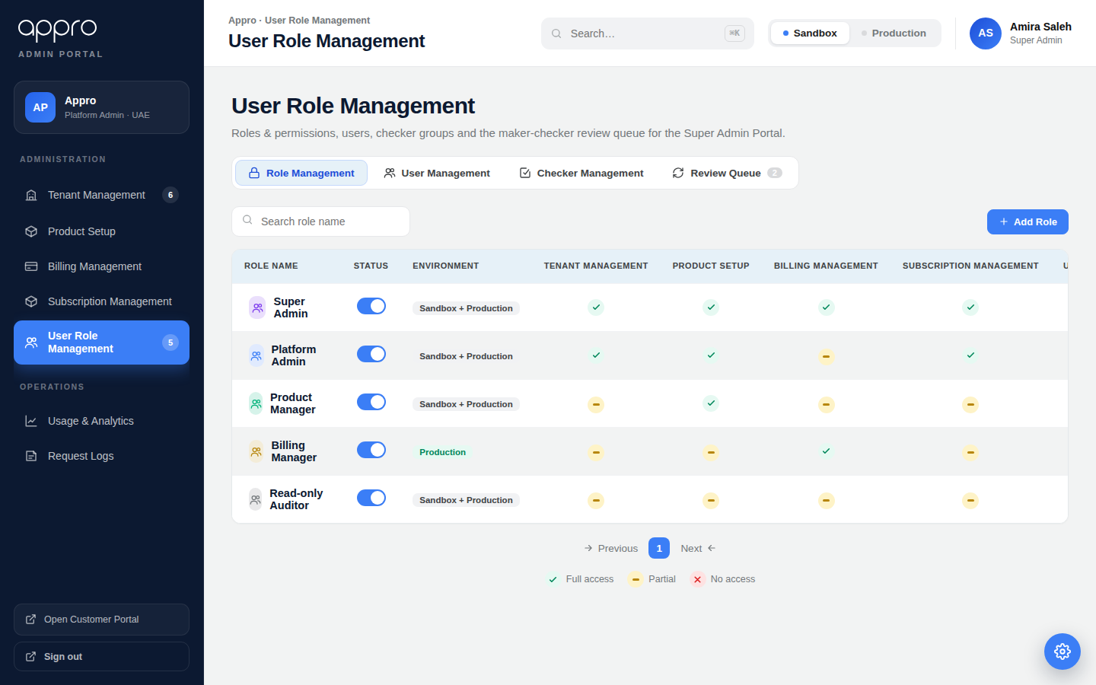
Figure 1 — Role Management list: status, environment and per-module access per role.

2.4 Add / Edit role (SC2)
The Add-role and Edit-role screens share one layout — a Role Information block (Role Name + Environment) followed by Permission assignment (collapsible module groups with a per-group “Select all”; the User Role Management group carries a Role Management / User Management / Checker Management sub-menu rail).
Component | Type | Editable | Mandatory | Default | Description
Role information
Role Name | Single line of text | Y | Y | — | Unique across Active and Inactive roles. Max 200 characters. Inline error IEM003 if blank; IEM010 if duplicate.
Environment | Selector (Sandbox / Production / Both) | Y | Y | Both | The environment(s) this role can act in (2.6).
Permission assignment
Group Permission section | Section (collapsible) | N/A | N/A | — | One section per module group (Appendix A). Selections retained across collapse/expand.
Select all (group) | Checkbox | Y | N | Unticked | Ticks / clears every permission in that group.
Sub-menu rail | List | N/A | N/A | — | For User Role Management: Role / User / Checker Management, each with its own permission set and “Select all”.
Detail permission | Checkbox | Y | N | Unticked | Gates the corresponding menu, screen or button across the portal.
Add role / Save changes | Button | N/A | N/A | — | Validate (2.9) then save.
Cancel | Button | N/A | N/A | — | Discard confirmation; returns to the role list.
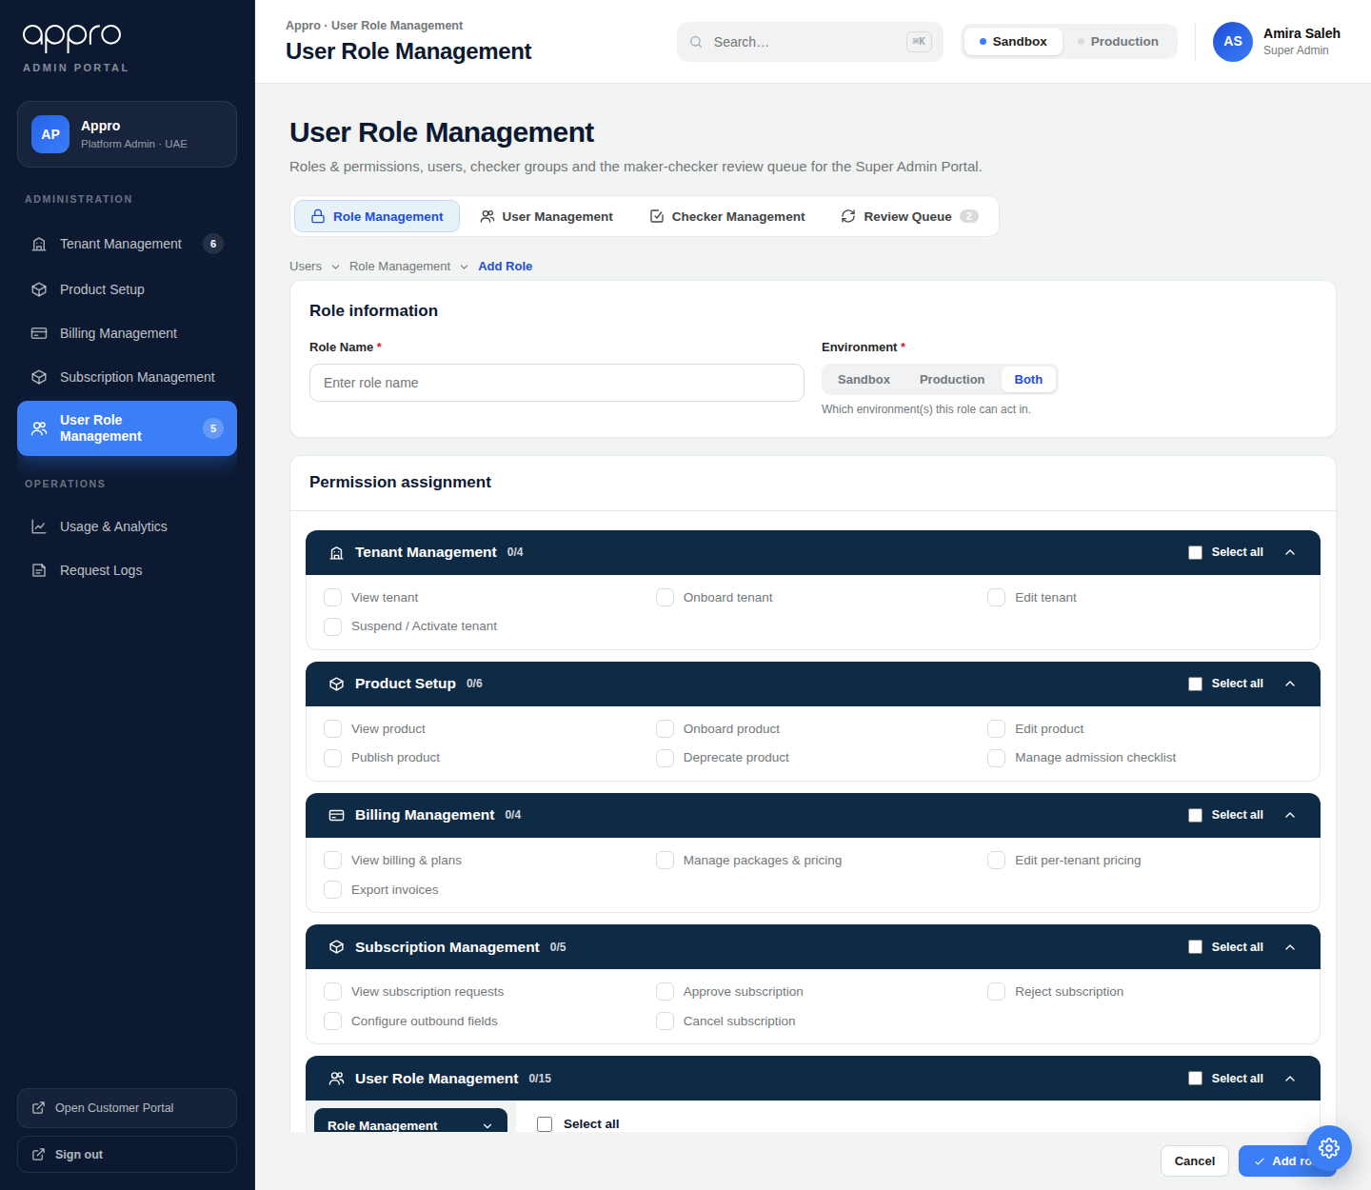
Figure 2 — Add / Edit role: Role Information and the permission-assignment groups.

2.5 Permission matrix
The system gates every menu, screen and button on the permissions held by the signed-in user’s role(s). The full Marketplace permission matrix is listed in Appendix A. Access Requests is not included.
Effective permissions across multiple roles (CLR-003). Where a user holds more than one role, the user’s effective permissions are the union of the permissions granted by all assigned roles; permissions are purely additive and no permission acts as a deny that overrides a grant from another role. (Deny-based rules are out of scope for v1.) There is no hard cap on the number of roles per user; five or fewer is recommended for manageability but is not enforced. Environment scope, by contrast, intersects rather than unions (2.6). [UPDATED v1.2 · CLR-003]

2.6 Environment scope (Sandbox / Production)
Rather than prefixing every permission, environment is a single selector held at the role level (2.4) and user level (2.8):
- A role/user scoped to Sandbox only cannot act on Production objects, and vice-versa; “Both” grants either.
- Environment scope narrows the permissions the role already grants — it never widens them.
- The effective environments for a user are the intersection of the user’s and their role’s environment scope.
Non-empty intersection rule (CLR-004). The intersection of user and role environment scope must be non-empty. A user scoped to one environment may not be assigned only role(s) scoped to the other, since that yields zero effective environments (a record that consumes a licence but can do nothing). This is enforced on both create and edit (see 2.9 AC1, error IEM012); the User Role selector shows-but-disables role(s) incompatible with the currently selected environment. [UPDATED v1.2 · CLR-004]

2.7 User Management — user list (SC3)
The User Management screen lists all platform users: name and email, assigned User Role(s) as chips, Environment scope, a Status indicator, Last Updated Date and Last Updated By. It provides free-text search, an Apply Filter panel (2.7.1), Export, and Add User. Selecting a row opens the user in edit.
Two-state status + Last-Updated fallback (CLR-002, CLR-010, CLR-014). Status is shown as a pill with two states — Active (green) and Inactive (grey) — and is governed solely by the enable/disable control. There is no Invited status: a user who has not yet set a password is Active but cannot sign in, because sign-in requires a credential that does not yet exist. Nothing about the invitation is surfaced on the user list. For a user created and never subsequently edited, Last Updated Date / Last Updated By fall back to the creation stamp (never blank); a status change counts as an update. [UPDATED v1.5 · CLR-014]
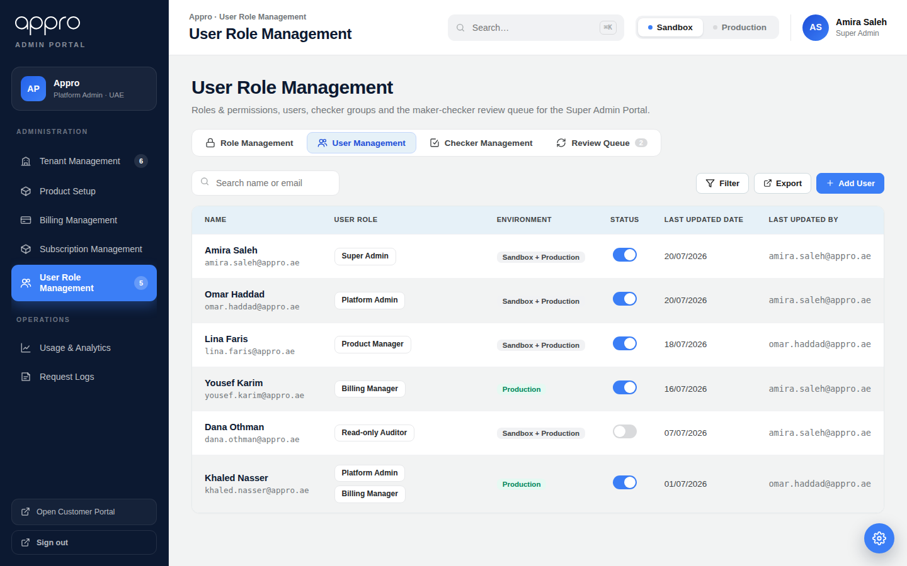
Figure 3 — User Management list with role chips, environment and last-updated audit columns.

2.7.1 Apply Filter
The Filter action opens the Apply Filter panel. In place of the bank Super Portal’s “Filter by role”, the Marketplace filters by Environment.
Component | Type | Editable | Mandatory | Default | Description
Environment | Dropdown | Y | N | All Environments | All / Sandbox / Production. Matches users whose environment scope includes the value. Replaces the bank “Filter by role”.
Status | Dropdown | Y | N | All | All / Active / Inactive. [UPDATED v1.5 · CLR-014]
Last Updated Date | Date picker | Y | N | — | Shows users updated on or after the selected date (matches the creation-stamp fallback for never-edited users — CLR-010).
Clear All / Apply | Button | N/A | N/A | — | Reset all filters / apply and close.
AC — Filtering. Filters combine with search (AND); the Filter button shows a count of active filters; applied filters appear as removable chips with a Clear all shortcut and a “Showing X of Y” note. Filters are view-only.
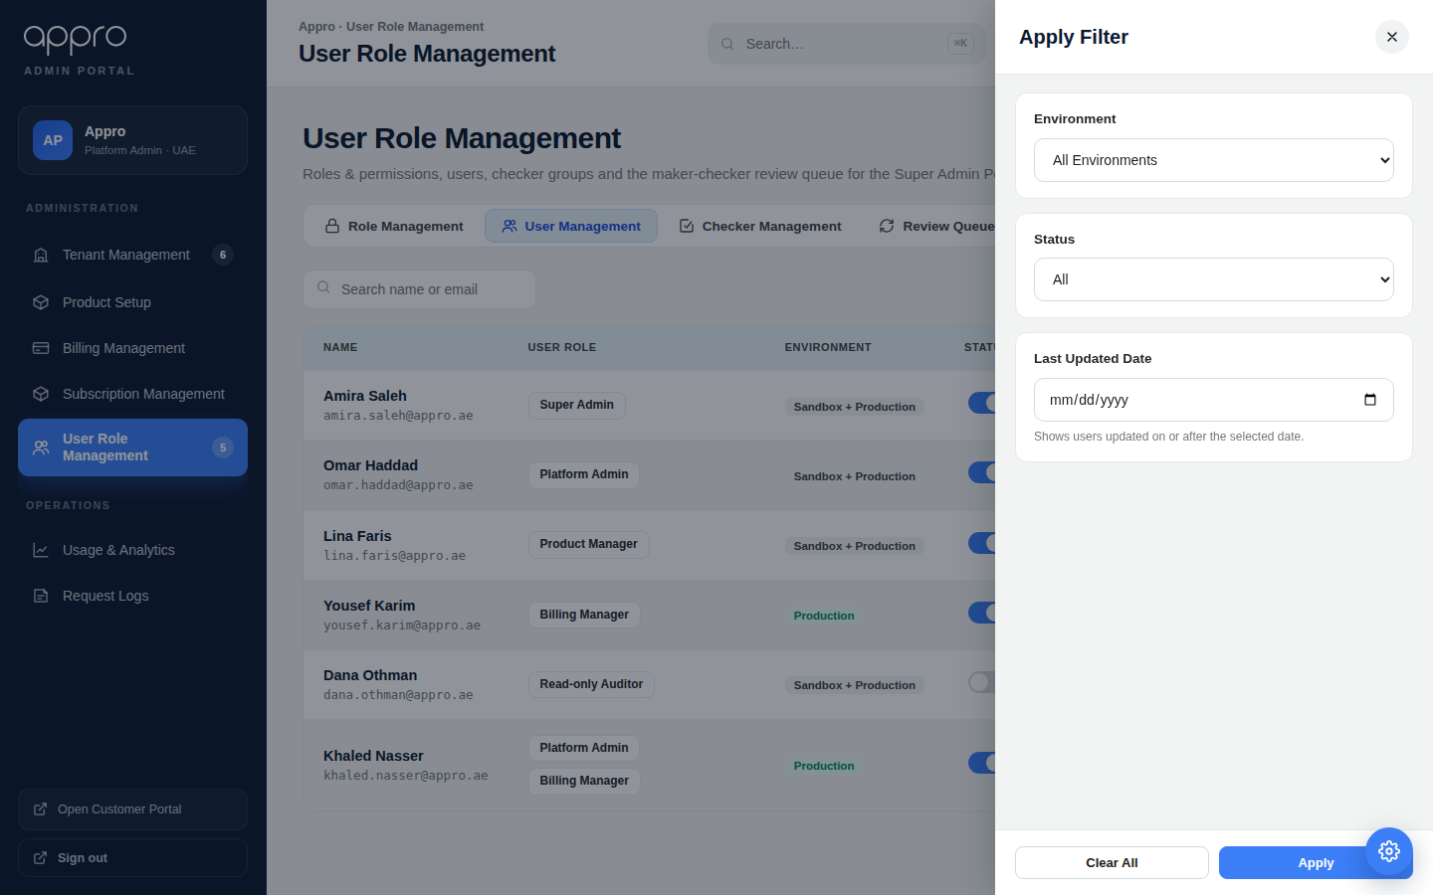
Figure 4 — Apply Filter panel: filter by Environment, Status and Last Updated Date.

2.8 Add / Edit user (SC4)
Component | Type | Editable | Mandatory | Default | Description
Name | Single line of text | Y | Y | — | The user’s display name. Max 150 characters.
User Email | Single line of text | Y | Y | — | Unique work email; sign-in identity and notification address. Uniqueness is case-insensitive and whitespace-trimmed, enforced across Active and Inactive records (NFR-4). Max 254 characters. Errors: IEM013 (blank), IEM014 (malformed), IEM015 (duplicate). Any valid address is accepted in v1 (domain allowlist is a per-portal roadmap option). Editable after creation by a Super Admin only; the change is audited and, where the user has not yet activated, re-issues the activation link. (CLR-006) [UPDATED v1.5 · CLR-014]
Mobile Number | Country-code selector + number field | Y | N | +971 | Country-code selector (default +971) plus a separate number field — not a fixed prefix. Non-UAE numbers are permitted. Validated as E.164 (error IEM016). Contact-only in v1; if SMS-MFA is later enabled it becomes conditionally required (see 2.8.1 / CLR-001). (CLR-007)
Department | Dropdown | Y | N | — | Platform / Product / Finance / Compliance / Operations, plus Other (with optional free text). Persisted on the User entity (2.10); used for display and reporting only — not access logic, not a filter in v1. (CLR-008)
User Role | Dropdown (multi-select) | Y | Y | — | One or more Active roles, shown as removable chips. If no active role exists the control is disabled with the message “No active roles available — create a role first” and a permission-gated link to Role Management. The five default roles are seeded at deployment, so the list is normally never empty (CLR-009). Ineligible / environment-incompatible roles are shown-but-disabled (CLR-004, CLR-005).
Environment | Checkboxes (Sandbox / Production) | Y | Y | — | The environment(s) the user may act in. Replaces the bank product-type field. At least one required, and the intersection with the selected role(s) must be non-empty (2.6, 2.9 AC1 / IEM012).
Add user / Save changes; Cancel | Button | N/A | N/A | — | Validate then save; discard confirmation on cancel.
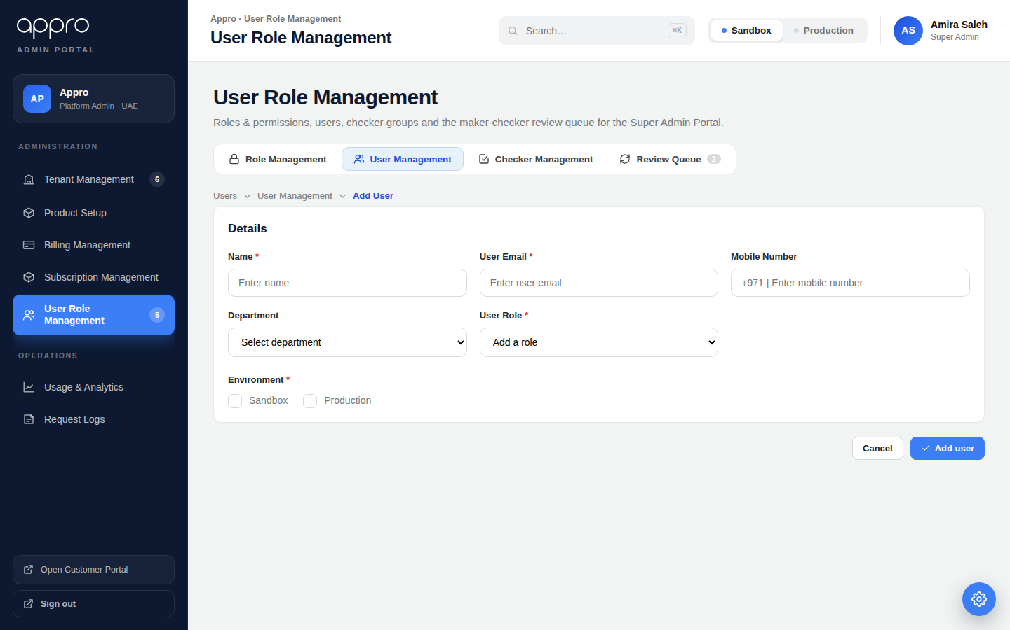
Figure 5 — Add / Edit user: role assignment and Environment (Sandbox / Production) in place of product type.

2.8.1 Credential establishment & invitation (NEW)
A newly created user must be able to establish credentials and sign in. The authentication model is:
- Local password. On save, the backend creates the user with Status = Active and sends an invitation email carrying a single-use set-password / activation link of the form …/activate?token=<token> to the User Email (template AT01). The user cannot sign in until the link is completed — access is gated by the absence of a credential, not by a status. The link expiry is a configurable per-environment platform setting (10-minute default; see NFR-6), and whether a given link is still usable is DERIVED by comparing the generated-link date against that setting. No link-validity duration is displayed on screen. [UPDATED v1.5 · CLR-014]
- SSO / IdP — Phase 2, NOT in this release. Federated sign-in is out of scope for this sprint and is deferred to Phase 2, together with notification template AT02 (access granted). Every user in this release establishes a local password through the Activate Account screen. [UPDATED v1.5 · CLR-014]
- Resend invitation. A Resend invitation action is available on the Edit-user screen for a user who has not yet activated; it issues a fresh link with a new expiry window and invalidates the previous one (template AT03), so only the most recent link works. It is deliberately NOT surfaced on the user list, which shows status only. [UPDATED v1.5 · CLR-014]
Creation always triggers exactly one email — the invitation (AT01). Template content is specified in 2.12; dispatch is handled by the platform notification service. [UPDATED v1.5 · CLR-014]

2.8.2 Activate Account screen (NEW)
A user activates their account from the link in the invitation email (…/activate?token=<token>, template AT01). The link opens the Activate Account screen, where the user sets a password and accepts the Terms of Use. On success the account can be signed into with email and password. The screen is a three-mode state machine driven by the server-validated token: set-password (valid token), activated (success) and expired (expired / already used / not found). The screen does not state how long the link remains valid. [UPDATED v1.5 · CLR-014]
Component | Type | Editable | Mandatory | Default | Description
New Password | Password field | Y | Y | — | The user’s chosen password. Must meet the platform password policy (length and complexity); strength is indicated as the user types. Error IEM017 if blank or below policy.
Confirm Password | Password field | Y | Y | — | Must match New Password exactly. Error IEM018 on mismatch.
I agree to the Terms of Use | Checkbox (+ link) | Y | Y | Unticked | Mandatory consent, with a link to the current Terms of Use. Must be ticked to activate; acceptance (version + timestamp) is recorded on the User (2.10). Error IEM019 if not accepted.
Activate account | Button | N/A | N/A | — | Enabled only when the password meets policy, Confirm matches and the Terms checkbox is ticked. On click, validate the token and save (see AC below).
AC1 — Token validity. The screen is reachable only with a valid, unexpired, single-use token. Validity is computed from the generated-link date against the configurable window (2.8.1 / NFR-6) — it is not read from any stored invitation state. If the token is missing, malformed, already used or expired, the form is not shown; an error state (IEM020) is displayed with guidance to request a fresh link (AT03). [UPDATED v1.5 · CLR-014]
AC2 — Activation. On a valid submission the backend stores the password hash against the shared user store (admin_users — 2.10), consumes the token (single-use), records Terms-of-Use acceptance (version + timestamp), stamps activatedAt, and writes an audit entry (CR 003). Status is unchanged by activation — the user was already Active; what changes is that a credential now exists. The user is then signed in (or redirected to sign-in). [UPDATED v1.5 · CLR-014]
AC3 — Constraints. The activated user MUST live in the same user table as Super Admin users (admin_users), differing only by Role; there is no separate credential store per portal. The password is never displayed, logged or emailed, and the token is stored only as a hash. Activation does not change the user’s roles or environment scope — those are fixed at creation (2.8). [UPDATED v1.5 · CLR-014]

2.9 Validation and saving rules
AC1 — Validation. Mandatory fields present; [Role Name] / [User Email] unique across Active and Inactive records (inline error otherwise); a role has ≥ 1 permission; a user has ≥ 1 role and ≥ 1 environment; and the user × role environment intersection is non-empty (IEM012); User Email passes blank / format / duplicate checks (IEM013–IEM015) and Mobile Number, when present, passes E.164 (IEM016). [UPDATED v1.5 · CLR-014]
AC2 — Saving. Persist the record with Status = Active on create. The user still cannot sign in until they establish credentials via the Activate Account screen (2.8.1–2.8.2); that is a property of the account, not a status. Maker-Checker is NOT implemented in this release — user and role creation are committed immediately, with no intermediate pending / approval state. Preserve status on edit, stamp created/updated by-and-date, write an audit entry (CR 003), and show a success toast. [UPDATED v1.5 · CLR-014]
Forward-looking note (Maker-Checker). When Maker-Checker is introduced in a later phase, user and role creation may become governed actions: the maker’s submission would be held as a Request and the record created only on checker approval, with pending items living in the Review Queue rather than the user list. Nothing in this release should assume that behaviour; the user status enum stays active | inactive. [UPDATED v1.5 · CLR-014]
AC3 — Credential dispatch. On successful create, dispatch the invitation notification per 2.8.1 and 2.12. The save post-condition is “user can obtain access”, not merely “record persisted”. If dispatch fails, the failure is surfaced to the administrator, who can resend from the Edit-user screen. [UPDATED v1.5 · CLR-014]

2.10 Data model (key entities)
Entity | Key attributes
Role | roleId, name (unique), description, status, environmentScope[] (Sandbox/Production), permissionIds[], createdBy/At, updatedBy/At
Permission | permissionId, module (group), subMenu, action, displayName
User (admin_users) | userId, name, email (unique, case-insensitive), passwordHash, mobile, mobileCountryCode, department, departmentOther, roleIds[], environmentScope[], status (active | inactive), activationLinkSentAt, activatedAt, termsAcceptedVersion, termsAcceptedAt, createdBy/At, updatedBy/At. There is no invited status and no stored invitation state — whether a user has credentials is passwordHash / activatedAt, and link validity is derived from activationLinkSentAt. All portal identities live in this single admin_users table, differentiated only by Role. [UPDATED v1.5 · CLR-014]
ActivationToken | tokenId, userId, tokenHash (single-use), generatedAt, expiresAt (derived: generatedAt + the configurable window, default 10 min — 2.8.1 / NFR-6), consumedAt. Issued on create and on Resend invitation; issuing a new token invalidates the previous one. Only the hash is persisted. [UPDATED v1.5 · CLR-014]
Status model clarification (CLR-002, CLR-008, CLR-011, CLR-014). The user status enum is active | inactive. There is no invited and no pending status. A newly created user is Active and simply lacks a credential until they activate. If Maker-Checker is added later, an in-flight creation would live in the request layer (Review Queue), not as a User row — but that is out of scope here. [UPDATED v1.5 · CLR-014]

2.11 Non-functional requirements
ID | Requirement
NFR-1 | Permission checks are enforced server-side on every menu, screen and action, not only hidden in the UI.
NFR-2 | All create/edit/status/delete actions are captured in an immutable, append-only audit trail (CR 003), with privilege/role changes flagged.
NFR-3 | Role/scope changes apply at next sign-in; active sessions are not silently re-permissioned mid-session.
NFR-4 | Role name and user email uniqueness is enforced across Active and Inactive records; email comparison is case-insensitive and whitespace-trimmed. [UPDATED v1.5 · CLR-014]
NFR-5 | Privilege-assignment rules (2.1) are enforced server-side: an admin cannot assign permissions beyond their own effective set, and only a Super Admin may assign User Role Management permissions. Self-deactivation and self-role-change are prevented. (CLR-005)
NFR-6 | Invitation / set-password (activation) links are single-use, time-limited and delivered only to the target User Email. The expiry window MUST be configurable per environment (10-minute default) and a link’s validity MUST be computed from its generated-link date against that window, never from a stored invitation status. The duration is not displayed to the user. On expiry the link is rejected and a fresh one must be issued. Passwords and activation tokens are stored only as hashes, and the URL carrying the raw token is never logged. (CLR-001, CLR-012, CLR-014) [UPDATED v1.5 · CLR-014]
NFR-7 | All portal user identities are held in a single shared user store (admin_users), differentiated only by Role; authentication is by email + password (or SSO) against this store. (CLR-012)

2.12 Notifications (NEW)
The module dispatches the following notifications. Full subject and body content is provided in Appendix B (English; Arabic RTL parity to follow). Codes AT01–AT15 are placeholders to be aligned to the live catalogue at build time. The maker-checker notifications (AT10–AT15) belong to the future Maker-Checker phase and are NOT sent in this release.
Code | Notification | Trigger | In this release?
AT01 | User invitation / set password | User created (local password) | Yes
AT02 | Access granted (SSO) — Phase 2 | User created (SSO portal) | No — Phase 2
AT03 | Resend invitation | Admin resends the activation link to a user who has not yet activated [UPDATED v1.5 · CLR-014] | Yes
AT04 | Login OTP | Sign-in / device registration | Yes
AT05 | Action verification code | Step-up on a sensitive action | Yes
AT06 | Password expiry warning | Password nearing expiry | Yes
AT07 | Account deactivated | User deactivated | Yes
AT08 | Account locked | Account locked | Yes
AT10–AT15 | Maker-Checker lifecycle (assigned / approved / rejected / on-hold / expired / checker reminder) | Governed create/edit requests | No — future Maker-Checker phase

3. User stories

US-1 Define a role
As Admin User of the Super Admin Portal, I want to create a role by selecting permissions and setting its environment scope, so that I can grant exactly the access a job function needs in the right environment.

US-2 See roles at a glance
As Admin User of the Super Admin Portal, I want a role list showing each role’s status, environment and per-module access, so that I can review who can do what without opening each role.

US-3 Assign a role and environment to a user
As Admin User of the Super Admin Portal, I want to add a user with one or more roles and an environment scope, so that the user can act only where and how they are entitled.

US-4 Filter the user list
As Admin User of the Super Admin Portal, I want to filter users by environment, status and last-updated date, so that I can quickly find the users relevant to a Sandbox or Production review.

US-5 Audit user changes
As Admin User of the Super Admin Portal, I want the user list to show the last-updated date and by whom, so that I can see who changed access and when.

US-6 Onboard a new user with access (NEW)
As Admin User of the Super Admin Portal, I want a newly created user to receive an invitation to set their own password, so that they can sign in for the first time without me ever handling or communicating a password. [UPDATED v1.5 · CLR-014]

US-7 Activate my account (NEW)
As a newly created user, I want to open the activation link in the email I received from the Appro API Marketplace (…/activate?token=), be taken to the Activate Account screen, set a valid password, tick “I agree to the Terms of Use” and click Activate account, so that I can sign in with my email and password. Given the link is still within its validity window — derived from when it was generated — when I submit a valid password and accept the Terms, then my account is activated and I am signed in; if the link has lapsed, already been used or is not recognised, I am shown the expired state and can request a fresh link. [UPDATED v1.5 · CLR-014]

4. Impact analysis
Impact | Change required
Left navigation | A Users group (Role Management, User Management) added to the Super Admin sidebar.
RBAC enforcement | Gate every menu, screen and action on the permission matrix, server-side, including the privilege-assignment constraints (NFR-5). Permissions union across roles; environment scope intersects (CLR-003, CLR-004).
Seeding & release order | Seed the five default roles (Super Admin, Platform Admin, Product Manager, Billing Manager, Read-only Auditor) at deployment so the User Role list is never empty; seeded roles are editable but delete-protected, and the last active Super Admin role cannot be deleted or deactivated (CLR-009).
Credentials & notifications | Integrate the invitation / set-password (activation) flow and templates AT01 / AT03–AT09 with the platform notification service. Build the Activate Account screen served at …/activate?token=, expose the link-expiry window as a configurable per-environment setting (10-minute default), and compute link validity from the generated-link date. Do NOT display the validity duration on screen. AT02 ships with SSO in Phase 2. [UPDATED v1.5 · CLR-014]
Shared identity store | Hold all portal identities in one admin_users table differentiated by Role, with a single email + password sign-in against it; persist password and activation-token hashes, the generated-link date and Terms-of-Use acceptance (version + timestamp). The status enum is active | inactive only — drop any invited value (CLR-014, 2.10, NFR-7). [UPDATED v1.5 · CLR-014]
Environment scope | Honour the Sandbox / Production scope on roles and users; intersect user × role scope to compute effective environments, and block an empty intersection (CLR-004).
Maker-Checker (future phase) | NOT in this release. User and role creation are committed immediately. When Maker-Checker is later introduced, creation may be deferred to checker approval and notifications AT10–AT15 enabled; no work in this release should assume it (CLR-011).
Audit trail | Append-only trail for all governed actions, with a privilege/role-change flag (CR 003).
Access Requests | Removed from both portals; not part of this module.

Appendix A Marketplace permission matrix
The Marketplace function list used to build roles (2.4–2.5). Environment (Sandbox / Production) is a separate scope selector (2.6), not a per-permission prefix. Access Requests is excluded.
Module (group) | Sub-menu | Detail permissions
Tenant Management | — | View tenant list & details; Onboard tenant; Edit tenant; Suspend / Activate tenant
Product Setup | — | View product; Onboard product; Edit product; Publish product; Deprecate product; Manage admission checklist
Billing Management | — | View billing & plans; Manage packages & pricing; Edit per-tenant pricing; Export invoices
Subscription Management | — | View subscription requests; Approve subscription; Reject subscription; Configure outbound fields; Cancel subscription
User Role Management | Role Management | View role; Create role; Edit role; Activate / Deactivate role; Delete role
User Role Management | User Management | View user; Create user; Edit user; Activate / Deactivate user; Delete user
User Role Management | Checker Management | View / Create / Edit / Activate-Deactivate / Delete checker group
Usage & Analytics | — | View usage & analytics; Export analytics
Request Logs | — | View request logs; Export request logs

Appendix B Email notification content
Full notification content for User Role Management (NEW in v1.3). Content is rebranded from the platform notification catalogue: Reem Finance / Reem Bank → Appro; “Super Portal” → Appro API Marketplace; sign-off → The Appro Team; footer → developer.appro.ae. Merge fields use the %%VARIABLE%% convention; any field left unbound renders literally to the recipient. Codes are placeholders to be aligned to the live catalogue at build time.

B.1 Credential & account lifecycle (this release)
User invitation / set password [UPDATED v1.5 · CLR-014]
Email · New user · Trigger: user created (status Active, no credential yet). Link: …/activate?token= → Activate Account screen (2.8.2). %%HYPERLINK%% carries the activation token. Source: ET4 + ET3. Resolves CLR-001, CLR-012, CLR-014. [UPDATED v1.5 · CLR-014]
Field | Content
Subject | Appro API Marketplace — Set up your account
Body | Dear %%USER_NAME%%,  You have been invited by %%INVITED_BY%% to the Appro API Marketplace %%PORTAL_NAME%% as %%ROLE_NAME%% (%%ENVIRONMENT%%)%%ORG_NAME%%.  To activate your account, please set your password using the link below.  Activate your account: %%HYPERLINK%%  This link is valid for %%VALID_TIME%% and can be used once. If it expires, ask your administrator to resend the invitation.  If you did not expect this email, please contact your administrator.  Best regards, The Appro Team  developer.appro.ae · This email is auto-generated. Please do not reply.
Variables | USER_NAME, INVITED_BY, PORTAL_NAME, ROLE_NAME, ENVIRONMENT, ORG_NAME, HYPERLINK, VALID_TIME
AT02 — Access granted (SSO / IdP) — PHASE 2, not in this release [UPDATED v1.5 · CLR-014]
Email · New user · Trigger: user created on an SSO-federated portal (no local password). Source: ET3. Resolves CLR-001 (SSO branch).
Field | Content
Subject | Appro API Marketplace — Access granted
Body | Dear %%USER_NAME%%,  You have been granted access to the Appro API Marketplace %%PORTAL_NAME%% as %%ROLE_NAME%% (%%ENVIRONMENT%%)%%ORG_NAME%%.  Sign in with your organization single sign-on — no separate password is required: %%HYPERLINK%%  If you have any questions, please contact your administrator.  Best regards, The Appro Team  developer.appro.ae · This email is auto-generated. Please do not reply.
Variables | USER_NAME, PORTAL_NAME, ROLE_NAME, ENVIRONMENT, ORG_NAME, HYPERLINK
AT03 — Resend invitation
Email · Not-yet-activated user · Trigger: admin uses Resend invitation. Variant of AT01. Resolves CLR-001 (resend). [UPDATED v1.5 · CLR-014]
Field | Content
Subject | Appro API Marketplace — Your invitation link (resent)
Body | Dear %%USER_NAME%%,  Here is a new link to set up your Appro %%PORTAL_NAME%% account. Any previous link is no longer valid.  Set your password: %%HYPERLINK%%  This link is valid for %%VALID_TIME%%.  Best regards, The Appro Team  developer.appro.ae · This email is auto-generated. Please do not reply.
Variables | USER_NAME, PORTAL_NAME, HYPERLINK, VALID_TIME
AT04 — Login OTP
Email + Push/SMS · User · Trigger: sign-in / device registration. Source: ET17 / ET35.
Field | Content
Subject | Appro — Your one-time passcode
Body | Dear %%USER_NAME%%,  Thanks for using the Appro API Marketplace. Your one-time passcode is %%OTP%% (valid %%VALID_TIME%% min). Please contact support if this was not initiated by you.  Best regards, The Appro Team
Variables | USER_NAME, OTP, VALID_TIME
AT05 — Action verification code
Email · User · Trigger: step-up verification on a sensitive action (change password, change email). Source: ET5.
Field | Content
Subject | Appro — Verification code for %%ACTION_NAME%%
Body | To protect your account, a verification code is required to complete %%ACTION_NAME%%:  %%VERIFICATION_CODE%%  This code expires in %%VALID_TIME%% minutes.  This email is auto-generated. Please do not reply.  Best regards, The Appro Team
Variables | ACTION_NAME, VERIFICATION_CODE, VALID_TIME
AT06 — Password expiry warning
Email · User · Trigger: password nearing expiry. Source: ET6 / ET24.
Field | Content
Subject | Appro API Marketplace — Password expiry warning
Body | Dear %%USER_NAME%%,  Your account password will expire in %%PASSWORD_EXPIRATION_DAY%% day(s) on %%PASSWORD_EXPIRATION_DATE%%.  To keep your account active and secure, please sign in and change your password before then.  This email is auto-generated. Please do not reply.  Best regards, The Appro Platform Team
Variables | USER_NAME, PASSWORD_EXPIRATION_DAY, PASSWORD_EXPIRATION_DATE
AT07 — Account deactivated
Email · User · Trigger: user deactivated. Source: ET7 / ET25.
Field | Content
Subject | Appro API Marketplace — Your account has been deactivated
Body | Dear %%USER_NAME%%,  Your account has been deactivated. Please contact your administrator if you require access.  This email is auto-generated. Please do not reply.  Best regards, The Appro Platform Team
Variables | USER_NAME
AT08 — Account locked
Email · User · Trigger: account locked. Source: ET030.
Field | Content
Subject | Appro API Marketplace — Your account is locked
Body | Dear %%USER_NAME%%,  Your account is locked. Please contact your Appro administrator to restore access.  Best regards, The Appro Platform Team
Variables | USER_NAME

B.2 Maker-Checker lifecycle (future phase — not in this release)
Not sent in this release. Retained here so the content is ready when the Maker-Checker phase is delivered.
AT10 — Request assigned to checker [Future Maker-Checker phase — not sent in this release]
Email · Checker (internal) · Trigger: maker submits a governed action. Source: ET32.
Field | Content
Subject | Appro — A %%ACTION_NAME%% request is assigned to you
Body | Dear %%CHECKER_NAME%%,  You have been assigned to review request %%REQUEST_ID%% — %%ACTION_NAME%% on %%AFFECTED_MODULES%%.  Please review it here: %%HYPERLINK%%  Best regards, The Appro Team
Variables | CHECKER_NAME, REQUEST_ID, ACTION_NAME, AFFECTED_MODULES, HYPERLINK
AT11 — Request approved [Future Maker-Checker phase — not sent in this release]
Email · Maker · Trigger: checker approves. Source: ET28.
Field | Content
Subject | Appro — Your %%ACTION_NAME%% request is approved
Body | Dear %%USER_NAME%%,  Your request %%REQUEST_ID%% (%%ACTION_NAME%%) has been approved. The changes now take effect on %%AFFECTED_MODULES%%.  Best regards, The Appro Team
Variables | USER_NAME, REQUEST_ID, ACTION_NAME, AFFECTED_MODULES
AT12 — Request rejected [Future Maker-Checker phase — not sent in this release]
Email · Maker · Trigger: checker rejects. Source: ET27.
Field | Content
Subject | Appro — Your %%ACTION_NAME%% request is rejected
Body | Dear %%USER_NAME%%,  Your request %%REQUEST_ID%% (%%ACTION_NAME%%) was rejected.  Reason: %%REJECTED_REASON%%  If you believe this is in error, please contact your reviewer at %%CHECKER_EMAIL%%.  Best regards, The Appro Team
Variables | USER_NAME, REQUEST_ID, ACTION_NAME, REJECTED_REASON, CHECKER_EMAIL
AT13 — Request on hold (no authorised checker) [Future Maker-Checker phase — not sent in this release]
Email · Maker · Trigger: no authorised checker available. Source: ET30.
Field | Content
Subject | Appro — Your %%ACTION_NAME%% request is on hold
Body | Dear %%USER_NAME%%,  Your request %%REQUEST_ID%% (%%ACTION_NAME%%) is on hold because no authorized checker is currently available. We will notify you as soon as it can be processed.  Best regards, The Appro Team
Variables | USER_NAME, REQUEST_ID, ACTION_NAME
AT14 — Request expired [Future Maker-Checker phase — not sent in this release]
Email · Maker · Trigger: request not approved within the window. Source: ET29.
Field | Content
Subject | Appro — Your %%ACTION_NAME%% request has expired
Body | Dear %%USER_NAME%%,  Your request %%REQUEST_ID%% (%%ACTION_NAME%% on %%AFFECTED_MODULES%%) was not approved within the allowed window and has expired. If you still need this change, please resubmit.  Best regards, The Appro Team
Variables | USER_NAME, REQUEST_ID, ACTION_NAME, AFFECTED_MODULES
AT15 — Checker reminder (requests expiring) [Future Maker-Checker phase — not sent in this release]
Email · Checker · Trigger: requests about to expire. Source: ET33.
Field | Content
Subject | Appro — Requests awaiting your review are about to expire
Body | Dear %%CHECKER_NAME%%,  The following requests will expire today and need your review:  %%LIST_OF_REQUEST_ID%%  Please review them before they expire.  Best regards, The Appro Team
Variables | CHECKER_NAME, LIST_OF_REQUEST_ID
Localisation & security. Arabic (RTL) variants to be added per the platform EN/AR parity standard before UAT. OTP and verification codes (AT04, AT05) are sent only to the target user’s registered channel and are never shown in-app to another user.

Appendix C Inline error messages (IEM)
Consolidated IEM catalogue (NEW in v1.3). Every inline validation error referenced in this BRD, with the field it attaches to, when it fires, and the message shown. IEM001–IEM011 belong to the shared platform Inline-Error-Message series (maintained centrally); the codes below are those used by User Role Management. Message wording is indicative and subject to copy review / localisation (EN + AR).
Code | Field / control | Trigger | Message (EN) | Ref
IEM003 | Role Name (2.4) | Blank on submit | Role name is required. | v1.0
IEM010 | Role Name (2.4) | Duplicate (across Active + Inactive) | A role with this name already exists. | v1.0
IEM012 | User Role / Environment (2.6, 2.8, 2.9) | User × role environment intersection is empty | The selected role(s) share no environment with the user’s environment scope. Adjust the environment or the role selection. | CLR-004
IEM013 | User Email (2.8) | Blank on submit | User email is required. | CLR-006
IEM014 | User Email (2.8) | Malformed address | Enter a valid email address. | CLR-006
IEM015 | User Email (2.8) | Duplicate (case-insensitive, across Active + Inactive) [UPDATED v1.5 · CLR-014] | A user with this email already exists. | CLR-006
IEM016 | Mobile Number (2.8) | Malformed / non-E.164 (when a value is entered) | Enter a valid mobile number in international format (e.g. +971 50 123 4567). | CLR-007
IEM017 | New Password (2.8.2) | Blank or below the password policy on submit | Enter a password that meets the security requirements. | CLR-012
IEM018 | Confirm Password (2.8.2) | Does not match New Password | Passwords do not match. | CLR-012
IEM019 | Terms of Use (2.8.2) | Activate clicked without accepting the Terms | You must accept the Terms of Use to activate your account. | CLR-012
IEM020 | Activation link / token (2.8.2) | Token missing, invalid, already used or expired | This activation link is invalid or has expired. Ask your administrator to resend the invitation. | CLR-012
Notes. Uniqueness checks (IEM010, IEM015) are server-authoritative and evaluated on submit; IEM015 compares emails case-insensitively after trimming whitespace (NFR-4). IEM012 is evaluated on both create and edit. Blank/format errors (IEM003, IEM013, IEM014, IEM016, IEM017, IEM018) may also fire on blur for faster feedback. IEM020 is a page-level (not field) error shown when the Activate Account screen is opened with a bad or expired token. All messages have an EN and AR variant.

