

BUSINESS REQUIREMENTS DOCUMENT
Salary Transfer
STL and FSTL in the digital journey — Credit Card and Personal Loan: one toggle, four customer cases, the account created along the way
V1.0 / 3 November 2026
Prepared for Reem Bank
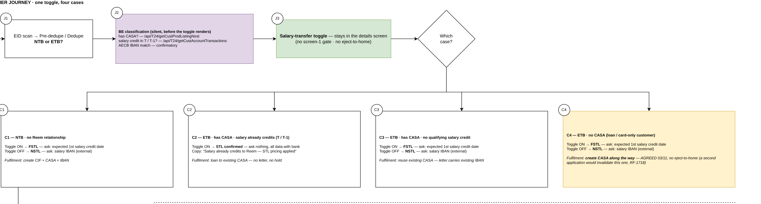

Appro Onboarding Solutions FZ-LLC · Customer Journey
This is not a legally binding document. Highly confidential not to be shared without written consent.
Consolidates the salary-transfer baseline of 4 October 2026 and the design agreed in the working sessions of 28 October – 3 November 2026. Items awaiting confirmation are listed in section 10.
appro.ae · 105, Arjaan Office Towers, Dubai Media City, UAE
VERSION HISTORY
Date | Version | Author | Change Description
03-11-2026 | 1.0 | Hailey, Appro | Created BRD — Credit Card and Personal Loan salary transfer: the toggle and the four customer cases, detection, fulfilment with the account created along the way, the letter and the release flow.

TABLE OF CONTENTS
1. FEATURE OVERVIEW AND KEY COVERED AREAS 3
2. SCOPE 5
3. CUSTOMER JOURNEY 6
4. SALARY TYPE DETECTION 11
5. FULFILMENT 12
6. SUPER PORTAL 14
7. BACKEND LOGIC AND INTEGRATION 17
8. BUSINESS RULES 17
9. IMPACT ANALYSIS 18
10. OPEN QUESTIONS 20
APPENDIX 1: SUMMARY OF CHANGES 21
APPENDIX 2: CASE QUICK REFERENCE 21
APPENDIX 3: GLOSSARY 21

1. FEATURE OVERVIEW AND KEY COVERED AREAS
This document describes the requirements for Salary Transfer in the Reem Bank digital journey for Credit Card and Personal Loan.
A salary-transfer product prices on the customer’s salary reaching their Reem Bank account. Three salary situations exist: STL — the salary already credits to a Reem Bank account; FSTL (future salary transfer) — the customer undertakes to move the salary to Reem Bank; NSTL — the salary stays with the current bank. Today the journey covers NSTL only; nothing detects an existing salary, nothing captures the transfer undertaking end-to-end, and a customer without a Reem account cannot complete a salary-transfer application at all.
The design rests on four pillars:
- One toggle, four customer cases. A single salary-transfer question on the details screen adapts to what the bank already knows: C1 new to bank, C2 salary already credits to Reem, C3 has an account but the salary is elsewhere, C4 banks with Reem but has no account. Each case asks only what the bank cannot derive.
- The account is created along the way. A customer without a Reem account (C1, C4) never leaves the journey: the current account and its IBAN are created at fulfilment, before the loan or card, by one core call that returns the account number and the IBAN.
- The letter drives the release. The salary-transfer letter is generated with the account IBAN, uploaded inside the journey, validated by operations, and the funds (PL) or the card activation (CC) wait for the first salary credit.
- NSTL is untouched. Toggle OFF keeps today’s flow: salaried IBAN, direct debit, immediate disbursal.
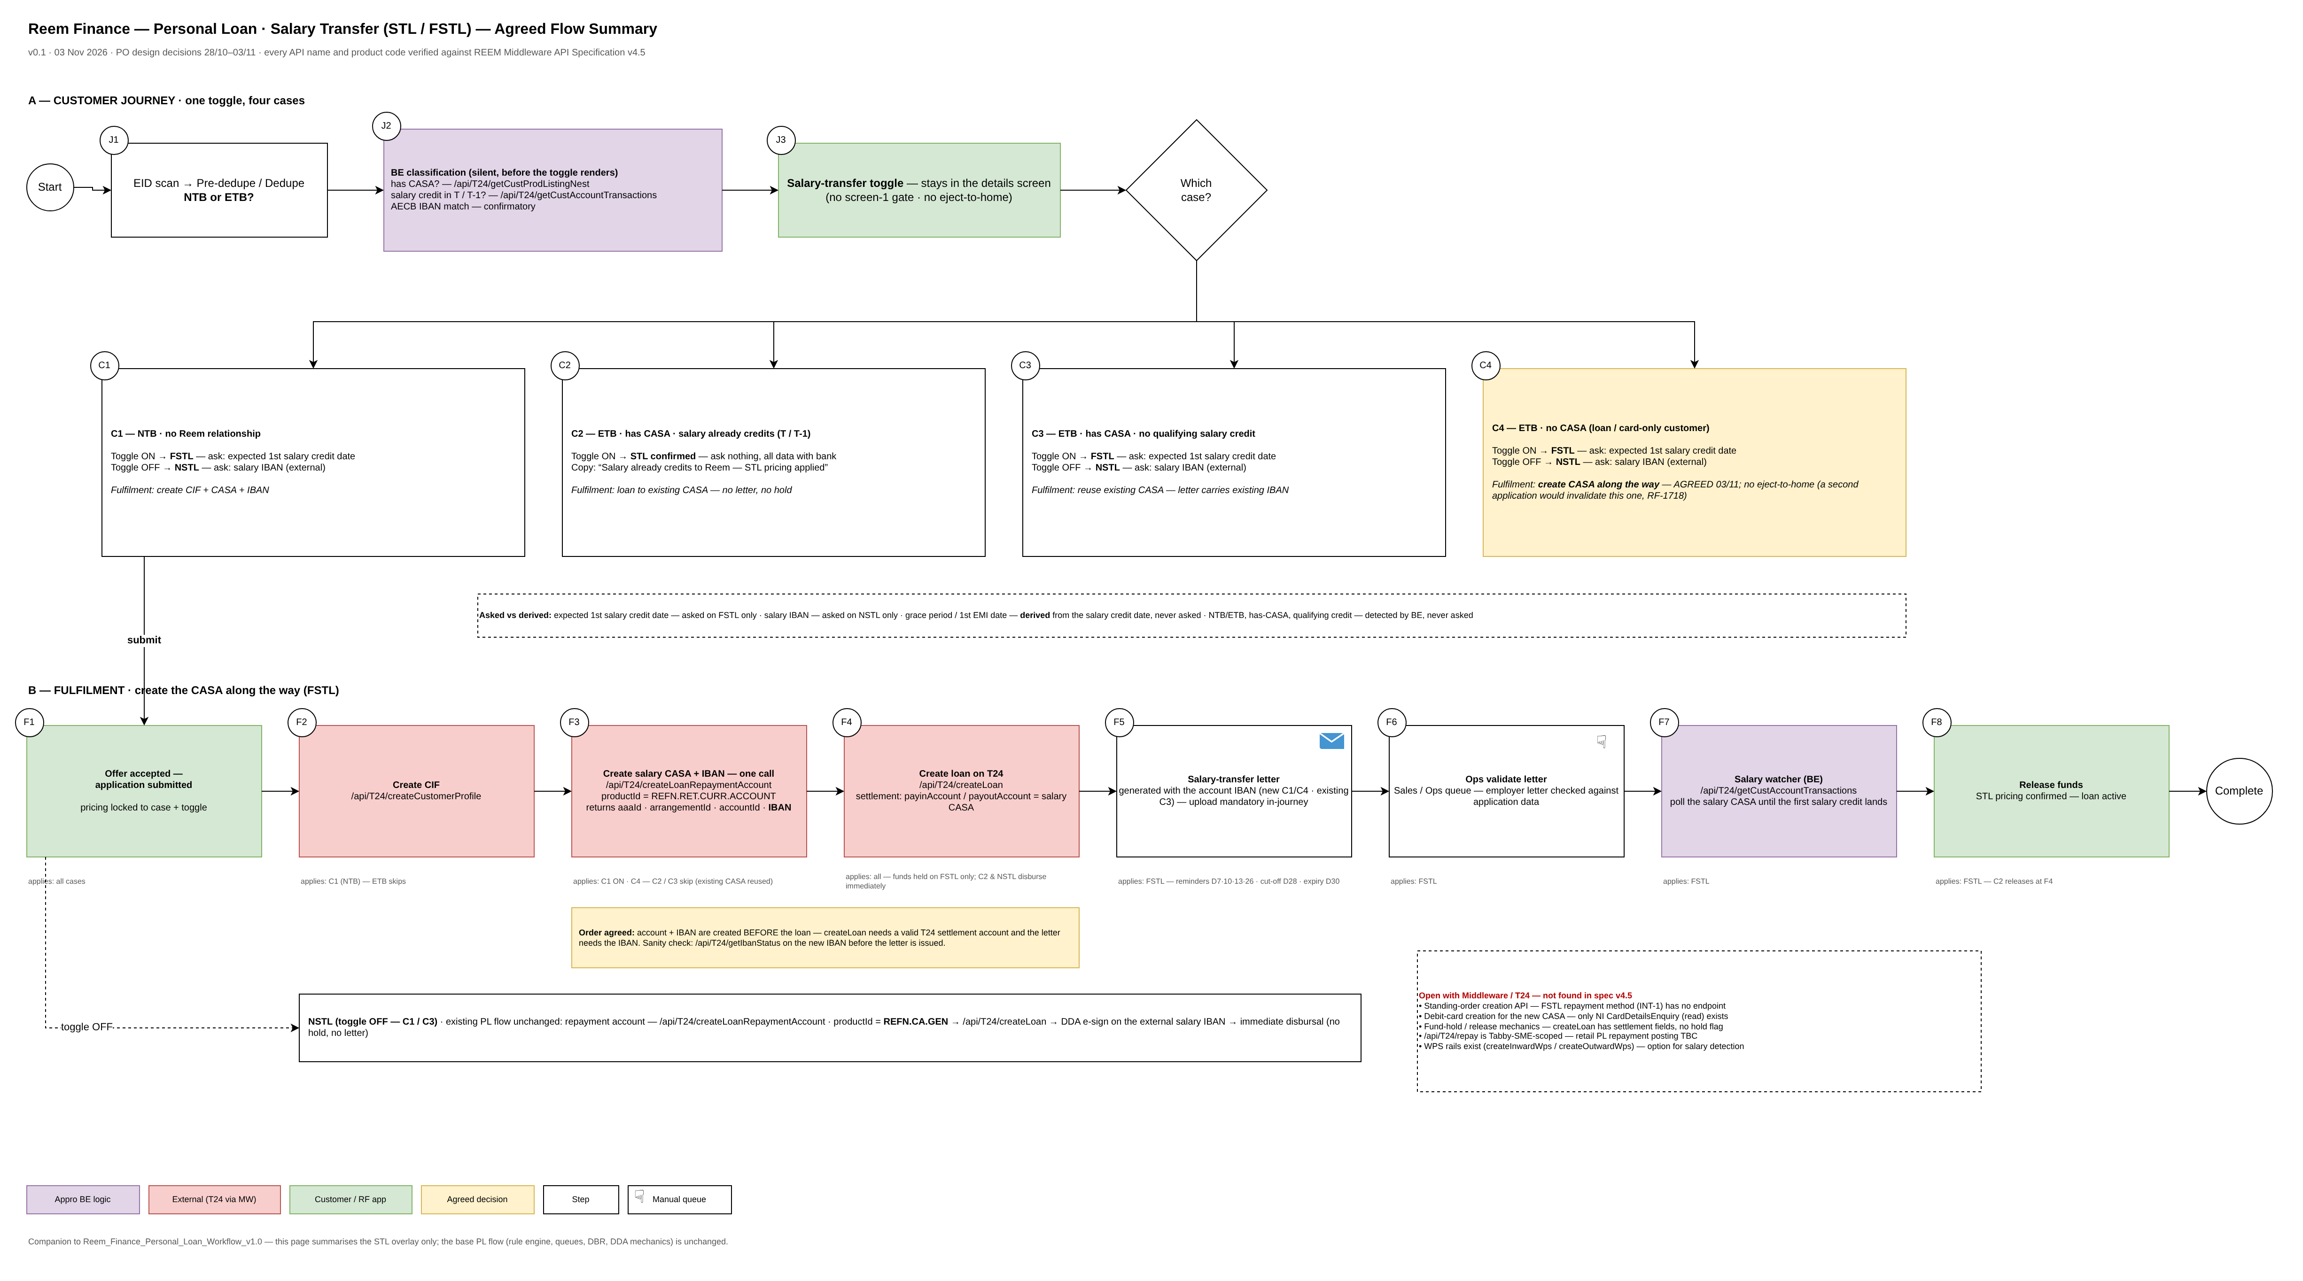
Figure 1 — The agreed flow on one page — the journey decision model (top) and the fulfilment chain (bottom)
Key steps
- Before the details screen renders, the system classifies the customer (C1–C4) from the core account history, the products list and the credit bureau.
- The customer answers the salary-transfer toggle; the case decides what, if anything, is asked.
- Pricing and limits follow the Salary Type; the offer screen carries the grace control and the first-instalment date.
- On acceptance, fulfilment runs in order: customer record (new to bank) → current account + IBAN (C1, C4) → loan or card.
- For FSTL the loan funds are held (PL) or the card is created inactive (CC); the salary-transfer letter is issued with the IBAN and uploaded in the journey.
- Operations validate the letter; reminders run on days 7, 10, 13 and 26; day 28 is the cut-off and day 30 the offer expiry.
- The salary watcher polls the Reem account; the first salary credit releases the funds or activates the card with the salary-transfer pricing confirmed.
- Every step is written to the application audit trail and tracked in Super Portal statuses.
Note: The CASA opening journey itself is unchanged — the account created along the way reuses only the account-specific steps (account type, tax declarations, account KFS, debit-card preference). Emirates ID, selfie and address are never asked twice.

2. SCOPE

2.1 Product scope
Credit Card and Personal Loan. The CASA product journey is out of scope (the in-journey account creation reuses its account-specific steps only). NSTL applications keep today’s behaviour on both products.

2.2 In-scope scenarios
- R1 — C1 (new to bank), toggle ON: FSTL — customer record, account and IBAN created at fulfilment; letter and release flow.
- R2 — C1, toggle OFF: NSTL as today (salaried IBAN, direct debit, immediate disbursal).
- R3 — C2 (salary already credits to Reem, detected), toggle ON: STL confirmed — nothing further asked; loan to the existing account, funds released at creation; card active at creation.
- R4 — C2, toggle OFF: standard (non-STL) pricing; repayment from the existing Reem account.
- R5 — C3 (has an account, salary elsewhere), toggle ON: FSTL — existing account reused; the letter carries the existing IBAN.
- R6 — C3, toggle OFF: NSTL as today.
- R7 — C4 (banks with Reem, no account), toggle ON: FSTL — the account is created along the way; no exit from the journey.
- R8 — C4, toggle OFF: NSTL as today.

2.3 Not in scope
- Business / WPS salary detection — the rules in this document cover salaried individuals.
- A security cheque — not required for any salary-transfer variant (BR8).
- Changes to the NSTL direct-debit flow, the credit decisioning engine or the CASA product journey.
- Configurable letter reminder ladders per product — the ladder is fixed in this release.
- Tracking of salary credits beyond the first one (ongoing salary-stop monitoring is a separate initiative).

3. CUSTOMER JOURNEY

3.1 One toggle, four cases
The salary-transfer question lives on the details screen and stays visible in every case. Detection runs before the screen renders, so the toggle adapts its label and its follow-up questions to the case. There is no separate gate screen and the customer is never sent out of the journey to open an account first — a parallel application would invalidate the one in progress.
Case | Who | Toggle ON | Toggle OFF | Asked on the journey
C1 | New to bank | FSTL — undertakes to move the salary | NSTL — as today | ON: expected first salary credit date  OFF: salaried IBAN + disbursement account
C2 | Salary already credits to a Reem account (detected) | STL confirmed — label reads “my salary already credits to Reem Bank” | Standard pricing | Nothing. Date, account and IBAN are already with the bank
C3 | Has a Reem account; salary elsewhere | FSTL — existing account reused | NSTL — as today | ON: expected first salary credit date  OFF: salaried IBAN + disbursement account
C4 | Banks with Reem (loan or card); no account | FSTL — account created along the way | NSTL — as today | ON: expected first salary credit date  OFF: salaried IBAN + disbursement account
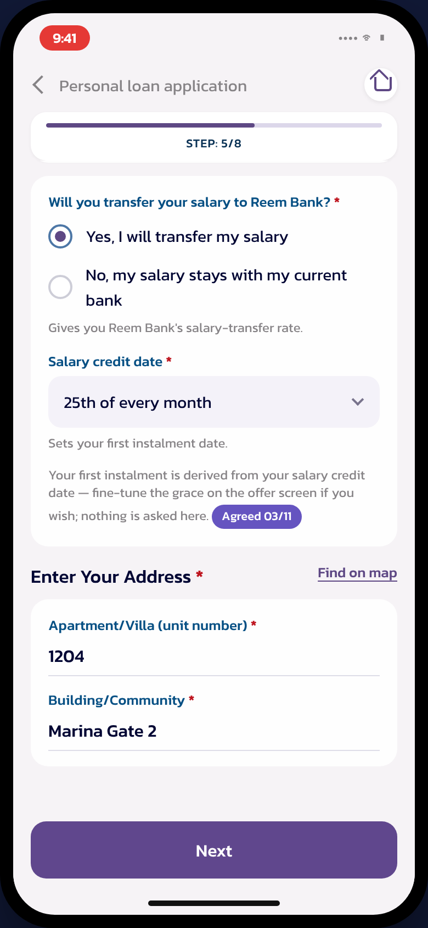 | 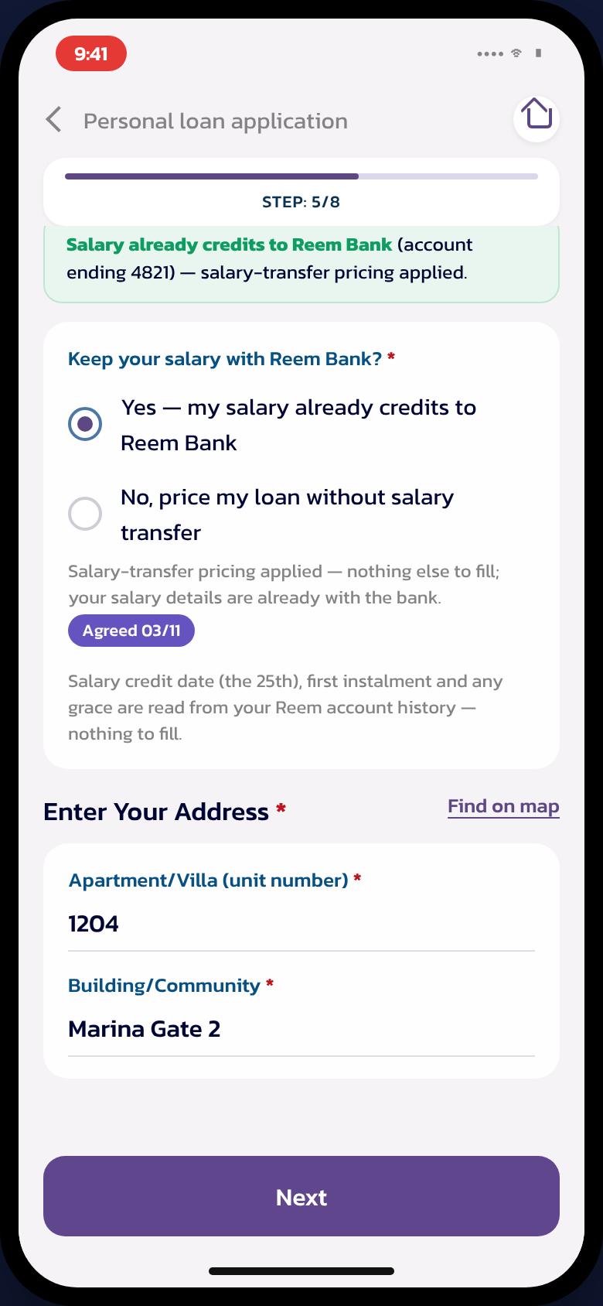
Figure 2 — The details screen — left: C3 with the toggle ON (FSTL) asking only the salary credit date; right: C2 — salary detected, nothing asked

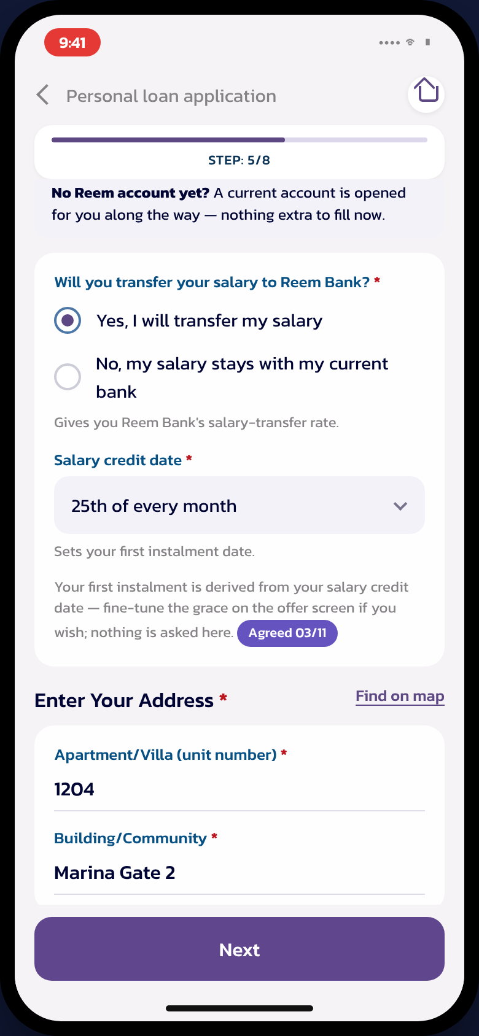 | 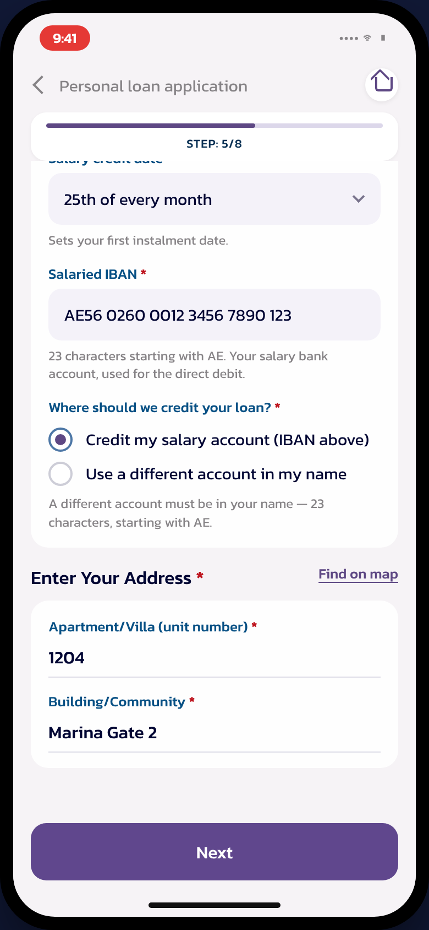
Figure 3 — Left: C4 — the banner announces the account created along the way; right: toggle OFF (NSTL) — salaried IBAN and the disbursement-account choice

3.2 Data points — asked versus derived
Data point | Asked? | Rule
Expected first salary credit date | FSTL only (C1/C3/C4, toggle ON) | Sets the first-instalment derivation and the salary watcher window. For C2 it is read from the account history and never asked.
Salaried IBAN | NSTL only (toggle OFF) | Used for the direct debit, exactly as today. FSTL and STL never see an IBAN question.
Disbursement account | NSTL only | Default “credit my salary account”; a different own-name account as the exception.
Grace period | Never asked as a question | Derived default aligned to the salary credit date; adjustable once, on the offer screen (section 3.3).
Relationship, account, salary presence | Never asked | Detected by the backend before the details screen renders (section 4).

3.3 Offer and grace period
- The offer screen carries a grace period control beside amount and tenure. Bounds come from Product Setup / the pricing matrix; the default is the minimum grace that lands the first instalment on the first salary credit date after disbursal.
- Changing the grace recalculates the EMI and the first-instalment date inline; the offer can be accepted without touching the control. Grace-period interest appears in the EMI exactly once.
- The first-instalment date with grace applied shows on the offer, the KFS, the contract pack and the tracking screen. No grace field exists anywhere else in the journey.
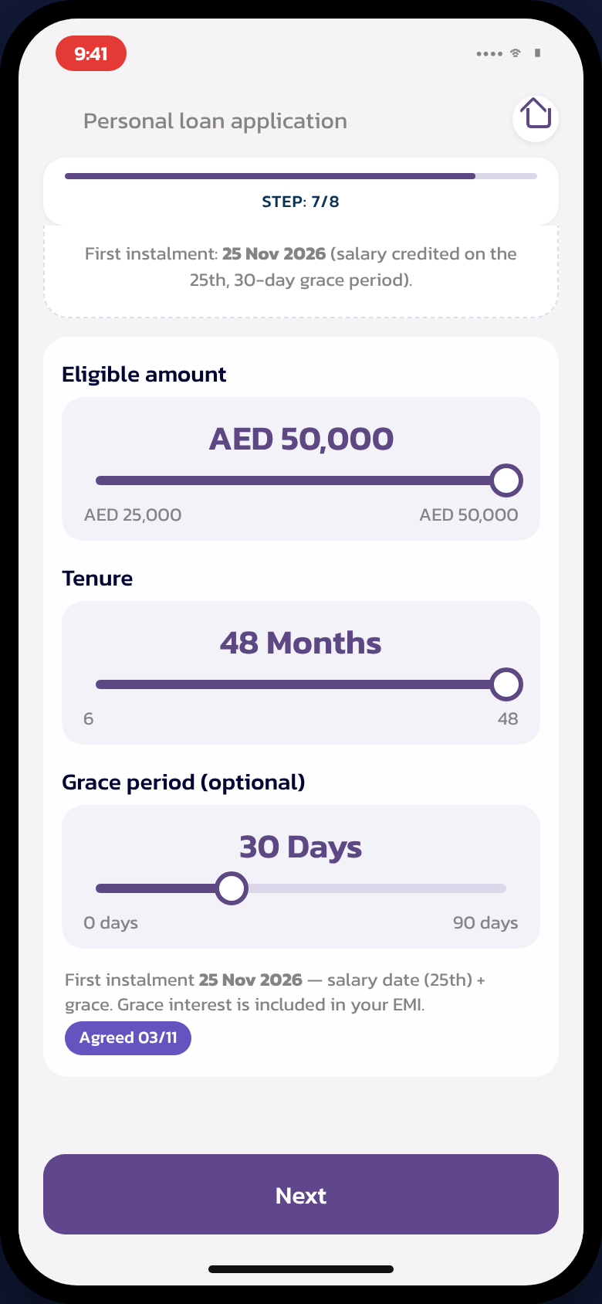
Figure 4 — The offer screen — grace adjusted here only, first instalment derived from the salary date

3.4 The salary-transfer letter
- Generated at fulfilment with the account IBAN — the new account’s IBAN for C1/C4, the existing one for C3.
- Upload is mandatory inside the journey; the application status screen accepts the letter until day 28.
- Reminders on days 7, 10, 13 and 26; day 28 is the cut-off; day 30 the offer expiry — the application terminates and the customer is informed.
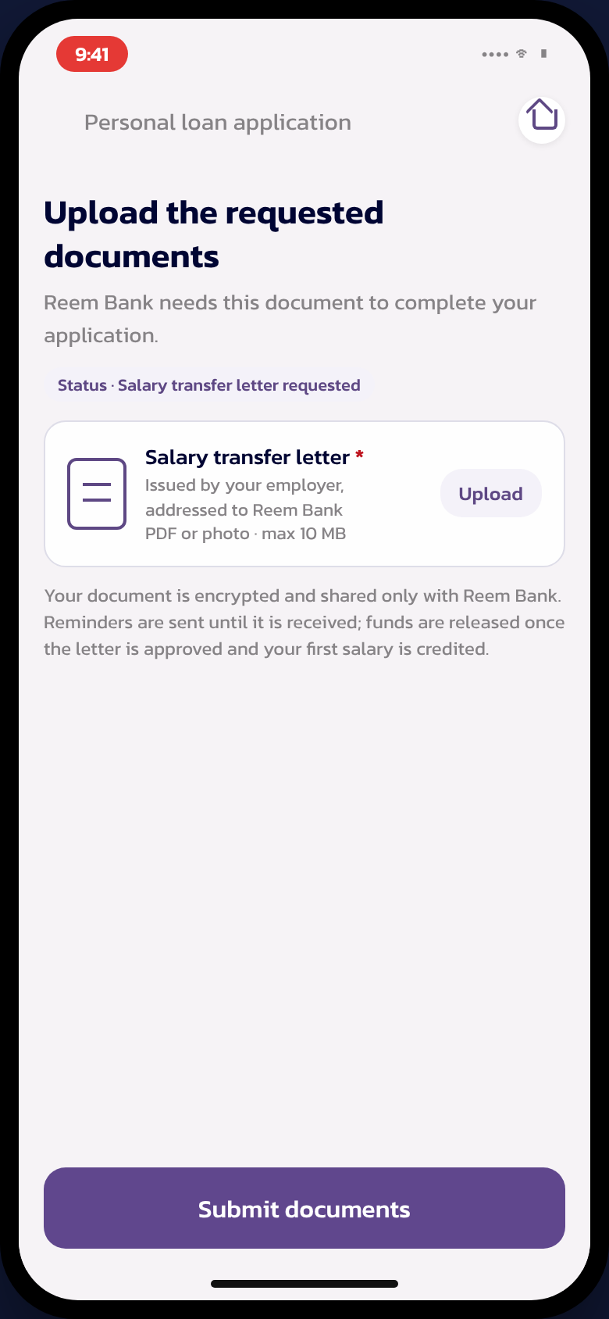 | 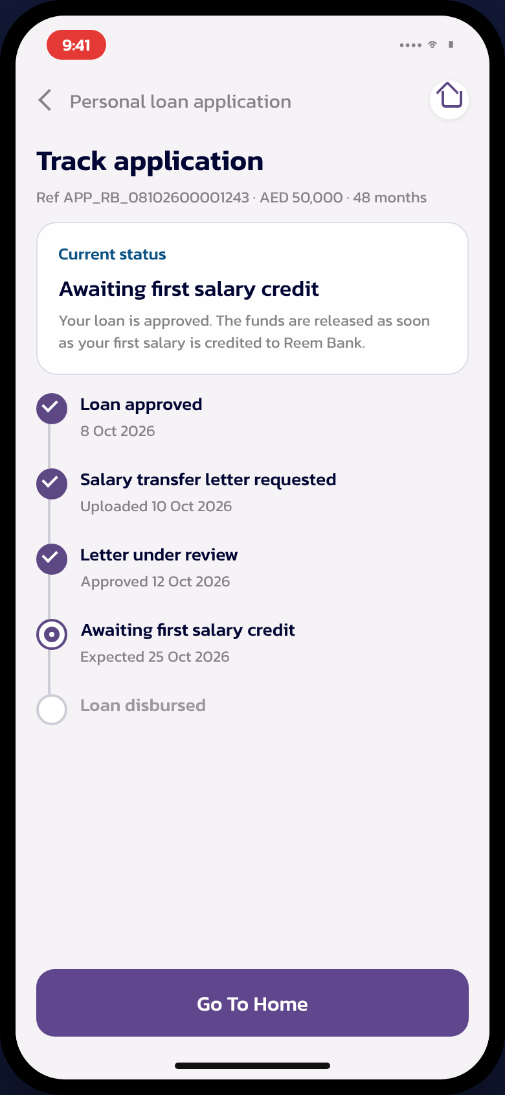
Figure 5 — Left: the letter request with upload; right: application tracking through the salary-transfer statuses

3.5 The account created along the way (C1, C4)
- Only the account-specific steps of the account-opening journey are reused: account type (Current, pre-selected), tax declarations, account KFS and the debit-card preference.
- Emirates ID, selfie and address are never asked again — the loan or card journey already captured them.
- The account and its IBAN exist before the loan or card is created, and are written to it as the settlement account.
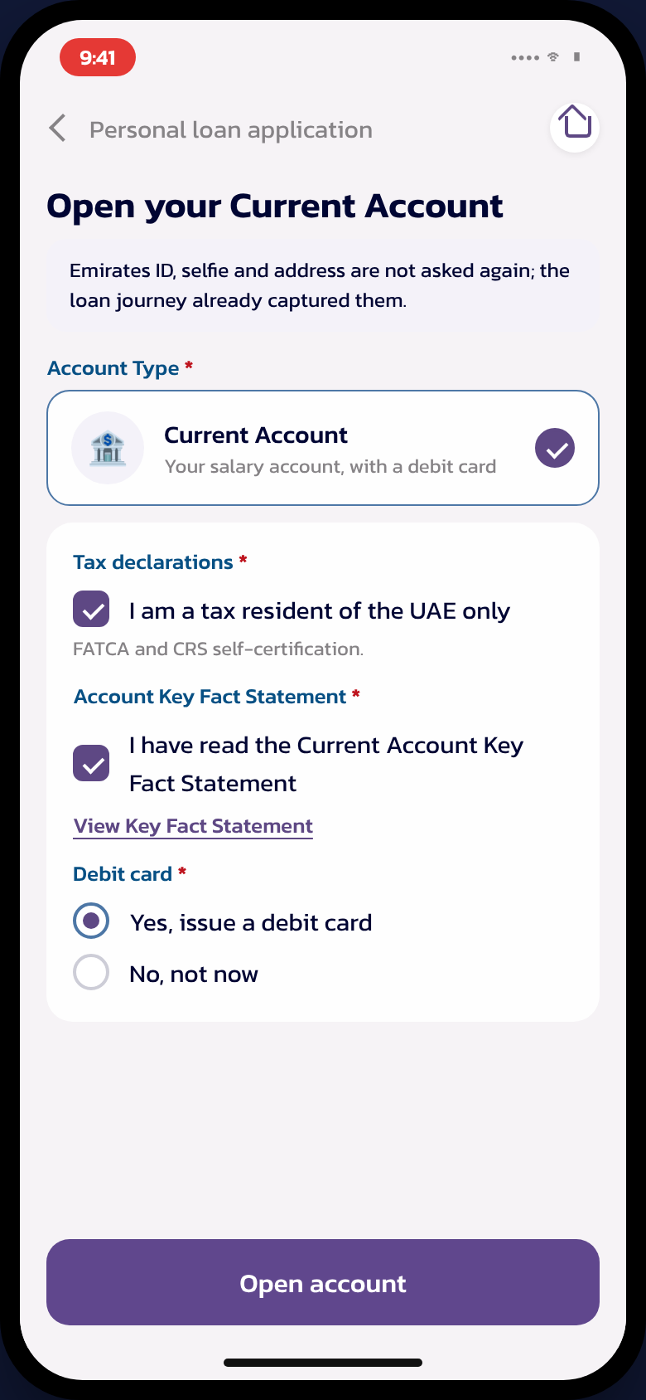
Figure 6 — The reused account-opening steps for C1 and C4

4. SALARY TYPE DETECTION
Detection runs in the backend after identification (Emirates ID scan and deduplication) and before the details screen renders, so the toggle can adapt. The customer is never asked what the bank can derive.
Order | Source | Rule | Outcome
1 | Core account history | A salary credit on an own Reem current/savings account in the current or previous month (T / T-1) | STL confirmed → case C2
2 | Core products list | Customer holds an active current/savings account | Distinguishes C3 (has account) from C4 (no account)
3 | Credit bureau report | Salary IBAN on the bureau report matches a Reem IBAN | Confirmatory signal for case C2
4 | Deduplication result | No Reem relationship | C1 — new to bank
Note: Detection classifies the customer; it never blocks. When no salary can be verified, the customer simply answers the toggle and the standard income verification applies unchanged.

5. FULFILMENT

5.1 The order rule
The account and the IBAN are created before the loan or card. The loan’s settlement fields need a valid account, and the letter needs the IBAN. One core call creates the account and returns the account number and the IBAN in the same response; the same service, with the account product as a parameter, serves both the full current account (C1, C4) and the repayment-only account used by the NSTL flow. The IBAN is sanity-checked before the letter is issued.

5.2 Personal Loan — FSTL
Step | What happens | Applies
15.1 Customer record | CIF created on the core system | C1 only — existing customers skip
15.2 Account + IBAN | Current account created; account number and IBAN returned in one call | C1, C4 — C2/C3 reuse the existing account
15.3 Loan creation | Loan booked with settlement = the salary account; funds held | All FSTL
15.4 Letter issued | Salary-transfer letter generated with the IBAN; uploaded in the journey | FSTL
15.5 Operations validate | Sales/Ops queue checks the letter against the application | FSTL
15.6 Salary watcher | The system polls the salary account until the first salary credit lands | FSTL
15.7 Release | Funds released; salary-transfer pricing confirmed; application Completed | FSTL — C2 releases at loan creation
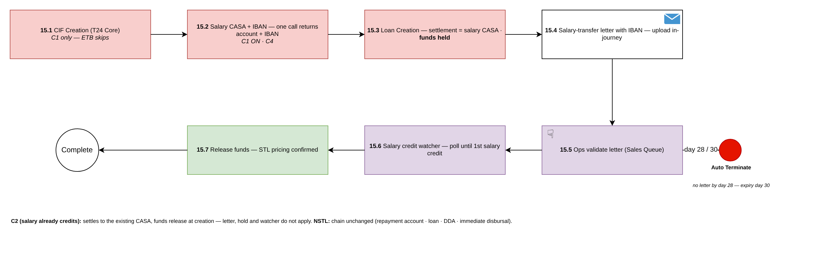
Figure 7 — The Personal Loan FSTL fulfilment chain (workflow v2.0)
C2 (salary already credits): the loan settles to the existing account and the funds release at creation — letter, hold and watcher do not apply. NSTL: today’s chain is unchanged — repayment account, loan creation, direct debit on the salaried IBAN, immediate disbursal.

5.3 Credit Card — FSTL
Step | What happens | Applies
17.1 Account + IBAN | Current account created on the core system; IBAN returned in one call | C1, C4 — C2/C3 reuse the existing account
17.2 Card created INACTIVE | The card is created on the card system but stays inactive | All FSTL
17.3 Letter issued | Salary-transfer letter with the IBAN; uploaded in the journey | FSTL
17.4 Operations validate | Sales/Ops queue checks the letter | FSTL
17.5 Salary watcher | Polls the salary account for the first salary credit | FSTL
17.6 Activation | Card activated with the salary-transfer pricing and limit confirmed | FSTL — C2’s card is active at creation
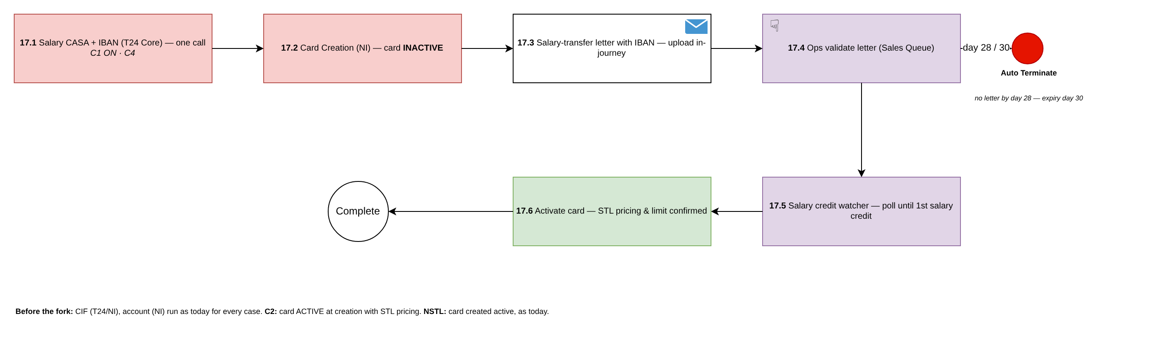
Figure 8 — The Credit Card FSTL fulfilment chain (workflow v1.7)
The customer record and card-system steps (CIF, account, card) run exactly as today before the fork; the salary-type fork sits after the card-system account creation. NSTL: the card is created active, as today.

5.4 Release conditions and the day-28/30 rule
- Release (PL funds / CC activation) requires both: the letter validated by operations and the first salary credit detected on the salary account.
- No letter by day 28 → cut-off; the application terminates at day 30 (offer expiry) and the customer is informed by email and in-app notification.
- A release never happens on the letter alone — the salary credit is the trigger; operations confirm through the Disbursement Maker and Checker exactly as today.

6. SUPER PORTAL

6.1 Status model
Figure 9 — The salary-transfer statuses between acceptance and completion
Status | Entered when | Exits to
Awaiting STL Letter | FSTL booking done (account + loan/card created, funds held or card inactive) | Awaiting STL Validation (letter uploaded) · Expired (day 30)
Awaiting STL Validation | Letter uploaded in the journey or from the status screen | Awaiting First Salary Credit (approved) · Awaiting STL Letter (rejected, re-request)
Awaiting First Salary Credit | Letter approved by operations | Completed (salary credit detected and release approved)
Completed | Funds released / card activated | —

6.2 Queue work
- Sales/Ops queue — letter validation: view the uploaded letter, approve or reject with a reason; a rejection re-requests the letter from the customer within the day-28 window.
- Disbursement Maker / Checker: the maker confirms the first salary credit on the account, the checker approves the release — the same maker–checker pattern as today’s disbursement.
- Fulfilment queue: the first salary credit date field is mandatory by customer segment — derived and read-only for C2.

6.3 Application Details and documents
Application Details (Application Enquiry) displays: Salary Type (STL / FSTL / NSTL), Customer case (C1–C4), Grace Days, First Instalment Date, and the letter status. The salary-transfer letter appears under View Documents with its validation result.
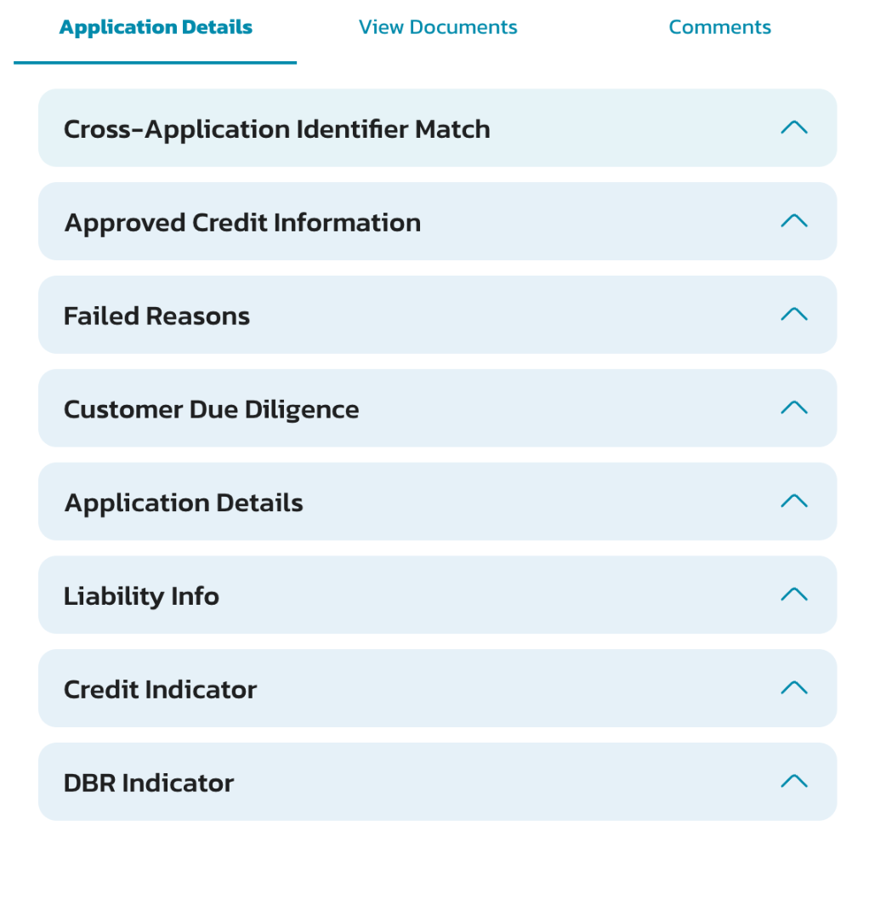
Figure 10 — Application Enquiry — the Application Details panel carrying the new fields

6.4 Audit trail
Every salary-transfer event writes one structured entry, visible in Application Enquiry:
Event | Step Details
Toggle answered | Salary transfer: ON/OFF · case C1–C4 · detected salary type
Account created | Account **<last 4> · IBAN AE…<last 4> — written as settlement account
Loan / card created | Booking reference · funds held (PL) / card inactive (CC)
Letter received | Upload date · day <n> of 28
Letter validated | Approved / Rejected with reason · by <user>
Salary credit detected | Credit date · account ****<last 4>
Release / activation | Released by Checker · salary-transfer pricing confirmed
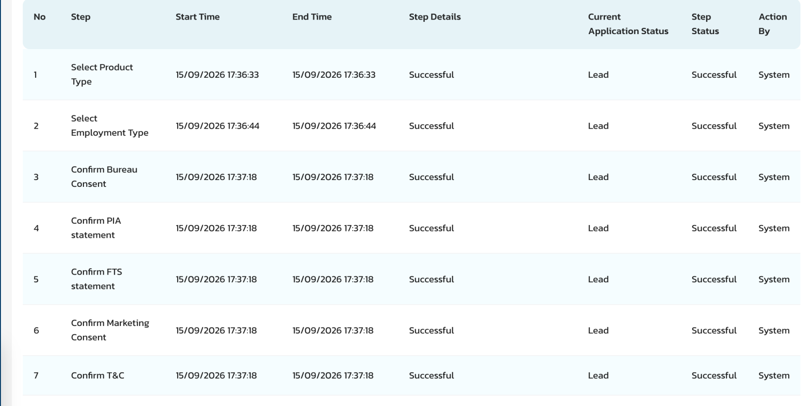
Figure 11 — Application Enquiry — the audit trail carrying the salary-transfer steps (illustrative rows on the live screen)

6.5 Communication Setup
All templates below are newly added in Communication Setup; client communication is in banking English, signed “Reem Bank”, exactly one client email per decision.
Template | Audience | Sent when
Letter request | Email (Client) | FSTL booking done — carries the IBAN and the upload link
Letter reminder | Email (Client) | Days 7, 10, 13 and 26 while the letter is outstanding
Letter approved / rejected | Email (Client) | Operations decision; a rejection re-requests the letter
Funds released / card activated | Email (Client) | First salary credit detected and release approved
Offer expiring / expired | Email (Client) | Day 28 cut-off warning and day 30 expiry

6.6 Product Setup
- Salary Transfer Requirement (Yes / No / Optional) and First Salary Transfer Allowed decide which products offer the toggle.
- Pricing and limits are grouped by Salary Type; the grace minimum and maximum come from the pricing matrix.

7. BACKEND LOGIC AND INTEGRATION
All core calls run through the Reem Bank middleware, following the existing integration pattern.
Capability | Behaviour
Salary detection | Account-transactions enquiry on the customer’s own accounts; a salary-type credit in the current or previous month (T / T-1) confirms STL. The bureau salary IBAN match is confirmatory.
Account + IBAN creation | One core call creates the account and returns the account number and the IBAN together. The account product is a parameter: full current account for C1/C4, repayment-only account for the NSTL chain. The IBAN is verified active before the letter is generated.
Loan creation (PL) | Booked with the salary account in the settlement fields; the funds are held until the release event. The hold/release mechanism on the core system is an open item (section 10).
Card creation (CC) | Created in inactive status; activation on the release event.
Salary watcher | Scheduled account-transactions enquiry on the salary account from the expected salary date until the first salary credit is found, within the offer window.
Repayment | STL/FSTL: instalments collected from the Reem salary account by standing instruction — no direct debit (the Central Bank direct-debit setup does not apply to an own-bank account). NSTL: direct debit on the salaried IBAN, unchanged.
Grace derivation | Default grace = the minimum that lands the first instalment on the first salary credit date after disbursal, within the pricing-matrix bounds; re-validated on the actual release date.

8. BUSINESS RULES
No. | Rule
BR1 | The customer is never sent out of the journey to open an account — a parallel application would invalidate the one in progress. The account is created at fulfilment (C1, C4).
BR2 | C2 (salary detected) is asked nothing: no date, no account selection, no IBAN. The toggle stays visible with the “salary already credits to Reem Bank” label.
BR3 | FSTL and STL never ask for an IBAN. The salaried IBAN and the disbursement-account choice belong to NSTL only.
BR4 | The salary-transfer letter is mandatory and uploaded inside the journey; the status screen accepts it until day 28; day 30 expires the offer.
BR5 | Grace is adjusted in exactly one place — the offer screen — within pricing-matrix bounds; the selected value maps downstream unchanged.
BR6 | Release (funds or card activation) requires the letter validated and the first salary credit detected; neither alone releases.
BR7 | NSTL keeps today’s flow end to end: salaried IBAN, direct debit, immediate disbursal, active card.
BR8 | No security cheque for any salary-transfer variant. Should Credit Policy require one for a segment, it is a physical instrument, capped at 120% of the loan value per the applicable Central Bank regulation, collected post-approval outside the digital journey.

9. IMPACT ANALYSIS
Area | Impact | Screen
Customer journey | The salary-transfer toggle with case-driven questions on the details screen; the grace control and first-instalment date on the offer; the letter upload and the salary-transfer statuses on tracking. NSTL screens unchanged.
Status model | Three new application statuses between acceptance and completion: Awaiting STL Letter, Awaiting STL Validation, Awaiting First Salary Credit.
Queues | Letter validation in the Sales/Ops queue; the Disbursement Maker confirms the salary credit and the Checker releases; the fulfilment-queue salary date is mandatory by segment.
Application Enquiry | Salary Type, customer case, Grace Days, First Instalment Date and letter status on Application Details; one structured audit entry per salary-transfer event.
Communication Setup | Five client email templates newly added: letter request, reminders, validation result, release/activation, expiry. | 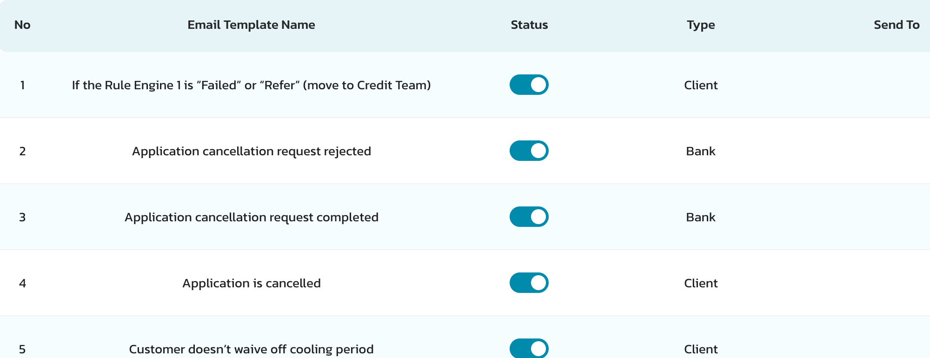
Documents | Salary Transfer Letter as a document type: generated with the IBAN, uploaded by the customer, validated in the queue, visible under View Documents.
Product Setup | Salary Transfer Requirement and First Salary Transfer Allowed flags; pricing and limit groups by Salary Type; grace bounds in the pricing matrix. | Configuration — no new screen
Core integration | Account + IBAN creation (parameterised product), loan booked with settlement account and funds held, card created inactive, scheduled account-transactions enquiry for the salary watcher.

10. OPEN QUESTIONS
Each item carries Appro’s proposal. Confirming the proposal is enough to proceed.
# | Question | Owner | Appro proposal
1 | The hold/release mechanism for FSTL loan funds on the core system (the loan is booked at fulfilment; funds must not reach the customer before the release event). | Reem Bank Core team | A posting restriction on the settlement account release, lifted by the Checker approval
2 | Debit-card issuance for the account created along the way — the card system exposes an enquiry only. | Reem Bank Cards | Launch with the account live and no debit card; issue the card as a follow-up
3 | The standing instruction for STL/FSTL repayment from the Reem salary account (no direct debit applies to an own-bank account). | Reem Bank Core team | Internal standing instruction created at booking, first collection on the first-instalment date
4 | Confirmation that no security cheque applies to any salary-transfer variant (BR8). | Reem Bank Credit Policy | Not required — the release condition and the bureau reporting carry the risk control
5 | Arabic copy: toggle labels, case banners, letter screens and the five email templates. | Reem Bank Business | To be provided before UAT
6 | Operations SLA for letter validation within the 28-day window. | Reem Bank Operations | Next business day
7 | C2 with the toggle OFF: the repayment account for the standard-priced loan. | Reem Bank Business | The existing Reem salary account — no direct debit needed

APPENDIX 1: SUMMARY OF CHANGES
Areas | Previous Behaviour | New Behaviour
Salary transfer | NSTL only; the salaried IBAN field implies the salary question | One toggle with four detected customer cases; STL, FSTL and NSTL all priced and fulfilled
Customer without a Reem account | Cannot complete a salary-transfer application | The current account and IBAN are created along the way at fulfilment (C1, C4)
Detected salary (C2) | Asked the same questions as everyone | Asked nothing — date, account and IBAN derived from the bank’s own records
Grace period | A field on the details screen | Derived default, adjusted once on the offer screen within pricing-matrix bounds
Release | Disbursal on checker approval | FSTL: funds held / card inactive until the letter is validated and the first salary credit lands
Letter | No in-journey letter handling | Issued with the IBAN, uploaded in the journey, validated by operations, reminder ladder to day 28, expiry day 30

APPENDIX 2: CASE QUICK REFERENCE
 | C1 — New to bank | C2 — Salary at Reem | C3 — Account, salary elsewhere | C4 — No account
Detected by | Deduplication: no relationship | Salary credit T/T-1 + bureau match | Products list: has account; no qualifying credit | Products list: no account
Toggle ON asks | First salary credit date | Nothing | First salary credit date | First salary credit date
Fulfilment | CIF + account + IBAN, then loan/card | Loan/card to the existing account | Existing account reused; letter carries its IBAN | Account + IBAN created, then loan/card
Release | On first salary credit | At creation | On first salary credit | On first salary credit

APPENDIX 3: GLOSSARY
Term | Meaning
STL | Salary transfer — the salary already credits to a Reem Bank account
FSTL | Future salary transfer — the customer undertakes to move the salary to Reem Bank
NSTL | No salary transfer — the salary stays with the current bank
C1–C4 | The four customer cases: new to bank; salary at Reem; account but salary elsewhere; relationship without an account
T / T-1 | The current or previous calendar month, used by the salary detection rule
Hold-and-release | The loan is booked with the funds held (or the card created inactive) until the release conditions are met
Salary watcher | The scheduled check on the salary account that detects the first salary credit
DDA | Direct Debit Authority — the NSTL repayment instrument, unchanged
KFS | Key Fact Statement
CIF | The bank’s customer identification number
THANK YOU
Appro Onboarding Solutions FZ-LLC
Customer Journey

