

Employer Name Edit in
Credit Queue
V1.0
29 September 2026


This is not a legally binding document
Highly confidential not to be shared without written consent



EMPLOYER NAME EDIT IN CREDIT QUEUE

FEATURE OVERVIEW
This document describes the Super Portal capability that allows authorised Credit users to correct the Employer Name of an application while it sits in the Credit Queue. Today the Employer Name is system-derived and locked — from the government employment record (sponsor name) or from the customer input — although it drives the employer classification (ALOC), the related company attributes, the Rule Engine evaluation and the maximum DBR used by limit assignment. A wrong employer name today leaves the Credit user only two options: decide the case on non-listed-company terms, or reject it. Key steps are as following:
- Credit user with the 'Edit Employer Name' permission opens the existing Edit Application pop-up in Credit Queue and corrects the Company Name in the new Employment Information section.
- On save and confirmation, the system overrides the finalized Employer Name, re-runs the employer classification (ALOC and MOD / MOI / Pensioner flags), recalculates the related fields and re-runs the Rule Engine.
- The application details display the updated name, the re-classified result and a full original → updated trail; every downstream consumer of the Employer Name reads the corrected value.
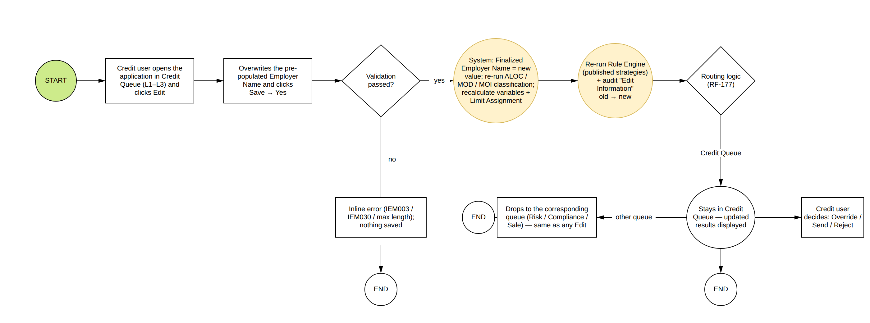

Applicable products: CC, PL. (CASA is excluded — it has no credit decisioning; Mortgage Loan and Auto Loan are not yet part of the platform scope.)
Product Type | Applicable Status where the Employer Name can be edited
CC | Credit Queue L1 / L2 / L3 — Application Status 'Awaiting Credit Approval'
PL | Credit Queue L1 / L2 / L3 — Application Status 'Awaiting Credit Approval'

The edit shall be restricted in below scenarios:
Scenario | Condition
Application waiting for income verification | The application is pending the income retrigger — Edit is disabled as today.
Application locked by another request | A recalculation or Rule Engine run is in progress — 'The Application is in another request processing.'
User without the permission | 'Edit Employer Name' = FALSE — the section is hidden; a role with all Edit permissions FALSE does not see the Edit button.
Application not in Credit Queue | Application Enquiry and the Risk / Compliance / Sale queues remain view only.

END-TO-END EMPLOYER NAME EDIT FLOW FROM SUPER PORTAL

1. Role Management: Edit Employer Name Permission
- A new role permission named 'Edit Employer Name' shall be added to the Editor group of Credit Queue L1, L2 and L3 under the Manually Queue section of Role Management — per product tab ([Credit Card] / [Personal Loan]), alongside the existing Edit permissions and with the same product-tab treatment as 'Edit Length of Service'.
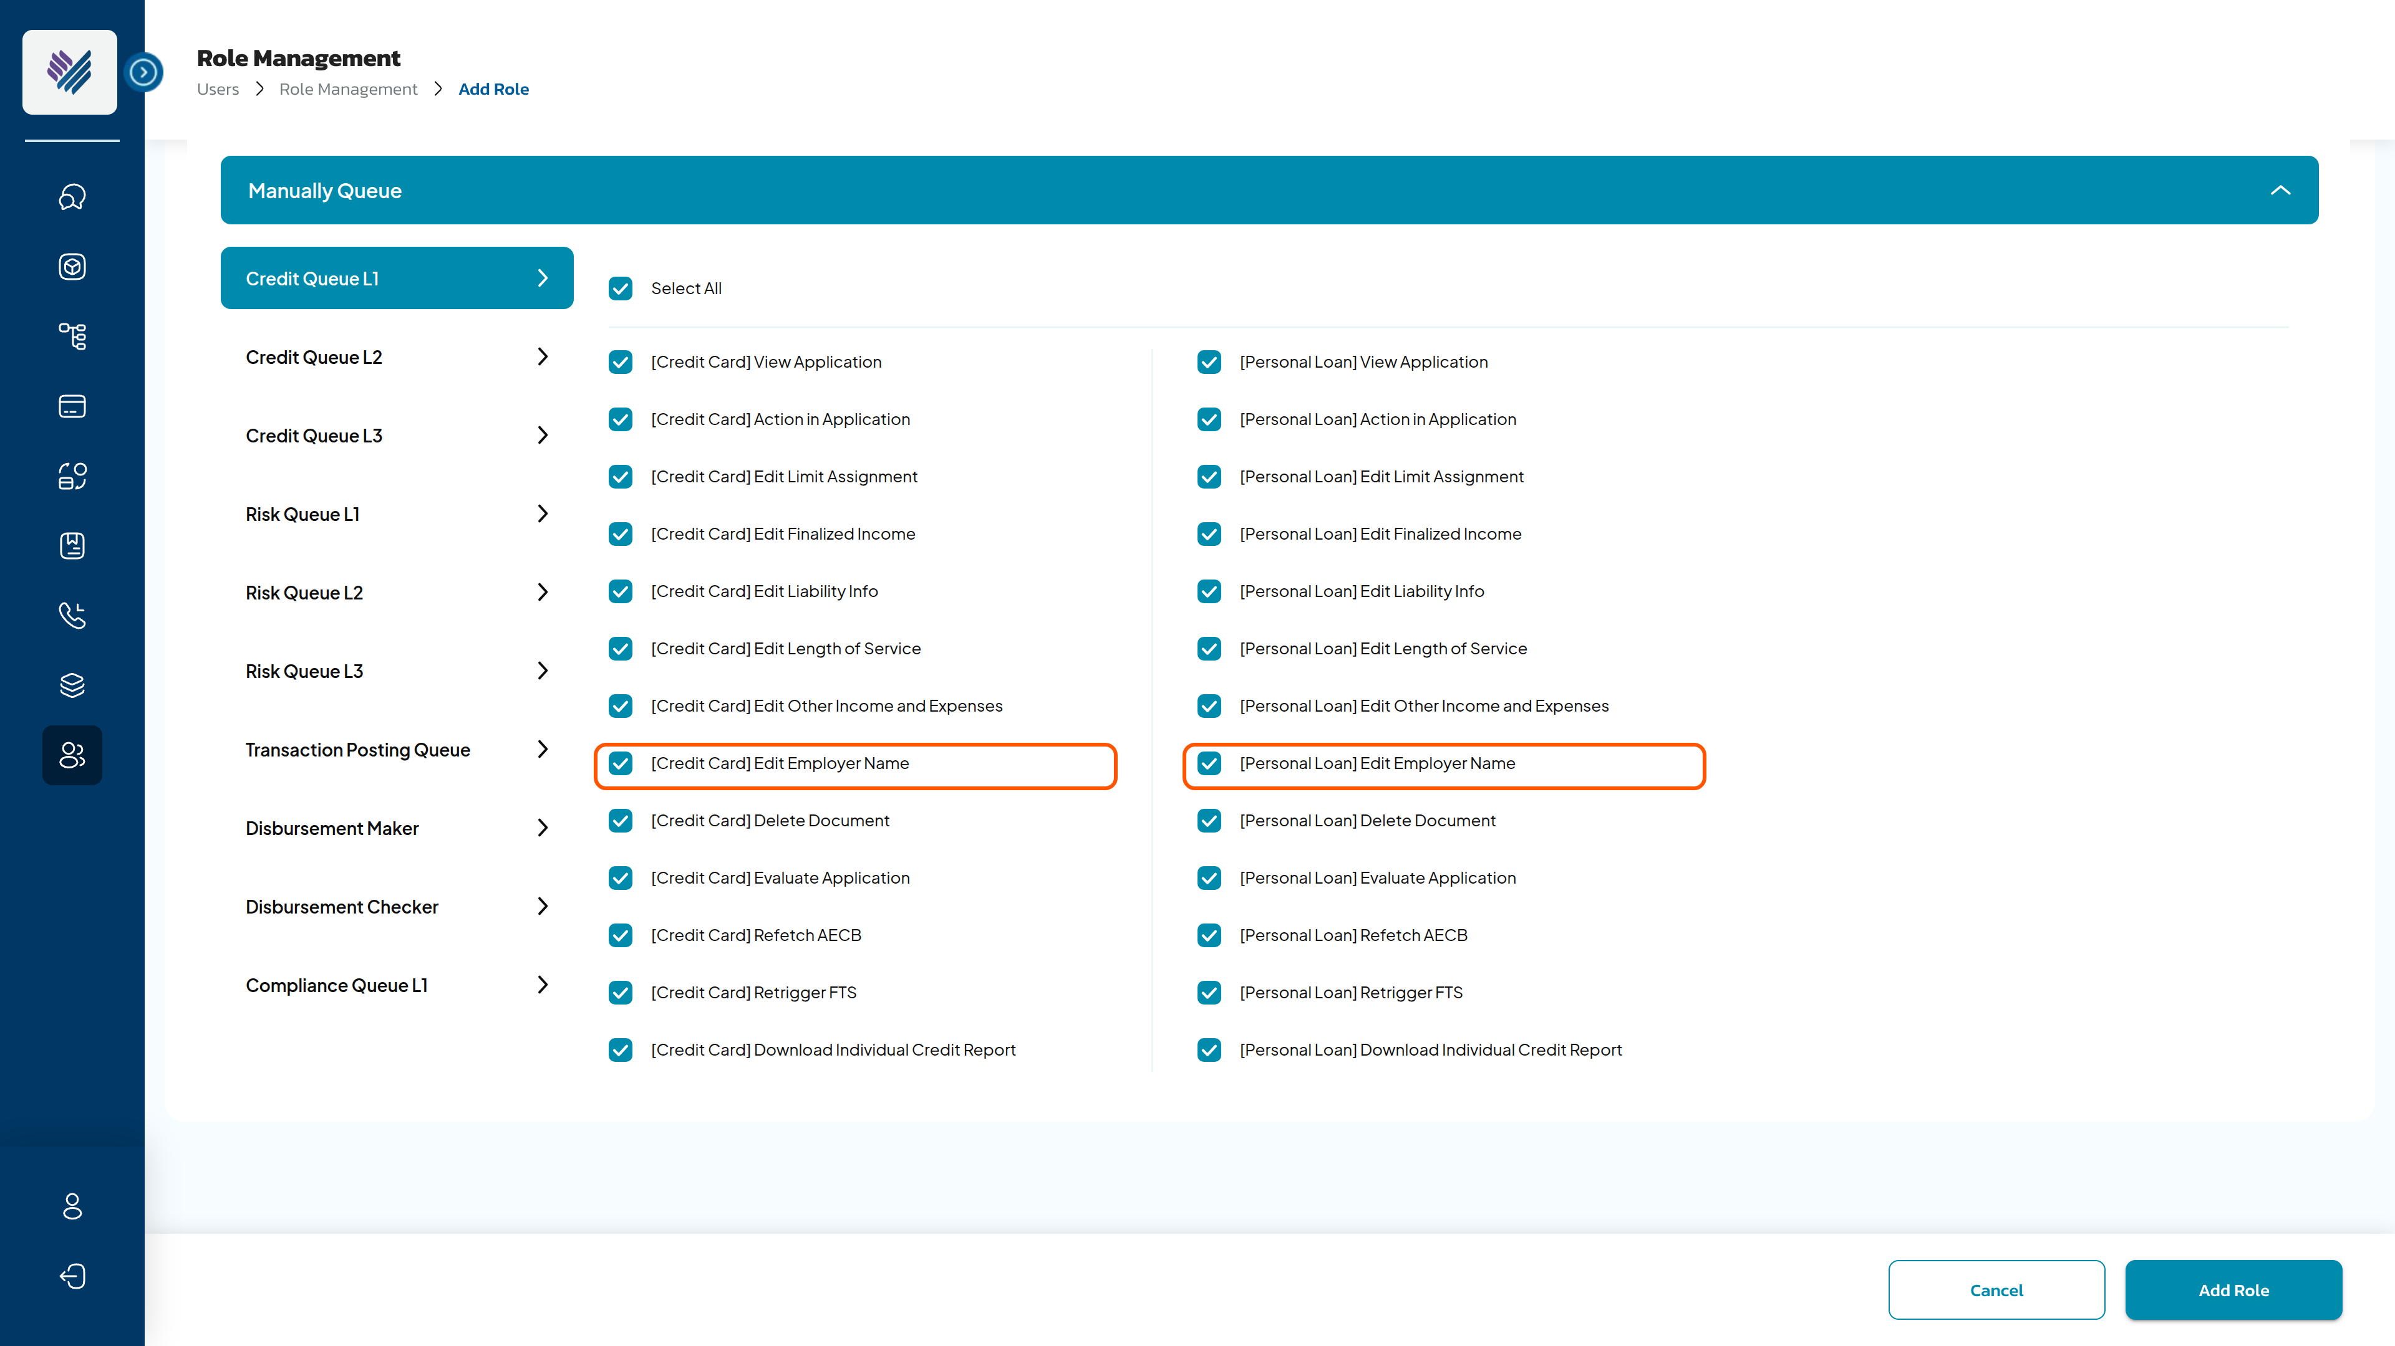
SC1: Add Role screen: Manually Queue > Credit Queue > 'Edit Employer Name' permission
Permission Value | Allowed Actions
[Product] Edit Employer Name = TRUE | Users can view and update the Employment Information section of the Edit Application pop-up for that product.
[Product] Edit Employer Name = FALSE | The Employment Information section is hidden. A role with all Edit permissions FALSE does not see the Edit button.

The permission is a distinct right — never bundled with Evaluate Application or Send Application. The Permission Matrix reference page shall be updated.

2. Employer Name edit from Credit Queue
- The existing Edit button on the Credit Queue Application Details screen is the entry point. The Edit Application pop-up gains a new section Employment Information, placed after Length of Service, holding a single editable field.
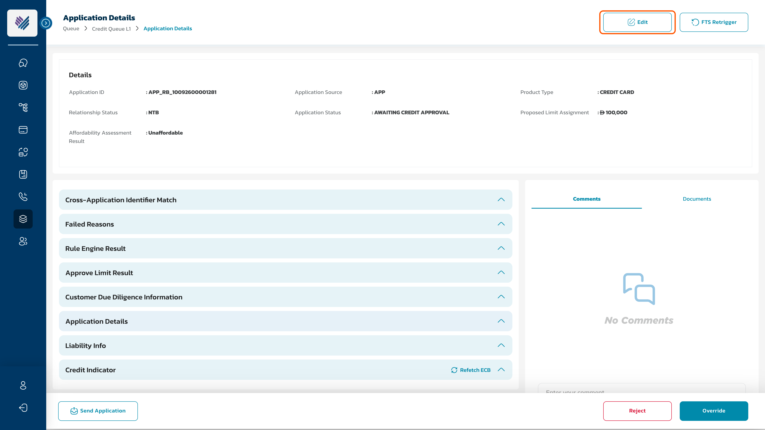
SC2: Credit Queue — Application Details, Edit entry point
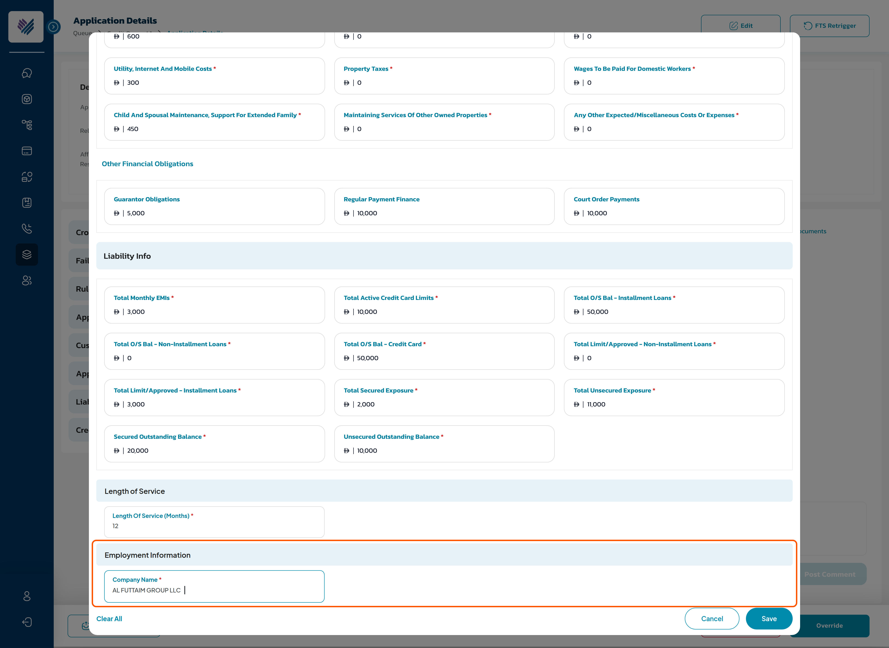
SC3: Edit Application pop-up — Employment Information section
Component | Type | Mandatory | Editable | Description
Employment Information | Section bar | N/A | N/A | Same style as the existing section bars. Shown only when the user's role has 'Edit Employer Name' = TRUE.
Company Name | Input field | Yes | Yes | The only field of the section. Pre-populated with the current finalized Employer Name. Validation as the customer journey field: alphabetic characters only; maximum 200 characters; blank not allowed. An unchanged value on Save does not trigger the re-run.
Clear All / Cancel / Save | Existing controls | N/A | N/A | Unchanged behaviour: Clear All reloads the stored values; Cancel closes without saving; Save is disabled until a value changes.

3. Impact of saving the updated Employer Name
When the user clicks Save, the standard confirmation is shown for the whole pop-up — 'Are you sure you want to update this <Application ID>?' — with the sub-text Company Name will change from "<current>" to "<new>" and the note 'Note that the system will re-run the ALOC classification, auto-recalculate the related fields and then re-run the Rule Engine. Please choose carefully!'
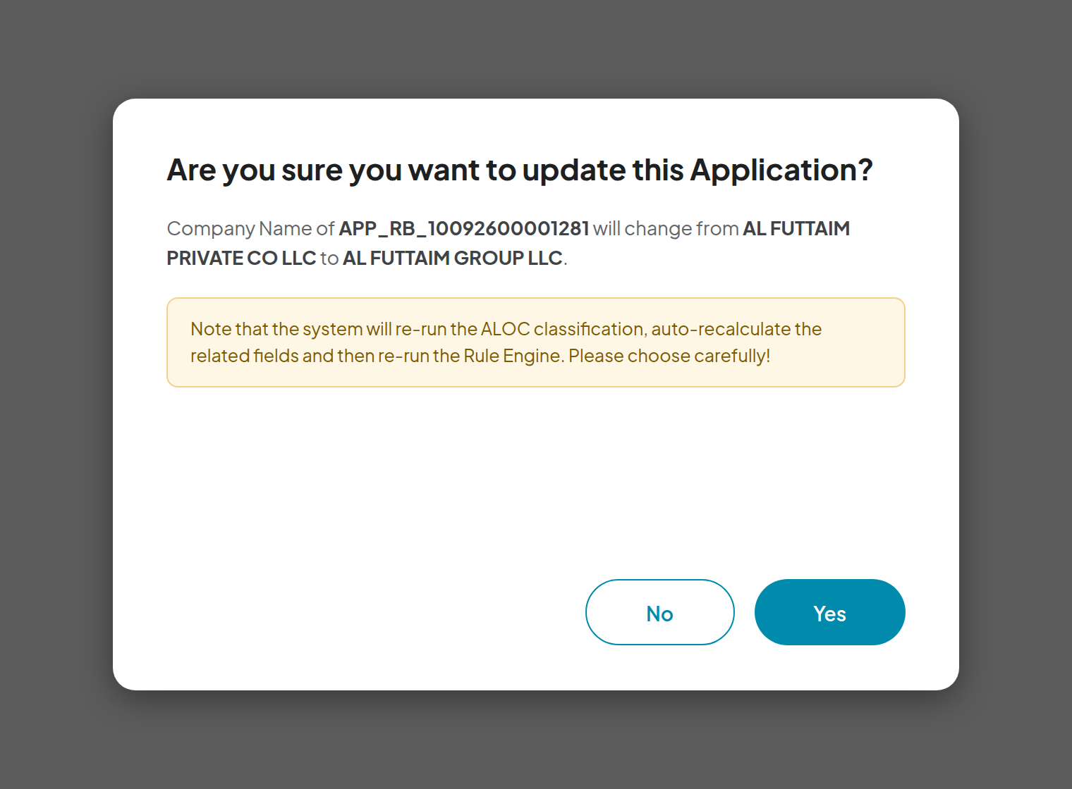
SC4: Confirmation before the re-run
On 'Yes', the system executes in order:
# | System action
1 | Override the finalized Employer Name with the input. The first system-derived value is kept as the Original Employer Name together with its original classification. Source is recorded as 'Credit User' with Updated By / Updated On. The government-record and customer-journey source data are not modified.
2 | Re-run the employer classification: match the new name against the Empaneled Company list — listed company → ALOC with its category, sector, industry and contact fields; otherwise N-ALOC. Re-evaluate the MOD / MOI / Pensioner flags.
3 | Recalculate the calculated variables and the limit assignment — the classification drives the maximum DBR and the income-multiplier group.
4 | Re-run the Rule Engine (segmentation, filtration, deviation) on the currently published versions. The shared re-run counter applies; more than 2 Rule Engine failures reject the application.
5 | Route the application per the standard routing logic. The status stays 'Awaiting Credit Approval' unless the routing changes it — no new Application Status, no mobile-app impact.
6 | Audit trail: Step = 'Edit Information'; Step Detail = 'Employer Name updated from "<old>" to "<new>" by %Username%. Classification: <original> → <updated>'; Action by = user email.
7 | Loading screen up to 15 seconds; the application is locked during the run ('The Application is in another request processing.').
8 | Toaster 'Application "<Application ID>" is updated successfully!'; the Application Details, Rule Engine Result and Approve Limit Result sections reload.

- Several sections edited in one Save → the recalculation and the Rule Engine run once, after all values are stored.
- No cap on repeat edits; the Original Employer Name is set once and never overwritten.

4. Display after the update
Application Details › Employment Information (Credit Queue, Risk / Sale / Compliance queues and Application Enquiry) shows the full picture — the Edit pop-up carries only the editable field:
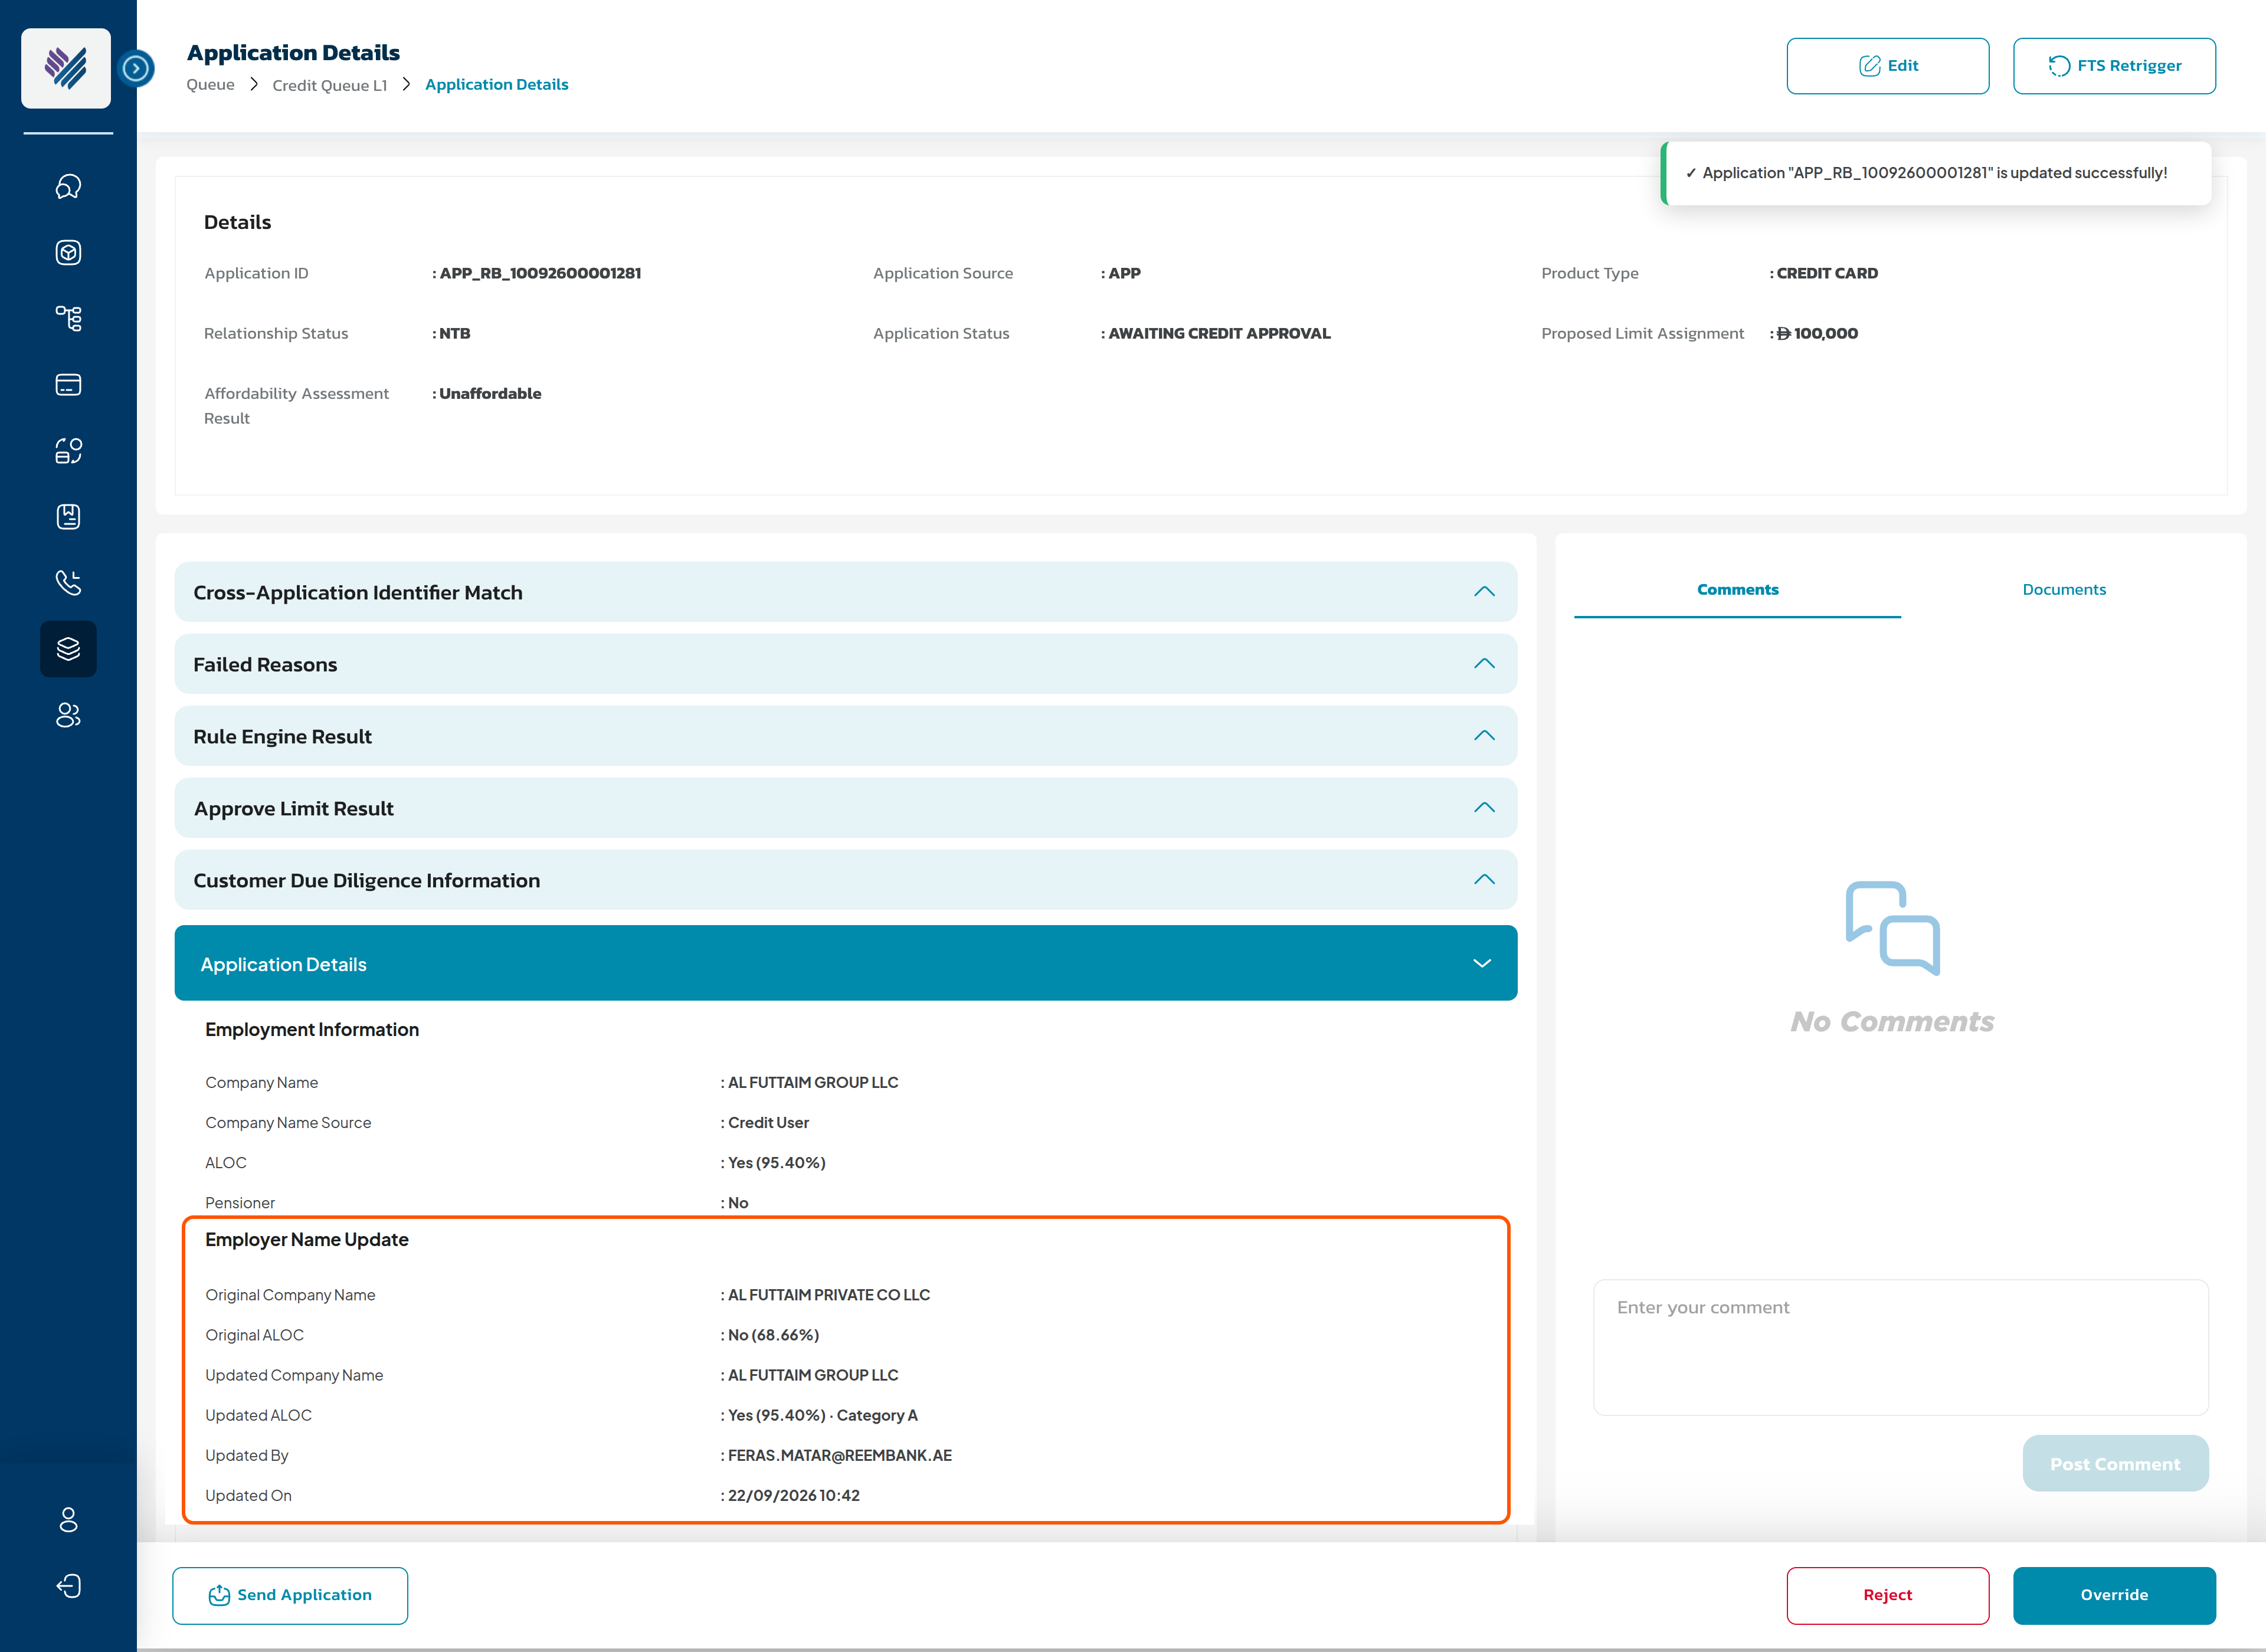
SC5: Application Details — Employment Information after the update
Field | Value after the edit
Company Name | Updated finalized Employer Name — the value the system uses
Company Name Source (new) | EFR (Sponsor Name) | Customer Journey | Credit User
ALOC / Pensioner | Re-classified result in the live display format: Yes | No (<match %>)
Employer Name Update (new sub-block, shown only after an edit) | Original Company Name · Original ALOC · Updated Company Name · Updated ALOC · Updated By · Updated On

- Repeat edits: the block keeps the first original and the latest updated value; the intermediate values are in the application history.
- The application history shows the 'Edit Information' step with the old → new values in the step details, followed by the system steps of the re-run.
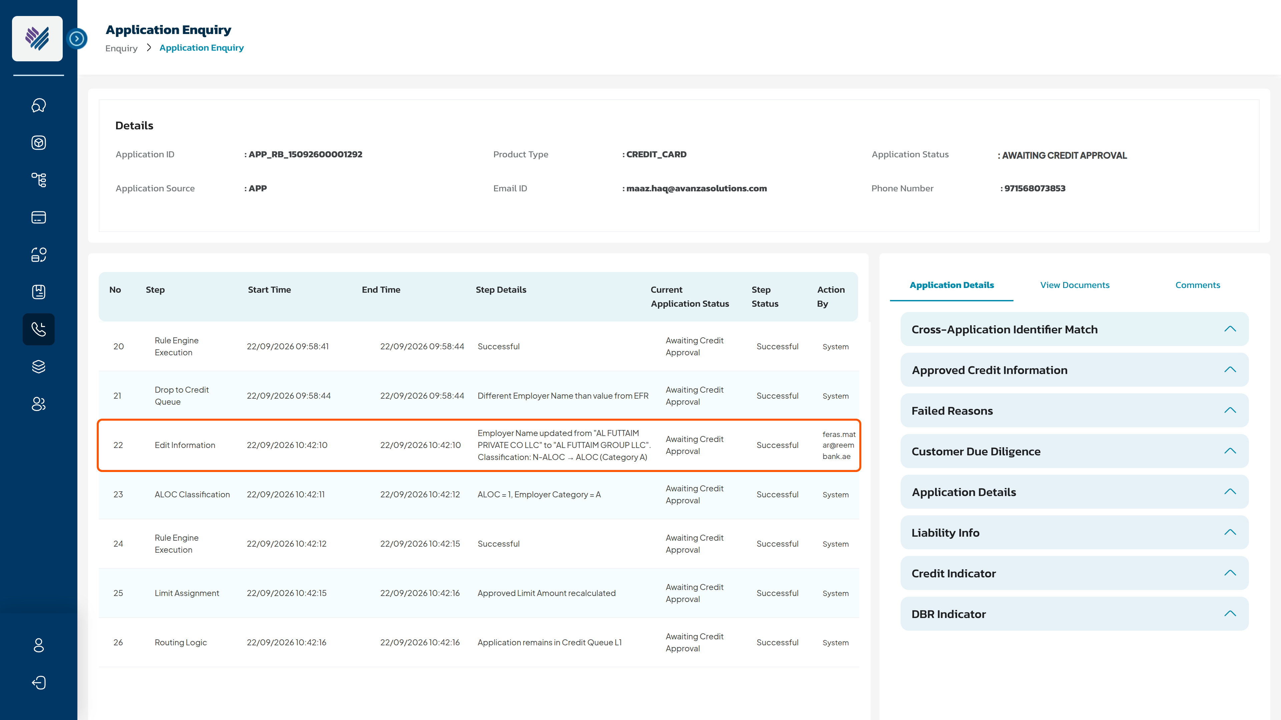
SC6: Application Enquiry — application history with the Edit Information step

5. Downstream consumers of the corrected Employer Name
After the edit, every consumer of the Employer Name reads the corrected finalized value:
Consumer | Behaviour after the edit
Application details (all queues + Application Enquiry) | Updated name, re-classified ALOC and the Employer Name Update trail — section 4.
CAM report + Affordability Assessment Form | Regenerated on the edit, carrying the updated name, classification and recalculated results.
Application Form | Not regenerated — it remains the record of what the customer submitted at OTP time.
Customer Document Stack | Generated after the decision — carries the updated value automatically.
Core banking (CIF creation) | No impact — the CIF mapping carries no Employer Name.
AML screening | No re-screening on the edit; the corrected name reaches the screening system through the post-decision CIF-update call.
Length of Service | Not re-run — it has its own edit section.
Customer communication | None — the customer is not notified of the correction.

6. Summary
Step | Actor | Action | Result
1 | Credit User (with permission) | Opens Edit on a Credit Queue application and corrects the Company Name | Save enabled once the value changes
2 | Credit User | Confirms the update | System actions of section 3 execute in order
3 | System | Overrides the finalized name, re-classifies, recalculates, re-runs the Rule Engine and routes | Status stays 'Awaiting Credit Approval' unless routing changes it
4 | System | Refreshes the view and writes the audit trail | Updated details, original → updated trail, history step
5 | Credit User | Decides the case on the corrected employer | Approve / override / reject on the true classification

ADDITIONAL IMPACT ANALYSIS
Beyond the direct scope above, the following areas of the Reem Bank platform are impacted and must be carried into estimation and test scope:
Area | Impact | Screen
Role Management / Permission Matrix | New permission 'Edit Employer Name' on Credit Queue L1–L3 (Editor group, per product tab). A distinct right, never bundled. Permission Matrix page updated. |   Role Management › Credit Queue (SC1)
Edit Application pop-up | New Employment Information section with the single Company Name field and customer-journey validation. | 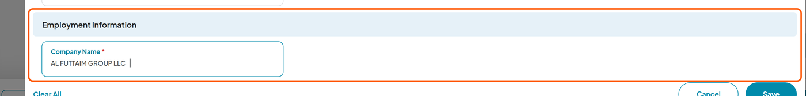  Edit Application › Employment Information (SC3)
Employer classification | The classification step becomes re-runnable on demand for one application with a user-provided name; it overwrites the previous results atomically. | 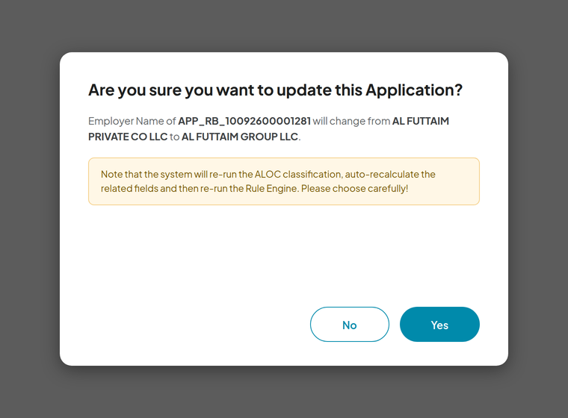  Confirmation before the re-run (SC4)
Rule Engine & Limit Assignment | Re-run on the new classification against the currently published versions; shared re-run counter; recalculation of calculated variables and approved limit. | 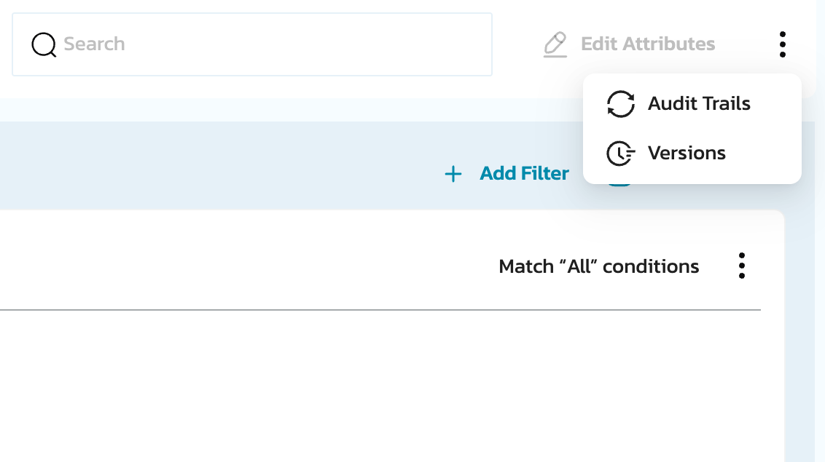  Rule Engine — published strategies
Application Details display | Company Name Source row and the Employer Name Update block on all queue and enquiry views; classification fields refreshed. | 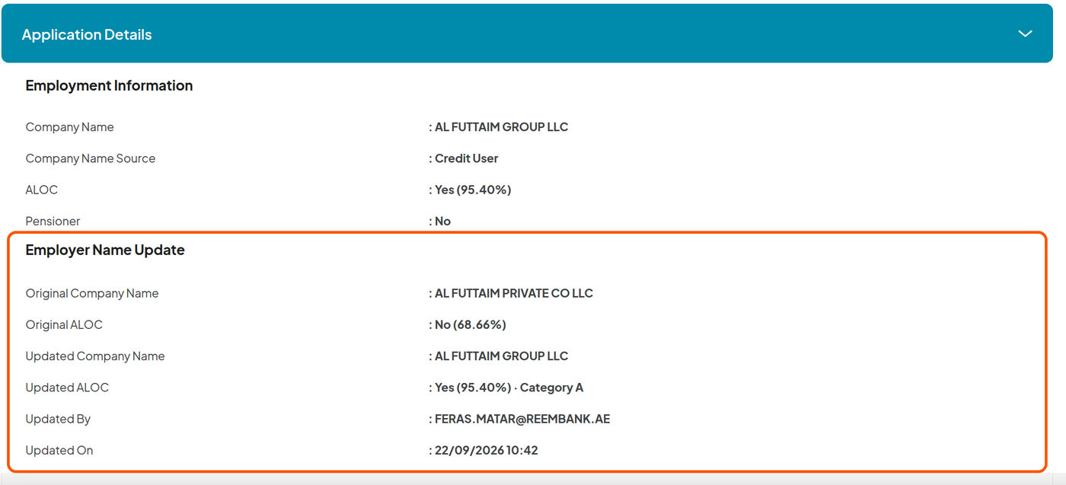  Application Details › Employment Information (SC5)
Audit trail | 'Edit Information' step with a dynamic old → new step detail; the re-run steps log with Action by = System. | Application history (SC6)
Documents | CAM report and Affordability Assessment Form regenerated on the edit; the Application Form stays the OTP-time record. | 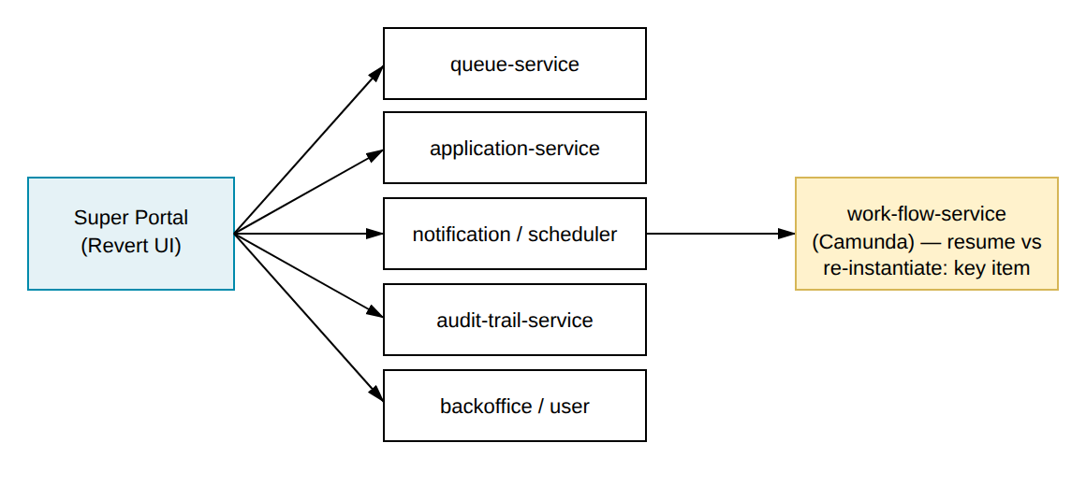  Document generation services
Status model / mobile app / Communication | No new Application Status, no mobile-app change, no new email template; the customer is not notified. | 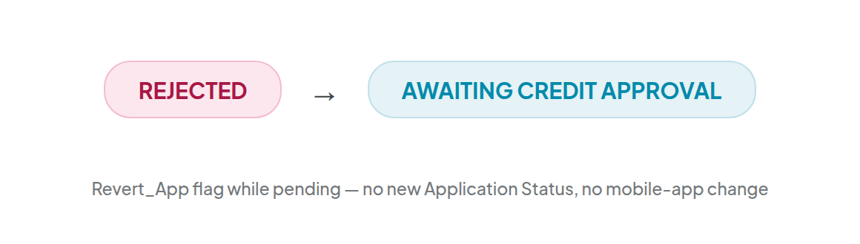  Status unchanged by the edit

THANK YOU

This is not a legally binding document
Highly confidential not to be shared without written consent

