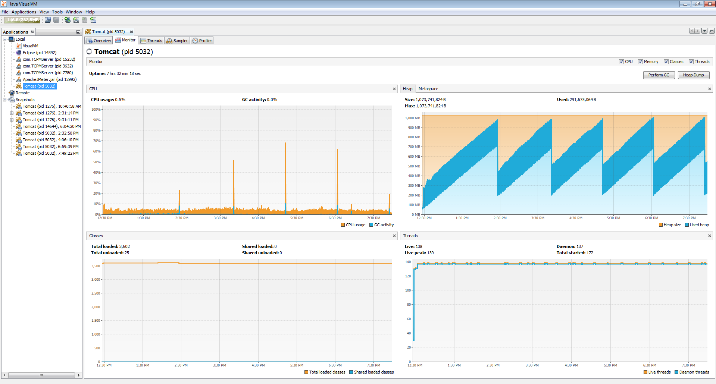

**Plumbr tool** – to check memory leak