Product Requirements Document

Drop Zone

Product Requirements Document

# Objective

|  |  |
| --- | --- |
| Vision | Every household should rely on Dropzone for the home to home delivery. |
| Goals | *-Delivery within 1 hour (max)*  *-Covering the whole Dallas within 3 months* |
| Initiatives | *List high-level product initiatives* |
| Persona | *-People who cannot take out time for personal work*  *-Emergencies*  *-People do not having transportation* |

# Features

|  |  |
| --- | --- |
| Feature | *On-demand hyperlocal parcel pickup and drop service for the users.* |
| Description | *Provides instant anytime parcel pickup and drop services to the app users.* |
| Purpose | *Instant pickup / delivery of the package from/ to the user’s place as per the demand.* |
| User problem | *No or very less time for going out due to fast-paced lifestyle, distance is also a barrier in metro cities. Moreover people now also need a safer no contact delivery option in these times to maintain social distancing.* |
| Solution | *Saves user time, effort, and money by offering a convenient option of delivery just with a press of a button anytime anywhere. No contact and safe delivery in the new normal.* |
| Assumptions | *The User must have a mobile device and proper internet connectivity for using the app. The User must be over 15 years of age.* |
| Out of Scope | *Not catering to interstate of intercity requests, limited pin codes and areas are covered. Only parcel pick and drop facility available as of now. Parcel weight is limited to 50 pounds.* |
| Acceptance criteria | 1. *Able to successfully create an account and login in to the app.* 2. *Able to select and chose areas of pickup and delivery.* 3. *Able to track the journey of the parcel in the app.* |

|  |  |
| --- | --- |
| Feature | *Parcel tracking Service for the recipient* |
| Description | *Share the parcel details option with your recipient so they can track the delivery and meet the driver to collect the package.* |
| Purpose | To let the user know about the arrival of the parcel using real-time tracking |
| User problem | Recipients were unsure about the exact delivery time which could come in between their daily routine. |
| Solution | *Letting the user know about the exact delivery time allows the recipient to plan their other activities as per the arrival.* |
| Assumptions | *The user should be available that time at the time of package arrival* |
| Out of Scope | *Not catering to interstate of intercity requests, limited pin codes and areas are covered. Only parcel pick and drop facility available as of now. Parcel weight is limited to 50 pounds.* |
| Acceptance criteria | *1)Able to successfully create an account and login in to the app.*  *2)Able to select and chose areas of pickup and delivery.*  *3)Able to track the journey of parcel in the app.* |

|  |  |
| --- | --- |
| Feature | *Drone delivery for parcels below 3 pounds.* |
| Description | *For faster delivery using the latest technology of drones that also provides reliable delivery.* |
| Purpose | To let the user get faster delivery avoiding human limitations like traffic and weather conditions |
| User problem | Users can be hesitant about unknown human contact delivery |
| Solution | It is contactless, safe, fast, and reliable for all users. |
| Assumptions | *Users must agree to this delivery option* |
| Out of Scope | *The radius of service is limited to 10 miles and the weight cannot be more than 3 pounds.* |
| Acceptance criteria | *1)Able to successfully create an account and login in to the app.*  *2)Able to select and chose areas of pickup and delivery.*  *3)Able to track the journey of parcel in the app.*  4)Able to understand how drone delivery works. |

|  |  |
| --- | --- |
| Feature | *Delivery agent rating and review* |
| Description | *A thorough background check will be conducted prior to recruitment of delivery agent and will get a rating by customers after each delivery.* |
| Purpose | To get specific information about every delivery agent’s performance and improve our delivery process. |
| User problem | Users cannot trust a third person deliver their package |
| Solution | Delivering packages via a reliable agent who has been verified by many users and has undergone a proper background checks by us. |
| Assumptions | *The delivery agent must agree to this policy.* |
| Out of Scope | *Fake ratings by friends and family* |
| Acceptance criteria | *1)Able to successfully create an account and login to the app.*  *2)Able to rate delivery agent after successful delivery.*  *3)Able to provide feedback.* |

|  |  |
| --- | --- |
| Feature | *Live chat customer care* |
| Description | Allows customers and drivers to have**real-time, back-and-forth conversations with support agents** |
| Purpose | It lets users and drivers get real-time assistance from support agents in case of discrepancies. |
| User problem | Users and drivers are unaware of what to do next in case of problems in delivery |
| Solution | Providing hassle-free solutions pre , post, and in between the delivery process. |
| Assumptions | *Delivery agents and users know how to use the feature efficiently.*  Every User understands English. |
| Out of Scope | *Customer care is only available in English as of now* |
| Acceptance criteria | *1)Able to successfully create an account and login to the app.*  *2)Clicking on the chat widget and able to connect with the support agent* |

|  |  |
| --- | --- |
| Feature | *Multiple payment options* |
| Description | Providing users with the ease of multiple payment modes and also an understanding of their purchase behavior. |
| Purpose | It Lets users choose from a wide range of options for payment at their convenience. |
| User problem | Not all users have the convenience of using a particular payment option at that given time. |
| Solution | Enabling users to choose from multiple payment modes |
| Assumptions | *The user knows how to use the feature* |
| Out of Scope | *-Not having the option of cryptocurrency*  -EMI option is not available |
| Acceptance criteria | 1. *Able to successfully create an account and log in to the app.* 2. *Able to select and chose areas of pickup and delivery.* 3. *Able to pay from a wide variety of payment options* |

# User flow and design

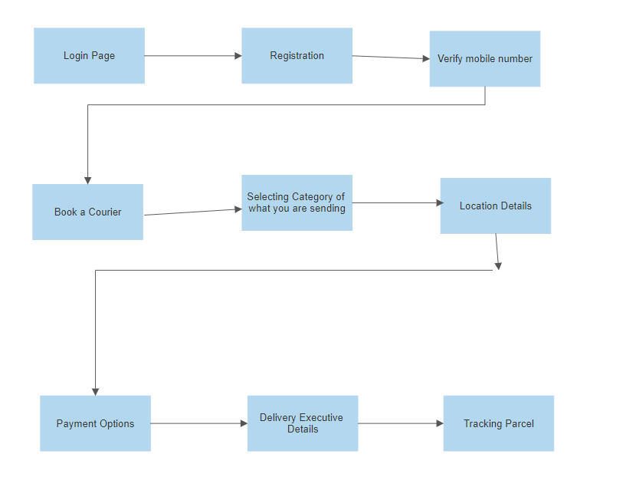

# System and Environment Requirement

* *User and delivery agent must have a mobile device and proper internet connectivity for using the app.*
* *The app is available in google play store and ios app store as well.*
* Location must be turned on for tracking.

# Assumptions Constraints and Dependencies

- *User must have a mobile device and proper internet connectivity for using the app*

*- User must be over 15 years of age.*

*-All users should understand English*

*-All users agree to background check*

*-Weather conditions can cause* hindrance *in delivery*

*-Traffic can delay deliveries during rush hours.  
-App should be able to handle surge demand*