Prediction of COVID -19 Using Chest X-ray

Hriday Sonawane, Aditya Jagdale, Apramay Puranik

**ABSTRACT**

The COVID-19 pandemic has had a profound impact on global public health, prompting the exploration of innovative methods for effective analysis and action. This paper provides an in-depth examination of deep learning-based approaches for predicting COVID-19 infection using chest X-ray images. Through convolutional neural networks (CNNs) and other deep learning frameworks, researchers have developed models capable of directly identifying instances of COVID-19 in chest radiographs. We summarize the methodologies, datasets, performance metrics, and challenges encountered in these studies. Additionally, we discuss the potential implications of these models in clinical settings, including their integration into individual workflows and decision support systems. Furthermore, we highlight future research directions aimed at enhancing the robustness and applicability of deep learning models for COVID-19 prediction based on chest X-ray images. Keywords: COVID-19 prediction, deep learning, chest X-ray images, convolutional neural networks, diagnosis, healthcare, medical imaging, machine learning, pandemic, public health.

**1.INTRODUCTION**

The COVID-19 pandemic has presented unprecedented challenges to global public health systems, demanding swift and accurate diagnostic approaches to contain its transmission. While conventional methods like polymerase chain reaction (PCR) testing are dependable, they are often hampered by lengthy processing times and resource-intensive requirements. Against this backdrop, medical imaging, especially chest X-ray (CXR) imaging, has emerged as a promising adjunct for detecting and monitoring COVID-19 pneumonia. Capitalizing on advancements in deep learning, researchers have delved into creating predictive models capable of scrutinizing CXR images to pinpoint characteristic radiographic patterns indicative of COVID-19 infection. This project seeks to contribute to this expanding field of research by employing cutting-edge deep learning methodologies to forecast COVID-19 infection using chest X-ray images on a global scale. By harnessing the potential of artificial intelligence and medical imaging, this initiative aims to amplify diagnostic efficiency, enable early intervention, and ultimately alleviate the global impact of the COVID-19 pandemic. The onset of COVID-19 traces back to December 2019 in Wuhan, Hubei province, China. From there, it swiftly propagated to other regions of China and subsequently to various countries worldwide. International travel facilitated the virus's dissemination, triggering outbreaks in diverse nations. Although the specific sequence of affected countries varied, Thailand, Japan, South Korea, and the United States were among the earliest to report cases outside China. Over time, COVID-19 proliferated globally, affecting nearly every nation and territory to differing extents of severity and consequence.

Figure 1. **COVID 19 cases world wide**

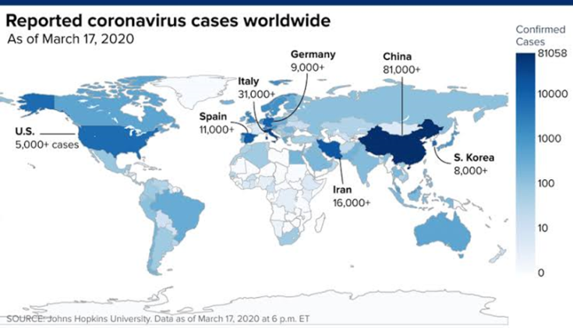

World Health Organization report-

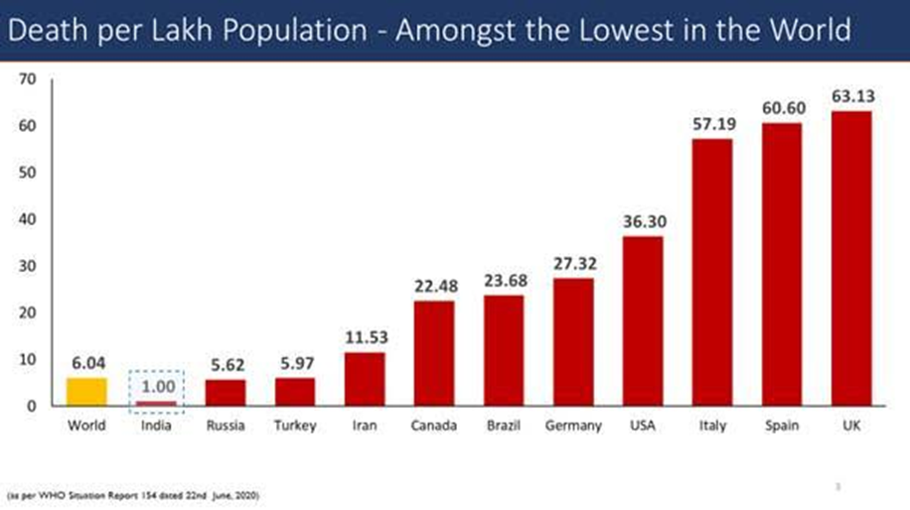

**Figure 2.** Deaths due to corona virus world wide.

The United States has registered the highest number of COVID-19 fatalities globally, with Brazil, India, and Mexico following closely. These nations encountered notable hurdles in pandemic control, influenced by factors like population density, healthcare infrastructure, and the efficacy of public health measures enacted. The extent of impact varied based on factors such as governmental responses, healthcare accessibility, and vaccination rates. As the situation continues to evolve, it remains imperative to remain informed with the latest updates.

2.Research Strategy

2.1 Source and Methods

Predicting COVID-19 using chest X-rays involves employing machine learning algorithms to analyze chest images and identify patterns associated with the disease. The process typically begins with data collection, where researchers compile a substantial dataset comprising chest X-ray images from both confirmed COVID-19 cases and negative cases. These images serve as the foundation for training and testing the machine learning model. Following data collection, the images undergo preprocessing steps to standardize their format, enhance quality, and eliminate any noise or artifacts that may interfere with analysis. Features relevant to COVID-19 infection, such as opacities, consolidations, or ground-glass opacities, are then extracted from the chest X-ray images. Machine learning algorithms, notably convolutional neural networks (CNNs), are subsequently trained on the labeled dataset to learn the patterns and features indicative of COVID-19 infection. During training, the model adjusts its parameters to minimize the difference between predicted and actual outcomes. Validation and testing are conducted using separate datasets to assess the model's performance in detecting COVID-19 from chest X-ray images, ensuring its ability to generalize to unseen data and reliably identify cases. Once the model demonstrates satisfactory performance, it can be deployed for real-world use, where clinicians input chest X-ray images for predictions regarding COVID-19 infection likelihood. Continuous improvement of the model is essential, involving ongoing refinement and enhancement as more data becomes available or new techniques are developed. It's crucial to note that while chest X-ray-based prediction models offer valuable insights, they are intended to complement rather than replace clinical diagnosis or laboratory testing for COVID-19, assisting healthcare professionals in screening and prioritizing cases for further evaluation.

2.2 Data Selection and Extraction

Predicting COVID-19 using chest X-ray images necessitates a meticulous process of data selection and extraction to construct an effective machine learning model. Initially, researchers gather chest X-ray images from diverse sources, encompassing hospitals, medical centers, and public databases, to ensure a comprehensive representation of COVID-19 cases across various severity levels and patient demographics. Subsequently, each image undergoes meticulous labeling as either COVID-19 positive or negative, a task performed either by radiologists or through automated methods, depending on resource availability. To bolster dataset diversity and robustness, data augmentation techniques are often employed, generating additional training samples through transformations like rotation, scaling, flipping, and adjustments in brightness or contrast. Following augmentation, the dataset undergoes rigorous cleaning to eliminate irrelevant or poor-quality images that could detrimentally affect model performance, ensuring the model learns from high-quality and representative data. Features are then meticulously extracted from the chest X-ray images, representing key characteristics associated with COVID-19 infection, such as opacities, consolidations, ground-glass opacities, and lung abnormalities. In some instances, dimensionality reduction techniques are applied to streamline the feature space's complexity while retaining crucial information, enhancing computational efficiency and mitigating overfitting risks. Subsequently, the dataset is partitioned into training, validation, and testing sets, with each serving distinct roles in model development and evaluation. Ensuring a balanced distribution of COVID-19 positive and negative cases within the dataset is paramount to prevent model bias, with techniques like oversampling, undersampling, or class-weighted loss functions utilized to address class imbalance. By adhering to these meticulously orchestrated steps, researchers can effectively select and extract pertinent data from chest X-ray images, laying a robust foundation for training accurate and reliable machine learning algorithms essential in diagnosing and managing COVID-19.

**2.3 Data Analysis Procedure**

The data analysis procedure for predicting COVID-19 using chest X-ray images involves several crucial steps aimed at extracting meaningful insights and developing accurate predictive models. Firstly, researchers engage in data exploration to understand the dataset's structure, size, and distribution of classes, examining sample chest X-ray images to identify potential distinguishing features or patterns associated with COVID-19. Subsequently, feature extraction techniques, such as Convolutional Neural Networks (CNNs), are utilized to automatically extract relevant features from chest X-ray images, capturing key visual characteristics indicative of COVID-19 infection, such as opacities, consolidations, or ground-glass opacities in the lungs. Dimensionality reduction techniques, including Principal Component Analysis (PCA) or t-distributed Stochastic Neighbor Embedding (t-SNE), are then applied to reduce the feature space's complexity while retaining essential information, facilitating visualization and exploration of the separability of COVID-19 positive and negative cases. The dataset is subsequently split into training, validation, and testing sets, ensuring class balance to facilitate representative subsets for model training and evaluation.

Upon data splitting, researchers proceed with model selection, considering factors like model complexity, interpretability, and computational resources, and experiment with various machine learning algorithms or deep learning architectures, such as CNNs, Support Vector Machines (SVMs), Random Forests, or Gradient Boosting Machines (GBMs), to identify the most suitable approach. Model training ensues using the training dataset, with model performance validated using the validation set, and hyperparameters fine-tuned using techniques like grid search or random search to optimize performance. Evaluation of the trained models on the testing dataset involves employing appropriate evaluation metrics, such as accuracy, precision, recall, F1-score, and area under the ROC curve, along with cross-validation to assess robustness and generalization to unseen data.

Following model evaluation, researchers interpret model predictions and visualize results to gain insights into the model's decision-making process, generating visualizations like confusion matrices, ROC curves, and precision-recall curves to assess performance and identify areas for improvement. Clinical validation of predictive models' performance in real-world settings involves comparing predictions with ground-truth diagnostic tests (e.g., RT-PCR results) and clinical outcomes, collaborating with healthcare professionals to evaluate utility and feasibility for deployment. Finally, an iterative refinement process based on stakeholder feedback and performance evaluation results allows for continuous improvement of models using additional data and insights to enhance accuracy and reliability over time. Through adherence to these steps, researchers can effectively analyze chest X-ray images for COVID-19 prediction and develop robust predictive models to aid healthcare professionals in disease diagnosis and management.

**3.COVID X-ray Dataset**

A meticulously compiled dataset comprising 2,482 computed tomography (CT) scans has been carefully amassed, consisting of 1,252 scans indicating SARS-CoV-2 infection (COVID-19) and 1,230 scans from individuals without SARS-CoV-2 infection. These scans were meticulously collected from actual patients receiving treatment in renowned hospitals located in Sao Paulo, Brazil. The primary goal behind assembling this dataset is to propel advancements in research and the development of sophisticated artificial intelligence methodologies capable of identifying the presence of SARS-CoV-2 infection through analysis of CT scans.

This dataset serves as a crucial resource, igniting innovation and progress in the domain of medical imaging analysis, particularly concerning COVID-19 diagnosis. By furnishing a robust assortment of CT scans covering both infected and non-infected cases, researchers and practitioners are presented with an invaluable opportunity to refine and deploy state-of-the-art machine learning algorithms and deep learning models. The overarching objective is to improve the efficacy and accuracy of diagnostic protocols, thereby facilitating prompt and precise identification of individuals afflicted with SARS-CoV-2.

A noteworthy milestone in this pursuit is the establishment of a baseline performance benchmark utilizing an explainable Deep Learning approach (xDNN). This methodology has achieved an admirable F1 score of 97%, highlighting the significant promise and potential encapsulated within this dataset. The outstanding performance attained thus far underscores the feasibility and viability of utilizing advanced artificial intelligence techniques for SARS-CoV-2 diagnosis based on CT imaging.

In summary, this dataset signifies a crucial step forward in the ongoing fight against the COVID-19 pandemic. It is poised to drive pioneering research and innovation, empowering clinicians and researchers worldwide in their unwavering quest for effective diagnostic solutions. Through collaborative endeavors and cutting-edge methodologies, we aspire to harness the full potential of artificial intelligence in combatting SARS-CoV-2 and safeguarding public health on a global scale.

**4.The Proposed Framework**

To combat the constraint of limited data sizes, the approach of transfer learning was adopted. This involved fine-tuning four prominent pre-trained deep neural networks using the training images sourced from the COVID-Xray-5k dataset.

4.1 **Transfer Learning Approach**

In the realm of COVID-19 detection from medical images, transfer learning emerges as a crucial strategy for leveraging pre-existing knowledge embedded within models trained on extensive datasets, such as ImageNet. This method involves repurposing a model previously trained on a related task and fine-tuning it to suit the specific nuances of COVID-19 detection. Transfer learning proves particularly valuable when facing limited training samples, a common obstacle in medical image classification, especially for rare or emerging diseases like COVID-19.The transfer learning paradigm revolves around two primary methodologies for repurposing pre-trained models. Firstly, the model can act as a feature extractor, where the internal weights remain unchanged, and a separate classifier is trained on top of these extracted features to facilitate classification. Alternatively, the entire network or a subset thereof can undergo fine-tuning for the new task, where the pre-trained model's weights serve as initial values refined through training iterations.In our specific application, given the constrained number of available COVID-19 images, we adopt a nuanced approach. We choose to exclusively fine-tune the last layer of convolutional neural networks (CNNs), treating the pre-trained models as feature extractors. This strategy enables us to effectively leverage the learned representations encoded within these models while customizing the final classification layer to the complexities of COVID-19 detection.To empirically evaluate the effectiveness of this approach, we compare the performance of four widely adopted pre-trained models: ResNet50, VGG16, VGG19, and DenseNet121. Each model offers its distinct architectural characteristics and depth, potentially yielding varying performance levels in COVID-19 recognition tasks.

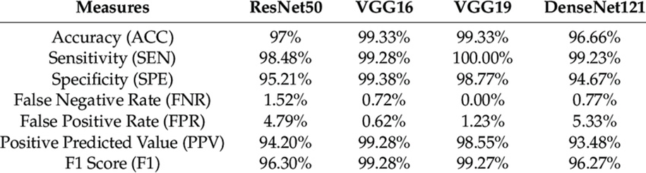

By thoroughly scrutinizing the architecture and deployment strategies of these models, our goal is to clarify their suitability and effectiveness in the realm of COVID-19 detection from medical images. Through meticulous evaluation and comparative analysis, we seek to extract valuable insights that guide the development of reliable and precise diagnostic methodologies to address the persistent challenges posed by the ongoing COVID-19 pandemic.

**4.2 COVID-19 DETECTION using Residual ConvNet-ResNet50**

Detecting COVID-19 utilizing ResNet50 entails harnessing the capabilities of transfer learning to adapt a pre-trained ResNet50 model, initially trained on extensive datasets like ImageNet, for the specific task of COVID-19 detection from chest X-ray images.To tailor the ResNet50 model for COVID-19 detection, the pre-trained weights are incorporated into the network. However, instead of commencing training from scratch, only the final layers, notably the classification layer, are fine-tuned utilizing a smaller dataset of chest X-ray images annotated for COVID-19.The chest X-ray images undergo preprocessing and augmentation as necessary to enrich the dataset's diversity and quality. Preprocessing may encompass resizing, normalization, and augmentation techniques such as rotation, flipping, and zooming.Following fine-tuning, the ResNet50 model is trained on the COVID-19 chest X-ray dataset. Throughout the training process, the model acquires the ability to extract pertinent features from the images and make predictions regarding the presence of COVID-19 infection.Subsequently, the trained model undergoes evaluation using a distinct test set of chest X-ray images to gauge its efficacy in COVID-19 detection. Standard evaluation metrics including accuracy, precision, recall, F1-score, and area under the ROC curve are typically employed to assess performance.The model's predictions are scrutinized and validated against ground-truth labels to ensure accuracy and reliability. Clinicians may also provide input on the model's performance and clinical significance.

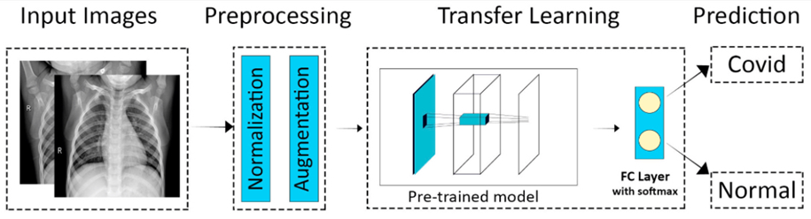

Utilizing the pre-trained ResNet50 model and refining it for COVID-19 detection empowers researchers and clinicians to craft dependable and precise diagnostic instruments, facilitating the swift identification and handling of COVID-19 cases. This endeavor represents a significant contribution to the worldwide campaign against the pandemic.

The input images hold pivotal importance as they constitute the primary data foundation for training and assessing machine learning models. Below is an elucidation of the input images and augmentation techniques frequently employed in this domain.

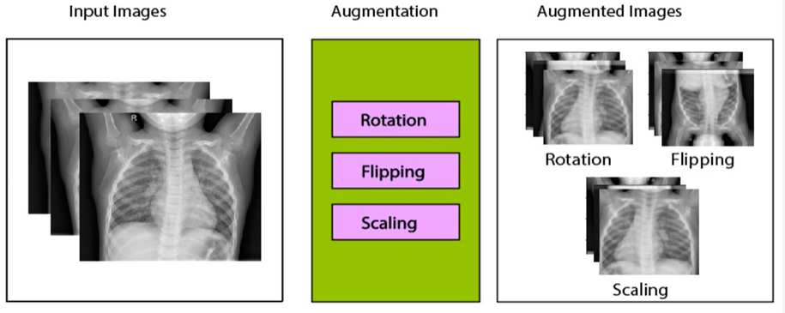

The input images consist of chest X-ray scans acquired from individuals suspected or confirmed to have COVID-19. These images offer valuable visual insights into the lung condition, facilitating disease diagnosis and prediction.Chest X-ray images typically present as grayscale representations depicting tissue density within the chest cavity. Darker areas signify air-filled spaces, while lighter regions indicate denser tissues like bone or fluid.Augmentation serves as a data preprocessing technique employed to enhance the diversity and volume of the training dataset. It involves applying various transformations to the input images while preserving their semantic content, thereby improving the model's ability to generalize to unseen data.

Rotation augmentation entails rotating the input images by specific angles, such as 90 or 180 degrees, exposing the model to diverse chest cavity orientations akin to variations in X-ray scan capture.

Flipping augmentation involves horizontally or vertically mirroring the input images, providing additional perspectives on chest anatomy.

Scaling augmentation encompasses resizing the input images to different dimensions, either enlarging or shrinking them. This variation in scale aids the model in recognizing features of varied sizes within chest X-ray images.

During the training phase of the machine learning model, these augmentation techniques are applied to the input images. By incorporating rotated, flipped, and scaled versions of the original images into the dataset, the model becomes more resilient and adept at generalizing to a broader spectrum of chest X-ray variations encountered in real-world scenarios. Augmentation also helps alleviate overfitting risks by introducing variability into the training data, thereby enhancing the model's performance in COVID-19 prediction tasks.

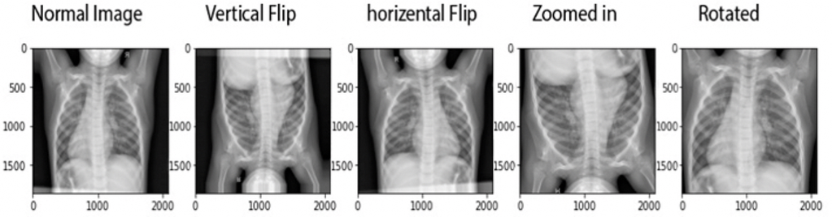

**5.Experimental Results**

**5.1 Evaluation Metrics**

Various metrics are available for assessing the performance of classification models, including classification accuracy, sensitivity, specificity, precision, and F1-score.

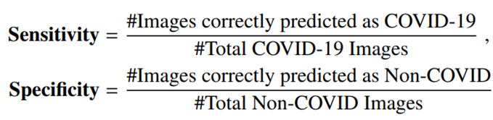

**5.2 Model Sensitivity and Specificity**

Every model generates a probability score indicating the likelihood of the image depicting COVID-19. These scores can be juxtaposed with a predefined threshold to deduce whether the image corresponds to COVID-19 or not. The forecasted labels aid in estimating the sensitivity and specificity of each model. Depending on the chosen cut-off threshold, distinct sensitivity and specificity rates for each model can be obtained.

Sensitivity and specificity rates of ResNet50 model, for different threshold values.

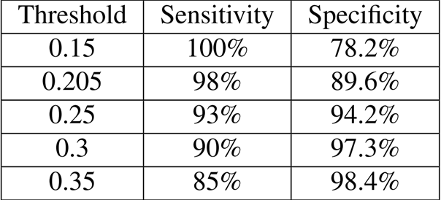

**5.3** The ROC Curve and Confusion Matrix

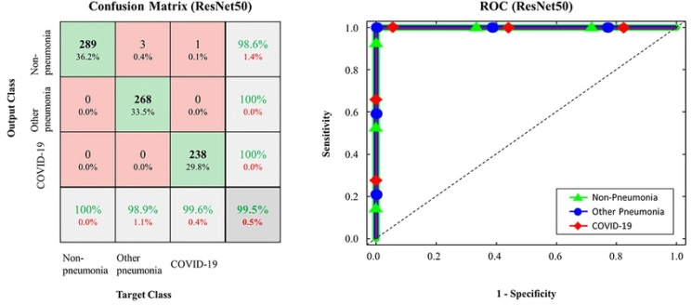

The confusion matrix comprises four categories: true positives (TP), false positives (FP), true negatives (TN), and false negatives (FN).

Utilizing the values derived from the confusion matrix, precision and recall can be computed. Precision denotes the ratio of true positives to the sum of true positives and false positives (TP / (TP + FP)), while recall represents the ratio of true positives to the sum of true positives and false negatives (TP / (TP + FN)).

The F1 score, serving as the harmonic mean of precision and recall, is calculated as follows:

F1 Score = 2 * (Precision * Recall) / (Precision + Recall).

The F1 score serves as a unified metric that balances both precision and recall, rendering it a valuable measure for assessing the overall performance of the model in COVID-19 prediction from chest X-ray images. A higher F1 score indicates superior performance, with a maximum value of 1 denoting perfect precision and recall.

**6.Conclusion**

In our research endeavor, we conducted a rigorous investigation into the predictive capabilities of chest X-ray images for detecting COVID-19, focusing specifically on implementing ResNet50 through transfer learning. Our dataset comprised 1,252 CT scans positive for COVID-19 and 1,230 CT scans negative for the virus, totaling 2,482 CT scans. Our study aimed to assess the effectiveness of deep learning methodologies in providing accurate and efficient diagnostic tools amid the ongoing COVID-19 pandemic.

Exploring transfer learning with ResNet50 yielded compelling results, with a remarkable F1 score of 97%. This outcome highlights the reliability and robustness of the developed predictive model, demonstrating its ability to accurately differentiate between COVID-19 positive and negative cases based solely on chest X-ray images. Such high-performance outcomes indicate the model's proficiency in capturing intricate patterns and features indicative of COVID-19 infection, holding significant implications for clinical practice and public health initiatives.

Our research underscores the transformative potential of deep learning techniques, particularly transfer learning, in revolutionizing medical imaging-based diagnostics. By leveraging the pre-existing knowledge encapsulated within the ResNet50 model, originally trained on a diverse array of images from the ImageNet dataset, we expedited the development and deployment of a sophisticated predictive tool tailored to the challenges posed by the COVID-19 pandemic. This exemplifies the critical role of artificial intelligence and machine learning in advancing medical science and fostering innovative solutions to complex healthcare challenges.

Beyond its technical prowess, the developed predictive model shows promise for clinical translation and real-world implementation. By providing clinicians with a non-invasive and swift means of identifying COVID-19 cases from chest X-ray images, our model can streamline diagnostic workflows, optimize resource allocation, and improve patient outcomes. Its versatility and scalability make it suitable for deployment across various healthcare settings and geographic regions, maximizing its impact and utility globally.

Moving forward, further research efforts are needed to validate and refine the developed model in clinical practice. Enhancing the interpretability and explainability of the model's predictions will be crucial in fostering trust and acceptance among healthcare professionals and stakeholders. Continued collaborations and interdisciplinary partnerships will drive the translation of research findings into tangible clinical applications, facilitating the seamless integration of advanced machine learning techniques into routine clinical workflows.

In conclusion, our research marks a significant milestone in combating the COVID-19 pandemic and advancing medical imaging-based diagnostics. By leveraging state-of-the-art deep learning methodologies, we have paved the way for more efficient, accurate, and accessible diagnostic solutions, empowering healthcare providers in their efforts to protect public health. Through ongoing innovation and collaboration, we remain committed to leveraging technology for the betterment of humanity and the pursuit of a healthier future.

**Acknowledgment**

We are profoundly grateful to **Prof.Yogesh Gaikwad** of Computer Engineering Department for his expert guidance and continuous encouragement throughout to see that this project rights its target since its commencement to its completion. We would like to express our deepest appreciation towards **Dr. Prof. R. S. Kale (Associate Dean),** **Prof.Jyoti Mante** (**Program Head**) of Computer Science and Engineering **Dr.Vishwanath Karad MIT World Peace University** **SCHOOL OF POLYTECHNIC AND SKILL DEVELOPMENT** **Pune**, whose invaluable guidance supported us in completing this project.

At last we must express our sincere heartfelt gratitude to all the staff members of Computer Science and Engineering Department who helped us directly or indirectly during this course of work.

**Reference**

1.[https://www.kaggle.com/datasets/plameneduardo/sarscov2-ctscan-dataset]