Examination Management System

*Project report (CA3) submitted in fulfilment of the requirements for the Degree of*

# BACHELOR OF TECHNOLOGY

**in**

## COMPUTER SCIENCE AND ENGINEERING

By

## Aprendu Aman

**12016997**

SUBJECT

## INT220 – SERVER SIDE SCRIPTING



**School of Computer Science and Engineering**

Lovely Professional University Phagwara, Punjab (India) November 2023

Table of Contents

|  |  |  |
| --- | --- | --- |
| **S No.** | **Contents** | **Page No.** |
| 1. | Introduction | 2 |
| 2. | Technologies Used | 2 |
| 3. | Requirements | 3 |
| 4. | Website Snapshots | 4 – 11 |
| 5. | Code Structure | 12 - 18 |
| 5. | Outcome and Future Prospects | 18 - 19 |
| 6. | GitHub Link | 19 |
| 7. | Bibliography | 19 |

# Introduction

The PHP Examination Management System is a dynamic and user-friendly project designed to simplify the process of conducting and participating in exams. This system features two distinct panels: the Admin panel, accessible by teachers, and the User panel, dedicated to students.

The Admin panel empowers teachers to create accounts, set up tests, and add questions with ease. It offers a range of privileged functionalities, allowing educators to manage the examination process efficiently. Teachers can not only define the scope of the tests but also maintain a high level of control over student assessments. This includes monitoring test results, tracking student progress, and ensuring a secure and organized examination environment.

On the other hand, the User panel caters to students. It provides a straightforward platform for students to participate in tests, view their results, and monitor their ranks. The system ensures that students have easy access to their performance data, enabling them to gauge their progress and identify areas for improvement.

This Examination Management System offers a seamless and accessible solution for educational institutions, streamlining the examination process and enhancing the overall learning experience. It provides a powerful tool for teachers to create, manage, and evaluate tests while empowering students to actively engage with their academic assessments. With these two panels working in tandem, the system fosters a more organized and efficient educational environment, benefiting both educators and students alike.

* 1. **Purpose**

The purpose of the PHP Examination Management System is to simplify and optimize the process of conducting exams for educational institutions. With the Admin panel, teachers can create accounts, design tests, and manage questions, all while enjoying privileged functionalities for effective exam administration. The User panel provides students with an accessible platform to take tests, view their results, and track their ranks. The system aims to enhance the examination experience for both educators and students, fostering a more organized and efficient educational environment.

## Scope

The The scope of the PHP Examination Management System encompasses the creation of a comprehensive platform that streamlines the examination process for educational institutions. It includes features such as account creation, test design, question management, and result tracking for teachers through the Admin panel. Students can access the User panel to take tests, view their results, and monitor their ranks. The system offers a wide range of opportunities for customization, security enhancements, and future scalability. Its scope is to provide an accessible and efficient solution for educational organizations, making exam management more straightforward and effective for teachers and students. The potential for

further development includes the implementation of additional features, performance analytics, and integration with other educational systems to create a holistic and versatile examination management tool.

# Technologies Used

1. **PHP:** PHP version 8.1 is the server-side scripting language used for backend development in this project. PHP is used to handle all server-side logic, including database operations, user authentication, and routing.
2. **MySQL:** MySQL is used as the database for this project, ensuring secure storage of all data including orders and cart items. All order details and cart items are stored in a MySQL database, ensuring data persistence and reliability.

# Requirements

### To run this website the functional requirements are:

* XAMPP server running, Apache and MySQL.
* The data is seeded, into the database so we have to create a database named ”project”.

# Website Snapshot

* To run the website locally, open <http://localhost/examapp/> in your browser, you will land on the homepage of this beautiful website.

*~The Register Page~*

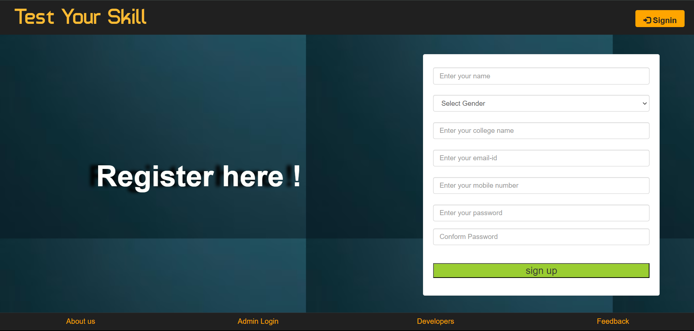

*~The LogIn Page~*

*~The Landing Page~*

*~The History Page~*

*~The Ranking List Page~*

*~The Admin Login Page~*

*~The Admin Landing Page~*

*~The Users list Page~*

*~The Feedback Page~*

Two options when clicked on quiz as a dropdown.

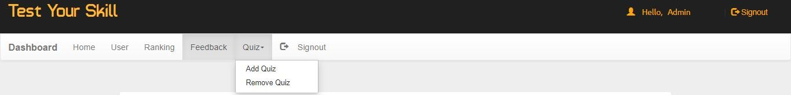

*~The Feedback/Report problem page~*

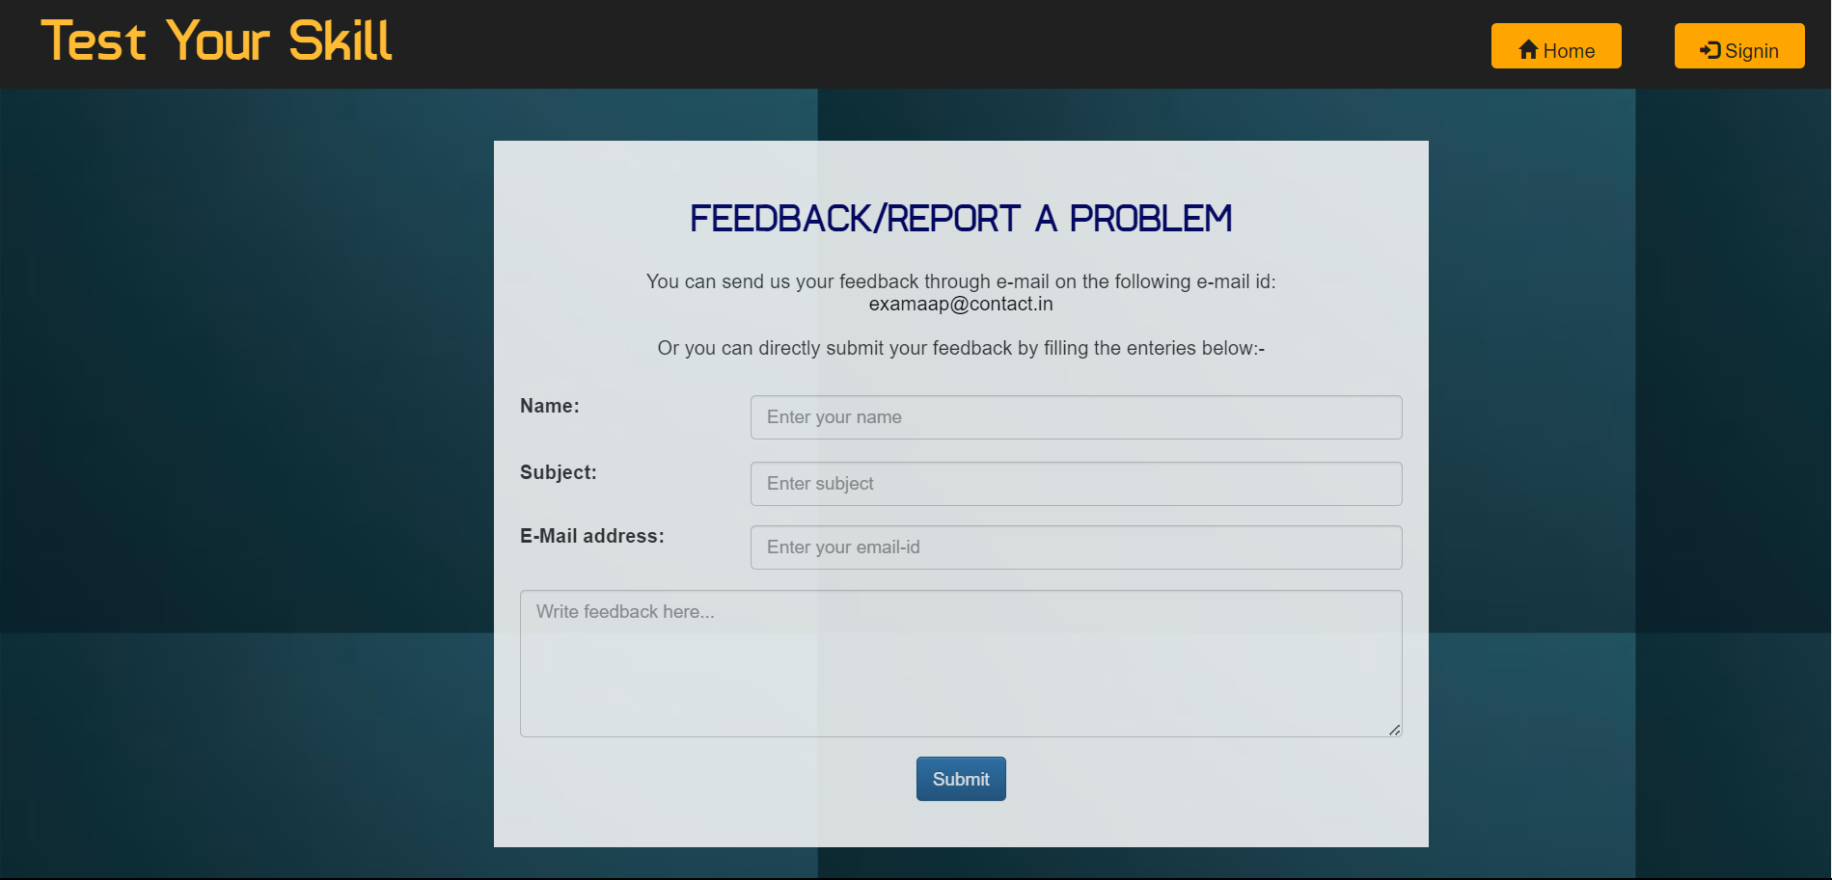

*~The Developer detail~*

*~The Add Quiz Page~*

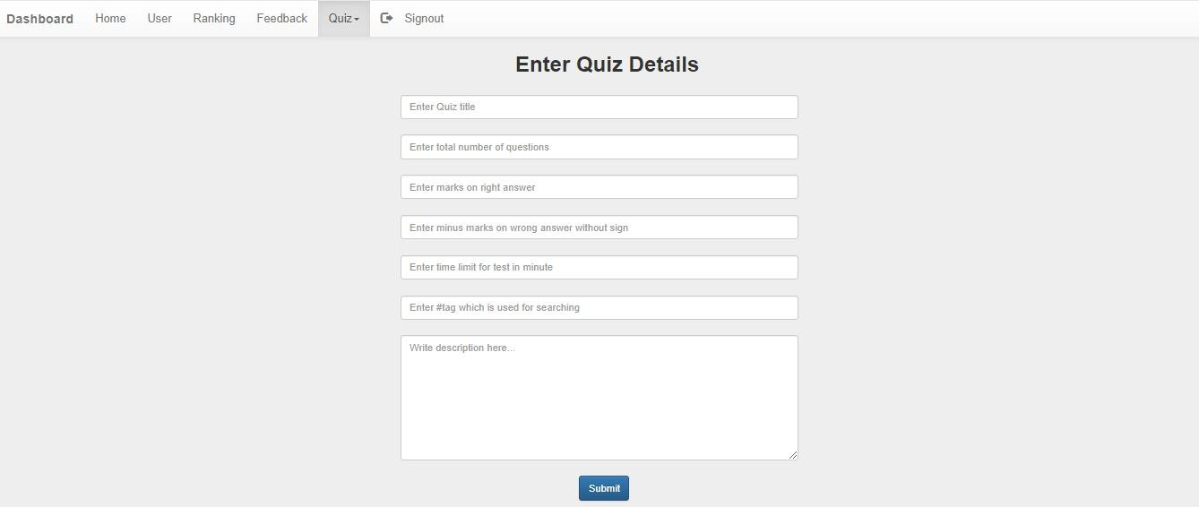

*~The Question Details Page~*

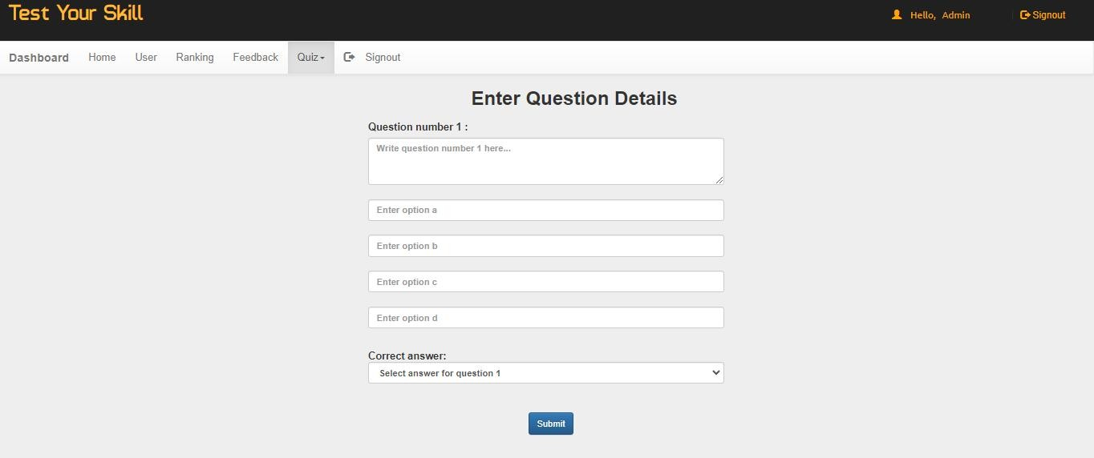

*~The Students landing Page~*

*~The Questions Page~*

*~The Results Page~*

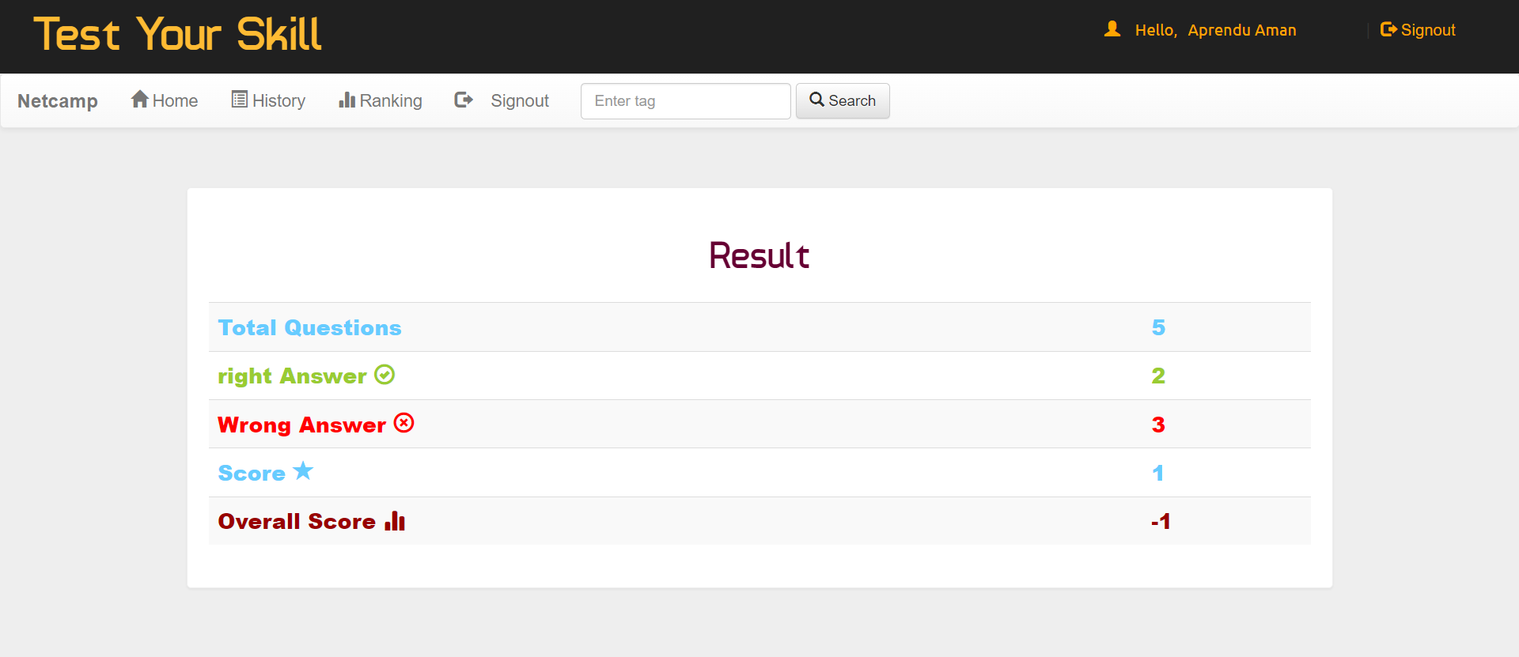

*~The Updated Ranking Page~*

and many more functionalities included which can be used accordingly.

# Code Structure

* **Dbconnection**

<?php

//all the variables defined here are accessible in all the files that include this one

$con= new mysqli('localhost','root','','project')or

die("Could not connect to mysql".mysqli_error($con));

?>

### Index.php

<!DOCTYPE html PUBLIC "-//W3C//DTD XHTML 1.0 Transitional//EN" "<http://www.w3.org/TR/xhtml1/DTD/xhtml1-transitional.dtd>">

<html xmlns="<http://www.w3.org/1999/xhtml>">

<head>

<meta http-equiv="Content-Type" content="text/html; charset=iso-8859-1" />

<meta name="viewport" content="width=device-width, initial-scale=1">

<title>TEST YOUR SKILL </title>

<link rel="stylesheet" href="css/bootstrap.min.css"/>

<link rel="stylesheet" href="css/bootstrap-theme.min.css"/>

<link rel="stylesheet" href="css/main.css">

<link rel="stylesheet" href="css/font.css">

<script src="js/jquery.js" type="text/javascript"></script>

<script src="js/bootstrap.min.js" type="text/javascript"></script>

<link href='[http://fonts.googleapis.com/css?family=Roboto:400,700,300'](http://fonts.googleapis.com/css?family=Roboto%3A400%2C700%2C300%27) rel='stylesheet' type='text/css'>

<?php if(@$_GET['w'])

{echo'<script>alert("'.@$_GET['w'].'");</script>';}

?>

<script>

function validateForm() {var y = document.forms["form"]["name"].value; var letters = /^[A-Za-z]+$/;if (y == null || y == "") {alert("Name must be filled out.");return false;}var z =document.forms["form"]["college"].value;if (z == null || z == "") {alert("college must be filled out.");return false;}var x = document.forms["form"]["email"].value;var atpos = x.indexOf("@");

var dotpos = x.lastIndexOf(".");if (atpos<1 || dotpos<atpos+2 || dotpos+2>=x.length) {alert("Not a valid e-mail address.");return false;}var a

= document.forms["form"]["password"].value;if(a == null || a == ""){alert("Password must be filled out");return false;}if(a.length<5 || a.length>25){alert("Passwords must be 5 to 25 characters long.");return false;} var b = document.forms["form"]["cpassword"].value;if (a!=b){alert("Passwords must match.");return false;}}

</script>

</head>

<body>

<div class="header">

<div class="row">

<div class="col-lg-6">

<span class="logo">Test Your Skill</span></div>

<div class="col-md-2 col-md-offset-4">

<a href="#" class="pull-right btn sub1" data-toggle="modal" data- target="#myModal"><span class="glyphicon glyphicon-log-in" aria- hidden="true"></span>&nbsp;<span class="title1"><b>Signin</b></span></a></div>

<!--sign in modal start-->

<div class="modal fade" id="myModal">

<div class="modal-dialog">

<div class="modal-content title1">

<div class="modal-header">

<button type="button" class="close" data-dismiss="modal" aria- label="Close"><span aria-hidden="true">&times;</span></button>

<h4 class="modal-title title1"><span style="color:orange">Log In</span></h4>

</div>

<div class="modal-body">

<form class="form-horizontal" action="login.php?q=index.php" method="POST">

<fieldset>

<!-- Text input-->

<div class="form-group">

<label class="col-md-3 control-label" for="email"></label>

<div class="col-md-6">

<input id="email" name="email" placeholder="Enter your email-id" class="form-control input-md" type="email">

</div>

</div>

<!-- Password input-->

<div class="form-group">

<label class="col-md-3 control-label" for="password"></label>

<div class="col-md-6">

<input id="password" name="password" placeholder="Enter your Password" class="form-control input-md" type="password">

</div>

</div>

</div>

<div class="modal-footer">

<button type="button" class="btn btn-default" data- dismiss="modal">Close</button>

<button type="submit" class="btn btn-primary">Log in</button>

</fieldset>

</form>

</div>

</div><!-- /.modal-content -->

</div><!-- /.modal-dialog -->

</div><!-- /.modal -->

<!--sign in modal closed-->

</div><!--header row closed-->

</div>

<div class="bg1">

<div class="row">

<div class="col-md-7"></div>

<div class="col-md-4 panel">

<!-- sign in form begins -->

<form class="form-horizontal" name="form" action="sign.php?q=account.php" onSubmit="return validateForm()" method="POST">

<fieldset>

<!-- Text input-->

<div class="form-group">

<label class="col-md-12 control-label" for="name"></label>

<div class="col-md-12">

<input id="name" name="name" placeholder="Enter your name" class="form- control input-md" type="text">

</div>

</div>

<!-- Text input-->

<div class="form-group">

<label class="col-md-12 control-label" for="gender"></label>

<div class="col-md-12">

<select id="gender" name="gender" placeholder="Enter your gender" class="form-control input-md" >

<option value="Male">Select Gender</option>

<option value="M">Male</option>

<option value="F">Female</option> </select>

</div>

</div>

<!-- Text input-->

<div class="form-group">

<label class="col-md-12 control-label" for="name"></label>

<div class="col-md-12">

<input id="college" name="college" placeholder="Enter your college name" class="form-control input-md" type="text">

</div>

</div>

<!-- Text input-->

<div class="form-group">

<label class="col-md-12 control-label title1" for="email"></label>

<div class="col-md-12">

<input id="email" name="email" placeholder="Enter your email-id" class="form-control input-md" type="email">

</div>

</div>

<!-- Text input-->

<div class="form-group">

<label class="col-md-12 control-label" for="mob"></label>

<div class="col-md-12">

<input id="mob" name="mob" placeholder="Enter your mobile number" class="form-control input-md" type="number">

</div>

</div>

<!-- Text input-->

<div class="form-group">

<label class="col-md-12 control-label" for="password"></label>

<div class="col-md-12">

<input id="password" name="password" placeholder="Enter your password" class="form-control input-md" type="password">

</div>

</div>

<div class="form-group">

<label class="col-md-12control-label" for="cpassword"></label>

<div class="col-md-12">

<input id="cpassword" name="cpassword" placeholder="Conform Password" class="form-control input-md" type="password">

</div>

</div>

<?php if(@$_GET['q7'])

{ echo'<p style="color:red;font-size:15px;">'.@$_GET['q7'];}?>

<!-- Button -->

<div class="form-group">

<label class="col-md-12 control-label" for=""></label>

<div class="col-md-12">

<input type="submit" class="sub" value="sign up" class="btn btn- primary"/>

</div>

</div>

</fieldset>

</form>

</div><!--col-md-6 end-->

</div></div>

</div><!--container end-->

<!--Footer start-->

<div class="row footer">

<div class="col-md-3 box">

<a href="<http://www.github.com/himansu46>" target="_blank">About us</a>

</div>

<div class="col-md-3 box">

<a href="#" data-toggle="modal" data-target="#login">Admin Login</a></div>

<div class="col-md-3 box">

<a href="#" data-toggle="modal" data-target="#developers">Developers</a>

</div>

<div class="col-md-3 box">

<a href="feedback.php" target="_blank">Feedback</a></div></div>

<!-- Modal For Developers-->

<div class="modal fade title1" id="developers">

<div class="modal-dialog">

<div class="modal-content">

<div class="modal-header">

<button type="button" class="close" data-dismiss="modal"><span aria- hidden="true">&times;</span><span class="sr-only">Close</span></button>

<h4 class="modal-title" style="font-family:'typo' "><span style="color:orange">Developers</span></h4>

</div>

<div class="modal-body">

<p>

<div class="row">

<div class="col-md-4">

<img src="image/DP.png" width=100 height=100 alt="Sunny Prakash Tiwari" class="img-rounded">

</div>

<div class="col-md-5">

<a href="https://facebook.com" style="color:#202020; font-family:'typo' ; font-size:18px" title="Find on Facebook">Himansu Sharma</a>

<h4 style="color:#202020; font-family:'typo' ;font-size:16px" class="title1">+91 9165063741</h4>

<h4 style="font-family:'typo' ">[himansusharma564@gmail.com](mailto:himansusharma564@gmail.com)</h4>

<h4 style="font-family:'typo' ">Lovely Professional University,Punjab</h4></div></div>

</p>

</div>

</div><!-- /.modal-content -->

</div><!-- /.modal-dialog -->

</div><!-- /.modal -->

<!--Modal for admin login-->

<div class="modal fade" id="login">

<div class="modal-dialog">

<div class="modal-content">

<div class="modal-header">

<button type="button" class="close" data-dismiss="modal"><span aria- hidden="true">&times;</span><span class="sr-only">Close</span></button>

<h4 class="modal-title"><span style="color:orange;font-family:'typo' ">LOGIN</span></h4>

</div>

<div class="modal-body title1">

<div class="row">

<div class="col-md-3"></div>

<div class="col-md-6">

<form role="form" method="post" action="admin.php?q=index.php">

<div class="form-group">

<input type="text" name="uname" maxlength="20" placeholder="Admin user id" class="form-control"/>

</div>

<div class="form-group">

<input type="password" name="password" maxlength="15" placeholder="Password" class="form-control"/>

</div>

<div class="form-group" align="center">

<input type="submit" name="login" value="Login" class="btn btn-primary" />

</div>

</form>

</div><div class="col-md-3"></div></div>

</div>

<!--<div class="modal-footer">

<button type="button" class="btn btn-default" data- dismiss="modal">Close</button>

</div>-->

</div><!-- /.modal-content -->

</div><!-- /.modal-dialog -->

</div><!-- /.modal -->

<!--footer end-->

</body>

</html>

* **Assets**
* A screenshot of a computer

  Description automatically generated

# Outcome and Future Prospects

### The PHP Examination Management System has already demonstrated significant outcomes and holds promising future prospects. The immediate outcomes include the simplification and optimization of the examination process for educational institutions. Teachers benefit from streamlined test creation and administration, while students enjoy a user-friendly platform for taking tests, viewing results, and tracking their academic progress.

In terms of future prospects, this system offers extensive room for growth and enhancement. Additional features can be integrated to further improve its functionality, including advanced analytics and reporting for educators, which can aid in identifying areas for curriculum improvement. Integration with other educational systems is a promising avenue for creating a more comprehensive educational ecosystem.

### Moreover, the system's potential for scalability is notable. As it gains traction and user feedback, it can expand to serve a broader range of educational institutions, including universities, online courses, and professional certifications.

In conclusion, the PHP Examination Management System has already proven its worth by simplifying and optimizing the examination process. Looking ahead, the project's prospects include advanced features, integration with other systems, and the potential to serve a broader educational audience. This system is poised to make a significant impact on the educational landscape, benefiting both educators and students alike.

# GitHub Link

https://github.com/AprenduAman/test-your-skill

# Bibliography

* Php Documentation : <https://www.php.net/docs.php>

19