ASSIGNMENT-3

Step-1 --- create view and add jobs under this view.

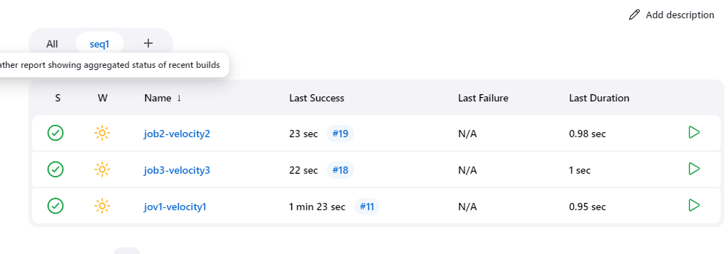

Step-2 -- enable build periodically in build triggers

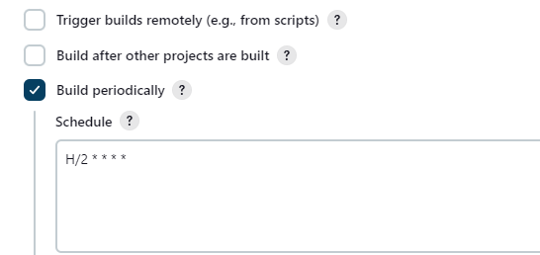

Step-3 – in build projects add second job under 1st job

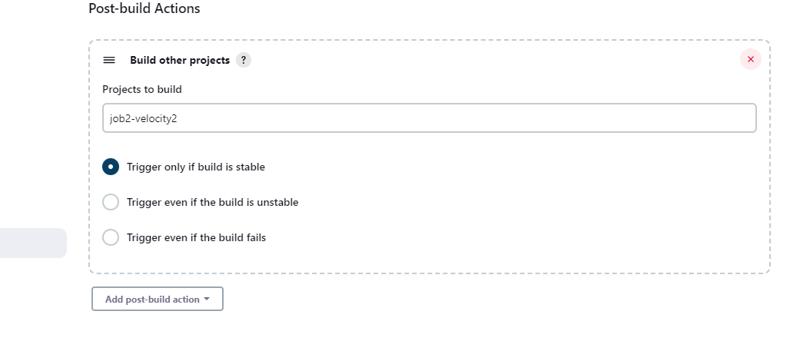

Step-4 – build now

Step -4 –due to enable build periodically it will run job after 2 minutes.

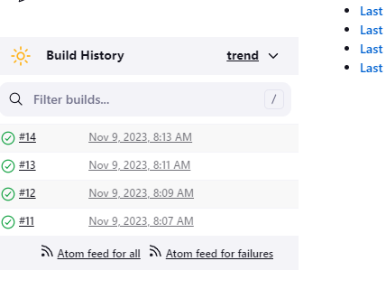

Step-5 hit ip on browser output becomes..

