2/8/2024

Madden, John

Social Security Administration

**IppTest**

A utility to test IPP compliance on office printers

Backround: SSA is moving towards adoption of the iPP protocol. In conjunction with Morpia technology, this trend promises a more secure, less complex, and more robust print architecture for the agency. Towards this end, site admins need to ensure the printers in each office are configured to process IPP requests from clients. While most modern (last 10 years) printers will offer IPP processing, there are some printers that do not. The IPPTest utility provides office admins an easy way to check all the printers in the office for compliance, and provides reasons for non-compliance as well.

If you are unsure of IPP technology or need to update your ability to service the printers, please see the Print technology website: [Pages - Home (sharepoint.com)](https://socialsecuritygov.sharepoint.com/sites/Collaboration-2d36c/Pages/default.aspx) for more information.

Finally, this utility was provided for admins to easily identify which printers are ready for IPP/Mopria service and which printers need intervention to conform. Use it to identify conforming printers and to provision non-conforming printers (if possible). This utility is provided on an as-is basis; however if there are issues with it or further additions should be contemplated, please reach me at [john.madden@ssa.gov](mailto:john.madden@ssa.gov) – Enjoy!

**How to use this product**

IPPTest was developed for users to quickly identify IPP/Mopria ready printers on the network. In the event a printer does not comply, the reason for the non-conformance is provided; in the event the printer does comply you may validate the result by sending a test print as proof. You can test a single printer entered in the textbox or you may test multiple printers simultaneously by using a list of printers that you can dynamically create in the utility if desired. The product allows users to create a .csv file and import that into Excel to review the results of the test. The utility provides properties of the printer that may be significant in planning: firmware level, Mopria compliance levels, IPP versions supported, etc.

**Testing options**

IPPTest work in 2 manners: multiple printers tested from a file and/or single use testing. This document shall cover multiple printers testing first.

**How to test multiple office printers for IPP compliance**

Prior to conversion to IPP/Mopria, SSA offices will need to ensure all the printers in the office will process IPP requests. This can be accomplished if you have a list of printers in your office. You will need to make a file and place the office printer names, one per line, into a text file. The actual name of the file is irrelevant, but the file should reside on your computer or on a network drive. For instance, you might have 3 printers: printerA, printer, and printer C in your office. In this case, place these in a file in a manner shown below:

printerA

printerB

printer C

and save that as myPrinters.txt in your Documents folder. The utility keeps user information in the

HKEY_CURRENT_USER\Software\IppTest hive – this is where you will find your settings as well. Since there is no printer file associated with the utility when it is first installed, you will see the following error when first starting up the application:

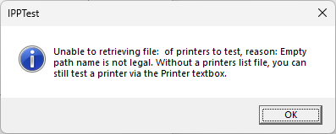

You could now start testing by entering a printer to query in the **Printer to test** textbox as shown below,

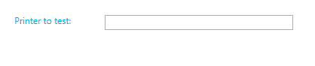

But for now let’s create a text file of printers you want tested. To have the utility record this file, click the Setup icon in the upper right.

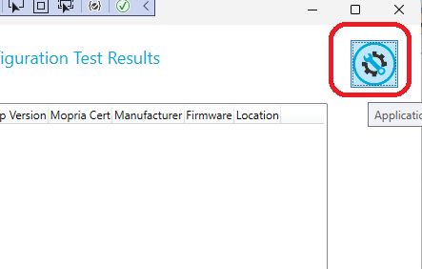

If you have not created a file of printer names (one per line), do so now. Put it in a convenient location you can access (the utility by default opens to your Documents folder).

On the **Setup** page, click the down arrow button to open a file dialog operation and locate your file of

printers to test.



Locate your file of printers you created and click **Open**.

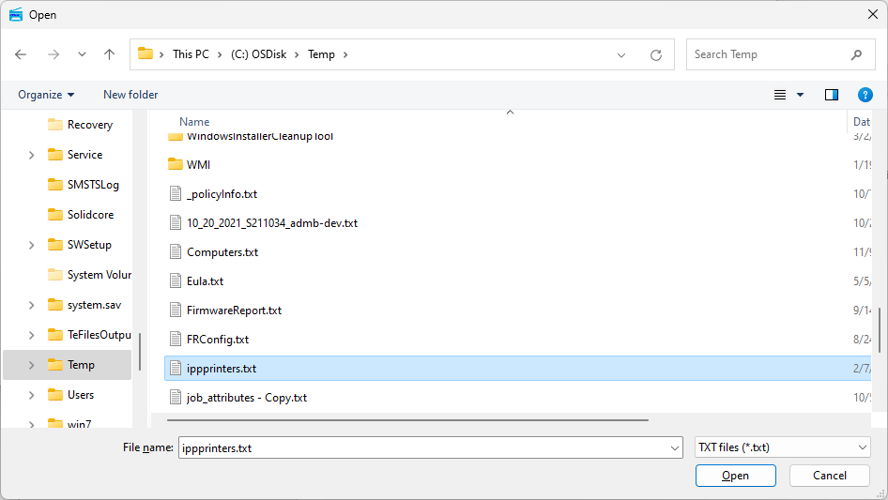

You should see your file on the **Printer File Path** textbox. Click **Save** to save this information and click **Close** to close the dialog. You are now ready to start testing. Note: you can create a empty file of printers that you can modify within the utility as well.

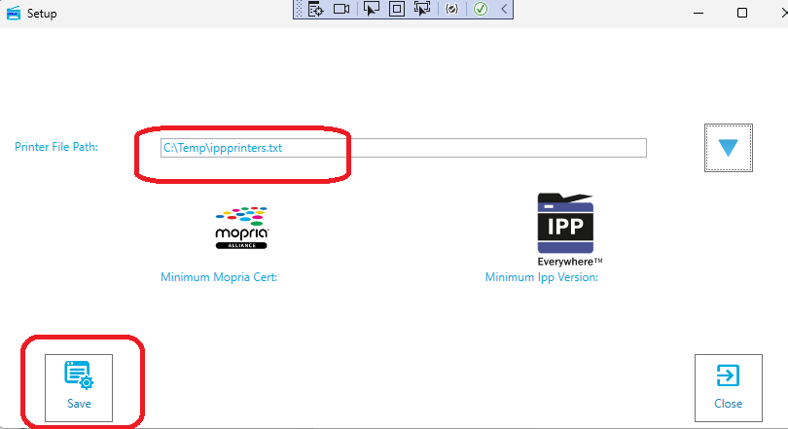

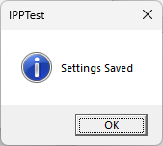

You should receive a Success dialog on the save action. You are now ready to test against all the printers in your list.

**Modifying File Contents**

In the event the file you specified as a printer list was just created (empty), you can add or remove printers within the utility if you desire. To do this, you will need to click the file list button which should appear next to the **Settings** button.

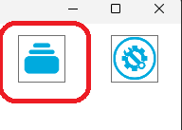

Click the button to open the dialog. If there were any printers in the list, they will be visible in the listbox, if not the listbox will be empty:

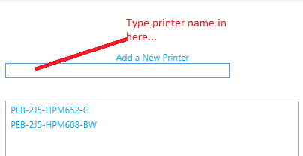

To add a printer to the list, start typing the name in the Add a New Printer textbox. When the printer name exceeds 5 characters, the **Add** (+) button will appear to the left of the textbox.

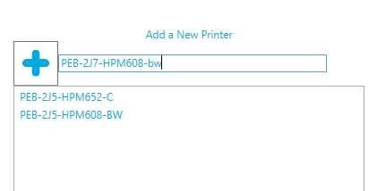

If the name is typed correctly and you want to add it to the list, click the **Add** (+) button. In the event you want to remove a printer from the list, you need to right click the printer to remove and click the **Remove Printer** context menu choice.

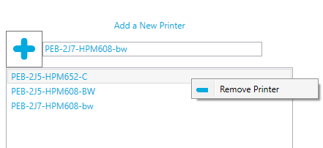

Important: In the event you have modified the list, the **Write** button will become visible. You must click this button to save any printer modifications ***to the printer file***.



If you do not use the **Write** button to save changes, the printers added to the list will be volatile; that is they will be usable for the utility session only and will not persist the next time the utility is started. You can now close the dialog and proceed to testing.

**Testing**

If you have successfully completed the prior steps, you should see the number of printers to test string below the test results listview:



The numbers will vary depending on the list size, but this indicates that the printer list is loaded and ready to test. You can now click the Test button and the utility will query the printers.

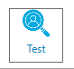

When completed, the query should result in an output in the listview similar to that shown:

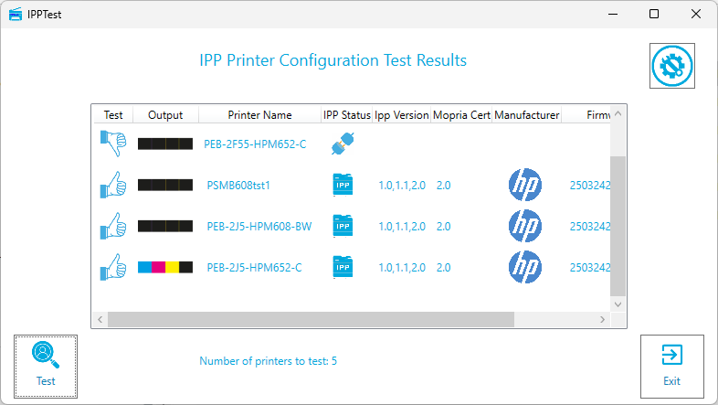

There are several columns to pay attention to, as they reveal the result of the test. Starting from the left, the first (and possibly most important) column indicator is the **Test** column.

If the printer can process the IPP protocol, then you will see a success icon like that tone shown below:



Conversely, if the printer cannot process IPP requests, you will see a failure icon similar to that shown below:



The reason for the failure will be indicated in the **IPP Status** column. There are several indicators to be aware of.

The first indicator reveals a printer that passed the test and can successfully process IPP requests.



If your printer could be reached by the utility, but cannot process IPP requests, you should see the following – notice there is no “IPP” on the icon.



The reasons for this condition is most likely that the printer does not have the IPP service activated. To fix this, obtain the documentation for activating IPP on your printer form the Print Technology website and turn the protocol on. Notice: You must have admin rights on the printer to complete this step.

Finally, the issue may be that the utility could not connect to your printer. In this case, you will see an icon similar to that shown below:



The reasons for this are varied but most likely network related. The DNS resolution may be incorrect, the printer may be off the network, or the printer may be in an error state and unable to process connection requests.

The **Output** column indicates whether the printer is color capable or not.

 Not color capable

 Color capable

The **IPP Version** and **Mopria Certification** columns reveal the IPP versions supported on the printer and the Mopria certification level obtained on the printer. These levels are checked against the utility set values for compliance (the utility sets the values in the registry). The Printer Working Group (PWG) and Mopria group continually release upgrades, and each upgrade may support new printer capabilities.

The **Firmware** column indicates the latest firmware running on the printer.

The **Location** column (if configured on the printer) indicates the location of the printer.

**Single use testing**

You can also test a single printer for IPP compliance by adding the name of the printer in the textbox above the common listview. When an entry is detected in this textbox, the utility will go into single mode and disregard the list of printers in favor of single printer testing. In all other aspects, the process is identical to multiple printer testing – i.e. you must click **Test** to start the process. Clear this listbox if you want to go back to multiple printer testing by list.

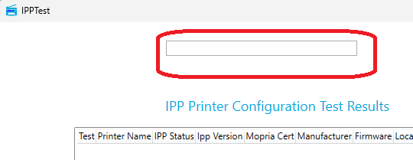

**Sending a Test page to an IPP Printer**

To send a pre-formed test pdf page to a printer, right click on a printer in the ListView and click **Send Test Print** from the context menu. You can only send a test page to a printer that passes the IPP test.

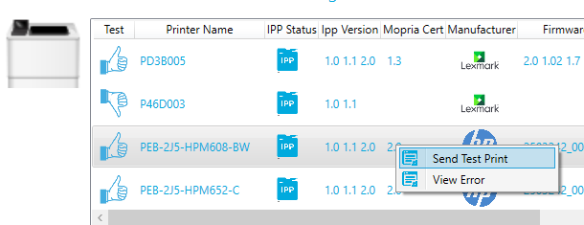

**Viewing Test Failures**

Invariably, some of the printers tested will not comply with requirements and will fail. To discern the reason for the failure, you can first look to the IPP Status columns which gives a general indication of what went wrong. For those printers that recorded a connection error, you can further investigate what the issue was.

Connection error icon:



To look at a failure issue reason, right click the failed printer in the listview. From the context menu, click the **View Error** meu choice.

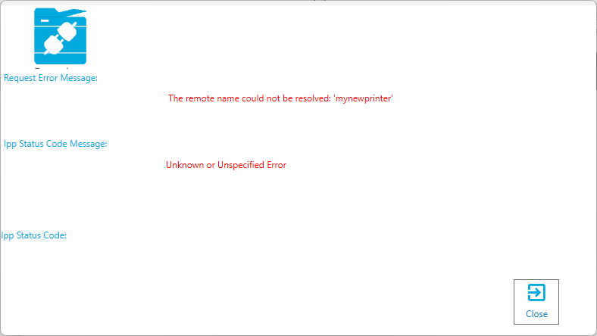

In this case, the printer named mynewprinter did not have address resolution success, i.e. it is not in DNS (as you would assume). In the case of the printer which is online but does not have the IPP service

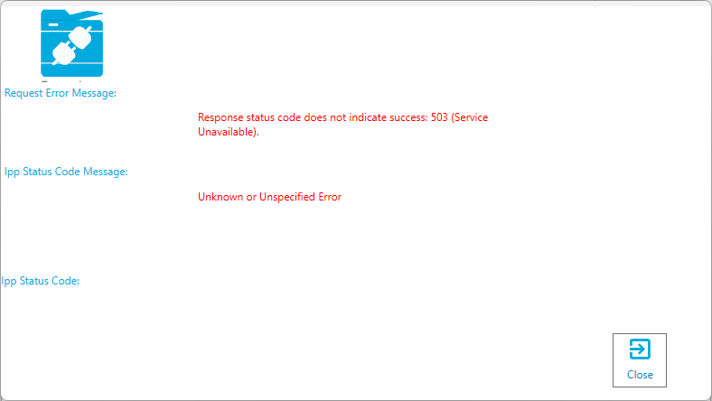

configured, you will see an error indicating the service (IPP) is unavailable - similar to that shown above. This is logical, the printer accepts the connection attempt, but the IPP service is not configured so cannot respond to the IPP attributes query request. This means you will likely have to access the printer embedded web server and provision the IPP service.

In the even the printer is accepting connection requests but is not provisioned for IPP, you can connect to the printer embedded web service by right clicking the printer in question and choosing Connect from the context menu choices.

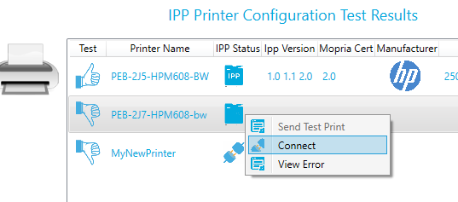

This will open a web connection through the embedded web server so you can provision the IPP service. Note; you will require admin rights on the printer to do so.

Finally, you should note that successfully configured IPP printers will provide a 2D image of themselves to the left of the listview box. Any failures or non-conforming printers can only provide a generic 2D printer image.

**Recording Test Results**

The utility provides an option to write the test results to a CSV file that can then be imported into Excel for further analysis. To do this you will need to provide a csv file name and path and then enable the output file option. To do this, click the Setup button on the top right-hand side.



Enable the **Create CSV Results File** checkbox and a textbox for the csv file will appear.

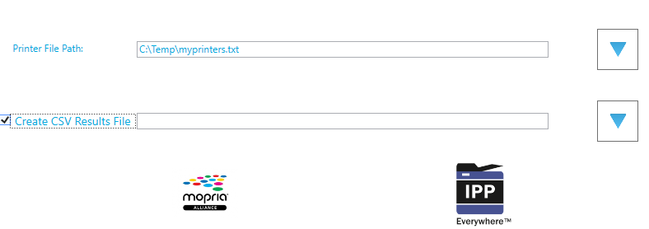

You can directly enter a filename and path or you can click the **Down Arrow** button and create the filename. Either way, the *filename must have a .csv extension*. Click **Save** and then click **Close** to complete the process.

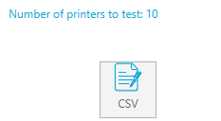

You might initially see a disabled **CSV** button now. When you have completed a test, the button will then be enabled. Click **Test** to run a test and when completed, you can now write the results to a CSV file.

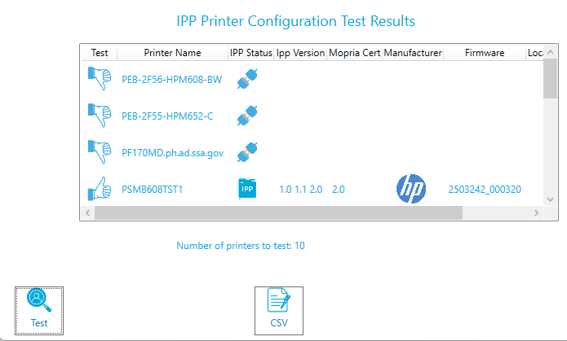

You can now click the CSV button, and if the write operation is successful, you should see the following:

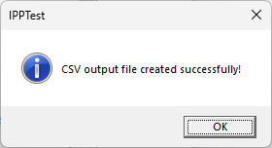

You can then right click the resulting file in Explorer and use the **Open With Excel** menu option to load the results into an Excel spreadsheet.