Neoclassicism: The Idea in Material Form

This project explores the intersection of physical substance and computational logic, drawing inspiration from the principles of Neoclassicism to translate them into the language of new media.

The Concept: From Matter to Algorithm
Neoclassicism, emerging around 1776, marked a return to classical ideals of perfection, proportion, and harmony. In this movement, the artist's task was not merely to imitate nature, but to distill it into pure, essential structures—forms that embodied reason, balance, and permanence.
In the "Digital Frontier," this process of distillation occurs through code:
- The Idea as Form: Just as the Neoclassical vision established that the concept preceded the object, modern digital art begins with the algorithmic idea before its execution.
- The Gesture and the Process: While Canova’s process was grounded in physical gesture and craft, the "gesture" in this work is the logical instruction that shapes data and pixels.

Case Study: Antonio Canova
Antonio Canova (1757-1822) is the central symbolic figure of this bridge between vision and material. His work represents the transition from a raw idea to a perfected physical form.
- Psyche Revived by Cupid's Kiss: This masterpiece translates the artist's vision of idealized beauty into marble. The interplay was direct: the artist's idea guided the choice and shaping of material.
- From Sketch to Sculpture: The transition from the terracotta sketch (Material) to the finished marble (Form) reflects the modern workflow between digital prototyping and final installation.
- Institutional Influence: Canova's alignment with academic principles made his art an enduring point of reference for generations of artists, bridging the gap between historical tradition and future innovation.

Visual Documentation
The images included in this repository document this dialogue between the initial concept and the final material output:
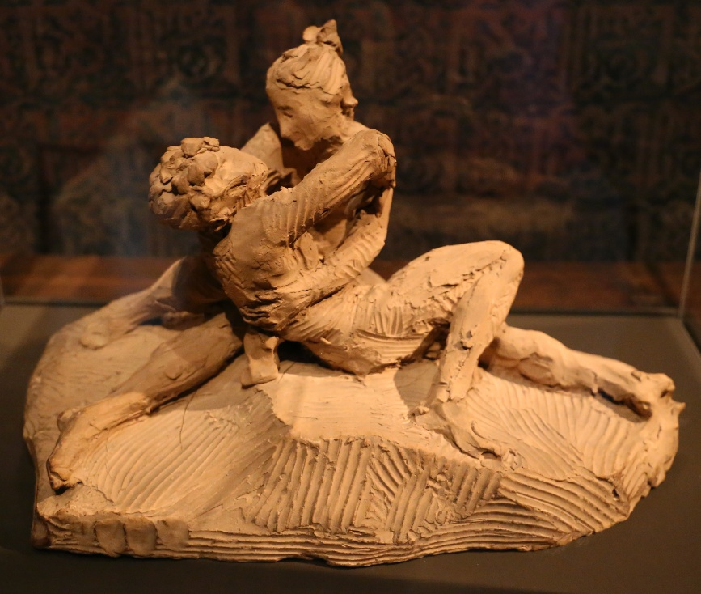
- Figure 1: Terracotta sketch of Cupid and Psyche by Antonio Canova (Museo Correr) – Representing the raw idea in material form.
Figure 1. Terracotta sketch of Cupid and Psyche by Antonio Canova (Museo Correr).
Photo by Didier Descouens - Own work, Public Domain, https://commons.wikimedia.org/w/index.php?curid=143616924
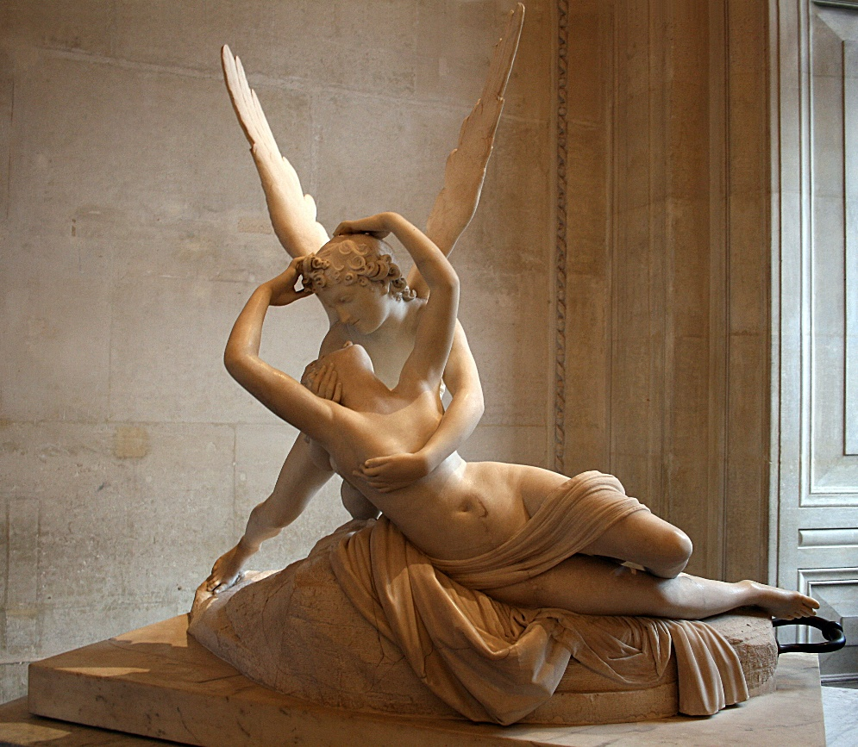
- Figure 2: Psyche Revived by Cupid's Kiss (Louvre Museum) – Representing the perfected vision and technical mastery.
Figure 2. Antonio Canova, Psyche Revived by Cupid’s Kiss, 1787–1793. Marble, 155 × 168 cm, Louvre Museum, Paris
Photo: Wikimedia Commons – © Jean-Pol GRANDMONT, Public Domain (placed in the public domain by the rights holder).

Licensing and Credits
- Code and Technical Content: Released under the [Your Choice, e.g., MIT] License.
- Historical References: Textual data based on research regarding the Brera Academy and Neoclassical reforms.
- Photographic Documentation: Images of Canova's works are in the Public Domain (Credits: Didier Descouens and Jean-Pol GRANDMONT via Wikimedia Commons).

