Chapter 1 – Ideas, Materials, Technologies and Aesthetics

1.1.2 The Plaster Archive: From Scarpa’s Light to Bistolfi’s Matter
While previous the previous in-depth analysis examined the transition from conceptual idea to final stone execution, this section treats the Gipsoteca (plaster cast gallery) not as a simple storage of copies, but as a living archive of the creative process.
This perspective is deeply embedded in Lombard and Venetian sculptural traditions.
The Scarpian Lesson: Staging the Gesture
The extension of the Gipsoteca Canoviana in Possagno by Carlo Scarpa (1955–1957) marks a pivotal shift in viewing sculptural prototypes.
- The Architecture of Light — Scarpa’s luminous white spaces elevate plaster casts from mere technical intermediaries to central protagonists.
- Digital Parallel — In contemporary 3D workflows, this mirrors the "Clay Render" or "Work-in-Progress" stage: stripped of complex textures, the focus remains on silhouette, volume, and light interaction.
To experience Scarpa’s masterful integration of architecture, light, and Canova’s plaster casts firsthand, here are two insightful videos:
CANOVA GYPSOTHECA MUSEO CANOVIANO ( POSSAGNO TV )
https://www.youtube.com/watch?v=gYW-A5GsVYc
This video offers a visual exploration of the Gipsoteca Canoviana, focusing on Carlo Scarpa’s extension. It highlights the interplay of diffused natural light with the white plaster forms, the clean minimalist spaces, and how the architecture transforms technical casts into contemplative artworks—perfect for appreciating the "staging" of gesture in a serene, luminous environment.
https://www.youtube.com/watch?v=e-9Zg0Hgs2g
Titled "Carlo Scarpa - Museum Gipsoteca Antonio Canova, Possagno (Treviso), Italy. 1955-1957" (uploaded by 99archi), this architectural showcase presents detailed views of Scarpa’s addition to the museum. It emphasizes the spatial design, material contrasts, and the way light animates Canova’s plaster models, revealing the evolution of form through subtle shadows and reflections—making it an excellent companion for understanding the shift from preparatory models to protagonists in their own right.

The plaster casts preserve the immediacy of Canova’s gesture, displayed in a contemplative environment where every fragment reveals the evolution of form.
Figure 1: Gipsoteca Canoviana, Possagno. Extension by Carlo Scarpa, 1957.
(Interior views showing plaster casts bathed in dramatic, diffused light.)

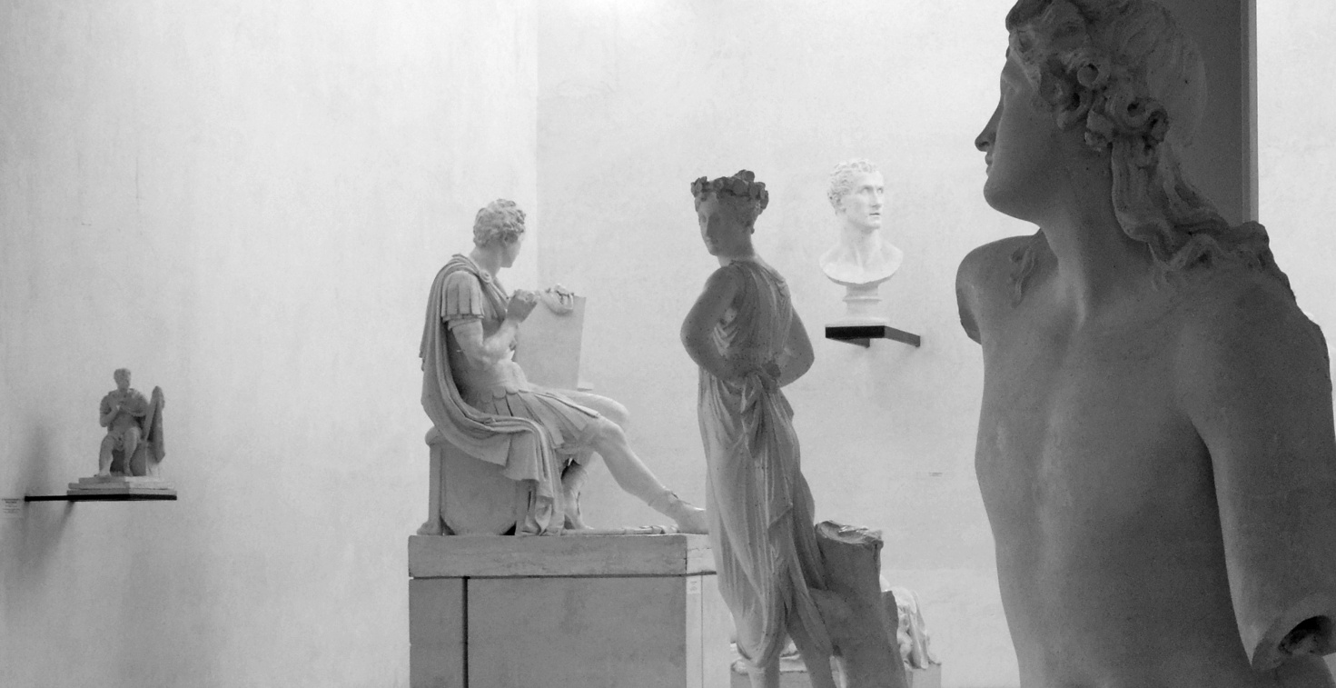
Figure 1: Gipsoteca Canoviana, Possagno. Extension by Carlo Scarpa, 1957.
The plaster casts preserve the immediacy of Canova’s gesture, displayed in a contemplative environment where every fragment reveals the evolution of form.

Recommended public domain / openly licensed source:
- https://commons.wikimedia.org/wiki/File:Possagno,_Gipsoteca_Canoviana.jpg (view from exterior/south, showing Scarpa's addition)
- For interior light and casts: Search Wikimedia or museum site for "Scarpa Gipsoteca Possagno interior" (e.g., high-res photos from Divisare or official Museo Canova archives often licensed for reuse).
(Alternative: https://divisare.com/projects/511609-carlo-scarpa-aldo-amoretti-gypsotheca-canoviana-extension – features excellent interior shots with light effects.)

The Lombard Expressionism: Leonardo Bistolfi
In contrast to Neoclassical clarity, the Gipsoteca Leonardo Bistolfi in Casale Monferrato introduces a different material intelligence. Here, plaster is not a preparatory step toward marble but a direct medium of emotional urgency.
- Tactile Surfaces — Bistolfi’s Gli Amanti (The Lovers) displays a vibrant, almost liquefied surface, anticipating the expressive deformations of Medardo Rosso.
- The Fragmented Archive — Isolated torsos, hands, and fragments evoke a modular approach, akin to the Asset Browser in modern 3D software—repertoires of anatomical elements for future recomposition.
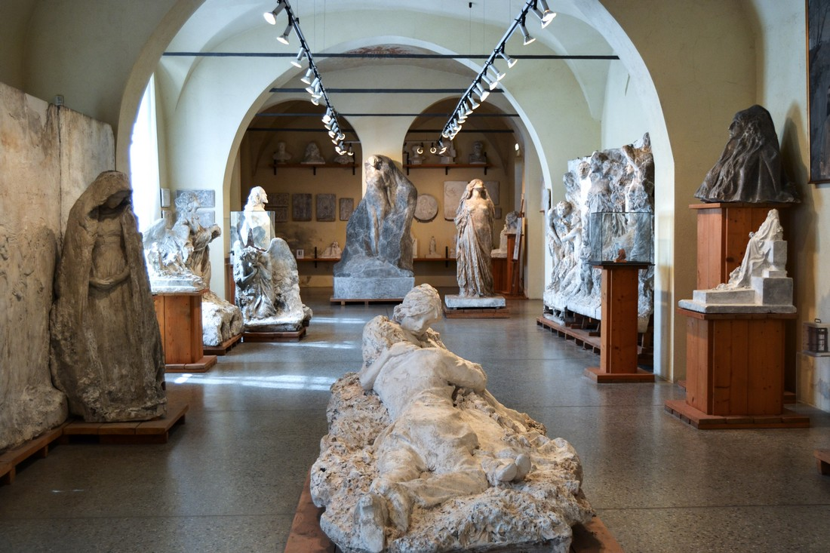
Figure 2: Gipsoteca Bistolfi, Casale Monferrato.
The hall illustrates the passage from intimate, unfinished pieces to monumental structures, highlighting a processual intelligence centered on plaster’s malleability.

https://www.youtube.com/watch?v=JqPA7W-BddM
Recommended public domain source: Search Wikimedia Commons for interior views of the Gipsoteca Bistolfi (limited high-res interiors publicly available; use museum or Flickr creative commons photos of halls with plaster displays).Figure 3: Leonardo Bistolfi, Gli Amanti (Detail).
A prime example of the Lombard tradition’s shift toward subjective vision and tactile, expressive materiality.
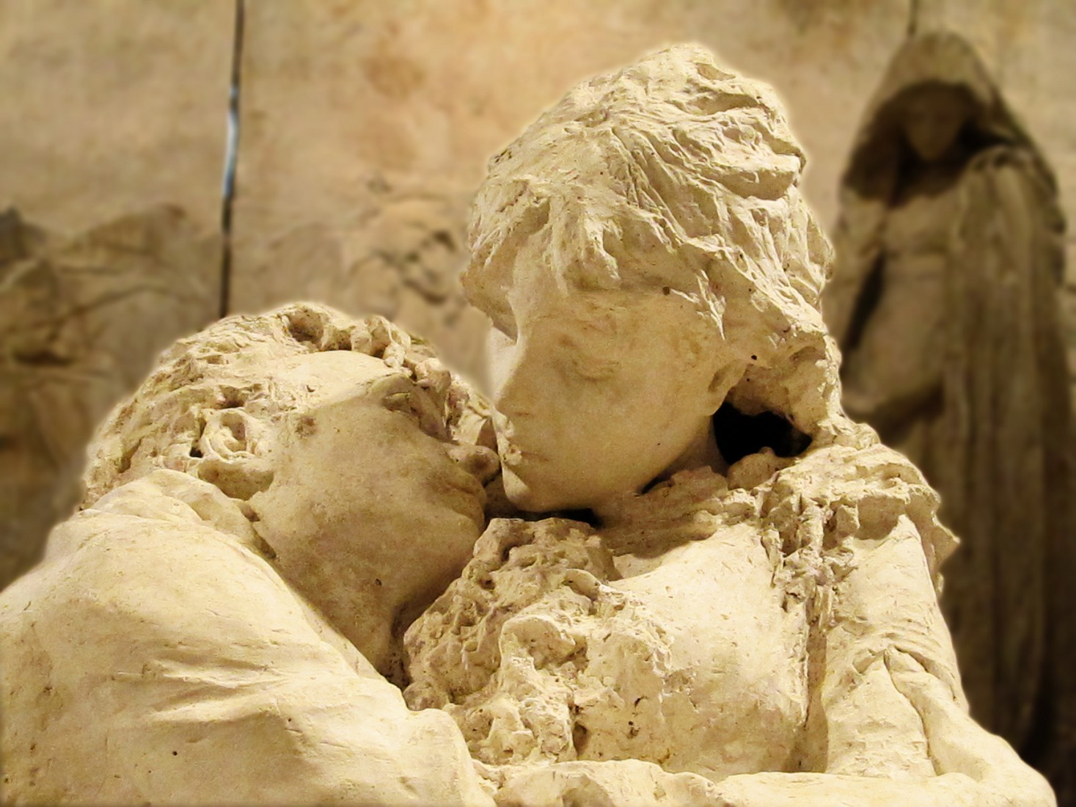
Recommended public domain source:
- https://commons.wikimedia.org/wiki/File:Leonardo_Bistolfi_Gli_Amanti_Gipsoteca_Casale_Monferrato.jpg (detail of the plaster work at the Gipsoteca entrance)
- Alternative: https://commons.wikimedia.org/wiki/File:Leonardo_Bistolfi_-_Gli_amanti.jpg (related monument view, adaptable for detail focus).
Technical Reflection: Gypsum as a Proto-Digital Material
As Vitruvius noted in De Architectura, the Latin root of gypsum suggests immediacy and malleability. In our contemporary context:
- Plaster as Data — The plaster cast serves as the historical counterpart to a 3D scan, capturing a precise snapshot in the sculpture’s lifecycle.
- Brera’s Legacy — The Gipsoteca at the Accademia di Brera perpetuates this tradition, treating fragments not as ruins but as perpetually available resources for reinterpretation.
Insert the three figures into Word below their captions. Use "Insert > Pictures" and apply square text wrapping if needed for layout flow. For high-resolution downloads, visit the linked Wikimedia pages (all public domain or CC0/CC-BY compatible for educational use).Licensing and Credits
- Original text and analysis: © Gianpiero Moioli (2026). Permitted for educational/non-commercial use with attribution.
- Photographic documentation: Primarily Public Domain via Wikimedia Commons (credits to contributors as noted on file pages, e.g., various photographers for Bistolfi and Scarpa-related images).
- Historical references: Drawn from studies on Scarpa’s architecture, Bistolfi’s symbolism, and the plaster traditions at Brera, Possagno, and Casale Monferrato.
Companion GitHub Repository (optional extension)
For digital parallels: Include 3D scans or procedural recreations of plaster-like forms (e.g., low-poly "clay" renders in Blender, noise-displaced meshes mimicking Bistolfi’s tactile surfaces).This section bridges historical materiality with modern digital prototyping, emphasizing how archives of fragments enable endless reinterpretation—much like latent spaces in AI or procedural asset libraries.

