Chapter 1 – Ideas, Materials, Technologies and Aesthetics
1.1.4 Brera Academy: Narrated Space, Lived Space
The post-war decades at the Accademia di Belle Arti di Brera (1950s–1970s) represent a crucial turning point where the weight of tradition met the urgency of new spatial languages. Central to this evolution was Lucio Fontana, himself a former student of the Academy under Adolfo Wildt, whose "immaterial revolution" opened the canvas to the third dimension.
In this fertile environment, the Sculpture Department saw the emergence of a new generation that reinterpreted the legacy of their masters—most notably Marino Marini—to expand sculpture toward narrative and environmental dimensions.
The Legacy of Marino Marini
Marino Marini conveyed to his students the idea of sculpture as a profound tension between the archaic and the modern.
For Marini, the act of sculpting was a dramatic excavation into matter, but equally a dynamic interrogation of statics and structural tension: the precarious balance between rooted stability and impending collapse, between harmonious form and disruptive rupture.
This lesson branched into two complementary directions among his Brera students: Giancarlo Marchese’s poetics of silence and mental thresholds, and Alik Cavaliere’s narrative scenography of memory and metamorphosis.
Artisti del '900 - Marino Marini intervista
In this rare 1970s television interview from the historic RAI series “Artisti del '900,” Marino Marini speaks with disarming simplicity and depth about his work, his relationship with matter, the tension between the archaic and the modern, and the existential drama that runs through his sculptures—especially the Horses and Riders. A precious and direct document that captures the voice, thought, and humanity of the Pistoian artist at the height of his creative maturity.
https://www.youtube.com/watch?v=CLlhMPqgATs
Firenze - Museo Marino Marini
Marino Marini is widely regarded as one of the most important Italian artists of the 20th century. Florence has dedicated a beautiful museum to him, housed in the former Church of San Pancrazio.
The church, of very ancient origins, also contains Leon Battista Alberti’s Tempietto del Santo Sepolcro, the burial place of Giovanni Rucellai. It underwent major restorations in the 18th century and again in the 19th century in Neoclassical style. Suppressed during the Napoleonic reforms, it was never returned to worship and has since served various purposes until it was decided to convert it into a museum.
The Marino Marini Museum was inaugurated in 1988, eight years after the artist’s death.
The multi-level space—with mezzanines, balconies, and shifting perspectives—offers an excellent viewing experience for around 200 works, mostly sculptures but also paintings. Visitors can admire Marini’s iconic Horses and Riders, Venuses, portraits, and pieces ranging from figurative to more abstract forms, all beautifully framed by large windows overlooking Florence’s rooftops, creating a striking dialogue between the sculptures and the city.
https://www.youtube.com/watch?v=vy7ftl_BiLw
Marino Marini. Passioni visive | Marino Marini. Visual Passions - VIDEO
From January 27 to May 1, 2018, this landmark exhibition at Palazzo Reale in Milan presented the first major retrospective ever dedicated to Marino Marini (1901–1980), featuring over 70 works.
It places the Pistoian sculptor firmly within the history of sculpture, creating a rich dialogue between his powerful, expressive oeuvre and the plastic traditions he drew upon—from ancient masterpieces to the great modern sculptors of the 20th century.
https://www.youtube.com/watch?v=NqCQSrsLUEI
Giancarlo Marchese: The Mental Threshold
Marchese interpreted Marini's teaching through a poetics of silence.
Space is no longer merely physical but becomes a "mental presence", a site of introspective thresholds where form serves as an essential, meditative inner trace.
https://www.giancarlomarchese.com/giancarlomarchese.com/Sculture/Sculture.html
Digital Parallel
This approach echoes the use of emptiness and zenithal light in virtual environments, where the absence of dense geometry defines a sense of the sacred.
"Sculture di vetro: strati di sensazioni visive" (2012) - film di Bart Herreman (8 min) - VIDEO
The short film "Sculture di vetro: strati di sensazioni visive" (2012) by Bart Herreman is an intimate and hypnotic 8-minute documentary that delicately captures the essence of Giancarlo Marchese's glass sculptures.
Through luminous close-ups, layered reflections, and César Franck's music (performed by Dora Schwarzberg on violin and Martha Argerich on piano), the video turns the works into pure sensory experiences: glass becomes an evanescent medium that dialogues with light, cast iron, and the surrounding environment, revealing Marchese's poetics of silence, transparency, and the tension between presence and absence.
A perfect tribute to his research on immaterial matter, ideal for anyone who appreciates art as a layered visual meditation.
https://www.youtube.com/watch?v=GkGwDmMbcNk
Alik Cavaliere: The Theater of Memory
Cavaliere expanded Marini's synthesis toward narrative scenography. His vegetal and metaphysical structures transform space into a journey, where the viewer becomes an active participant in a philosophical narrative.
https://www.alikcavaliere.it/
Digital Parallel
These works anticipate concepts of World Building and Environmental Storytelling.
In tools like Blender 5.0, this translates to creating complex ecosystems via Geometry Nodes.
Le avventure di Gustavo B. - VIDEO
This short YouTube video from the Centro Artistico Alik Cavaliere offers a serene, intimate glimpse into the sculptural cycle Le avventure di Gustavo B., a long-term project by Italian artist Alik Cavaliere that he developed from 1960 for over 30 years.
Through slow pans and close-ups of bronze and mixed-media pieces—depicting everyday domestic scenes, surreal transformations, and narrative vignettes like "G.B. si innamora della signorina Bene" or "Piccola scena familiare in casa di Gustavo B."—it highlights Gustavo B. as Cavaliere's fictional everyman alter ego.
A character navigating themes of love, memory, absurdity, and human fragility in post-war Italy, blending metaphysical storytelling with organic, vegetal motifs.
It's a understated tribute to Cavaliere's innovative "theater of sculpture," where objects and figures create immersive, philosophical environments; the video's minimalist style (no narration, just ambient music and visuals) invites quiet reflection, making it a perfect entry point for appreciating how this cycle anticipates contemporary hybrid art.
https://www.youtube.com/watch?v=82cI0W3aRHs
Alik Cavaliere: L'universo verde - VIDEO
On the 20th anniversary of Alik Cavaliere's passing—one of the most significant Italian sculptors of the second half of the 20th century—Palazzo Reale in Milan is hosting a major retrospective from June 27 to September 9, 2018.
The exhibition offers a deep exploration of his artistic journey, with a special focus on the theme of nature.
The show extends beyond Palazzo Reale into a widespread and richly articulated itinerary across the city of Milan, involving five additional venues: the Museo del Novecento, Palazzo Litta, Gallerie d’Italia, Università Bocconi, and the Centro Artistico Alik Cavaliere.
An interview with the curator, Elena Pontiggia.
https://www.youtube.com/watch?v=0tmUuYNSV1c
NELL' ANTRO DELL' ALCHIMISTA. Arturo Schwarz racconta Alik Cavaliere - VIDEO
This poignant 17-minute interview, "Nell'antro dell'alchimista. Arturo Schwarz racconta Alik Cavaliere" (uploaded by Marco Agostinelli, originally for RAI SAT ART), is a heartfelt and poetic tribute by the renowned art historian, collector, and Dada/Surrealism expert Arturo Schwarz. In Cavaliere's final Milan studio, Schwarz describes the space as a true "alchemist's cave"—a magical, chaotic workshop filled with animals, evolving bronze casts, and works in progress via lost-wax technique—where the artist identifies deeply with nature ("natura naturans" creating itself) to achieve metamorphosis and tragic-grandiose beauty.
Schwarz evokes Cavaliere's ethical optimism amid post-war disillusionment, his revolutionary roots, and sculptures as continuous "becoming" (echoing Ovid and Tantric ideas), making this a moving, intimate portrait of one of Italy's greatest late-20th-century sculptors. Essential viewing for anyone exploring Cavaliere's legacy.
https://www.youtube.com/watch?v=dkKdpZvhuqU

Adolfo Wildt: The Master of Marble and Bridge to Modernity
Adolfo Wildt (1868–1931), a pivotal figure in early 20th-century Italian sculpture, serves as a foundational link in Brera's sculptural tradition. Known for his masterful command of marble—characterized by extreme technical precision, symbolic intensity, polished surfaces, and a blend of Gothic torment with Baroque expressiveness—Wildt elevated the medium beyond mere craftsmanship to a vehicle of psychological and spiritual depth. After studying at the Accademia di Brera himself, he founded his own Scuola del Marmo in Milan in 1921, which was incorporated into the Academy as a three-year sculpture course in 1927, where he taught as Professor of Sculpture.Wildt's rigorous, almost obsessive approach to form—focusing on idealized yet emotionally charged figures, intricate detailing, and the interplay of light on smooth, luminous marble—directly influenced his most famous pupils, including Lucio Fontana (who studied under him from 1927 to 1930) and Fausto Melotti. Fontana absorbed Wildt's discipline in handling material while rebelling against its confines, channeling that technical mastery into his revolutionary Spatialism: the precise incisions and voids in his works can be seen as an extension and radical inversion of Wildt's polished perfection, opening matter to the infinite and immaterial. This teacher-student dynamic bridges the chapter's themes—from the neoclassical distillation of idea into perfected form (echoing Canova's legacy) to the post-war shift toward spatial, narrative, and technological experimentation at Brera.In the context of Marino Marini's later tenure at the Academy (succeeding Wildt's line through Francesco Messina), Wildt represents the "pre-modern" anchor: his symbolic, introspective marble works provided the technical and expressive foundation that allowed students like Fontana to break free into abstraction, light, movement, and eventually electronic media (as seen in Studio Azzurro's immersive environments). Thus, Wildt embodies the tension between tradition's material rigor and modernity's quest for new spatial languages, making him essential to understanding Brera's evolution from gesture in stone to gesture in code and digital space.

From Fontana's Spatialism to Studio Azzurro's Immersive Narratives
Lucio Fontana's radical gesture—piercing the canvas to reveal the infinite beyond—directly influenced the post-war Brera environment, inspiring a move toward art that incorporates time, movement, technology, and viewer participation.
This legacy culminated in the 1980s with Studio Azzurro, the Milan-based collective founded in 1982 by Fabio Cirifino (photography), Paolo Rosa (direction), and Leonardo Sangiorgi (graphics/design).
Drawing on Spatialism's emphasis on real space and immaterial phenomena, Studio Azzurro pioneered interactive video installations, sensor-based environments, and performative "sensitive images" that transform passive observation into lived, embodied experience.
Their works—such as Il giardino delle cose (1985), Tavoli (1985), or later immersive pieces like Il bosco dei volti (2016)—extend Fontana's voids and Marini's dramatic tensions into electronic media: video projections respond to movement, bodies interact with projected figures, and space becomes a narrated, mutable theater.
In Brera's tradition of spatial experimentation, Studio Azzurro represents the contemporary evolution—from Fontana's slashes opening the canvas to digital interfaces opening the viewer's perceptual field—bridging sculpture's materiality with video art's ephemerality and interactivity.Digital Parallel
Studio Azzurro's sensor-driven environments prefigure today's interactive installations in Unity/Unreal Engine, AR/VR experiences, or AI-responsive artworks, where gesture (viewer movement) triggers algorithmic responses, turning physical presence into coded narrative.
This continuity—from Fontana's immaterial revolution through Marini's existential drama to Studio Azzurro's technological immersion—underscores Brera's enduring role as a laboratory where ideas, materials, technologies, and aesthetics converge, evolving gesture into instruction and space into lived, narrated reality.

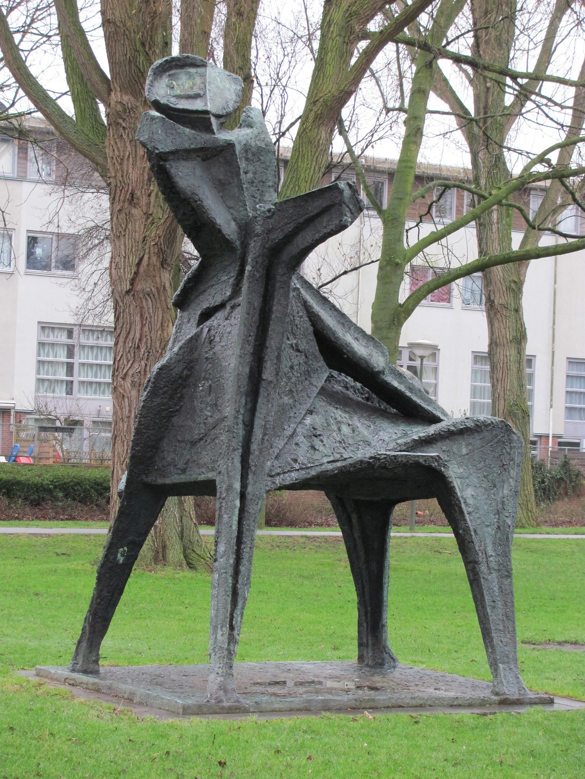
Figure 1 - Marino Marini
Marino Marini, “Horse and Rider”, Cavallo e Cavaliere / Rider (Arcangelo), bronze sculpture installed in Marinipark (formerly near Winkelstede), The Hague (Den Haag), Netherlands.
This monumental work (installed 1959, relocated 1996) captures the artist's signature equestrian motif: an anonymous rider in precarious tension atop a dynamic, abstracted horse.

The fragmented, expressive volumes evoke Marini's dramatic "excavation" of matter—blending archaic poise with modern anxiety—and directly reflect the influence he transmitted to Brera's Sculpture Department in the post-war decades, inspiring generations with the idea of sculpture as a site of existential drama and formal synthesis.
Credits
Photograph by Hansaviertel (own work), uploaded to Wikimedia Commons on 28 December 2009. Licensed under Creative Commons Attribution-Share Alike 4.0 International (CC BY-SA 4.0).
Direct source: https://commons.wikimedia.org/wiki/File:Denhaag_the_hague_rider_marino_marini.jpg (file curid=54715215).
Sculpture © Estate of Marino Marini / Artists Rights Society (ARS), New York / ADAGP, Paris (typical for Marini's works; check for reproduction rights in book publication). Used here for educational and scholarly commentary under fair use principles.

Figure 2 - Giancarlo Marchese
Giancarlo Marchese, “S.N.274 Dialettica Formale” Vetro e ghisa, 1993. Cm. 230x160x40.
This work exemplifies a poetic of silence: space as a "mental presence" and introspective threshold.
The translucent layers, subtle refractions, and deliberate emptiness allow light to define the form, creating a meditative zone where the physical object dissolves into inner contemplation, mirroring digital parallels like zenithal lighting and void-based virtual environments.

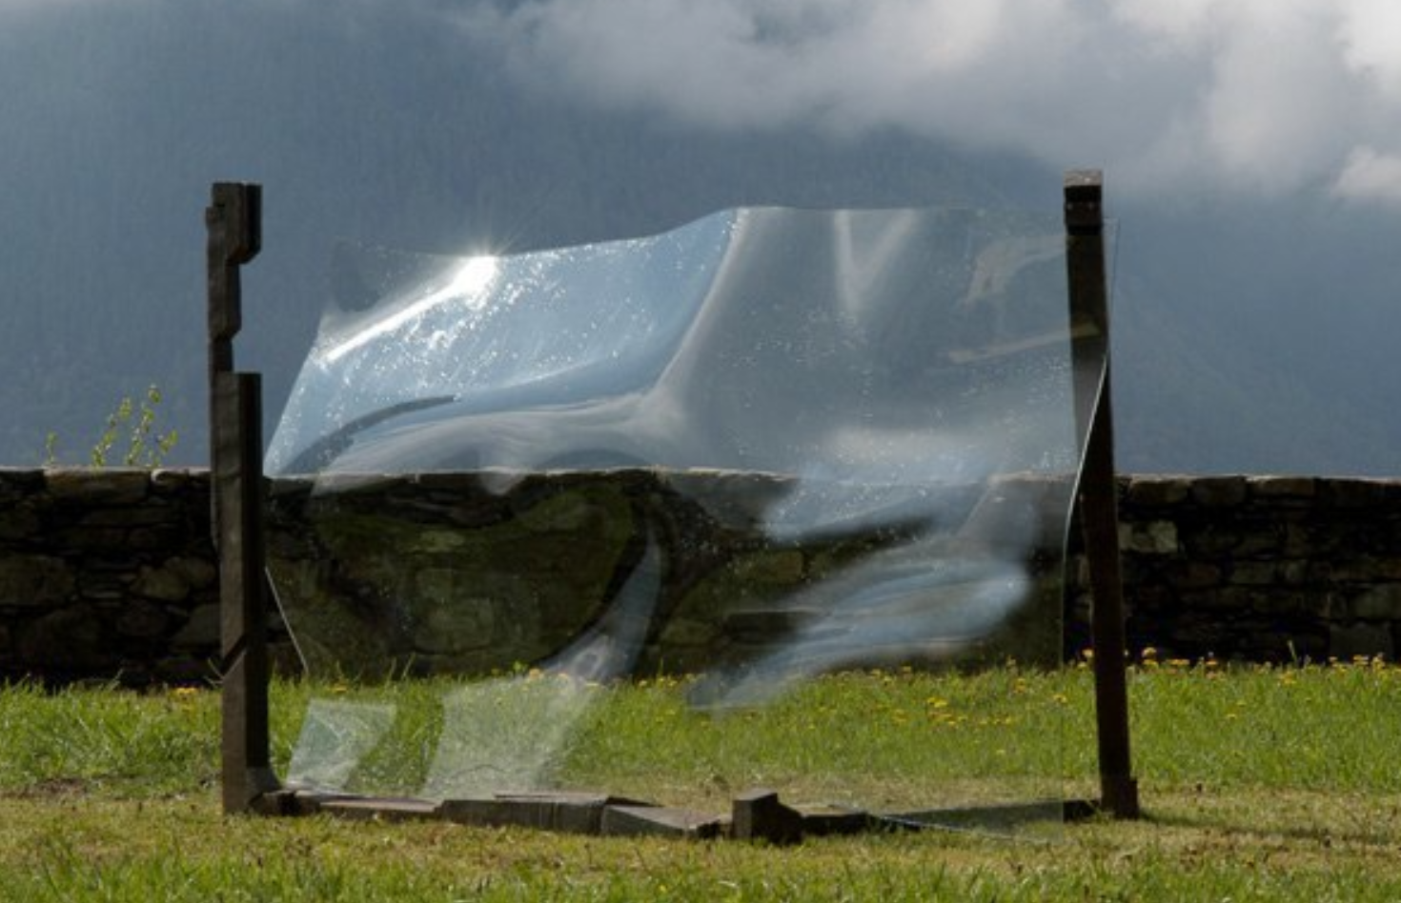
Credits
Image sourced from the artist's official website: Giancarlo Marchese, "Sculture in Vetro" gallery (anchor #5). © Giancarlo Marchese (all rights reserved; website content protected under standard copyright).
Courtesy: Francesca Marchese, photo by Bart Herremann.
Direct page: https://www.giancarlomarchese.com/giancarlomarchese.com/Sculture/Pagine/Sculture_in_Vetro.html#5
Used here for educational and scholarly commentary in the book context (fair use principles for analysis of the artist's work). For publication, contact the artist or estate via the website for reproduction permissions if needed.

Figure 3 - Giancarlo Marchese
The work, “ S.N. 416 A”, vetro, corten, argento, 2003, Cm. 380x220x140, features a glass element that emphasize transparency, refraction, and subtle internal textures (e.g., bubbles, fractures, or faint color veils).
Light interacts dynamically with the material, producing soft glows, shadows, and illusory depths that blur the boundary between object and void.
The overall effect is one of suspended stillness: the sculpture does not dominate but quietly defines a contemplative field, aligning with Marchese's emphasis on essential traces and inner silence rather than overt narrative or physical mass.

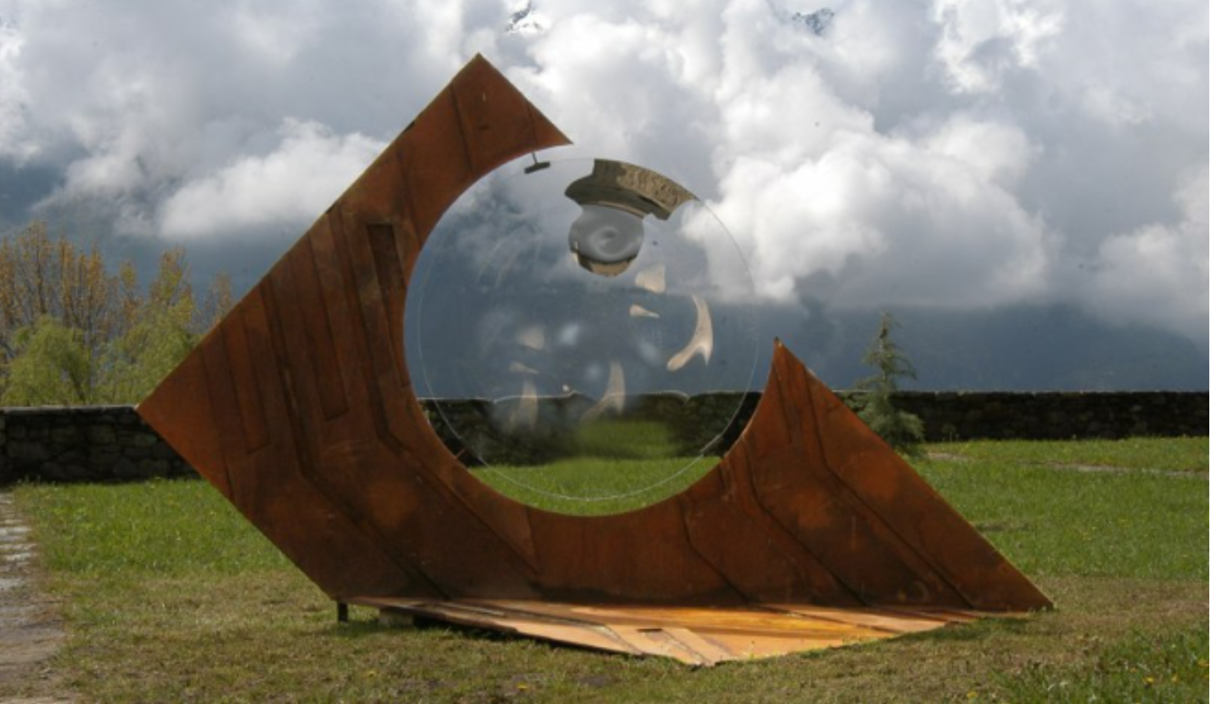
Credits
Image sourced from the artist's official website: Giancarlo Marchese, "Sculture in Vetro" gallery (anchor #34). © Giancarlo Marchese (estate/all rights reserved; website content protected under standard copyright).
Courtesy: Francesca Marchese, photo by Bart Herremann
Direct page: https://www.giancarlomarchese.com/giancarlomarchese.com/Sculture/Pagine/Sculture_in_Vetro.html#34
Used here for educational/scholarly analysis in the book context (fair use principles). For full publication or high-res reproduction, contact the estate via the website or associated galleries.

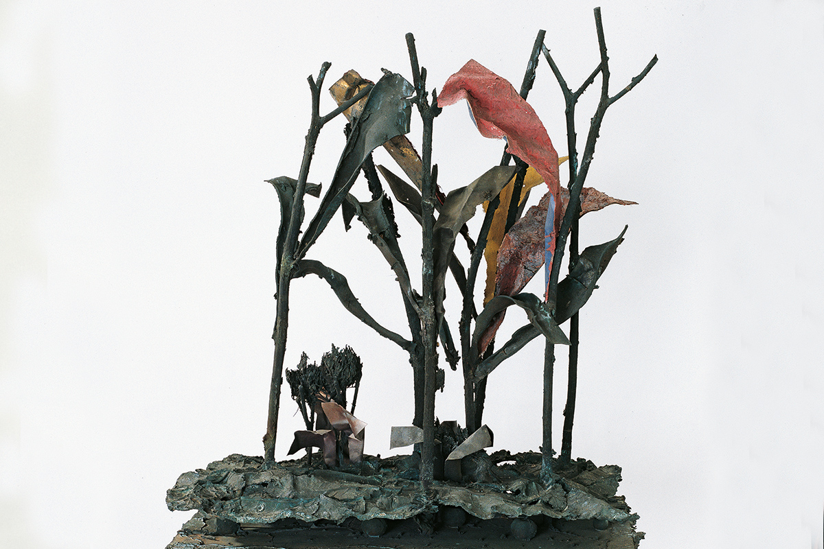
Figure 4 – Alik Cavaliere
Ogni cosa è limite e libertà di un’altra, bronzo, 1964, Cm. 122x126x82, Archivio Cavaliere, Milano, is an installation with organic, vegetal elements and narrative framing, illustrating Cavaliere's metaphysical scenography and the transformation of space into a philosophical journey.
The sculpture is an abstract bronze composition that suggest mutual enclosure and release: forms that curve, overlap, and pierce one another, creating a sense of dynamic equilibrium between restriction and openness.
Overall, it appears as a compact yet expansive spatial device: not a passive object but a narrative field that the viewer "enters" conceptually, aligning with Cavaliere’s interest in space as lived and interrogated.

Credits
Image and details sourced from the artist's official website: Alik Cavaliere, Portfolio – "Ogni cosa è limite e libertà di un’altra". © Estate of Alik Cavaliere (all rights reserved; website content protected under standard copyright).
Courtesy Fania Cavaliere.
Direct page: https://www.alikcavaliere.it/portfolio-item/ogni-cosa-e-limite-e-liberta-di-unaltra/
Exhibition history includes: XXXII Biennale di Venezia (1964), Gallery Twelve (Minneapolis, 1965), Martha Jackson Gallery (New York, 1965), Gemeentemuseum (The Hague, 1967), and others. Used here for educational/scholarly analysis in the book context (fair use principles). For publication or high-res reproduction, contact the estate via the website or Archivio Cavaliere, Milano.

Figure 5 – Alik Cavaliere
Alik Cavaliere, Apollo e Dafne, 1971. 44 elements in bronze, expanded polyurethane, polished steel, and mirror; dimensions 385 × 600 × 450 cm. Archivio Cavaliere, Milano.
This monumental environmental installation reinterprets Ovid's myth of Apollo's pursuit of Daphne, but radically subverts it: nature avenges itself by reclaiming the woman and denying Apollo the love he could not conquer. Partly paradisiacal and partly hostile, the work generates elusive images and phantoms—impenetrable roots everywhere, lost objects on the ground—in a swamp-like setting of large leaves, bronze fragments, and a large-knotted metallic net. Apollo (in expanded polyurethane) and Daphne (polyurethane with bronze elements) are embedded in this mutable, labyrinthine space, where mirrors and polished steel create reflective distortions and spatial ambiguity. As Cavaliere stated in 1967/1971 catalogs, sculpture here becomes a "mutable spectacle" that can freeze into monumental hieraticity or allow circulation and entry, inviting the viewer to traverse, interrogate, and become part of the narrative—foreshadowing immersive digital/metaverse environments and procedural world-building.
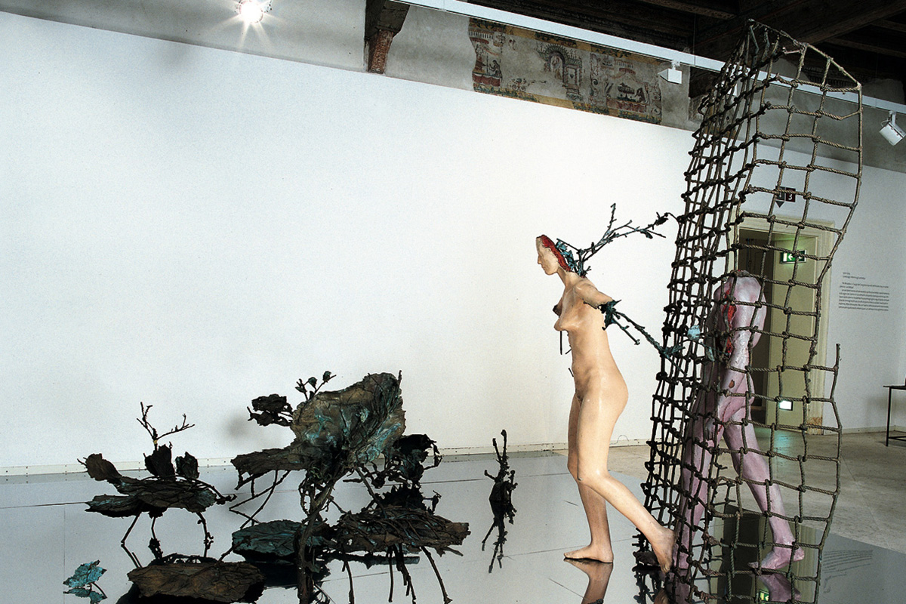

Credits
Image and details sourced from the artist's official website: Alik Cavaliere, Portfolio – "Apollo e Dafne". © Estate of Alik Cavaliere (all rights reserved).
Courtesy Fania Cavaliere.
Direct page: https://www.alikcavaliere.it/portfolio-item/apollo-e-dafne/
First exhibited: Galleria Schwarz, Milano (1971, as part of "3 environments"). Later shown at Palazzo Reale, Milano (1992) and Galleria d’Arte Moderna Palazzo Forti, Verona (2005).
Used here for educational/scholarly analysis (fair use principles). For publication or high-res reproduction, contact the estate via the website or Archivio Cavaliere, Milano.

Conclusion: Sculpture as a Narrative Device
Both Marchese and Cavaliere, building on Marini's solid plastic foundation, transformed sculpture into a narrative device. Space ceases to be a passive container and becomes an active agent of meaning: a field to inhabit, traverse, and interrogate. These visions lay the conceptual groundwork for modern immersive installations and world-building in the Metaverse.
Insert the four figures into Word below their respective captions. Use "Insert > Pictures" to add your uploaded images, then apply captions via the References tab. Position them centered or right-aligned for better flow (e.g., square text wrapping).Licensing and Credits
- Original text and analysis: © Gianpiero Moioli (2026). Permitted for educational/non-commercial use with attribution.
- Photographic documentation: Images provided by the author (or sourced for illustrative purposes in the book project). If using external/public domain alternatives (e.g., Wikimedia for Marini-related works), credit accordingly.
- Historical references: Based on studies of Marino Marini's teaching at Brera, Giancarlo Marchese's poetics of silence, Alik Cavaliere's narrative installations, and the post-war Sculpture Department evolution.
Companion GitHub Repository (optional extension)
For digital parallels: Include procedural recreations (e.g., Geometry Nodes setups in Blender mimicking Cavaliere's vegetal ecosystems or Marchese-inspired minimalist voids with procedural lighting).
This section connects Brera's post-war sculptural heritage to contemporary digital practices, showing how narrated and lived spaces evolve from physical matter to immersive, algorithmic worlds.

