Chapter 1 – Ideas, Materials, Technologies and Aesthetics
1.1.1 From Neoclassical Chisels to Digital Code: Distilling Ideas into Eternal Forms
This section explores the intersection of physical substance and computational logic, drawing inspiration from Neoclassicism to re-translate its principles into the language of new media, digital modeling, procedural generation, AI-driven forms, 3D printing, and immersive virtual environments.

Core Concept: From Matter to Algorithm
Neoclassicism, emerging prominently around 1776 – 1800, represented a return to classical ideals of perfection, proportion, harmony, and rational order.
The artist's role was not mere imitation of nature but its distillation into pure, essential structures: forms embodying reason, balance, and timeless permanence.
In today's "Digital Frontier" this same process of distillation takes place through code and algorithms:
- The Idea Precedes the Object. As in Neoclassical theory, the concept exists before material realization; in digital art, the algorithmic logic defines the form prior to any physical or rendered output.
- Gesture Becomes Instruction. Canova's physical chisel strokes and manual refinements are paralleled by logical instructions, parametric functions, and iterative optimization processes that shape data, meshes, and pixels.
One of the most striking illustrations of this shift from the tactile, manual gesture to algorithmic precision, appears in the work of neoclassical sculptors like Antonio Canova and Bertel Thorvaldsen.
These artists fundamentally transformed sculpture, making it more controlled, smoothly polished, and idealized: a clear forerunner of today's "computational perfection.
Here is an excellent short video that introduces this theme in a vivid, accessible way:
Canova | Thorvaldsen: Innovation in the Technique of Sculpture (Gallerie d'Italia, Milan)
https://www.youtube.com/watch?v=GSvRhLHz6vM
This short video from the Gallerie d'Italia explains how Antonio Canova and Bertel Thorvaldsen revolutionized sculpture between the 18th and 19th centuries, shifting from dramatic, textured Baroque surfaces to smoother, more controlled, and idealized forms that emphasize rational harmony and perfection—precisely the qualities that echo today's algorithmic refinement in digital creation.Watch it to see vivid examples of their innovative techniques, including Canova's obsessive polishing and Thorvaldsen's systematic modeling, which together mark the birth of a more "calculated" approach to sculptural beauty.

Case Study: Antonio Canova (1757–1822)
Antonio Canova stands as the central symbolic figure bridging classical vision and material execution. His practice exemplifies the rigorous transition from abstract idea to perfected physical form: an approach that anticipates modern digital workflows.
A compelling video that vividly illustrates these ideas is this time-lapse demonstration from the National Gallery of Art, where master sculptor Fred X. Brownstein recreates one of Canova's iconic works ("Venus") using Canova's original 200-year-old techniques step by step, from initial clay sketch (bozzetto) through plaster models to final marble refinement.
See a sculptor recreate Antonio Canova’s “Venus” step-by-step, from clay to marble | Time Lapse Art (National Gallery of Art, Washington DC)
https://www.youtube.com/watch?v=XkueS09XEFE
This short film captures the iterative, controlled process Canova employed: starting with a loose, gestural clay model to capture the pure idea, then scaling and refining through precise stages toward an idealized, almost algorithmically perfect marble surface.
It mirrors the core theme—from conceptual distillation to materialized form—and shows why Canova's method feels like a precursor to today's parametric and non-destructive digital sculpting pipelines.
Watch it to see the gesture becoming instruction in real time.
In the context of the time-lapse video recreating Canova's Venus, we witness exactly this transformation unfolding.
At the start, the gesture is pure and direct: sculptor Fred X. Brownstein's hands freely model the soft clay of the bozzetto (the small initial sketch, about a foot tall).
It is an intuitive, tactile, expressive act—the hand "speaking" straight to the material, capturing the initial idea in a fluid, organic way. The artist improvises, feels the form, corrects with fingers and small wooden tools, building the rough figure additively.
As the process advances—from the clay bozzetto to the full-scale model cast in plaster to create a hollow mold, then to a refined plaster version, and finally to precise transfer onto the marble block—the initial gesture radically changes.
It becomes increasingly controlled, measured, and systematic: the sculptor turns to pointing tools, calipers, geometric reference points (such as the three-circle method for transferring proportions), intermediate casts, and repeated iterations to eliminate every imperfection and faithfully approach the pre-conceived ideal form.
The manual touch does not vanish entirely, but it subordinates itself to a true system of precise instructions.
In this flow—from intuitive additive building to rigorous subtractive refinement—the video makes visible in real time how spontaneous human gesture evolves into structured, repeatable instruction, foreshadowing the algorithmic logic of the digital realm: from tactile improvisation to scalable precision, from chaotic matter to distilled, eternal form.

Emblematic Work: Psyche Revived by Cupid's Kiss (1787–1793)
This masterpiece translates the artist's idealized vision of beauty, love, and harmony into marble. The direct dialogue between mental concept and material shaping is evident: the artist's idea dictates the selection of stone, the carving technique, and the final polish.
- Workflow Parallel — From initial terracotta sketch (raw, expressive idea in material) → full-scale plaster model → finished marble sculpture
Modern digital equivalent: Concept/prompt → low-resolution prototype (e.g., in Blender or procedural tools) → refined high-resolution mesh (via subdivision, AI upscaling, or optimization) → 3D print, real-time render, or virtual/metaverse installation.
Canova's alignment with academic principles and institutions (such as the Brera Academy reforms) established his work as an enduring reference, linking historical tradition to future aesthetic innovation.

Visual Documentation
The following public domain images (sourced from Wikimedia Commons) illustrate the dialogue between initial concept and perfected form.

Figure 1: Terracotta Sketch of Cupid and Psyche
Antonio Canova, 1787–93 (Museo Correr, Venice)
Represents the raw, gestural idea captured in material, spontaneous and unrefined.

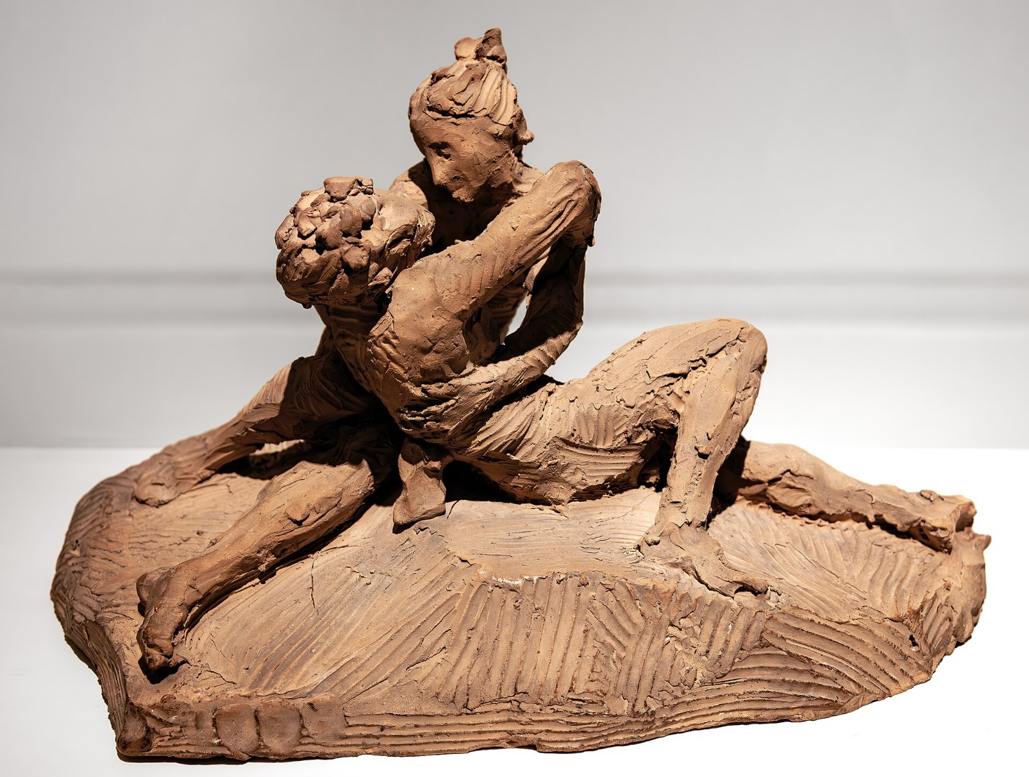
Source: https://commons.wikimedia.org/wiki/File:(Venice)_Sculptures_of_Cupid_and_Psyche_Terracotta_sketch_by_Canova_-_Museo_Correr.jpg
(High-resolution public domain; photographer credits where available: e.g., Didier Descouens or similar contributors.)

Figure 2: Psyche Revived by Cupid's Kiss (Marble Version)
Antonio Canova, 1787–93 (Louvre Museum, Paris)
→ Embodies the distilled ideal: perfect proportions, serene harmony, and technical mastery in polished marble.

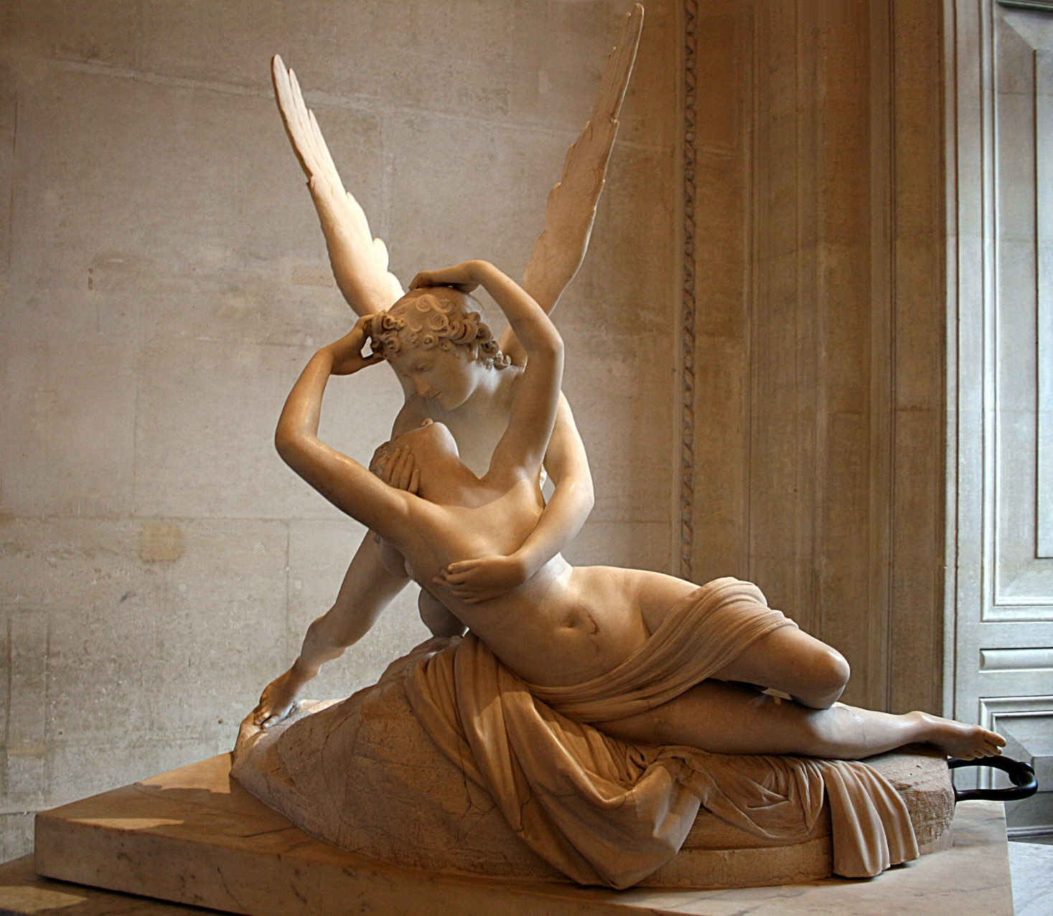
Sources (high-resolution public domain):
- https://upload.wikimedia.org/wikipedia/commons/b/b7/Psyche_revived_by_cupid%27s_kiss%2C_Paris_2_October_2011_002.jpg
- https://upload.wikimedia.org/wikipedia/commons/4/46/Psych%C3%A9_ranim%C3%A9e_par_le_baiser_de_l%27Amour%2C_Louvre.jpg
- https://upload.wikimedia.org/wikipedia/commons/0/0f/Antonio_canova%2C_amore_e_psiche_louvre_04.JPG
(Credits: Various Wikimedia contributors, including Jean-Pol GRANDMONT.)
- Original text, analysis, and project concept: © Gianpiero Moioli (2026). All rights reserved for commercial use; permitted for educational/non-commercial citation with attribution.
- Code, technical prototypes, and generative content (if included in companion repository): MIT License (permissive open-source).
- Historical references: Based on scholarly research concerning the Accademia di Brera, Neoclassical reforms, and Canova's biography.
- Photographic documentation: Public Domain (Wikimedia Commons). Credits to photographers/contributors as noted on individual file pages (e.g., Didier Descouens, Jean-Pol GRANDMONT).

Companion GitHub Repository
For interactive extensions:
- Procedural variations inspired by Canova (Jupyter notebooks with Perlin noise, geometry nodes, or diffusion models).
- 3D models (.obj/.glb) of re-interpreted Neoclassical forms.
- Web-based viewers (Three.js) for real-time exploration in browser or VR.
This material forms part of a broader investigation into how contemporary sculpture balances structure and organic transformation while questioning authenticity, uniqueness, and the boundaries between physical matter, digital code, blockchain/NFTs, and metaverse experiences.

