How to tell Unix to use the C++26 standard
(as much as is currently supported)
Easiest solution: make a copy of basicStandardProject, and edit its source files. The Makefile already knows how to do this.
If you're doing it on your own, add this flag to the g++ command: -std=c++2b. (See Chapter 13 for how to use the g++ command.)

How to tell Visual Studio to use the C++26 standard
(as much as is currently supported)
Easiest solution: make a copy of basicStandardProject, and edit its source files. The .vcxproj file already knows how to do this.
If you're doing it on your own…at present, right click the project (hello, in the case shown) in Solution Explorer -- it has to be the project, not the solution or any other file.
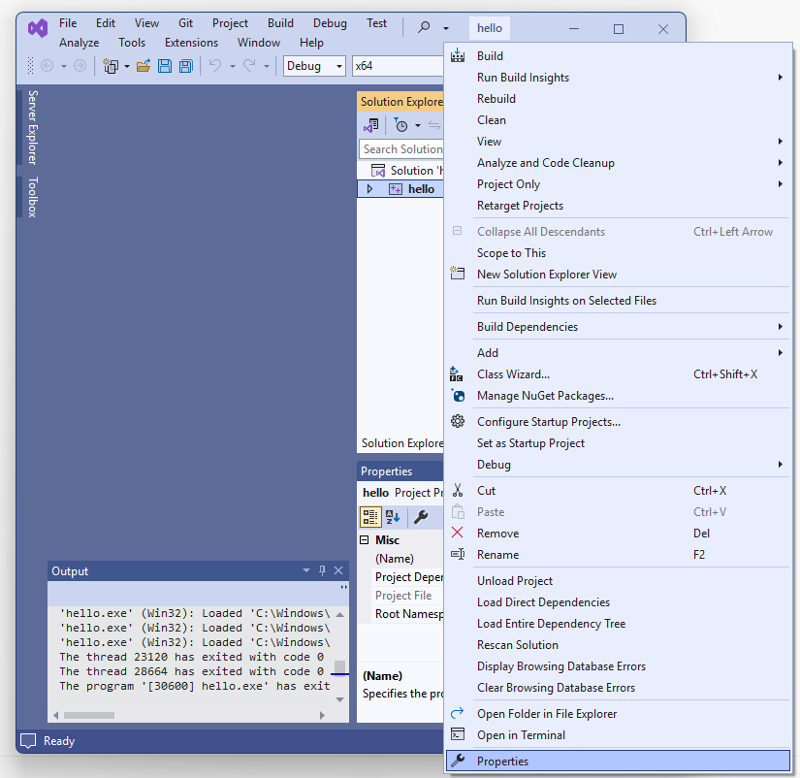
Select Properties; go to Configuration Properties > C/C++ > Language. Set C++ Language Standard to Preview – Features from the Latest C++ Working Draft (/std:c++latest).

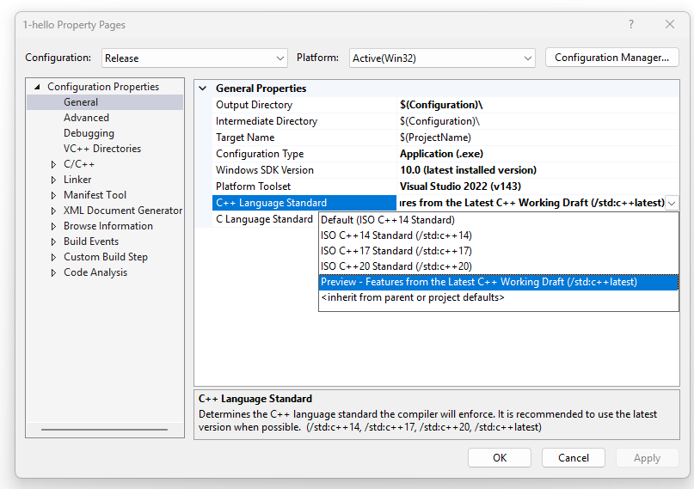
Click OK.

