# Beginning Drupal 8 - Chapter 6 Errata

In chapter 6 I demonstrated the installation of the Gratis theme, one of the few Drupal 8 themes that were available at the time the book was written. Gratis was abandoned by its creator and is no longer available as a Drupal 8 theme. A viable alternative to Gratis is the Zircon theme, which can be found at drupal.org/project/zircon. Zircon is widely used, with 5,000 sites reporting that they use it as their base theme, and provides similar capabilities as Gratis.

To install Gratis follow the same process as described in Chapter 6. I’ll outline the process here, additional details can be found in Chapter 6.

1. Download the Zircon theme from drupal.org/project/zircon by right clicking on the download link for the Drupal 8 version of the theme. Click on either the tar.gz or zip file link to download the theme to your desktop or laptop.
2. After the tar.gz or zip file has downloaded to your desktop or laptop, copy that file to your Drupal 8 sites theme directory, found in the root directory of your Drupal 8 site.
3. Uncompress the targ.gz or zip file using the tools provided by your operating system. In most cases you can double click on the file in your operating systems file manager.
4. You may now remove the tar.gz or zip file as it is no longer needed.
5. Visit your site and log in as a site administrator.
6. Navigate to Appearance and scroll down the page until you see the Zircon theme.
7. Click the install and set as default link for the Zircon theme.
8. Visit the homepage and see your site rendered using the Zircon theme.
9. You may now place blocks in the new regions that are enabled by Zircon. Navigate to Structure > Block Layout to see the regions that are available.

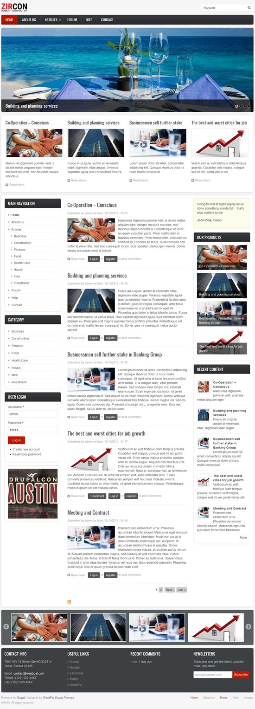

Figure 1. The Zircon theme.