OLE Graph

Data for this graph was produced with the following code:

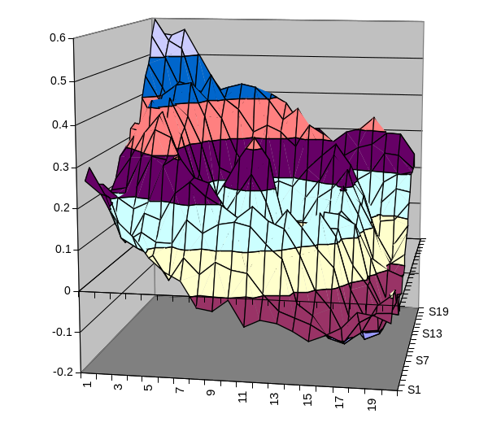' Make some random surface data.
Sub GenerateData()
Dim r As Single
Dim c As Single
Dim d As Single

Randomize
For r = 1 To 20
For c = 1 To 20
d = Sqr((10 - r) * (10 - r) + _
(10 - c) * (10 - c))
Cells(r, c) = _
Cos(d) * 2 / (d + 15) + _
(r + 10 - c) / 60 + _
(Rnd / 15)
Next c
Next r
End Sub

