This graph was last viewed maximized in Excel:
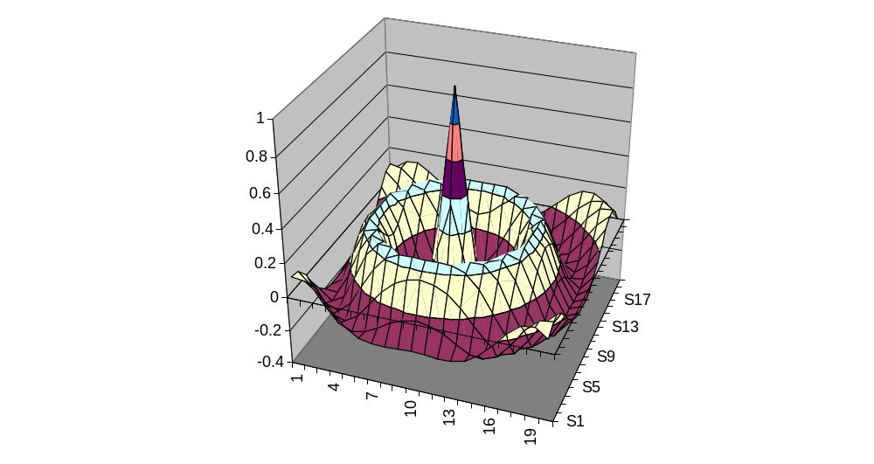
This graph was last viewed at a reduced scale in Excel:
