postgres=# CREATE TABLE test(ID int);  
CREATE TABLE  
postgres=# INSERT INTO test VALUES(1);  
INSERT 0 1  
postgres=# SELECT xmin, xmax, id FROM test;  
 xmin | xmax | id  
------+------+----  
 1739 | 0 | 1  
(1 row)

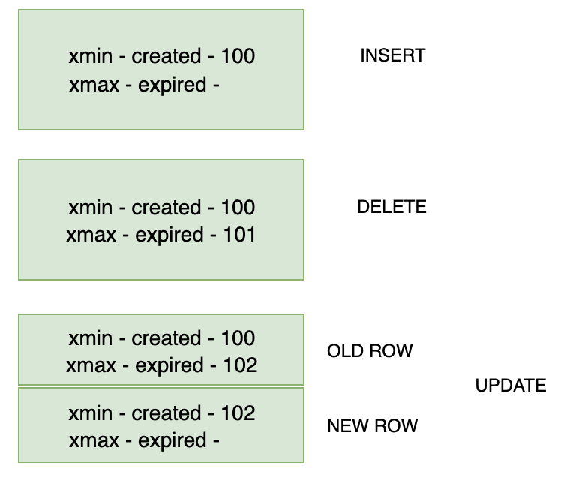

postgres=# select name, setting, context from pg_settings where category ~ 'Autovacuum';

name | setting | context

-------------------------------------+-----------+------------

autovacuum | on | sighup

autovacuum_analyze_scale_factor | 0.1 | sighup

autovacuum_analyze_threshold | 50 | sighup

autovacuum_freeze_max_age | 200000000 | postmaster

autovacuum_max_workers | 3 | postmaster

autovacuum_multixact_freeze_max_age | 400000000 | postmaster

autovacuum_naptime | 60 | sighup

autovacuum_vacuum_cost_delay | 20 | sighup

autovacuum_vacuum_cost_limit | -1 | sighup

autovacuum_vacuum_scale_factor | 0.2 | sighup

autovacuum_vacuum_threshold | 50 | sighup

(11 rows)

SELECT schemaname,

relname,

now() - last_autovacuum AS "noautovac",

now() - last_vacuum AS "novac",

n_tup_upd,

n_tup_del,

pg_size_pretty(pg_total_relation_size(schemaname||'.'||relname)),

autovacuum_count,

last_autovacuum,

vacuum_count,

last_vacuum

FROM pg_stat_user_tables

WHERE (now() - last_autovacuum > '7 days'::interval

OR now() - last_vacuum >'7 days'::interval )

OR (last_autovacuum IS NULL AND last_vacuum IS NULL )

ORDER BY novac DESC;

SELECT pid,

state,

query

FROM pg_stat_activity

WHERE query like '%VACUU%

AND state = 'active';

select pg_terminate_backend(pid);

postgres=# set vacuum_cost_delay=10;

SET

postgres=# VACUUM VERBOSE pgbench_branches ;

INFO: vacuuming "public.pgbench_branches"

INFO: index "pgbench_branches_pkey" now contains 10 row versions in 2 pages DETAIL: 0 index row versions were removed.

0 index pages have been deleted, 0 are currently reusable.

CPU 0.00s/0.00u sec elapsed 0.00 sec.

INFO: "pgbench_branches": found 0 removable, 10 nonremovable row versions in 1 out of DETAIL: 0 dead row versions cannot be removed yet.

There were 0 unused item pointers.

0 pages are entirely empty.

CPU 0.00s/0.00u sec elapsed 0.00 sec.

VACUUM

postgres=#

--set vacuum_cost_delay=

VACUUM VERBOSE ANALYZE table1;

VACUUM VERBOSE ANALYZE table2;

VACUUM VERBOSE ANALYZE table3;

etc...

Then, it can be run using psql from any host:

psql -h <server_ip> -f vacuum.sql -U <user> -d <db> >> /log/vacuum.log

This could be done more dynamically. Create a sql file using below command (for example, gen_vacuum_list.sql)

SELECT 'VACUUM VERBOSE ANALYZE ' || schemaname || '.' || relname ||';'

FROM pg_stat_user_tables

WHERE (now() - last_autovacuum > '7 days'::interval

OR now() - last_vacuum >'7 days'::interval )

OR (last_autovacuum IS NULL AND last_vacuum IS NULL );

Dump the output to a file, and execute the result against the database:

psql -h <server_ip> -f gen_vacuum_list.sql -U <user> -d <db> >> /tmp/vacuum_tables.sql

psql -h <server_ip> -f /tmp/vacuum_tables.sql -U <user> -d <db> >> /log/vacuum.log

In crontab:

* * * * * /usr/bin/pgrep -f ’postgres: autovacuum’ | xargs --no-run-if-empty -I $ renice -n 20 -p $ >/dev/null 2>/dev/null

* * * * * /usr/bin/pgrep -f ’postgres: autovacuum’ | xargs --no-run-if-empty -I $ ionice -c 3 -t -p $

In postgresql.conf:

autovacuum_max_workers = 20

autovacuum_vacuum_cost_delay = 10

postgres=# create table index_test (id int);

CREATE TABLE

postgres=# insert into index_test values (generate_series(1,10000000));

INSERT 0 10000000

postgres=# create index fragmented_index on index_test (id);

CREATE INDEX

postgres=#

postgres=# create extension pgstattuple ;

CREATE EXTENSION

postgres=# insert into index_test values (generate_series(1,10000000));

INSERT 0 10000000

postgres=# update index_test set id = 1 where id < 5000000;

UPDATE 4999999

postgres=# SELECT * FROM pgstatindex('fragmented_index');

-[ RECORD 1 ]------+----------

version | 2

tree_level | 2

index_size | 366919680

root_block_no | 412

internal_pages | 177

leaf_pages | 44612

empty_pages | 0

deleted_pages | 0

avg_leaf_density | 82.79

leaf_fragmentation | 35.65

postgres=# reindex index fragmented_index ;

REINDEX

Time: 7960.823 ms (00:07.961)

postgres=# SELECT * FROM pgstatindex('fragmented_index');

-[ RECORD 1 ]------+----------

version | 2

tree_level | 2

index_size | 224641024

root_block_no | 290

internal_pages | 98

leaf_pages | 27323

empty_pages | 0

deleted_pages | 0

avg_leaf_density | 90.09

leaf_fragmentation | 0

SELECT a.indexrelname, b.*  
FROM pg_stat_user_indexes a,  
LATERAL pgstatindex(indexrelname) b  
ORDER BY leaf_fragmentation DESC;

SELECT (x.a).indexrelname, (x.b).*  
FROM (SELECT a, pgstatindex(a.indexrelname) AS b  
 FROM pg_stat_user_indexes a) x  
ORDER BY leaf_fragmentation DESC;

SELECT relname AS table, indexrelname AS index, pg_size_pretty(pg_relation_size(indexrelid)) AS size  
FROM pg_stat_user_indexes  
WHERE idx_scan = 0  
ORDER BY pg_relation_size(indexrelid) DESC;

SELECT indrelid::regclass AS table, indkey AS column_numbers, array_agg(indexrelid::regclass) AS indexes, pg_catalog.pg_get_expr(indpred, indrelid, true) AS expression  
FROM pg_index  
GROUP BY indrelid, indkey, pg_catalog.pg_get_expr(indpred, indrelid, true)  
HAVING count(*) > 1;