|  |  |  |  |
| --- | --- | --- | --- |
| Availability | Downtime per | | |
| Year | Month | Week |
| 90% ('One Nine') | 36.5 days | 73 hours | 16.8 hours |
| 99% ('Two Nines') | 87.7 hours | 7.3 hours | 1.68 hours |
| 99.9% ('Three Nines') | 8.77 hours | 43.8 minutes | 10.1 minutes |
| 99.99% ('Four Nines') | 52.56 minutes | 4.38minutes | 1.01 minutes |
| 99.999% ('Five Nines') | 5.26 minutes | 26.3 seconds | 6.05 seconds |
| 99.9999% ('Six Nines') | 31.5 seconds | 2.63 seconds | 0.605 seconds |

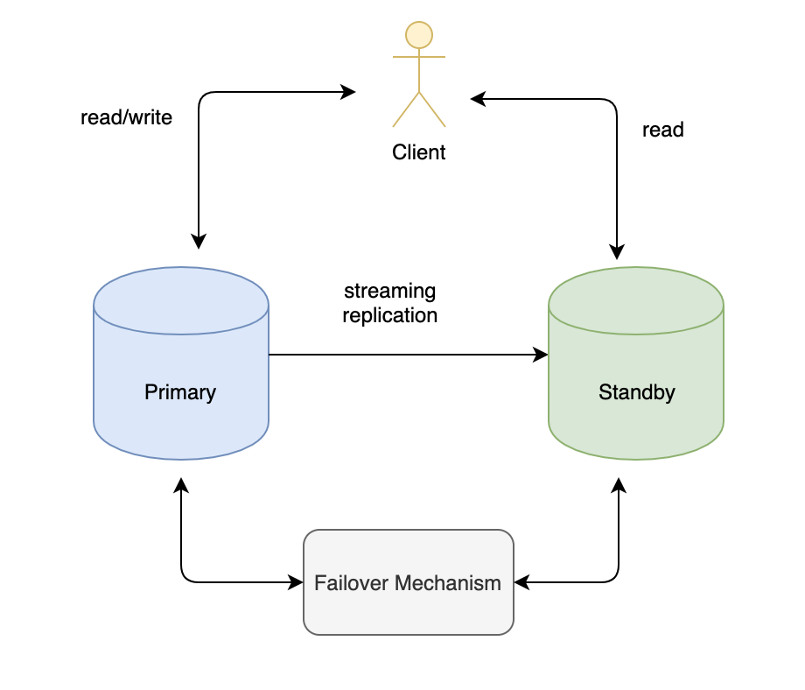

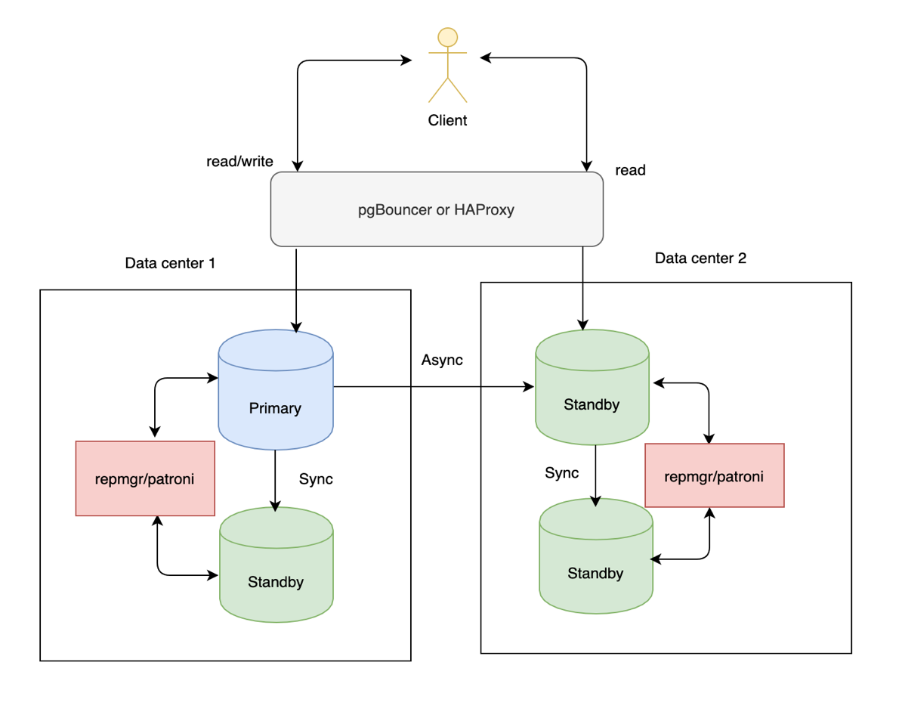

##########

Primary server – 192.168.0.1

Standby server – 192.168.0.2

psql -c 'CREATE USER REPLICATION rep_gmr';  
psql -c 'CREATE DATABASE rep_mgr OWNER rep_mgr';

cluster=cls

node=1

node_name=node1

conninfo= 'host=192.168.0.1 user=repmgr dbname=repmgr'

pg_bindir='/usr/pgsql-9.5/bin'

loglevel=DEBUG

reconnect_attempts=1

reconnect_interval=1

logfile='/var/lib/pgsql/repmgr.log'

use_replication_slots=6

service_start_command = 'sudo /bin/systemctl start postgresql-9.5'

service_stop_command = 'sudo /bin/systemctl stop postgresql-9.5'

service_restart_command = 'sudo /bin/systemctl restart postgresql-

9.5'

service_reload_command = '/usr/pgsql-9.5/bin/pg_ctl -D

/var/lib/pgsql/9.5/data reload'

service_promote_command = '/usr/pgsql-9.5/bin/pg_ctl -D

/var/lib/pgsql/9.5/data promote'

priority=100

failover='automatic'

promote_command='/var/lib/pgsql/standby_promote.sh'

follow_command='/usr/pgsql-9.5/bin/repmgr standby follow -f

/etc/repmgr/9.5/repmgr.conf -W'

cluster=cls

node=2

node_name=node2

conninfo= 'host=192.168.0.2 user=repmgr dbname=repmgr'

pg_bindir='/usr/pgsql-9.5/bin'

loglevel=DEBUG

logfile='/var/lib/pgsql/repmgr.log'

use_replication_slots=6

service_start_command = 'sudo /bin/systemctl start postgresql-9.5'

service_stop_command = 'sudo /bin/systemctl stop postgresql-9.5'

service_restart_command = 'sudo /bin/systemctl restart postgresql-

9.5'

service_reload_command = '/usr/pgsql-9.5/bin/pg_ctl -D

/var/lib/pgsql/9.5/data reload'

service_promote_command = '/usr/pgsql-9.5/bin/pg_ctl -D

/var/lib/pgsql/9.5/data promote'

priority=100

failover='automatic'

master_response_timeout=10

reconnect_attempts=1

reconnect_interval=1

promote_command='repmgr standby promote -f /etc/repmgr.conf --log-to-file'

follow_command='/usr/pgsql-9.5/bin/repmgr standby follow -f

/etc/repmgr/9.5/repmgr.conf -W'

host rep_mgr rep_mgr 192.168.0.2/32 trust

host replication rep_mgr 192.168.0.2/32 trust

host rep_mgr rep_mgr 192.168.0.1/32 trust

sudo /bin/systemctl start postgresql-9.5  
sudo /etc/init.d/repmgrd restart

sudo -u postgres repmgr primary register

$ psql -U rep_mgr -c 'select node_id, node_name, type, conninfo from repmgr.nodes' -d rep  
-mgr

node_id | node_name | type | conninfo

---------+----------------+---------+------------------

1 | primary-server | primary | host=192.168.0.1

sudo /etc/init.d/postgresql stop

sudo -u postgres repmgr -h '192.168.0.1' -U repmgr -d repmgr -D

/var/lib/pgsql/9.5/data -f /etc/repmgr/9.5/repmgr.conf standby

clone

sudo /bin/systemctl start postgresql-9.5

repmgr -f /etc/repmgr/9.5/repmgr.conf standby register --verbose

$ psql -U rep_mgr -c 'select node_id, upstream_node_id, node_name, type from repmgr.nodes' -d rep_mgr

node_id | upstream_node_id | node_name | type |   
--------+------------------+-----------------+---------+  
 1 | | primary-server | primary |  
 2 | 1 | standby-server | standby |

#########

SELECT application_name, pg_xlog_location_diff(sent_location, flush_location) AS lag  
FROM pg_stat_replication  
ORDER BY replay_delta ASC, application_name;

DO $$  
 DECLARE result int;  
BEGIN  
 EXECUTE 'SELECT x''' || replace(sent_location,'/','') || '''::int - x''' || replace(flush_location,'/','') || '''::int' FROM pg_stat_replication INTO result;  
 RAISE NOTICE 'Replication lag: % bytes', result;  
END $$;