Read Me

_BISolutionsBookFiles\Chapter02Files\_BISolutions
You need to add this folder to your C: drive. This step is the foundation of all your future Exercises, and must be completed for these future Exercises to work properly.
Note: This process is covered in Exercise 2-1.
- If you have not done so, download the book files from the Apress website. These files are in a Zipped format so unzip them on you C:\ drive into a folder called _BISolutionsBookFiles. Once unzipped this folder will include all the files and projects you will need to complete each of the exercises within this book.
- Inside the _BISolutionsBookFiles locate the Chapter02Files folder and open it. You will find a subfolder called _BISolutions. Use Windows Explorer to Copy this folder to the root of C:\. After this, you will now have a folder on your hard drive called C:\_BISolutions. To open Windows Explorer, access your computer’s Start menu and click Computer. In the left hand column select Local Disk (C:). On the right, you will see all of your C:\ files listed. Paste the entire folder here.
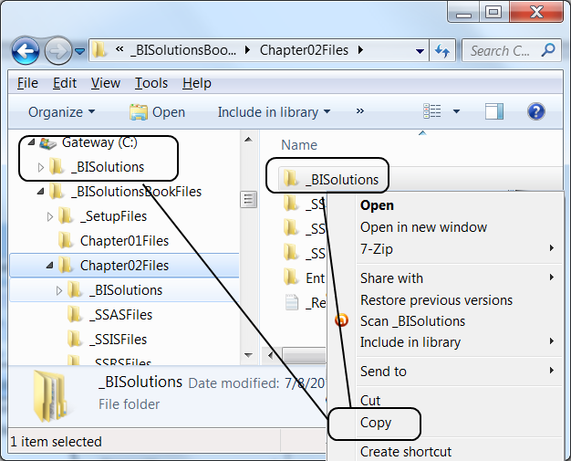
Figure 2-6. Now both _BISolutions and _BISolutionsBookFiles are on the C drive

