Read Me

_BISolutionsBookFiles\Chapter02Files\_SSASFiles
This folder contains a completed Analysis Server project that you will add to your own Visual Studio solution.
Note: This process is covered in Exercise 2-4.
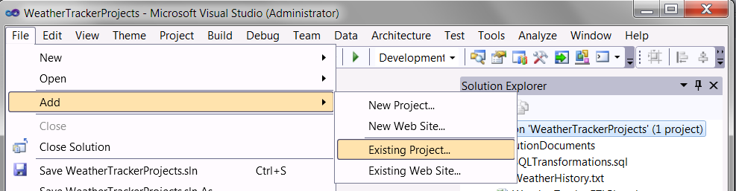
Figure 2-53. Adding an existing project to your Visual Studio solution

