Read Me

_BISolutionsBookFiles\Chapter02Files\_SSISFiles
This folder contains a completed SSIS package file that you will add to your own SSIS project.
Note: This process is covered in Exercise 2-3.
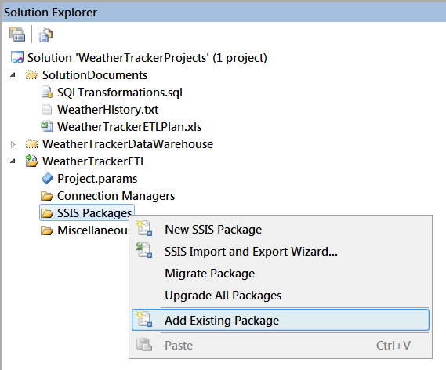
Figure 2-40. Adding an exsitng SSIS package to the project.

