Read Me

The _BookFiles folder
The _BookFiles folder contains all of the listing code and exercise files for each chapter of the Pro SQL Server 2012 BI Solutions book. It is intended that you place this subfolder directly on the root of your C:\ drive. All instructions in the book assume that you have done so and we strongly recommend that you use this location.

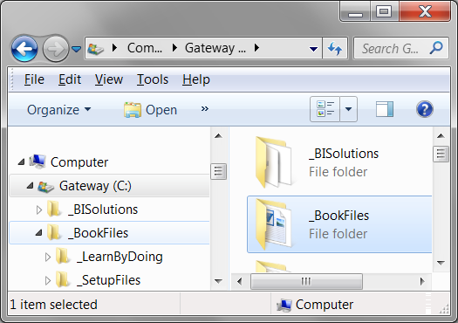
Figure 1. Please place the _BookFiles directly on your C:\ drive

We will be updating the book files as we find errors, so please check the Apress web site for the most recent version. You may also want to check the author's website http://www.NorthwestTech.org.

