Read Me

_BookFiles\_LearnByDoing\Chapter05Files
This folder contains listing code and the files needed for the Learn By Doing exercises in Chapter 5.

Outlined Instructions
Please use the following instruction to complete each exercise. Remember that the instructions are intentionally brief and that you may need to refer to the Pro SQL 2012 BI Solutions book for examples of how to perform these tasks.

EXERCISE 5-1. CREATING THE NORTHWIND FOODS DATABASE
In this exercise, you create a database for the Northwind Foods data warehouse.
- Open SQL Server Management Studio 2012 and use the Query Window to create a database using the code in Listing 1.
Listing 1. Creating the DWNorthwindOrders Data Warehouse Database
USE [master]
GO
IF EXISTS (SELECT name FROM sys.databases WHERE name = N'DWNorthwindOrders')
BEGIN
-- Close connections to the DWNorthwindOrders database
ALTER DATABASE [DWNorthwindOrders] SET SINGLE_USER WITH ROLLBACK IMMEDIATE
DROP DATABASE [DWNorthwindOrders]
END
GO

CREATE DATABASE [DWNorthwindOrders] ON PRIMARY
( NAME = N'DWNorthwindOrders'
, FILENAME = N'C:\_BISolutions\NorthwindFoods\DWNorthwindOrders.mdf'
, SIZE = 10MB
, MAXSIZE = 1GB
, FILEGROWTH = 10MB )
LOG ON
( NAME = N'DWNorthwindOrders_log'
, FILENAME = N'C:\_BISolutions\NorthwindFoods\DWNorthwindOrders_log.LDF'
, SIZE = 1MB
, MAXSIZE = 1GB
, FILEGROWTH = 10MB)
GO
EXEC [DWNorthwindOrders].dbo.sp_changedbowner @loginame = N'SA', @map = false
GO
ALTER DATABASE [DWNorthwindOrders] SET RECOVERY BULK_LOGGED
GO

EXERCISE 5-2. CREATING TABLES AND FOREIGN KEY CONSTRAINTS
In this exercise, you create the tables and foreign key constraints in the Northwind Foods data warehouse. You can choose to use the SQL code presented here, the table designer, or the diagramming tools to accomplish your goal.
Creating the Tables
The first thing we need to do is create the tables. Let’s do that now.
- Open SQL Server Management Studio and create the tables defined in Listing 2.
Listing 2. Creating the DWNorthwindOrders Tables
USE [DWNorthwindOrders]
GO

/****** Create the Fact Tables ******/
CREATE TABLE [dbo].[FactOrders](
[OrderID] [int] NOT NULL,
[CustomerKey] [int] NOT NULL,
[EmployeeKey] [int] NOT NULL,
[ProductKey] [int] NOT NULL,
[OrderDateKey] [int] NOT NULL,
[RequiredDateKey] [int] NOT NULL,
[ShippedDateKey] [int] NOT NULL,
[PriceOnOrder] [money] NOT NULL,
[QuantityOnOrder] [int] NOT NULL
CONSTRAINT [PK_FactOrders] PRIMARY KEY
(
[OrderID],
[CustomerKey],
[EmployeeKey],
[ProductKey],
[OrderDateKey],
[RequiredDateKey],
[ShippedDateKey]
)
)
GO

/****** Create the Dimension Tables ******/
-- DimCustomers
CREATE TABLE [dbo].[DimCustomers](
[CustomerKey] [int] IDENTITY(1,1) NOT NULL PRIMARY KEY,
[CustomerID] [nchar](5) NOT NULL,
[CustomerName] [nvarchar](100) NOT NULL,
[CustomerCity] [nvarchar](50) NOT NULL,
[CustomerRegion] [nvarchar](50) NOT NULL,
[CustomerCountry] [nvarchar](50) NOT NULL,
)
GO

CREATE TABLE [dbo].[DimProducts](
[ProductKey] [int] IDENTITY(1,1) NOT NULL PRIMARY KEY,
[ProductID] [int] NOT NULL,
[ProductName] [nvarchar](100) NOT NULL,
[ProductCategory] [nvarchar](100) NOT NULL,
[ProductStdPrice] [decimal](18,4) NOT NULL,
[ProductIsDiscontinued] [bit] NOT NULL
)
GO

CREATE TABLE [dbo].[DimEmployees](
[EmployeeKey] [int] IDENTITY(1,1) NOT NULL PRIMARY KEY
[EmployeeID] [int] NOT NULL,
[EmployeeName] [nvarchar](100) NOT NULL,
[ManagerKey] [int] NOT NULL,
[ManagerID] [int] NOT NULL
)
GO

Adding Foreign Key Constraints
Now that the tables are created, we want to add foreign key constraints between the tables as described by the code in Listing 3.

Listing 3. Creating the DWNorthwindOrders Foreign Key Constraints
/****** Add Foreign Keys ******/
ALTER TABLE dbo.DimEmployees ADD CONSTRAINT
FK_DimEmployees_DimEmployees FOREIGN KEY
(
[ManagerKey]
) REFERENCES dbo.DimEmployees
(
EmployeeKey
)

ALTER TABLE dbo.FactOrders ADD CONSTRAINT
FK_FactOrders_DimCustomers FOREIGN KEY
(CustomerKey) REFERENCES dbo.DimCustomers(CustomerKey)

ALTER TABLE dbo.FactOrders ADD CONSTRAINT
FK_FactOrders_DimEmployees FOREIGN KEY
(EmployeeKey) REFERENCES dbo.DimEmployees(EmployeeKey)

ALTER TABLE dbo.FactOrders ADD CONSTRAINT
FK_FactOrders_DimProducts FOREIGN KEY
(ProductKey) REFERENCES dbo.DimProducts(ProductKey)

Verifying Your Tables
Once the tables are made and the foreign keys created, it is best to check your work by comparing it to the design document, the BISolutionWorksheet you reviewed in Chapter 3.

EXERCISE 5-3. CREATE A DATE DIMENSION
In this exercise, you create a date dimension table in the Northwind Foods data warehouse. You can choose to use the SQL code presented here, the table designer, or the diagramming tools to accomplish your goal. (In Chapter 7 you fill the table with data using the code in Listing 5-11.)
Create the DimDates Table
Your first task is to create a table to hold date dimension data using then code in Listing 4.
- Open SQL Server Management Studio and create the table defined in Listing 4.
Listing 4. Creating the DimDates table
CREATE TABLE [dbo].[DimDates](
[DateKey] [int] IDENTITY(1,1) NOT NULL PRIMARY KEY,
[Date] [datetime] NOT NULL UNIQUE,
[DateName] [nvarchar](50) NULL,
[Month] [int] NOT NULL,
[MonthName] [nvarchar](50) NOT NULL,
[Quarter] [int] NOT NULL,
[QuarterName] [nvarchar](50) NOT NULL,
[Year] [int] NOT NULL,
[YearName] [nvarchar](50) NOT NULL,
)
GO
Adding Foreign Key Constraints
We have added a new table to the data warehouse database, but now we want to connect this new table to the existing ones using foreign key constraints.
- Add the foreign key constraints to the DimDates table using the code in Listing 5.
Listing 5. Creating more DWNorthwindOrders Foreign Key Constraints

ALTER TABLE dbo.FactOrders ADD CONSTRAINT
FK_FactOrders_DimDates_OrderDate FOREIGN KEY
(OrderDateKey) REFERENCES dbo.DimDates([DateKey])

ALTER TABLE dbo.FactOrders ADD CONSTRAINT
FK_FactOrders_DimDates_RequiredDate FOREIGN KEY
(RequiredDateKey) REFERENCES dbo.DimDates([DateKey])

ALTER TABLE dbo.FactOrders ADD CONSTRAINT
FK_FactOrders_DimDates_ShippedDate FOREIGN KEY
(ShippedDateKey) REFERENCES dbo.DimDates([DateKey])
GO

EXERCISE 5-4. ADDING DATABASE FILES TO VISUAL STUDIO
In this exercise, you add scripts and backup files to the Visual Studio Solution you created in Chapter 3. You start by creating the files and a subfolder to hold the files. Then add these files to a logical Visual Studio folder, as shown in Figure 5-37.
Create a Database Backup and Restore Script
Your first task is to create an operating system folder on your hard drive to hold your scripts and backup files.
- Create a subfolder to hold the script. To do this, use Windows Explorer and navigate to C:\_BISolutions\NorthwindFoods and create a new folder called DWNorthwindOrders (Figure 5-38).
Create a Database Backup and Restore Script
Now we need to place files within the subfolder. Let’s start by making a backup and restore script and then use it to create a SQL backup file using the code in Listing 6.
- Using the code in Listing 6 to create the backup and restore script in a new query window.
Listing 6. Backing Up and Restoring the DWNorthwindSales Database
/************************************************
1) Make a copy of the empty database
before starting the ETL process
************************************************/

BACKUP DATABASE [DWNorthwindOrders]
TO DISK =
N'C:\_BISolutions\NorthwindFoods\DWNorthwindOrders\DWNorthwindOrders_BeforeETL.bak'
WITH INIT
GO

/************************************************
2) Send the file to other team members
and tell them they can restore the database
with this code...
************************************************/

-- Check to see if they already have a database with that name...
IF EXISTS (SELECT name FROM sys.databases WHERE name = N'DWNorthwindOrders')
BEGIN
-- If they do, they need to close connections to the DWNorthwindOrders database, with this code!
ALTER DATABASE [DWNorthwindOrders] SET SINGLE_USER WITH ROLLBACK IMMEDIATE
END

-- Now they can restore the empty database...
USE Master
RESTORE DATABASE [DWNorthwindOrders]
FROM DISK =
N'C:\_BISolutions\NorthwindFoods\DWNorthwindOrders\DWNorthwindOrders_BeforeETL.bak'
WITH REPLACE
GO
- Save the script file into the new DWNorthwindOrders folder as the Backing up and restoring database.sql file (Figure 5-39).
Create a Database Script File
You now have a tested backup and restore script as well as a database backup file in the DWNorthwindSales folder. Let’s add a complete script for creating the database.
Note: We have created a custom script for this process, so you just need to review the code and add to the folder you created in Exercise 5-1, at the beginning of this document.
- Open the author’s version of the script file and review its contents. To do this, use the File -> Open -> File menu in SQL Server Management Studio and open the file C:\_BookFiles\_LearnByDoing\Chapter05Files\Create DWNorthwindOrders Script.sql.
- Review the contents of the file, andthen save it to the DWNorthwindFoods folder.
Add the Files to Visual Studio
We now have three files: the backup and restore script, the backup file, and the database creation script. Let’s add them to the Northwind Foods Visual Studio solution you created in Chapter 3.
- Copy all three files to the C:\_BISolutions\NorthwindFoods\DWNorthwindOrders operating system folder (Figure 1).
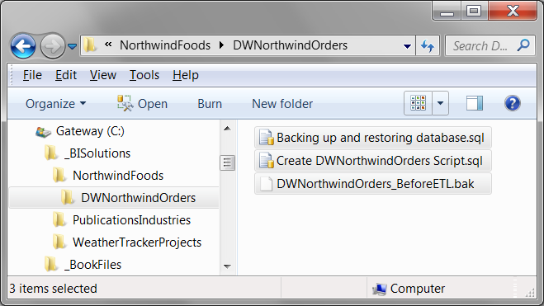
Figure 1. Placing the three files in the DWNorthwindOrders operating system folder.
- Create a new solution folder in Visual Studio called DWNorthwindOrders.
- Add the three files to the Visual Studio solution (Figure 2). Close any Visual Studio tabs that open can click the Save all button on the toolbar.

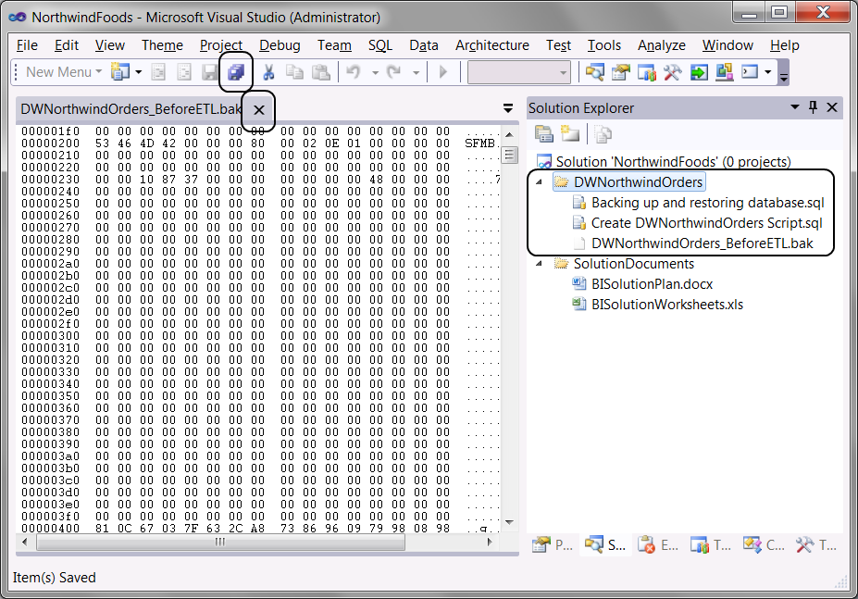
Figure 2. Adding the three files to the DWNorthwindOrders Visual Studio folder.
At the end of this chapter you database should look like the one in Figure 3. (That is of course, if you generate a diagram of the database using SQL Server Management Studio.)

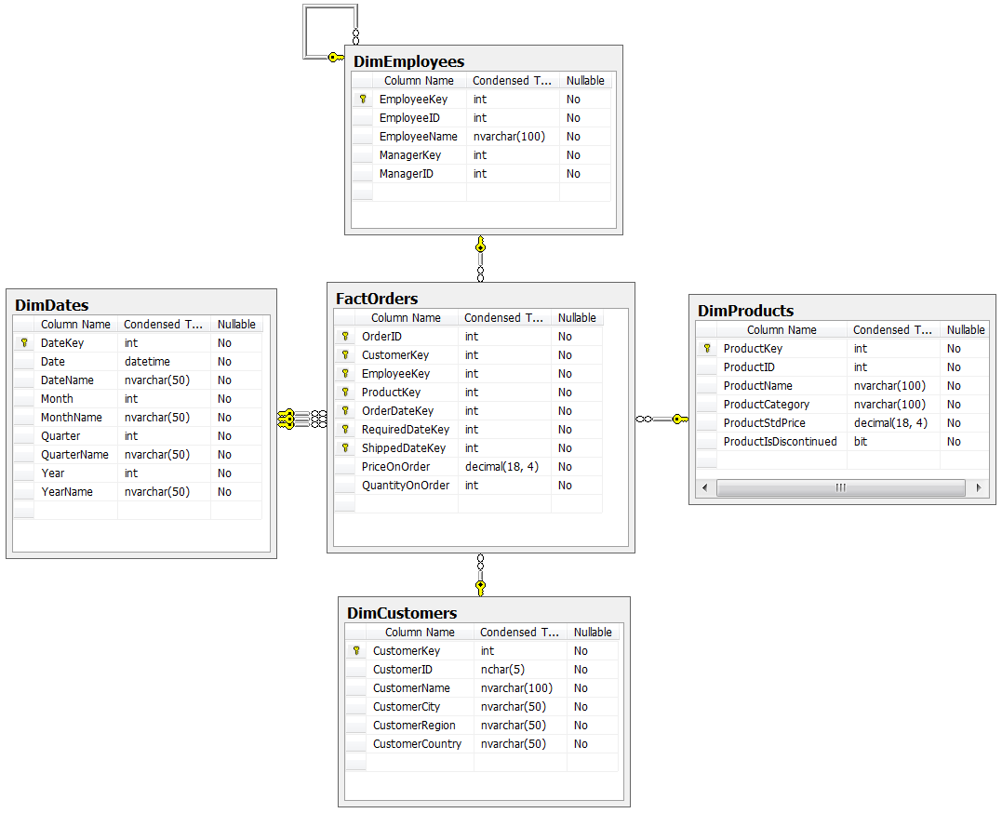
Figure 3. The completed DWNorthwindOrders database tables.

