Read Me

_BookFiles\_LearnByDoing\Chapter07Files
This folder contains listing code and the files needed for the Learn By Doing exercises in Chapter 7.

Outlined Instructions
Please use the following instruction to complete each exercise. Remember that the instructions are intentionally brief and that you may need to refer to the Pro SQL 2012 BI Solutions book for examples of how to perform these tasks.

EXERCISE 7-1. CREATING AN SSIS PROJECT
In this exercise, you create an SSIS project to perform the ETL processing required to fill the Northwind Orders data warehouse, DWNorthwindOrders.
Add a Project to the Current Solution
- Open the NorthwindFoods solution you have been working on in Chapter 6.
- Add a new project to the solution by selecting File > Add > New Project from the main menu at the top of Visual Studio (Figure 7-3). An Add New Project dialog appears (Figure 7-4).
- Select the Integration Services Project option from the center of the dialog (Figure 7-4).
- Name the Project DWNorthwindOrdersETL at the bottom of the dialog and click the OK button to add the new project to your current solution (Figure 7-4).
- Click the View > Solution Explorer menu item to display Solution Explorer (Figure 1). Note that an SSIS package has been created for you.
- Rename the Package.dtsx file to ETLProcessForDWNorthwindOrders.dtsx (Figure 1).
- Save your work using File > Save All on the Visual Studio main menu.
- Close the Getting Started window to provide more development space on your screen (Figure 7-6).
Your Visual Studio solution should now look like Figure 1. You need this solution for the next exercise, so leave it open for now.
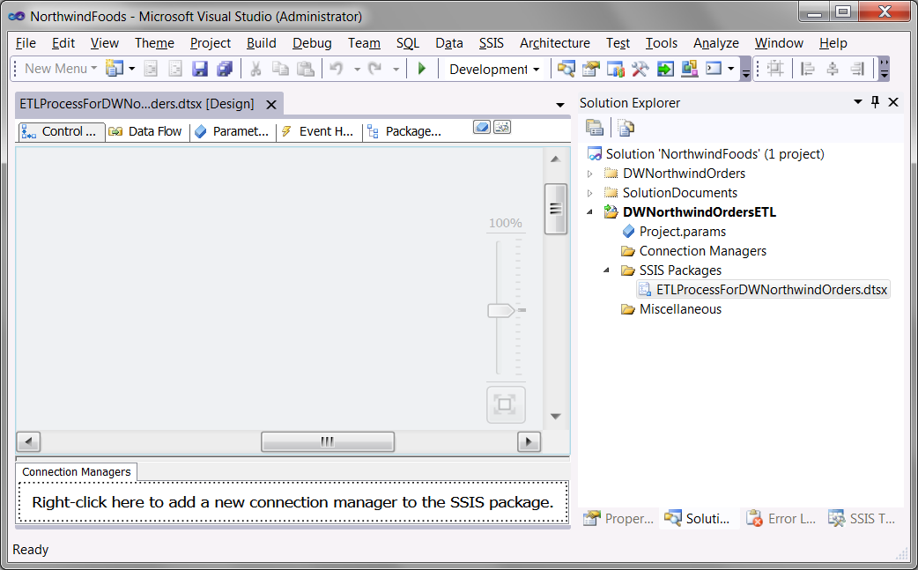
Figure 1. The NorthwindBIProjects Visual Studio solution at the end of Exercise 7-1

EXERCISE 7-2. FILLING THE DATA WAREHOUSE
In this exercise, we outline the steps needed to perform the ETL processing. The goal is to fill the DWNorthwindOrders data warehouse using the SSIS project that was created in Exercise 7-1. Figure 7-20 is an example of what your SSIS package should look like after having completed this exercise and it can be used as a reference for each of the following steps.
Add Sequence Containers
- Select the Control Flow table of the ETLProcessForDWNorthwindOrders.dtsx SSIS package you created in Exercise 7-1. Your screen should look like Figure 7-7.
- On the Control Flow tab, drag and drop four Sequence Containers to the control flow surface from the SSIS Toolbox, rename them by right-clicking the container, and select the Rename context menu item. When prompted, rename them as listed here (Figure 7-22):
- Prepare ETL Process Sequence Container
- Fill Dimension Tables Sequence Container
- Fill Fact Tables Sequence Container
- End ETL Process Sequence Container
Add Tasks to the Sequence Containers
- Drag and drop two Execute SQL Tasks into the Prepare ETL Process Sequence Container, and rename them to the following:
- Drop Foreign Keys Execute SQL Task
- Clear All Tables Execute SQL Task
- Drag and drop two Data Flow Tasks into the Fill Dimension Tables Sequence Container, and rename them to the following:
- Fill DimCustomers Data Flow Task
- Fill DimProducts Data Flow Task
- Drag and drop three Execute SQL Task into the Fill Dimension Tables Sequence Container, and rename them to the following:
- Fill DimEmployees Execute SQL Task
- Fill DimDates Execute SQL Task
- Add Null Date Lookup Values Execute SQL Task
- Drag and drop one Data Flow Tasks into the Fill Fact Tables Sequence Container, and rename it to the following:
- Fill FactOrders Data Flow Task
- Drag and drop one Execute SQL Task into the End ETL Process Tasks Sequence Containers, and rename it to the following:
- Add Foreign Key Constraints Execute SQL Task

Add Precedence Constraints
- Add Precedent constraints as shown in Figure 2.
Note: A red dot may appear on some tasks indicating that the task is not configured. As noted, we resolve this later in the chapter.
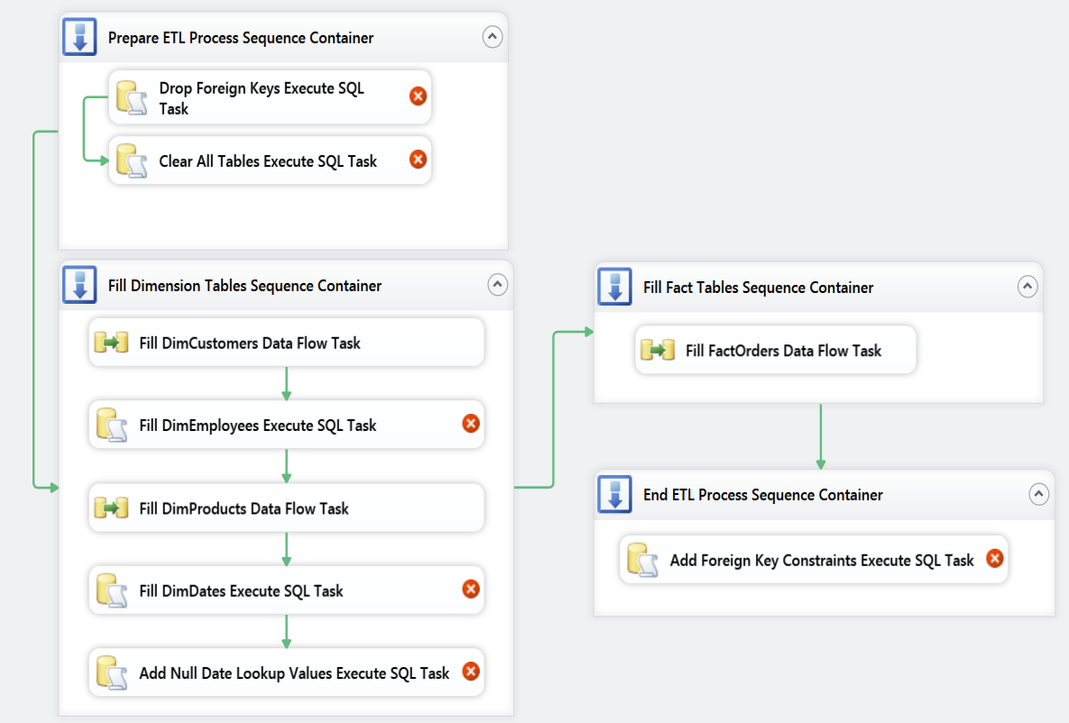
Figure 2. The SSSI package at the end of the Learn-By-Doing Exercise 7-2

EXERCISE 7-3. CONFIGURING AND TESTING TASKS
In this exercise, you continue to work on the SSIS package outlined in Exercise 7-2. In the previous exercise, you outlined all of the tasks and organized them within sequence containers. Now you focus on creating two SSIS connection managers, configuring three Execute SQL tasks, and testing that they run successfully. You also add an existing SQL code file containing all the SQL code you need to complete this exercise to the project.
Create Your Connections
Before you start to configure your SSIS tasks, you should create its connections. You need two connections: one to the Northwind database and another to the DWNorthwindOrders database. Let’s set those up now!
- At the bottom of the SSIS package designer, locate the Connection Managers tab; then right-click its background, and select New OLE DB Connection from the context menu.
- In the OLE DB Connection Manager dialog, click the New button to create a new connection. The Connection Manager dialog appears (Figure 7-27).
- In the Connection Manager dialog, type in your SQL Server’s name, typically the word (local) will suffice unless you are using a named instance of SQL server (Figure 7-27).
- On this same dialog, select or type Northwind into the “Select or enter a database name” textbox (Figure 7-27).
- Repeat this process to create a new OLE DB connection to the DWNorthwindOrders database.
- Rename the connections managers to match the naming conventions used in Figure 3.

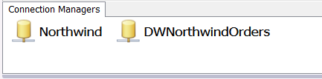
Figure 3. Two connection managers have been configured and renamed.

Adding an ETL Code File to Your Project
OK! The connections are in place; now it is time to configure the Execute SQL tasks. Let’s start with the task that drops the foreign keys from the DWNorthwindOrders database at the beginning of the ETL process, then configure the task that clears the tables out, and finally configure the task that replaces the foreign keys at the end of the ETL process. You will use your Chapter 6 script file for these tasks, so there is no need to re-create the same code. Instead, you add this SQL script file into your SSIS project and then copy and paste the sections of code you need for each task.

- Right-click the DWNorthwindOrdersETL project icon in Solution Explorer, and select the Add > Existing Item option from the context menu (Figure 7-40). An Add Existing Item dialog appears.
- Locate the C:\_BISolutions\NorthwindFoods\DWNorthwindOrdersETL\DWNorthwindOrders ETL Script.sql. file; highlight it with your mouse, and then click the Add button at the bottom of the dialog (Figure 7-41). The new file is placed in a Miscellaneous folder as part of the SSIS project.
- Once the SQL code file has been added to your project, right-click the file and choose the "Open With" option from the context menu. This opens the Open With dialog, as shown in Figure 4.
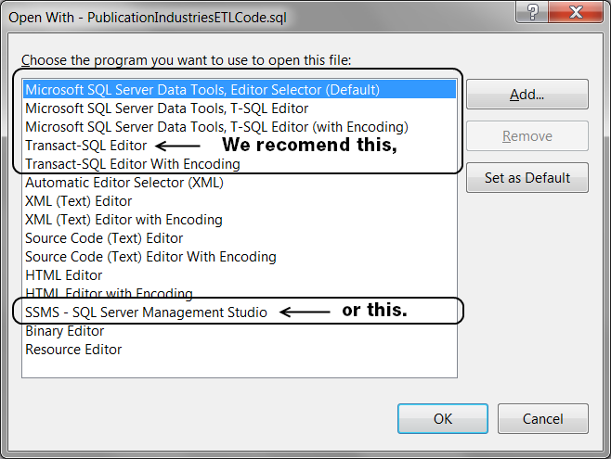
Figure 4. Selecting an editor to open the SQL file in Visual Studio
- In the Open With dialog, note the choice of editing tools avaliable.
- Select Transact-SQL Editor, and click the OK button.
Important: Depending on your Visual Studio configuration, you may not have all these options, and even if you do, some may not work. For example, opening an existing SQL code file with the Microsoft SQL Server Data Tool options does not work on some computers, and instead of seeing the code shown in Figure 7-43, a black screen appears! To avoid this issue, we recommend using the Transact-SQL Editor in this book instead of the more modern Data Tools options because this works on most computers. If you still have problems, you can always open the file in SQL Server Management Studio instead. That option is not as convenient, but it always works.

Configure the Drop Foreign Keys Execute SQL Task
With the SQL script file added and displayed in Visual Studio, it is time to use that code to configure your Execute SQL Tasks. For each task, locate code within the file, copy the code by right-clicking it, choose Copy from the context menu, and paste it into the appropriate SSIS task.
- Locate the code labeled “1a)” and verify that its purpose is to drop the foreign key constraints.
- Highlight this code, right-click it, and choose Copy from the context menu. In a moment you will paste it into the Execute SQL Task called Drop Foreign Keys Execute SQL Task.
- Edit the Drop Foreign Keys Execute SQL Task by right-clicking the task and selecting Edit from the context menu.
- Select the Connection property. A configuration dropdown box appears.
- Configure the Connection property by selecting the option DWNorthwindOrders from the dropdown box, as shown in Figure 7-28.
- Select the SQL Statement property. An ellipsis button appears.
- Configure the SQL Statement property by clicking the ellipsis button and pasting the code that you copied earlier into the Enter SQL Query dialog that appears (Figure 7-29).
- Verify that there are no SQL Go statements your code. SQL Go statements cause the Execute SQL Task to fail.
- Click the OK button to close the close SQL Query dialog.
- Click the OK button to close the Execute SQL Task editor.
Configure the Clear All Tables Execute SQL Task
- Locate the code labeled “1b)” and verify that its purpose is to truncate the tables’ data. The code you’re looking for should look like Listing 7-4.
- Highlight this code, right-click it, and choose Copy from the context menu.
- Edit the Truncate Tables Execute SQL Task by right-clicking the task and selecting Edit from the context menu.
- Select the Connection property. A dropdown box appears.
- Configure the Connection property by selecting the option of DWNorthwindOrders from the dropdown box, as shown in Figure 7-28.
- Select the SQL Statement property. An ellipsis button appears.
- Configure the SQL Statement property by clicking the ellipsis button and pasting the code that you copied earlier into the Enter SQL Query dialog that appears.
- Remove any SQL Go statements your code.
- Click the OK button to close the Enter SQL Query dialog.
- Click the OK button to close the Execute SQL Task editor.
Configure the Add Foreign Key Execute SQL Task
- Locate the code labeled “Step 3)” and verify that its purpose is to replace the foreign key constraints that were dropped earlier. The code you’re looking for should look like Listing 7-5 and is towards the bottom of the script file.
- Highlight this code, right-click it, and choose Copy from the context menu.
- Edit the Add Foreign Key Execute SQL Task by right-clicking the task and selecting Edit from the context menu.
- Select the Connection property. A dropdown box appears.
- Configure the Connection property by selecting the option of DWNorthwindOrders from the dropdown box, as shown in Figure 7-28.
- Select the SQL Statement property. An ellipsis button appears.
- Configure the SQL Statement property by clicking the ellipsis button and pasting the code from Listing 7-5 that you copied earlier into the Enter SQL Query dialog that appears.
- Remove any SQL Go statements your code.
- Click the OK button to close the Enter SQL Query dialog.
- Click the OK button to close the Execute SQL Task editor.
Reset the Database Objects Before Testing Your ETL Process
With these three Execute SQL tasks configured, it is important to test that they work correctly. But, before we do so, let’s make sure that the database is in its normal empty state by running the SQL code that re-creates the database.
- Locate the Create DWNorthwindOrders Script.sql file in Visual Studio or in SQL Server Management Studio. You should find this file under the DWNorthwindOrders solution folder you created in Exercise 5-4.
- Open this file and execute its code. You can do this by right-clicking an area in the SQL code window to bring up the context menu and select Execute SQL. You may remember doing this back in Chapter 2 (Figure 2-15).
- When the Connect to Database Engine dialog box appears, type in your server name, and click the Connect button.
Testing Your Tasks
Now we test the Execute SQL tasks you just configured.
- Right-click your SSIS task called Drop Foreign Keys Execute SQL Task and select Execute Task from the context menu (Figure 7-33).
- Verify that the tasks runs successfully, and if not, troubleshoot why (Figure 7-38).
Note: If you need to change setting in the task, you must first stop the debugging engine.
- Right-click your SSIS task called Truncate Tables Execute SQL Task and select Execute Task from the context menu.
- Verify that the task runs successfully, and if not, troubleshoot why.
- Right-click your SSIS task called Add Foreign Keys Execute SQL Task and select Execute Task from the context menu.
- Verify that the task runs successfully, and if not, troubleshoot why.
- Stop the debugger using the Debug menu or by clicking the link at the bottom of the screen (Figure 7-36).
At this point we are have not completed the ETL process, but we are done with the exercises in this chapter. We will finish the ETL process in the next chapter.
Update the Solution Documents
- Please take a moment to review the updated version of the BISolutionWorksheets.xls and BISolutionPlan.docx files. (_BookFiles\_LearnByDoing\Chapter07Files\ UpdatedBISolutionWorksheets.xls and UpdatedBISolutionPlan.docx).
- Review the ETL Objects tab in the Excel spreadsheet. Notice that we have updated this tab with our current design changes.
- Review the SSIS ETL Objects section of the Word document. Notice that we have updated this section with our current design changes.
- Copy the UpdatedBISolutionWorksheets.xlsx and the UpdatedBISolutionPlan.docx documents
- Navigate to the C:\_BISolutions\NorthwindFoods folder and paste both of these documents into it.
- Delete the current BISolutionWorksheets.xlsx and BISolutionPlan.docx files
- Rename the UpdatedBISolutionWorksheets.xlsx file to BISolutionWorksheets.xlsx.
- Rename the UpdatedBISolutionPlan.docx file BISolutionPlan.docx.
With this last step, you have created and test some of the ETL processing tasks. You will complete the remainder of the tasks in the Chapter 8 Learn By Doing exercise.

