Read Me

_BookFiles\_LearnByDoing\Chapter08Files
This folder contains listing code and the files needed for the Learn By Doing exercises in Chapter 8.

Outlined Instructions

EXERCISE 8-1. COMPLETING THE SSIS PACKAGE
In this exercise, you complete the SSIS package by configuring all of the remaining tasks, test them, and then verify that the entire SSIS package can execute as a whole. Use the same code file from Exercise 7-3 of Chapter 7 for all of SQL code required in this exercise.
Reset the Database Objects Before Testing Your ETL Process
Before we begin configuring and testing our tasks, let’s make sure that the database is in its normal empty state by running the SQL code that re-creates the database.
- Locate the Create DWNorthwindOrders Script.sql file in Visual Studio or SQL Server Management Studio (Figure 1). You should find this file under the DWNorthwindOrders solution folder you created in Exercise 5-4.

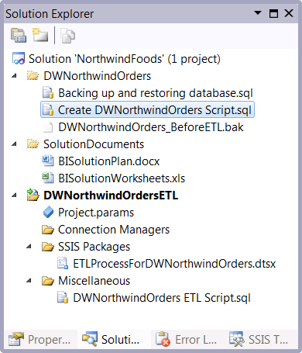
Figure 1. Locating the create DWNorthwindOrders script
- Open this file and execute its code in either Visual Studio or SQL Server Management Studio to re-create the database.

Fill DimCustomers Data Flow Task
Now, you use code inside of the DWNorthwindOrders ETL Script.sql file for configuring the task that fills DimCustomers table.
- Open the DWNorthwindOrders ETL Script.sql SQL script file in Visual Studio or SQL Server Management Studio (Figure 1) and locate the code that is commented as -- Step 2 Code used to fill tables.
- Navigate to the Data Flow tab and select Fill DimCustomers Data Flow Task from the Data Flow Task dropdown box.
- Add an OLE DB Data Source to the data flow surface. Rename it to Get Customer Data OLE DB Source.
- Locate the comment -- 2a) Get source data from Northwind.dbo.Customers in the SQL code file and review the code beneath it.
- Add this code to the SQL command text code area of the OLE DB data source as shown in Figure 8-8.
- Click the Preview button to verify that the query worked successfully.
- Click the Columns page to force the XML to be written properly in the .dtsx file.
- Close the OLE DB Source Editor window by clicking the OK button.
- Add an OLE DB Data Destination to the data flow. Rename it to Load DimCustomers OLE DB Destination.
- Connect the data flow path from the source to the destination.
- Edit the OLE DB data destination as shown in Figure 8-14. Selecting the DimCustomers table as the destination.
- Click the Mappings page to force the XML to be written properly in the .dtsx file and verify that the mappings look like Figure 8-16.
- Verify that the data flow looks similar to Figure 2.
Important: You do not need to configure anything more than the connection and the table name. Leave all the checkboxes on their default settings as shown. Nor should you need to do anything on the mappings page since our code uses column aliases that match the column names in the data warehouse tables. Just verify that the mappings are correct and move on.
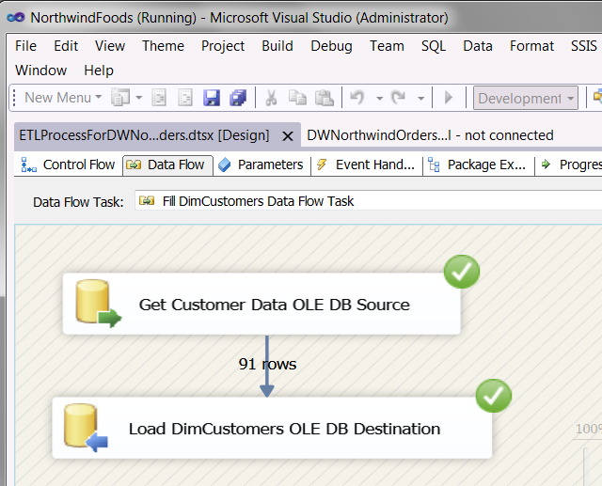
Figure 2. Verifying the Fill DimCustomers data flow task
- Right click the data flow design surface and choose Execute Task from the context menu. Visual Studio launches this data flow task with its debugging engine (Figure 8-18).
- When the task is complete, stop Visual Studio’s debugger and verify that the task ran successfully; or, if there are errors, troubleshoot and try again. You can stop the debugger using the Debug menu or by clicking the link at the bottom of the screen.
- Open SQL Server Management Studio and verify that DimCustomers has data in it.
Tip: Common errors include primary and foreign key violations. If those happen to you, try running the Execute SQL tasks that you created in Exercise 7-3 to clear the table data and drop the foreign key constraints. You can run both by executing the Prepare ETL Process sequence container.
Fill DimEmployees Execute SQL Task
- Locate the comment -- 2b) Get source data from Northwind.dbo.Employees in the SQL code file and review the code beneath it. The code should look like Listing 8-4.
Note that the code for this task is divided into 4 sub-steps, so make sure the copy all of them.
- Highlight this code, right-click it, and choose Copy from the context menu.
- Navigate to the Control Flow tab and select the Fill DimEmployees Execute SQL Task.
- Edit the Fill DimEmployees Execute SQL Task by right-clicking the task and selecting Edit from the context menu.
- Select the Connection property. A dropdown box appears in the dialog window that will let you configure this property.
- Configure the Connection property by selecting the option DWNorthwindOrders from the dropdown box, as shown in Figure 3.
- Select the SQL Statement property. An ellipsis button appears in the dialog window that will let you configure this property.
- Configure the SQL Statement property by clicking the ellipsis button and pasting the code into the Enter SQL Query dialog window that appears (Figure 3).
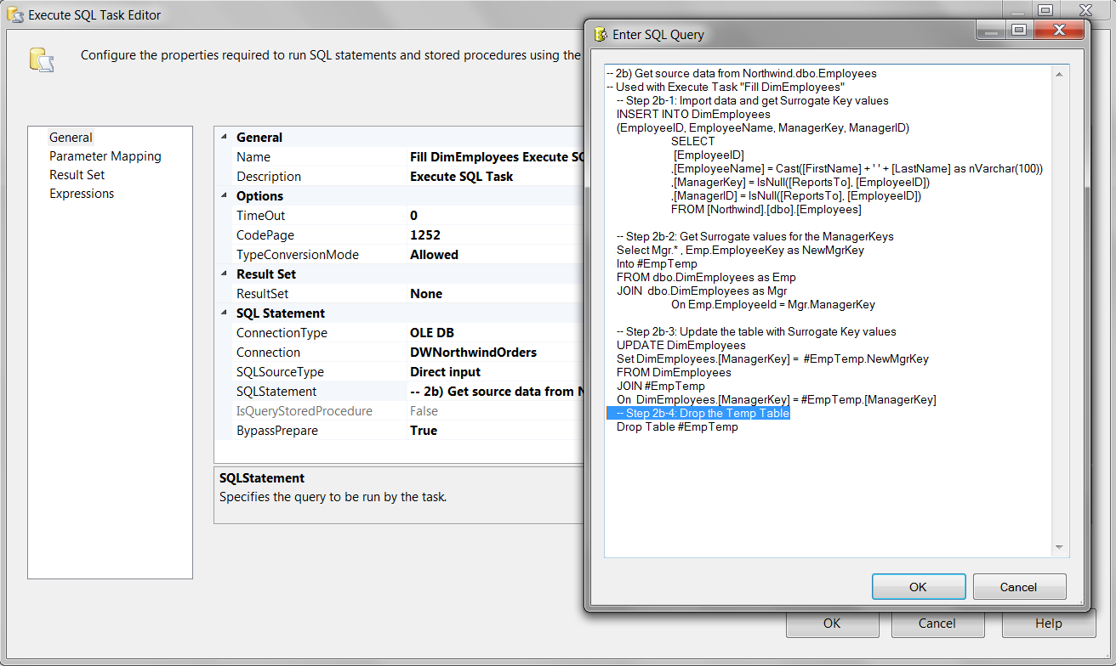
Figure 3. Adding ETL code the Fill DimEmployees execute sql task
- Remove any SQL Go statements from your code. SQL Go statements will cause the Execute SQL Task to fail.
- Click the OK button to close the Enter SQL Query dialog window.
- Click the OK button to close the Execute SQL Task editor.
- Right-click the Fill DimEmployees Execute SQL Task and choose Execute Task from the context menu (Figure 8-20).
- When the task is complete, stop Visual Studio’s debugger and verify that the task ran successfully; if there are errors, troubleshoot and try again.
- Open SQL Server Management Studio and verify that DimEmployees has data in it.
Configure the Fill DimProducts Data Flow Task
- Navigate to the Data Flow tab and select the Fill DimProducts Data Flow Task from the Data Flow Task dropdown box.
- Add an OLE DB Data Source to the data flow surface. Rename it to Get Products Data OLE DB Source.
- Locate the comment -- 2c) Get source data from Northwind.dbo.products in the SQL code file and review the code beneath it.
- Add this code to the SQL command text code area of the OLE DB data source (similar to Figure 8-8).
- Click the Preview button to verify that the query worked successfully.
- Click the Columns page to force the XML to be written properly in the .dtsx file.
- Close the OLE DB Source Editor window by clicking the OK button.
- Add an OLE DB Data Destination to the data flow surface. Rename it to Load DimProducts OLE DB Destination.
- Connect the data flow path from the data source to the data destination.
- Edit the OLE DB data destination so that it imports data to the DimProducts table (similar to Figure 8-14).
- Click the Mappings page to force the XML to be written properly in the .dtsx file and verify that the mappings look logically correct.
- Right click the data flow design surface and choose Execute Task from the context menu (similar to Figure 8-18).
- When the task is complete, stop Visual Studio’s debugger and verify that the task ran successfully or troubleshoot any errors and try again.
- Open SQL Server Management Studio and verify that DimProducts has data in it.

Configure the Fill DimDates Execute SQL Task
- Locate the comment -- 2d) Create values for DimDates as needed in the SQL code file and review the code beneath it. The code should look like Listing 8-4.
- Highlight this code, right-click it, and choose Copy from the context menu.
- Navigate to the Control Flow tab and select the Fill DimDates Execute SQL Task.
- Right-click this task and select Edit from the context menu.
- Edit the Fill DimDates Execute SQL Task by right-clicking the task and selecting Edit from the context menu.
- Select the Connection property. A dropdown box appears in the dialog window that will let you configure this property.
- Configure the Connection property by selecting the option DWNorthwindOrders from the dropdown box, as shown in Figure 8-19.
- Select the SQL Statement property. An ellipsis button appears in the dialog window that will let you configure this property.
- Configure the SQL Statement property by clicking the ellipsis button and pasting the into the Enter SQL Query dialog window that appears.
- Remove any SQL Go statements from your code. SQL Go statements will cause the Execute SQL Task to fail.
- Click the OK button to close the Enter SQL Query dialog window.
- Click the OK button to close the Execute SQL Task editor.
- Right-click the Fill DimDates Execute SQL Task and choose Execute Task from the context menu (Figure 8-20).
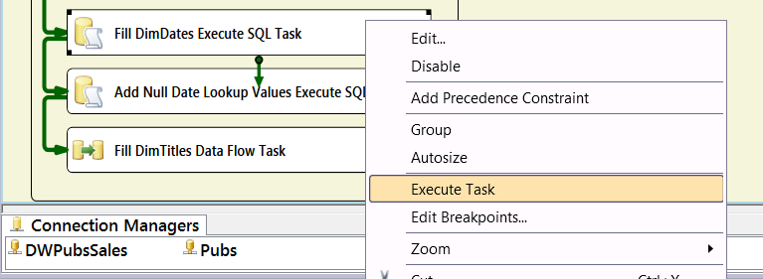
Figure 8-20. Executing the Fill DimDate Execute SQL Task
- When the task is complete, stop Visual Studio’s debugger and verify that the task ran successfully; if there are errors, troubleshoot and try again.
- Open SQL Server Management Studio and verify that DimDates has data in it.

Configure the Add Null Date Lookup Values Execute SQL Task
Now we need to add a couple of dates used to for null value lookups to the DimDates table. This was an option we discussed in Chapter 6 but have waited until now to implement it.
- Locate the comment -- 2e) Add additional lookup values to DimDates in the SQL code file and review the code beneath it. The code should look like Listing 8-5.
- Highlight this code, right-click it, and choose Copy from the context menu.
- Navigate to the Control Flow tab and select the Add Null Date Lookup Values Execute SQL Task.
- Edit the Add Null Date Lookup Values Execute SQL Task by right-clicking the task and selecting Edit from the context menu.
- Select the Connection property. A dropdown box appears in the dialog window that will let you configure this property.
- Configure the Connection property by selecting the option DWNorthwindOrders from the dropdown box (Figure 8-21).
- Select the SQL Statement property. An ellipsis button appears in the dialog window that will let you configure this property.
- Configure the SQL Statement property by clicking the ellipsis button and pasting the code from Listing 8-5 that you copied earlier into the Enter SQL Query dialog window that appears (Figure 8-21).
- Verify that there are no SQL Go statements your code. SQL Go statements will cause the Execute SQL Task to fail.
- Click the OK button to close the Enter SQL Query dialog window.
- Click the OK button to close the Execute SQL Task editor.
- Right click then Add Null Date Lookup Values Execute SQL Task and choose Execute Task from the context menu (similar to Figure 8-20). Visual Studio will launch this Execute SQL task with its debugging engine.
- When the task is complete, stop Visual Studio’s debugger and verify that the task ran successfully; if there are errors, troubleshoot and try again.
- Open SQL Server Management Studio and verify that DimDates has data in it. Figure 8-22 displays what the data should look like.

Configure the Fill FactOrders Data Flow Task
- Navigate to the Data Flow tab and select the Fill FactOrders Data Flow Task from the Data Flow Task dropdown box.
- Add an OLE DB Data Source to the Data Flow surface. Rename it to Get Orders Data OLE DB Destination.
- Locate the comment -- 2f)Get source data from Northwind.dbo.Orders, Order Details and exiting dimension tables in the SQL code file and review the code beneath it. The code should look like Listing 8-8.
- Edit the OLE DB data source to connect to the DWNorthwindOrders connection.
- Click the Preview button to verify that the query worked successfully.
- Click the Columns page to force the XML to be written properly in the .dtsx file.
- Close the OLE DB Source Editor window by clicking the OK button.
- Add an OLE DB Data Destination to the Data Flow surface. Rename it to Load FactOrders OLE DB Destination.
- Connect the Data Flow Path from the source to the destination.
- Edit the OLE DB data destination so that it imports data to the FactOrders table (similar to Figure 8-14).
- Click the Mappings page to force the XML to be written properly in the .dtsx file and verify that the mappings look logically correct.
- Right-click the data flow design surface and choose Execute Task from the context menu. Visual Studio will launch this data flow task with its debugging engine.
- When the task complete, stop Visual Studio’s debugger and verify that the task ran successfully or troubleshoot any errors and try again.
- Open SQL Server Management Studio and verify that FactOrders has data in it.
In this exercise, you configured the SSIS tasks that filled the dimension and fact tables of the DWNorthwindOrders data warehouse. You also tested each tasks as you went. Now we need to test that the entire SSIS package runs successfully as a whole.

EXERCISE 8-2: TESTING YOUR SSIS PACKAGE
In this exercise, you will test that the entire package works as expected by resetting the database and executing the package.

Reset the Database Objects Before Testing Your ETL Process
- Locate the Create DWNorthwindOrders Script.sql file in Visual Studio.
- Open this file and execute its code.
Testing Your SSIS Package
Now it is time to execute the entire SSIS package to verify that it runs as a unit.
- In Solution Explorer, right-click your SSIS package called ETLProcessForDWNorthwindOrders.dtsx and select Execute Task from the context menu, as shown in Figure 8-24. Visual Studio will launch this Execute SQL task with its debugging engine.
- When the task is complete, stop Visual Studio’s debugger and verify that the task ran successfully or troubleshoot any errors and try again. It should look like Figure 8-25.
- Open SQL Server Management Studio and verify that all the tables have data in them. You can use the code from Listing 1.
Listing 1. Code used to verify the ETL process
Select Top 100 * from DWNorthwindOrders.dbo.DimCustomers
Select Top 100 * from DWNorthwindOrders.dbo.DimEmployees
Select Top 100 * from DWNorthwindOrders.dbo.DimProducts
Select Top 100 * from DWNorthwindOrders.dbo.DimDates
Select Top 100 * from DWNorthwindOrders.dbo.FactOrders
- Once you have verified that the data is loaded, create a backup of the database in its filled state using the code in Listing 2.
Listing 2. Backing Up the Filled DWNorthwindOrders Database
Backup Database DWNorthwindOrders
To Disk='C:\_BISolutions\NorthwindFoods\DWNorthwindOrders\DWNorthwindOrders_AfterETL.bak'
With Init
In this exercise, you tested the SSIS package that filled the DWNorthwindOrders database. SSIS can be challenging to master, but with practice you will find it is a superior tool for performing ETL processing.
n Note Remember, if you had any trouble completing this exercise, you can always compare your package to the authors’ completed version. Optionally, you can restore the filled database using the SQL database backup file: C:\_BookFiles\LearnByDoing\Chapter08Files\FilledDWNorthwindOrdersDB.bak.

