Read Me

_BookFiles\_LearnByDoing\Chapter09Files
This folder contains listing code and the files needed for the Learn By Doing exercises in Chapter 9.
n Note Remember, if you had any trouble completing the Chapter 8 exercises, you can restore the filled database using the SQL database backup file: C:\_BookFiles\_LearnByDoing\Chapter08Files\FilledDWNorthwindOrdersDB.bak.

Outlined Instructions
We have created updated versions of the BISolutionPlan.docx and the BISolutionWorksheet.xlsx files that recorded the new SSAS objects. Optionally, if you would like an overview of the SSAS objects you will be creating in the few chapters, quickly review these documents before you begin the following exercises.

EXERCISE 9-1 CREATING A DATA SOURCE AND DATA SOURCE VIEW
In this exercise, you add a new SSAS project to your current Visual Studio Solution and create a new data source and data source view within the project. Once completed, your SSAS project should look similar to Figure 9-33.
Add an SSAS Project to an Existing Solution
- Open Business Intelligence Development Studio, and select Start -> All Programs -> Visual Studio 2010.
- Open the NorthwindFoods.sln file you have been working on in the previous chapter by selecting File -> Open -> Project/Solution from the main menu at the top of Visual Studio. When the Open Project dialog window opens, navigate to the C:\_BISolutions\NorthwindFoods\NorthwindFoods.sln file to open the solution.
- Add a new SSAS project to the solution by selecting File -> Add -> New Project from the main menu at the top of Visual Studio or by right-clicking the Solution icon in Solution Explorer (Figure 9-8).
- When the Add New Project dialog window appears, select the Analysis Services Multidimensional Cube project template and name the project NorthwindBICubes (Figure 9-9).
Create a Data Source
- Create a new data source that connects to the DWNorthwindOrders data warehouse by right-clicking the Data Source project folder and selecting New Data Source from the context menu, as shown in Figure 9-11 and 9-12.
- Configure the Impersonation Information dialog window to use a specific Windows account (Figure 9-13).
Type in a user name in this format: your_computer_name\a_SQL_and_SSAS_administrator (for example, MyPC\BobSmith). Type in the Windows password into the password textbox and click Next to advance the wizard to the final dialog window.
- In the final dialog window, enter the name of the data source as DWNorthwindOrders (Figure 9-15).

Create a Data Source View
- Create a new data source view by right-clicking the data source view project folder and selecting New Data Source from the context menu (Figure 9-18).
- When the Data Source View Wizard appears, click Next to continue to the second dialog window and select the data source you just created from the Relational Data Sources list box (Figure 9-20). Click Next to continue.
- In the Select Table and Views dialog window, highlight all the dimension and fact tables from the Available Objects list box and click the arrow button to insert them into the Included Objects list box, as shown in Figure 9-22.
- Click Next to proceed to the wizard’s final dialog window and name your data source view DWNorthwindOrdersTables.
Add a Friendly Name
- Right-click the Date column in the DimDates table, and select Properties from the context menu.
- When the Properties window appears, change the FriendlyName property to FullDate. At this point, your SSAS project should look similar to the one shown in Figure 1.
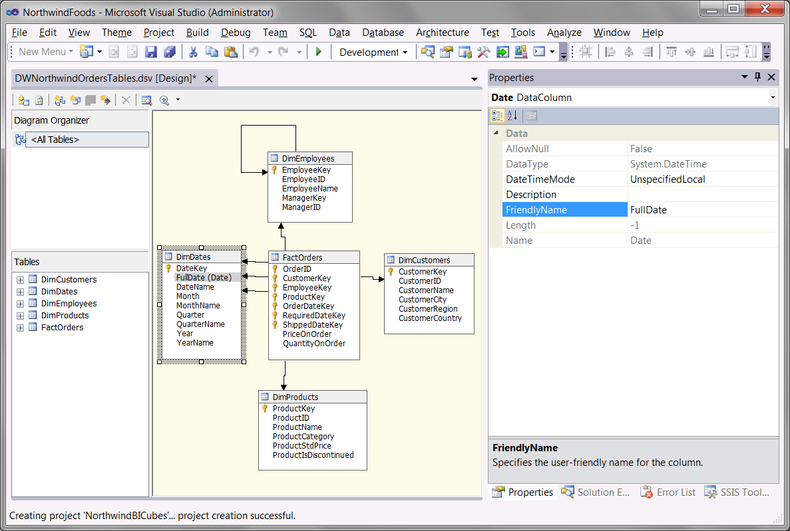
Figure 1. The DWNorthwindTables data source view
- Save your work by selecting File -> Save All from the Visual Studio main menu.
- Leave the Visual Studio solution open for the next exercise.

EXERCISE 9-2: CREATING THE DIMENSIONS
In this exercise, you create the dimensions for the SSAS project. In our current design we have five dimensions to create: Customers, Employees, Products, Dates, and Orders. Let’s start with the Customers dimension.
Create the Customers Dimension
- Start the Dimension Wizard by right-clicking the Dimensions folder in Solution Explorer, as shown in Figure 9-34.
- When the wizard opens, click Next to advance to the Select Creation Method dialog window (Figure 9-35). Choose the Use an Existing Table radio button, and click Next to advance to the Specify Source Information dialog window.
- Choose DWNorthwindOrdersTables in the “Data source view” dropdown box of the Specify Source Information dialog window, as shown in Figure 9-36.
- In the “Main table” dropdown box, choose the DimCustomers table, as shown in Figure 9-37.
- In the “Key columns” list box, choose the CustomerKey column, as shown in Figure 9-38.
- In the “Name column” dropdown, choose the CustomerName column, as shown in Figure 9-39. Click Next to advance to the Select Related Tables dialog window.
- Check all the attributes in the Select Dimension Attributes dialog window, as shown in Figure 9-41.
- Change the attribute type for the Customer Id attribute to Slowly Changing Dimension - Original Id (Figure 2)
- When you have completed this, the dialog window should look like Figure 2.
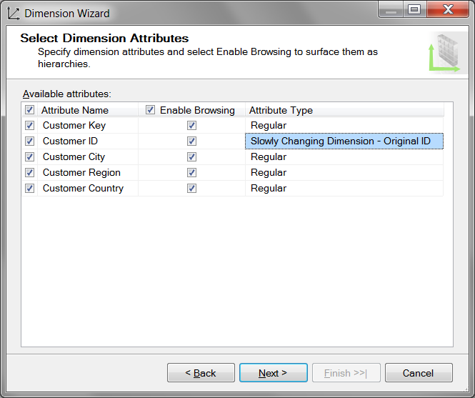
Figure 2. Selecting the attributes for the Customers dimension
- Click Next to advance to the Completing the Wizard dialog window.
- Rename the dimension from Dim Customers to DimCustomers (Figure 9-44), and then click Finish to complete the wizard.
- Use the Build menu to verify that the DimCustomers dimension builds successfully. If it does not, troubleshoot the problem or delete the dimension from Solution Explorer and create the dimension again, being careful to include any steps you may have omitted.

Create the Employees Dimension
- Start the Dimension Wizard by right-clicking the Dimensions folder in Solution Explorer.
- Click Next to advance to the Select Creation Method dialog window, and choose the Use an Existing Table radio button.
- Click Next to advance to the Specify Source Information dialog window, and choose DWNorthwindOrdersTables in the “Data source view” dropdown box, as shown in Figure 9-49.
- In the “Main table” dropdown box, choose the DimEmployees table.
- In the “Key columns” list box, choose the EmployeeKey column.
- In the “Name column” dropdown box, choose the EmployeeName column, and click Next to advance to the Select Dimension Attributes dialog window.
- Check all the checkboxes in the Select Dimension Attributes dialog window (Figure 3).
- Change the attribute type for the Employee ID and Manager ID attribute to Slowly Changing Dimension - Original ID.
- When you have completed this, the dialog window should look like Figure 3.
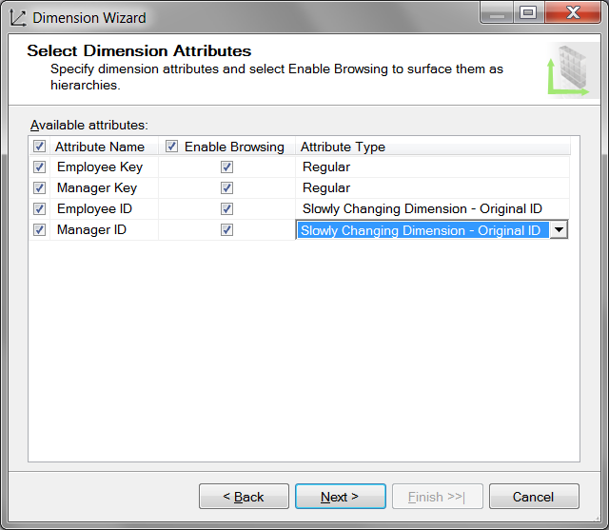
Figure 3. Selecting the attributes for the Employees dimension
- Click Next to advance the wizard.
- Change the name of your new dimension to the DimEmployees in the Completing the Wizard dialog, and then click Finish to complete the wizard.
- Use the Build menu to verify that the DimCustomers dimension builds successfully. If it does not, troubleshoot the problem or delete the dimension from Solution Explorer and go through the steps again, being careful to include any steps you may have omitted.

Create the Products Dimension
- Start the Dimension Wizard by right-clicking the Dimensions folder in Solution Explorer.
- Click the Next button to advance to the Select Creation Method dialog window, and choose the Use an Existing Table radio button.
- Choose DWNorthwindOrdersTables in the “Data source view” dropdown box within the Specify Source Information dialog window.
- In the “Main table” dropdown box, choose the DimProducts table.
- In the “Key columns” list box, choose the ProductKey column.
- In the “Name column” dropdown box, choose the ProductName column, and click Next to advance to the Select Dimension Attributes dialog window.
- Check all the checkboxes in the Select Dimension Attributes dialog window.
- Change the attribute type for the Product ID attribute to Slowly Changing Dimension - Original ID.
- When you have completed this, the dialog window should look like Figure 4.
- Click Next to advance the wizard.
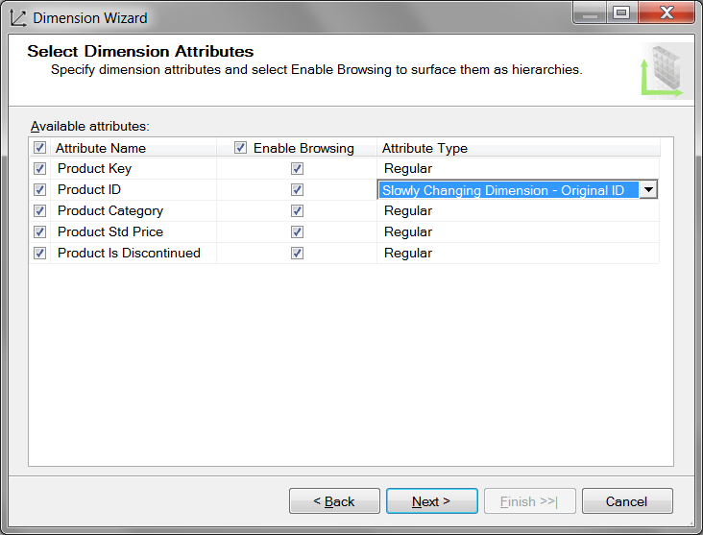
Figure 9-51. Selecting the attributes for the Products dimension
- Change the name of your new dimension to the DimProducts in the Completing the Wizard dialog window by removing the space between the word Dim and Products.
- Click Finish to complete the wizard.
- Use the build menu to verify that the DimProducts dimension builds successfully. If it does not, troubleshoot the problem or delete the dimension from Solution Explorer and go through the steps again, being careful to include any steps you may have omitted.
Create the Date Dimension
The Date dimension has nine columns. Most of these columns will be combined into name and key pairs so that we will end up with only five attributes. An example of this is combining the YearName column and year column into one dimensional attribute called year. Unfortunately, the wizard is unable to completely configure the attributes. Therefore, we select only a few columns during the wizard’s creation process and configure the attributes after the wizard is complete.
- Start the Dimension Wizard by right-clicking the Dimensions folder in Solution Explorer.
- Click Next to advance to the Select Creation Method dialog window, and choose the Use an Existing Table radio button. Click Next to advance to the Specify Source Information dialog window.
- Choose DWNorthwindOrdersTables in the “Data source view” dropdown box within the Specify Source Information dialog window.
- In the “Main table” dropdown box, choose the DimDates table.
- In the “Key columns” list box, choose the DateKey column.
- In the “Name column” dropdown box, choose the DateName column and click Next to advance to the Select Dimension Attributes dialog window.
- Check the Date Key, Full Date, Month, Quarter, and Year checkboxes in the Select Dimension Attributes dialog window (Figure 9-52).
- Date Key as Calendar -> Date
- Full Date as Calendar -> Date
- Month as Calendar -> Month
- Quarter as Calendar -> Quarter
- Year as Calendar -> Year
- Change the attribute types for the attributes listed here (Figure 9-52). When you have completed these steps, the dialog window should look like Figure 5.
- Click Next to advance the wizard.
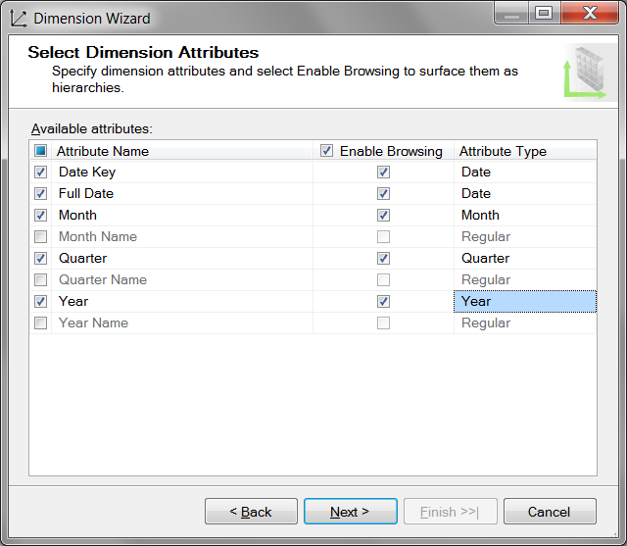
Figure 5. Selecting the attributes for the DimDates dimension
- Change the name of your new dimension to DimDates In the completing the Wizard dialog window, and then click Finish to complete the wizard.
- Use the build menu to verify that the DimDates dimension builds successfully. If it does not, troubleshoot the problem or delete the dimension from Solution Explorer and go through the steps again, being careful to include any steps you may have omitted.
Create the Orders Dimension
The last dimension we need to make is the Orders dimension. If you recall, this dimension is a fact dimension, meaning that all the columns we need to create the dimension are in a fact table. This dimension is also created using the wizard.
- Start the Dimension Wizard by right-clicking the Dimensions folder in Solution Explorer.
- Click Next to advance to the Select Creation Method dialog window, and choose the Use an Existing Table radio button. Click Next to advance to the Specify Source Information dialog window.
- Choose DWNorthwindOrdersTables in the “Data source view” dropdown within the Specify Source Information dialog window box, as shown in Figure 9-33.
- In the “Main table” dropdown box, choose the FactOrders table.
- In the “Key columns” list box, choose the OrderID column.
Important: You need to deselect all other columns besides the OrderNumber column. To do so, highlight each errant column, open the dropdown box, and click the blank area just above the column listing. For example, in Figure 9-53, the blank area is just above the ProductKey.
- In the “Name column” dropdown box, choose the OrderID column, and click Next to advance to the Select Dimension Attributes dialog window (Figure 9-54).
- In the Select Related Tables dialog window, uncheck all of the checkboxes, as shown in Figure 6. Click Next to advance to the Select Dimension Attributes dialog window.
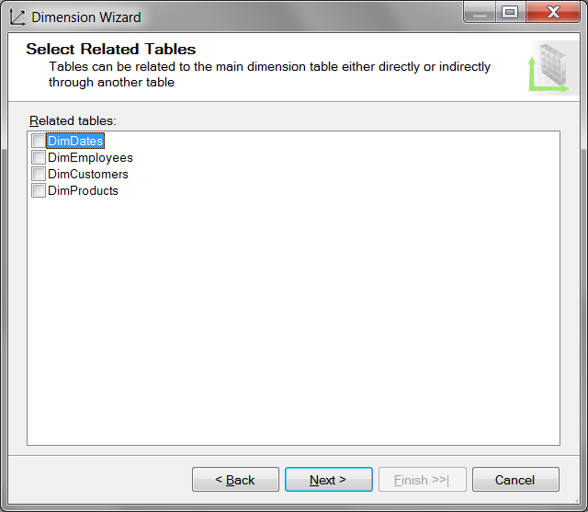
Figure 6. Unchecking the unrelated tables
- On the Select Dimension Attributes dialog window, uncheck all the checkboxes. except for the Order ID (Figure 7).
- Click Next to advance to the final Dimension Wizard dialog window.
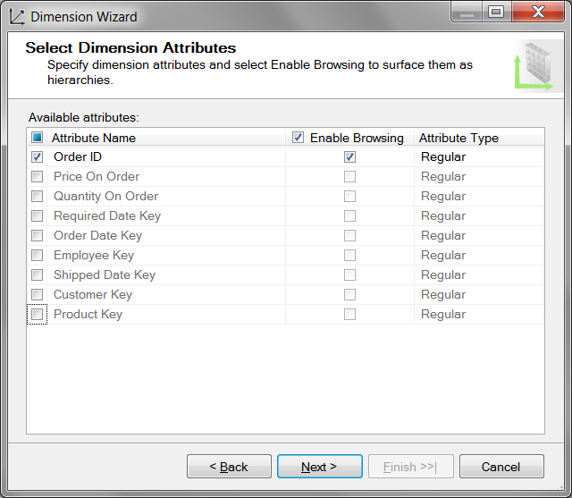
Figure 7. Unchecking the unrelated attributes
- In the Completing the Wizard dialog window, change the name of your new dimension to DimOrders, and then click Finish to complete the wizard.
- Use the Build menu to verify that the DimOrders dimension builds successfully. If it does not, troubleshoot the problem or delete the dimension from Solution Explorer and go through the steps again, being careful to include any steps you may have omitted.
In this exercise, we created five dimensions using the Dimension Wizard. At this point, all the dimensions are created but still need additional configurations. You will do those configurations in Chapter 10's Learn By Doing exercises.

