Read Me

_BookFiles\_LearnByDoing\Chapter10Files
This folder contains listing code and the files needed for the Learn By Doing exercises in Chapter 10.

Outlined Instructions
Please use the following instructions to complete each exercise. Remember that the instructions are intentionally brief and that you may need to refer to the Pro SQL 2012 BI Solutions book for examples of how to perform these tasks.

EXERCISE 10-1: CONFIGURING KEYS, NAMES, AND HIERARCHIES
In this exercise you will start configuring your dimensions by verifying or changing the names, keys, and hierarchy properties.
Configure the Customers Dimension
We begin by configuring the Customers dimension.
- Open the DimCustomers dimension editor by right-clicking the dimension in Solution Explorer and selecting View Designer from the context menu.
- When the dimension editor opens, select each attribute and use the Properties window to change or verify the settings shown in Table 1.
Table 1. The Initial Property Settings for the DimCustomers Dimension
Attribute | Property Name | Value
Customer Key | Name | Customer
 | KeyColumn | DimCustomers.CustomerKey
 | NameColumn | DimCustomers.CustomerName
 | AttributeHierarchyVisible | True
Customer ID | Name | CustomerID
 | KeyColumn | DimCustomers.CustomerID
 | NameColumn | DimCustomers.CustomerID
 | AttributeHierarchyVisible | True
Customer City | Name | CustomerCity
 | KeyColumn | DimCustomers.CustomerCity
 | NameColumn | DimCustomers.CustomerCity
 | AttributeHierarchyVisible | True
Customer Region | Name | CustomerRegion
 | KeyColumn | DimCustomers.CustomerRegion
 | NameColumn | DimCustomers.CustomerRegion
 | AttributeHierarchyVisible | True
Customer Country | Name | CustomerCountry
 | KeyColumn | DimCustomers.CustomerCountry
 | NameColumn | DimCustomers.CustomerCountry
 | AttributeHierarchyVisible | True

- Create a user-defined hierarchy for Customers, grouped by Cities, Regions, and Countries, by dragging and dropping the CustomerCountry attribute to the Hierarchies section of the dimension editor. This creates a new hierarchy.
- Drag and drop the CustomerRegion attribute just beneath the CustomerCountry attribute in the new hierarchy (Figure 1).
- Drag and drop the CustomerCity attribute just beneath the CustomerRegion attribute in the new hierarchy (Figure 1).
- Drag and drop the Customer attribute just beneath the CustomerCity attribute in the new hierarchy (Figure 1).
- Rename the new hierarchy to CustomersByLocation using the Properties window. When you are finished, your dimension editor should look like Figure 1.
- Disregard the warning icons or wavy blue lines beneath the dimension name for now. We will address this later in the chapter.
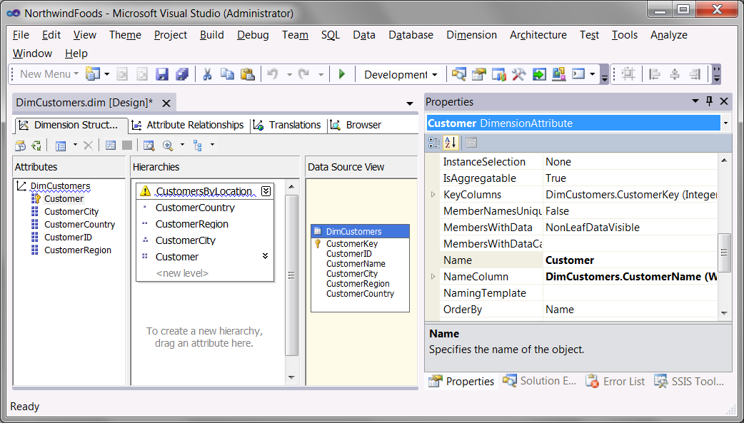
Figure 1.The DimCustomers dimension after configuration
Configure the Employees Dimension
Next we configure the Employees dimension.
- Open the DimEmployees dimension editor by right-clicking the dimension in Solution Explorer and selecting View Designer from the context menu.
- When the dimension editor opens, select each attribute and use the Properties window to change or verify the settings in Table 2.
Table 2. The Initial Property Settings for the DimEmployees Dimension
Attribute | Property Name | Value
Employee Key | Name | EmployeeKey
 | KeyColumn | DimEmployees.EmployeeKey
 | NameColumn | DimEmployees.EmployeeName
 | AttributeHierarchyVisible | False
Employee ID | Name | EmployeeID
 | KeyColumn | DimEmployees.EmployeeID
 | NameColumn | DimEmployees.EmployeeID
 | AttributeHierarchyVisible | True
Manager ID | Name | ManagerID
 | KeyColumn | DimEmployees.ManagerID
 | NameColumn | DimEmployees.ManagerID
 | AttributeHierarchyVisible | True
Manager Key | Name | Employees
 | KeyColumn | DimEmployees.ManagerID
 | NameColumn | (none)
 | AttributeHierarchyVisible | True
 | Usage | Parent
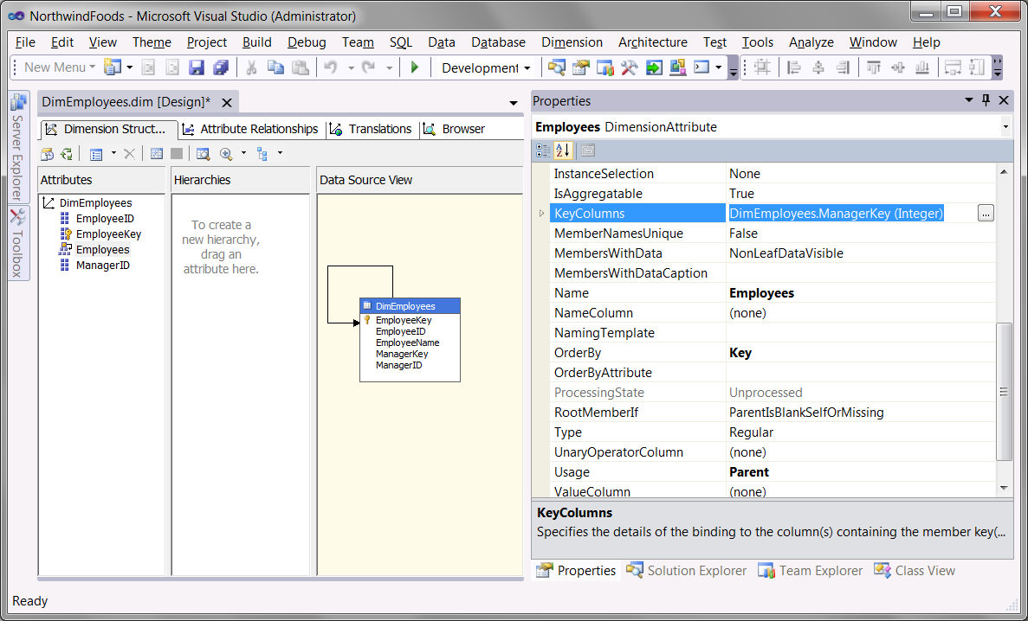
Figure 2. The DimEmployees dimension after configuration
Configure the Orders Dimension
Now we configure the Orders dimension.
- Open the DimOrders dimension editor by right-clicking the dimension in Solution Explorer and selecting View Designer from the context menu.
- When the dimension editor opens, select each attribute and use the Properties window to change or verify the settings in Table 3.
Table 3. The Initial Property Settings for the DimOrders Dimension
Attribute | Property Name | Value
Order ID | Name | OrderID
 | KeyColumn | FactSales.OrderID
 | NameColumn | FactSales.OrderID
 | AttributeHierarchyVisible | True
- When you are finished, your dimension editor should look similar to Figure 4.
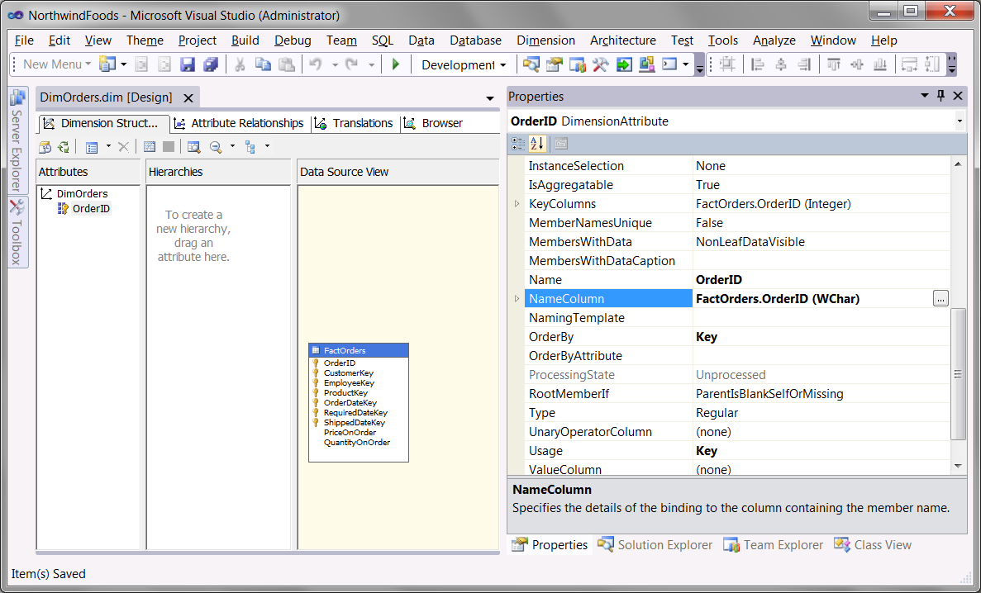
Figure 4.The DimOrders dimension after configuration
Configure the Dates Dimension
Now, it’s time to configure the Dates dimension.
- Open the DimDates dimension editor by right-clicking the dimension in Solution Explorer and selecting View Designer from the context menu.
- When the dimension editor opens, select each attribute and use the Properties window to change or verify the settings in Table 4.
Table 4. The Initial Property Settings for the DimDates Dimension
Attribute | Property Name | Value
Date Key | Name | Date
 | KeyColumn | DimDates.DateKey
 | NameColumn | DimDates.DateName
 | AttributeHierarchyVisible | True
Full Date | Name | FullDate
 | KeyColumn | DimDates.FullDate
 | NameColumn | DimDates.FullDate
 | AttributeHierarchyVisible | True
Month | Name | Month
 | KeyColumn | DimDates.Year  DimDates.Quarter,  DimDates.Month
 | NameColumn | DimDates.MonthName
 | AttributeHierarchyVisible | True
Quarter | Name | Quarter
 | KeyColumn | DimDates.Year  DimDates.Quarter
 | NameColumn | DimDates.QuarterName
 | AttributeHierarchyVisible | True
Year | Name | Year
 | KeyColumn | DimDates.Year
 | NameColumn | DimDates.YearName
 | AttributeHierarchyVisible | True
- Create a user-defined hierarchy for dates grouped by month, quarters, and years. You can do this by dragging and dropping the Year attribute to the Hierarchies section of the dimension editor. This creates a new hierarchy.
- Drag and drop the Quarter attribute just beneath the Year attribute in the new hierarchy (Figure 10-17).
- Drag and drop the Month attribute just beneath the Quarter attribute in the new hierarchy (Figure 10-17).
- Drag and drop the Date attribute just beneath the Month attribute in the new hierarchy (Figure 10-17).
- Rename the new hierarchy to Year-Qtr-Month-Day using the Properties window. When you are finished, your dimension editor should look like Figure 5.
- Disregard any warning icons or wavy blue lines beneath the dimension or hierarchy names for now.
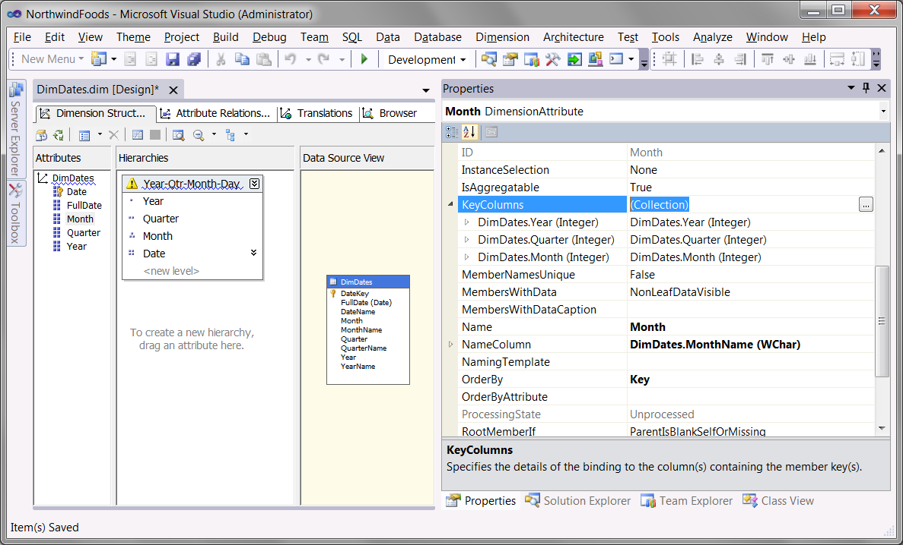
Figure 5.The DimDates dimension after configuration
Configure the Products Dimension
It’s time for the Products dimension! This one has a lot of attributes. Be careful not to miss any.
- Open the DimProducts dimension editor by right-clicking the dimension in Solution Explorer and selecting View Designer from the context menu.
- When the dimension editor opens, select each attribute and use the Properties window to change or verify the settings in Table 5.
Table 5. The Initial Property Settings for the DimProducts Dimension
Attribute | Property Name | Value
Product Key | Name | Product
 | KeyColumn | DimProducts.ProductKey
 | NameColumn | DimProducts.ProductName
 | AttributeHierarchyVisible | True
Product ID | Name | ProductID
 | KeyColumn | DimProducts.ProductID
 | NameColumn | DimProducts.ProductID
 | AttributeHierarchyVisible | True
Product Std Price | Name | ProductStdPrice
 | KeyColumn | DimProducts.ProductStdPrice
 | NameColumn | DimProducts.ProductStdPrice
 | AttributeHierarchyVisible | True
Product Category | Name | ProductCategory
 | KeyColumn | DimProducts.ProductCategory
 | NameColumn | DimProducts.ProductCategory
 | AttributeHierarchyVisible | True
ProductIsDiscontinued | Name | ProductIsDiscontinued
 | KeyColumn | DimPublishers. ProductIsDiscontinued
 | NameColumn | DimPublishers. ProductIsDiscontinued
 | AttributeHierarchyVisible | True
- Create a user-defined hierarchy for Products grouped by Product Categories by dragging and dropping the ProductCategory attribute to the Hierarchies section of the dimension editor. This creates a new hierarchy.
- Drag and drop the Product attribute just beneath the ProductCategory attribute in the new hierarchy, as shown in Figure 6.
- Rename the new hierarchy to ProductsByCategory using the Properties window. When you are finished, your dimension editor should look like Figure 68.
- Disregard any warning icons and wavy blue lines beneath the dimension or hierarchy names for now. We will address this later in the chapter.
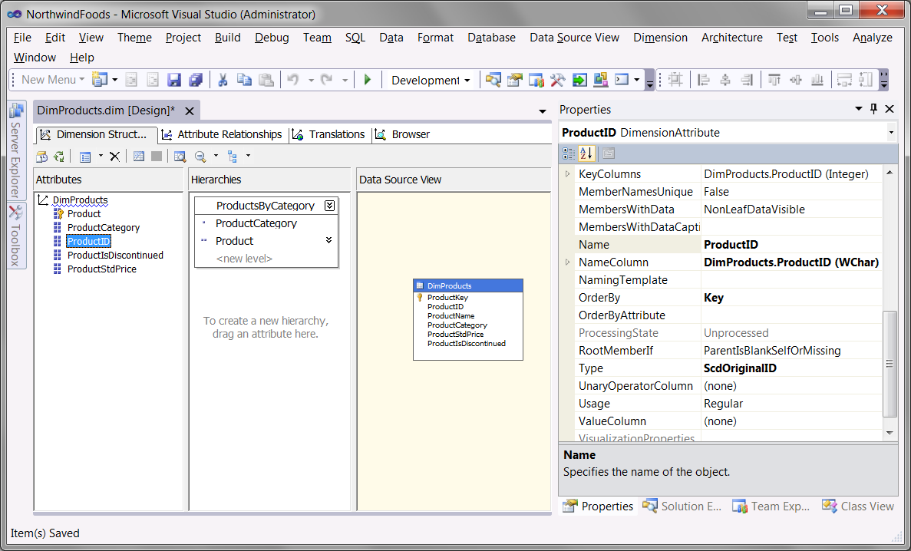
Figure 6. The final stage of the dimension editor
- Use the Build menu to verify that the dimension builds successfully. If it does not, troubleshoot the problem or delete the dimension from Solution Explorer and go through the steps again, being careful to include any steps you may have omitted.

EXERCISE 10-2: CONFIGURING ATTRIBUTE RELATIONSHIPS
In this exercise, you will configure the attribute relationships for each of the dimensions for the SSAS project.
Configure the DimCustomers Dimension
- Open the DimCustomers dimension editor by right-clicking the dimension in Solution Explorer and selecting View Designer from the context menu.
- When the dimension editor opens, access the Attribute Relationships tab (Figure 10-19).
- Highlight and delete all of the relationships listed under the Attribute Relationships pane.
- Recreated the relationships as shown in Figure 7.
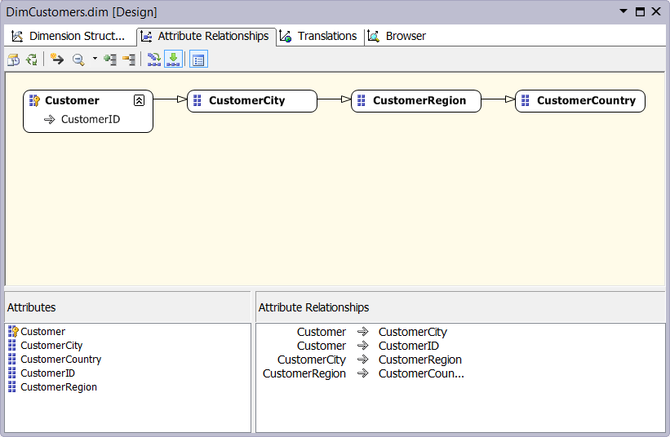
Figure 7. The DimCustomers attribute relationships
- Use the Build menu to verify that the dimension builds successfully (Figure 10-23). If it does not, troubleshoot the problem or delete the dimension from Solution Explorer and go through the steps again, being careful to include any steps you may have omitted.
Configure the Employees Dimension
- Open the DimEmployees dimension editor by right-clicking the dimension in Solution Explorer and selecting View Designer from the context menu.
- When the dimension editor opens, access the Attribute Relationships tab (Figure 8).
- Highlight and delete all of the relationships listed under the Attribute Relationships pane, as needed.
- Recreated the relationships as shown in Figure 8. You can do this by clicking on the EmployeeKey attribute, selecting the New Attribute Relationship option to launch the Create Attribute Relationship dialog, and mapping each of the other three attributes to Employee key. You will have to do this once for each of the three attributes, indicated in Figure 8.
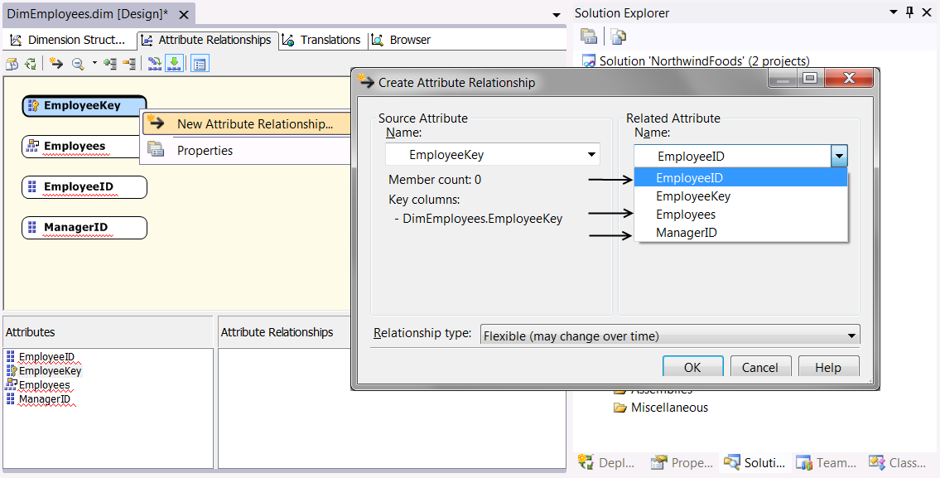
Figure 8. The DimEmployees attribute relationships
- When you are done, the relationships should like Figure 9.
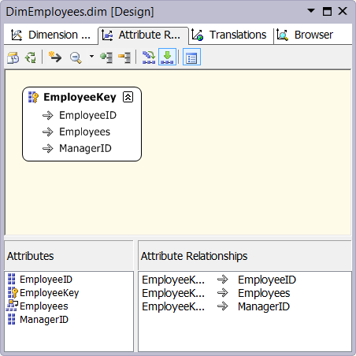
Figure 9. The DimEmployees attribute relationships
- Use the Build menu to verify that the dimension builds successfully (Figure 10-23). If it does not, troubleshoot the problem or delete the dimension from Solution Explorer and go through the steps again, being careful to include any steps you may have omitted.
Configure the Orders Dimension
Now we turn to the Orders dimension. It is even simpler than the DimEmployee dimension and should not require any configuration, because there is only one attribute in this dimension. Therefore, there cannot be any attribute relationships. Your goal is to review the current design.
- Open the DimOrders dimension editor by right-clicking the dimension in Solution Explorer and selecting View Designer from the context menu.
- When the dimension editor opens, access the Attribute Relationship tab and verify that it looks as shown in Figure10.
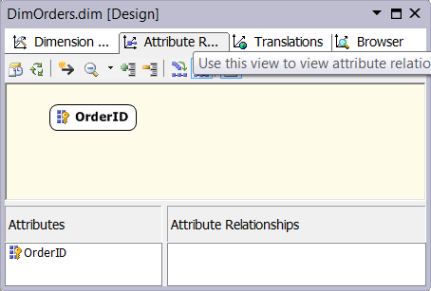
Figure 10. DimOrders Attribute Relationships box is empty
Configure the Dates Dimension
The Dates dimension has a number of attributes that need to be related correctly. Be sure to review it closely and make any changes necessary.
- Open the DimDates dimension editor by right-clicking the dimension in Solution Explorer and selecting View Designer from the context menu.
- When the dimension editor opens, access the Attribute Relationship tab.
- Highlight and delete all of the relationships listed under the Attribute Relationships pane.
- Recreated the relationships as shown in Figure 11.
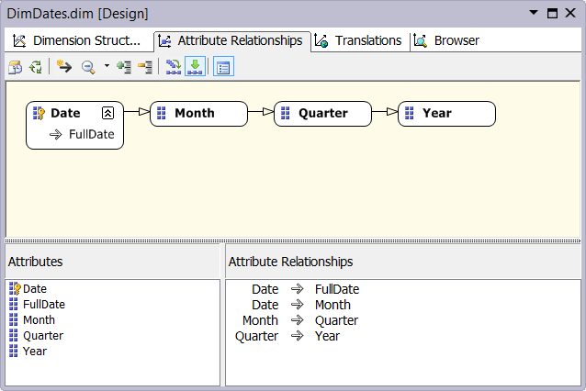
Figure 11. The DimDates attribute relationships
- Use the Build menu to verify that the dimension builds successfully (Figure 10-23). If it does not, troubleshoot the problem or delete the dimension from Solution Explorer and go through the steps again, being careful to include any steps you may have omitted.
Configure the Products Dimension
- Open the DimProducts dimension editor by right-clicking the dimension in Solution Explorer and selecting View Designer from the context menu.
- When the dimension editor opens, access the Attribute Relationship tab.
- Highlight and delete all of the relationships listed under the Attribute Relationships pane, as needed.
- Recreated the relationships as shown in Figure 12.
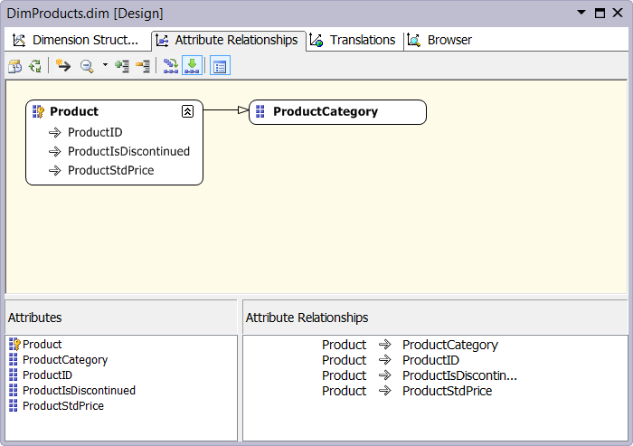
Figure 12. The attribute relationships of DimProducts
- Use the Build menu to verify that the dimension builds successfully (Figure 10-23). If it does not, troubleshoot the problem or delete the dimension from Solution Explorer and go through the steps again, being careful to include any steps you may have omitted.
At this point, the dimensions are configured with the common settings that you will use in all of your dimensions.

EXERCISE 10-3: DEPLOYING, PROCESSING, AND BROWSING THE DIMENSIONS
In this exercise, you will deploy, process, and browse the dimensions in your SSAS project. Let’s start by configuring the project deployment settings.
Configure Your Project Deployment Settings
Before we can deploy the project we need to configure the deployment options.
- Right-click the NorthwindBICubes project icon in Solution Explorer and select the Properties option from the context menu.
- When the Properties Pages dialog window appears, navigate to the Deployment page, select the Processing Options dropdown box (Figure 10-34), and select Do Not Process.
- Verify the server is configured to point to your SSAS server (Figure 10-35). Use (local), localhost, or your actual computer name; if you are using a named instance, include this in its proper name as well.
- Click OK to close the Properties Pages dialog window.
Build Your Project
When the configuration is verified, or reconfigured as needed, it is time for one last build to make sure that all is ready for deployment.
- Build the project one more time and troubleshoot any errors that may occur using the Error List window (Figure 10-38).
Tip: At this point there should not be any errors, because you have been using the Build option to test your configurations over and over again. If you do find an error and the problem is not apparent, isolate each dimension to determine which one is giving you the problem by excluding a dimension from the project and building the project again. If it builds successfully without the excluded dimension, you will know that the excluded dimension is the source of the issue.
Once you determine the problematic dimension, you can add the excluded dimension back into your project by right-clicking the SSAS project icon and selecting Add Existing Items from the context menu. Now you can focus your attention on the problematic dimension to correct the issue. Worst-case scenario: delete the dimension and remake it again. This sometimes is all it takes to get it working.
Deploy Your Project
With the build successful, we can now deploy or dimensions to the SSAS server.
- Deploy the NorthwindBICubes project using Visual Studio’s Build menu (Figure 10-38). If you are asked for a password, please supply the password.
- Troubleshoot any errors that may occur using the Error List window (Figure 10-40). Refer to the “When Deployment Fails” topic within this chapter for troubleshooting tips.
- Verify that the deployment has succeeded using the Deployment Processes window. If the window is not showing, you can access this by using the View -> Show Deployment Progress menu item, as shown in Figure 10-39.
Process Your Project
The dimensions are designed, built, and deployed, but they do not have data until they are processed. We will do that now.
- Right-click the NorthwindBICubes project icon in Solution Explorer and select Process from the context menu, as shown in Figure 10-43.
- When the Process dialog window appears, verify that the Processing Options dropdown box is set to Process Full, and click Run at the bottom of the dialog window.
- When processing succeeds, click Close to close the Process Progress window, as shown in Figure 10-44.
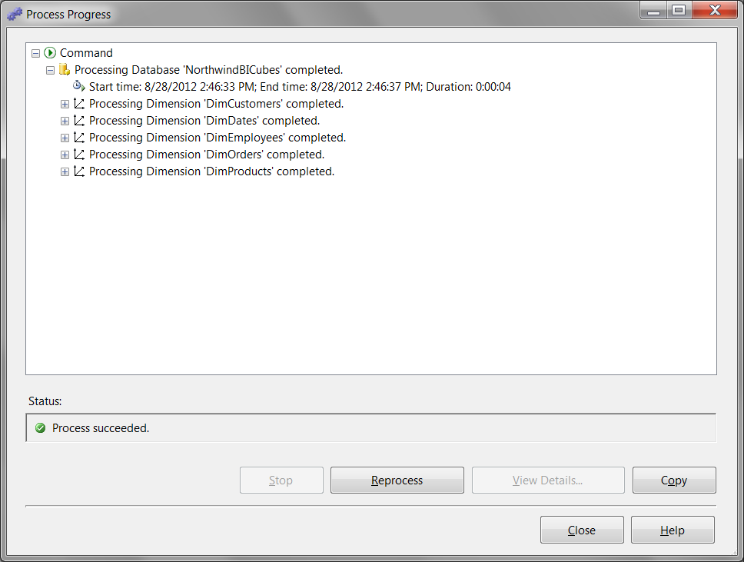
Figure 13, The NorthwindBICubes project has succefully processed.
Browse Your Dimensions
After the dimensions are processed, you can test your design using the dimension browser.
- Access the dimension designer Browser tab by right-clicking the DimCustomers dimension in Solution Explorer and selecting Browse from the context menu.
- Click the Reconnection button on the Browser tab’s toolbar, as shown in Figure 10-45.
- Use the treeview and the Hierarchy dropdown box to browse your dimension attributes and hierarchies (Figure 10-45).
- Browse all of the other dimensions and check for any errors or inconsistencies.
In this exercise, you deployed, processed, and browsed the dimensions that you created earlier. It is now time to create a cube so that these dimensions can be associated with our measures. Let’s discuss how that can be done in the next chapter.

