Read Me

_BookFiles\_LearnByDoing\Chapter11Files
This folder contains listing code and the files needed for the Learn By Doing exercises in Chapter 11.

Outlined Instructions
Please use the following instructions to complete each exercise. Remember that the instructions are intentionally brief and that you may need to refer to the Pro SQL 2012 BI Solutions book for examples of how to perform these tasks.

EXERCISE 11-1: CREATING A CUBE
In this exercise, you create a basic cube using the Cube Wizard.
- Right-click the Cubes folder in Solution Explorer, and select New Cube from the context menu. The Cube Wizard launches, as shown in Figure 11-1.
- Click Next to advance to the Select Creation Method dialog window, and verify that the “Use existing tables” radio button is checked, as shown in Figure 11-2.
- Click Next to advance to the Select Measure Groups Tables dialog window. Select the FactOrders.
- Click Next to advance to the Select Measures dialog window. Uncheck the Fact Orders Count measure, and verify that only the Price On Order and Quantity On Order measures are selected.
- Click Next to advance to the Select Existing Dimensions dialog window. Verify that all five of your existing dimensions are selected, as shown in Figure 1.
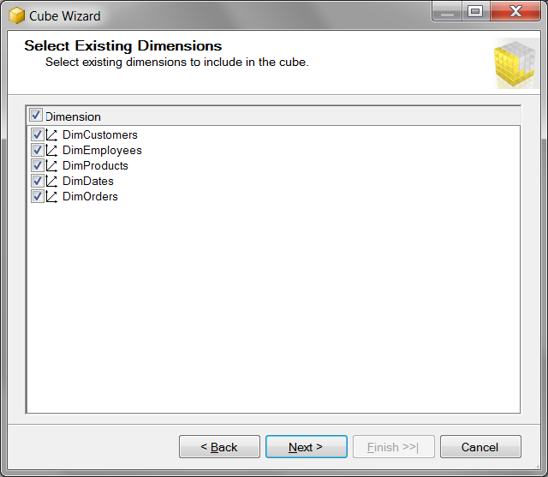
Figure 1. The Select Exisitng Dimensions page of the Cube Wizard.
- Click next to advance to the Completing the Wizard dialog window, and rename the cube to DWNorthwindOrdersV1.
- Click Finish to exit the wizard.

EXERCISE 11-2: CONFIGURING MEASURES PROPERTIES AND RELATIONSHIPS
In this exercise you begin configuring the cube you created in Exercise 11-1 using the first two tabs of the cube designer.
Configure Cube Structure Tab
With the cube designer open, select the Cube Structure tab. Highlight the various measures and adjust their properties. There are four main properties to choose from for each dimension. Please verify that the current selection is correct, and if it is not, adjust it.
- Change or validate the properties of the measure in the Fact Orders measure group. You can do so by highlighting each object in the Measures pane and, if necessary, changing the properties in accordance with those listed in Table 11-5.
Table 11-5. Property Settings for the Fact Orders Measure Group
Object | Property | Value
Fact Orders measure group | Name | Orders
Price On Order measure | Name | PriceOnOrder
 | AggregationFunction | Sum
 | FormatString | Standard
 | Visible | True
Quantity On Order measure | Name | QuantityOnOrder
 | AggregationFunction | Sum
 | FormatString | Standard
 | Visible | True

Configure Dimension Usage Tab
Let’s go to the Dimension Usage tab and change some of the relationship type settings.
- Click the Dimension Usage tab.
- Click the cell row named OrderID. It is beneath the Orders column and alongside DimOrders.
- Click the ellipsis button when it appears (Figure 11-24), and the Define Relationship dialog window will open.
- In the Define Relationship dialog window, change the relationship type to Fact (Figure 11-25).
- Verify that the Dimension Usage tab displays, as shown in Figure 2.
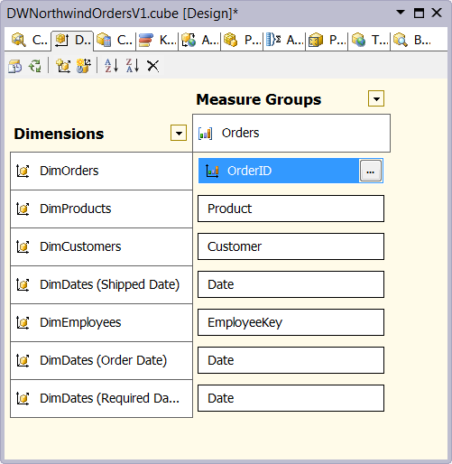
Figure 2. The Dimension Usage tab after configuration
Verify Your Design with the Browser Tab
Now that we have made our changes, let’s process the cube and then use the Browser tab to verify that our design is correct.
- Right-click the cube file in Solution Explorer called DWNorthwindOrdersV1.cube and choose Process from the context menu.
- If a message box appears indicating that that changes need to be uploaded to this deployment, click Yes to accept deployment and then Yes to accept your changes overwriting the existing cube. The Process Cube dialog window will appear.
- Click Run to start the processing. When processing completes, click Close to close the processing windows.
- Click the Browser tab in the cube designer window.
- Drag and drop measures and dimensions from the treeview to create a result that looks like the one displayed in Figure 3.
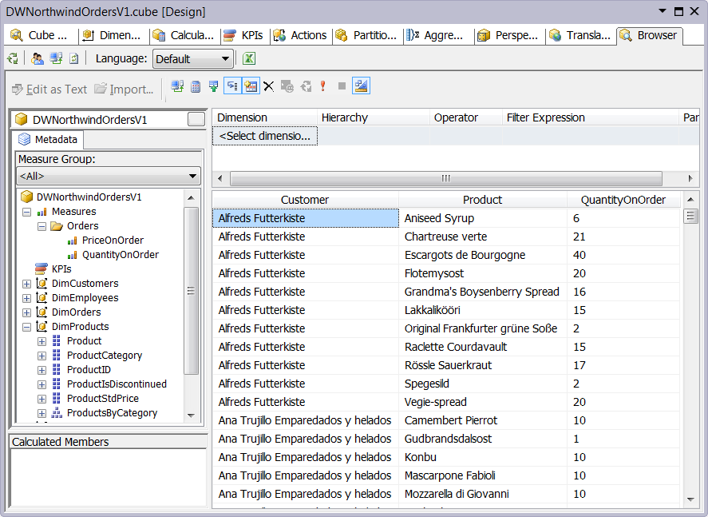
Figure 3. Browsing the DWNorthwindOrdersV1 cube
As we conclude this exercise, review the values in the report to make sure they are accurate. We provided some SQL code for this in Listing 1.
Listing 1. SQL code to validate products orderd by customers.
SELECT
CustomerName = CompanyName
, ProductName
, Quantity
FROM Northwind.DBO.Customers
JOIN Northwind.DBO.Orders
ON Customers.CustomerID = Orders.CustomerID
JOIN Northwind.DBO.[Order Details]
ON Orders.OrderId = [Order Details].OrderId
JOIN Northwind.DBO.[Products]
ON Products.ProductId = [Order Details].ProductId
WHERE CompanyName = 'Alfreds Futterkiste'
Order By CompanyName, ProductName

EXERCISE 11-3: ADDING CALCULATED AND DERIVED MEASURES
There is no Learn By Doing exercise associated with Exercise 11-3.

EXERCISE 11-4: ADDING A KPI TO YOUR CUBE
There is no Learn By Doing exercise associated with Exercise 11-4.

