Read Me

_BookFiles\_LearnByDoing\Chapter12Files
This folder contains listing code and the files needed for the Learn By Doing exercises in Chapter 12.

Outlined Instructions
Please use the following instructions to complete each exercise. Remember that the instructions are intentionally brief and that you may need to refer to the Pro SQL 2012 BI Solutions book for examples of how to perform these tasks.

Exercise 12-1: Changing the Cube’s Name
In this exercise, you use a live connection to SSAS to change the name of the DWNorthwindSalesV1 cube to CubeNorthwindOrders.

Note: This exercise is important to perform, because later in this book we refer to the new name!
Open a Live Connection to SSAS
You cannot change the name of a cube from the context menu in SQL Server Management Studio, but you can in Visual Studio. Let’s use Visual Studio to make a live connection to the SSAS server.
- Open Visual Studio by clicking the Start button and navigating to All Programs -> Visual Studio 2010. Right-click this menu item, select Run as Administrator, and then answer Yes to close the UAC.
- Open a live connection to SSAS by selecting Visual Studio’s File -> Open -> Analysis Services Database menu (Figure 12-44).
- When the Connect To Database dialog window opens, type in your server’s name and the name of the database in the appropriate textboxes, as shown in Figure 1. Remember, unlike the picture, you use only (local) if you are connecting to your default instance of SSAS.

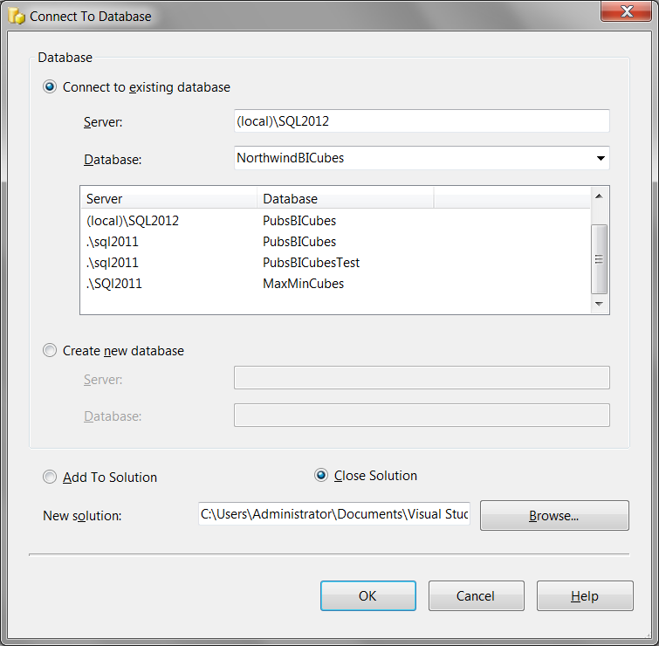
Figure 1. Connecting to SSAS from Visual Studio.
- Click OK to create the live connection to the SSAS server.
Rename the Cube
Now that you have a live connection established, you can change the cube’s name.
- Locate the cube in Solution Explorer (Figure 2). Right-click the cube’s icon and select Rename from the context menu.
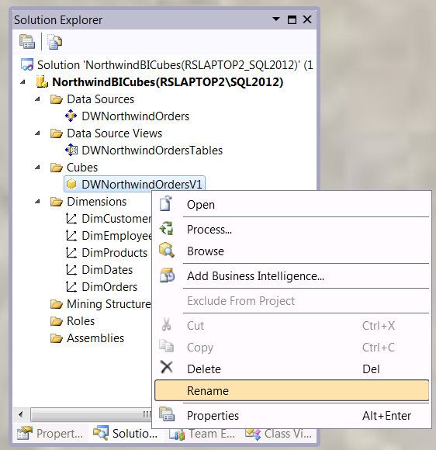
Figure 2. Renaming the cube with a live connection
- Change the cube’s name to CubeNorthwindOrders. A dialog window will briefly appear telling you that your change is being updated to the SSAS server (Figure 12-48).
Verify the Change in SQL Server Management Studio
- Open SQL Server Management Studio (SSMS) and connect to the SSAS server, as shown in Figure 12-41.
- When SSMS opens, locate the NorthwindBICubes database folder icon in the Object Explorer treeview.
- Expand the NorthwindBICubes folder icon and locate the Cubes folder icon (Figure 12-49).
- Expand the Cubes folder icon and verify that the cube is now named CubesNorthwind, as shown in Figure 3.
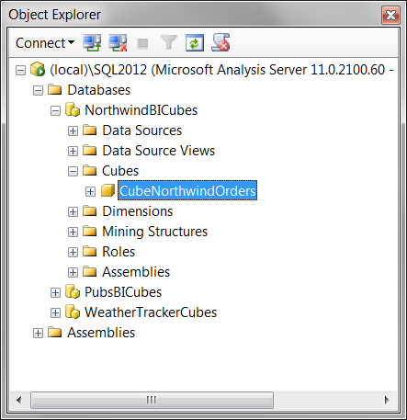
Figure 3. Verifying the cube has been renamed
Update the BI Solution Documents
- Open the UpdatedBISolutionWorksheets.xslx and the UpdatedBISolutionPlan.docx file found in the downloadable book files c:\_BookFiles\_LearnByDoing\Chapter04Files.
- Open both files and note that we have updated the documents to match the current design of the SSAS project.
- Copy the UpdatedBISolutionWorksheets.xlsx and the UpdatedBISolutionPlan.docx documents
- Navigate to the C:\_BISolutions\NorthwindFoods folder and paste both of these documents into it.
- Delete the current BISolutionWorksheets.xlsx and BISolutionPlan.docx files
- Rename the UpdatedBISolutionWorksheets.xlsx file to BISolutionWorksheets.xlsx.
- Rename the UpdatedBISolutionPlan.docx file BISolutionPlan.docx.

