Read Me

_BookFiles\_LearnByDoing\Chapter13Files
This folder contains listing code and the files needed for the Learn By Doing exercises in Chapter 13.

Outlined Instructions
Please use the following instructions to complete each exercise. Remember that the instructions are intentionally brief and that you may need to refer to the Pro SQL 2012 BI Solutions book for examples of how to perform these tasks.

Exercise 13-1. Creating Report Queries
In this exercise, you create your own custom report query similar to the one we just walked though. To make this process simpler, we do not include parameters at this point. You combine data from three tables, aggregate the values, and then format your results. If you build the query a little at a time, as described in this chapter, you will find your query will be completed in no time at all!
- Review the data in the FactOrders table by executing the following SQL code in a query window:
Select * From FactOrders
- Review the data in the DimCustomers table by executing the following SQL code in a query window:
Select * From DimCustomers
- Review the data in the DimDates table by executing the following SQL code in a query window:
Select * From DimDates
- Combine the data from these tables into a report query that returns store names, store IDs, order dates, and the sum quantity by store and date. Your results should look like Figure 13-16.
If you get stuck, the answers for this exercise are in the downloadable example files for this book. Look in the folder for C:\_BookFiles\_LearnByDoing\Chapter13Files\ Chapter13_ExerciseAnswers.sql.
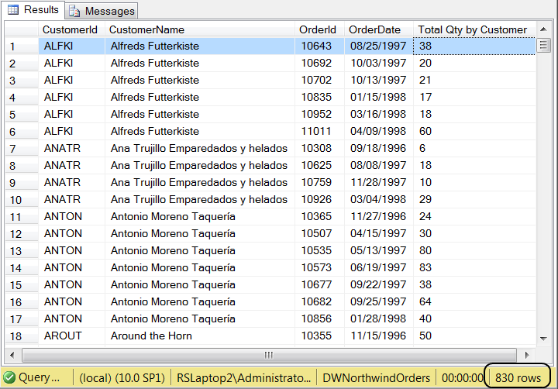
Figure 1. The results needed for the sales by stores report

Exercise 13-2. Creating Stored Procedures
In this exercise, you create your own custom report stored procedure similar to the one discussed in this chapter. This time, you include parameters that filter the results based on a start date and end date. Try using building the query a little at a time, as described in this chapter. You may find that creating a report procedure is easier than you think.
- Create a stored procedure that allows report users to filter the results based on a range of dates using the code generated in Exercise 13-1.
Tip: You will need to add a where clause and parameters to the stored procedure.
- Execute the stored procedure to verify that it works. (Your results should look like Figure 2.)
If you get stuck, the answers for this exercise can be found in the example files for this book. Look in the folder for C:\_BookFiles\_LearnByDoing\Chapter13Files\ Chapter13_ExerciseAnswers.sql.
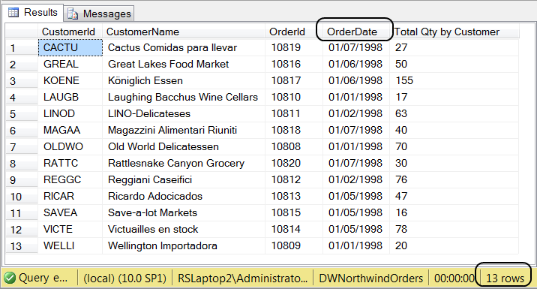
Figure 13-24. Results showing order by customer on a given week.
In this exercise, you wrote a report query that captured sales data based on sales by stores.

