Read Me

_BookFiles\_LearnByDoing\Chapter14Files
This folder contains listing code and the files needed for the Learn By Doing exercises in Chapter 14.

Outlined Instructions
Please use the following instructions to complete each exercise. Remember that the instructions are intentionally brief and that you may need to refer to the Pro SQL 2012 BI Solutions book for examples of how to perform these tasks.

Exercise 14-1: Executing MDX Queries
In this exercise, you create a new MDX query similar to the ones we just walked though in Chapter 14. You also write another query that returns the order quantity for the product called "Alice Mutton". Your final results should look similar to Figure 2.
- Open SQL Server Management Studio. You can do so by clicking the Start button and selecting All Programs -> Microsoft SQL Server 2012 -> SQL Server Management Studio.
Important: Remember to right-click the menu item, select Run as Administrator, and then answer Yes to close the UAC.
- When SQL Server Management Studio opens, it will display a dialog window similar to the one in Figure 14-5.
- Select Analysis Server from the “Server type” drop-down box.
- Type the name of your server in the “Server name” textbox.
Tip: This will usually be (local) unless you use a named instance of SQL Server, as shown in Figure 14-5.
- Click Connect to open a connection to the SSAS server in Object Explorer, as shown in Figure 14-6.
- Click the New Query button to create a new MDX coding window.
- Use the Database dropdown box to select the NorthwindBICubes database as shown in Figure 1.
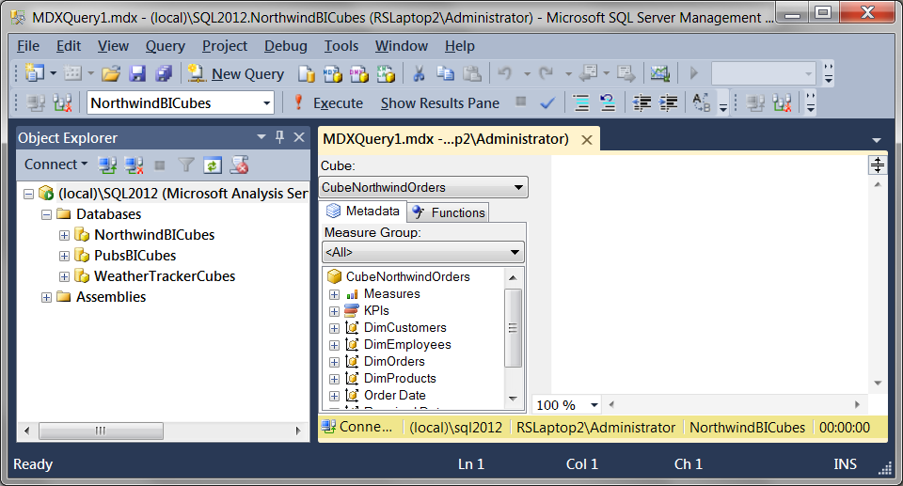
Figure 1. Launching a new MDX query window

- When the new Query window opens, type in the MDX code shown in Listing 1.
Listing 1. Code for the Learn By Doing Exercise 14-1
-- Write a Query that returns the Order Qty by Product "Alice Mutton"

-- Version 1: Using a member's name
Select
{ [Measures].[QuantityOnOrder] } on Columns,
{[DimProducts].[Product].[Alice Mutton] } On Rows -- Using the Name
From [CubeNorthwindOrders]
GO
-- Version 2: Using a member's key
Select
{ [Measures].[QuantityOnOrder] } on Columns,
{ [DimProducts].[Product].&[17] } On Rows -- Using the Key
From [CubeNorthwindOrders]
GO
- Highlight the first version of the select statement from the code you typed in, right-click the highlighted code, and select Execute. Alternately, you can run the query by clicking the “! Execute” button on the toolbar.
- Verify that your results match the results shown in Figure 2.
- Run all three queries at once and verify that they return the same results.
Tip: Remember that the word GO is case sensitive! You will receive an error when attempting to run all three queries at once if GO is not all caps.
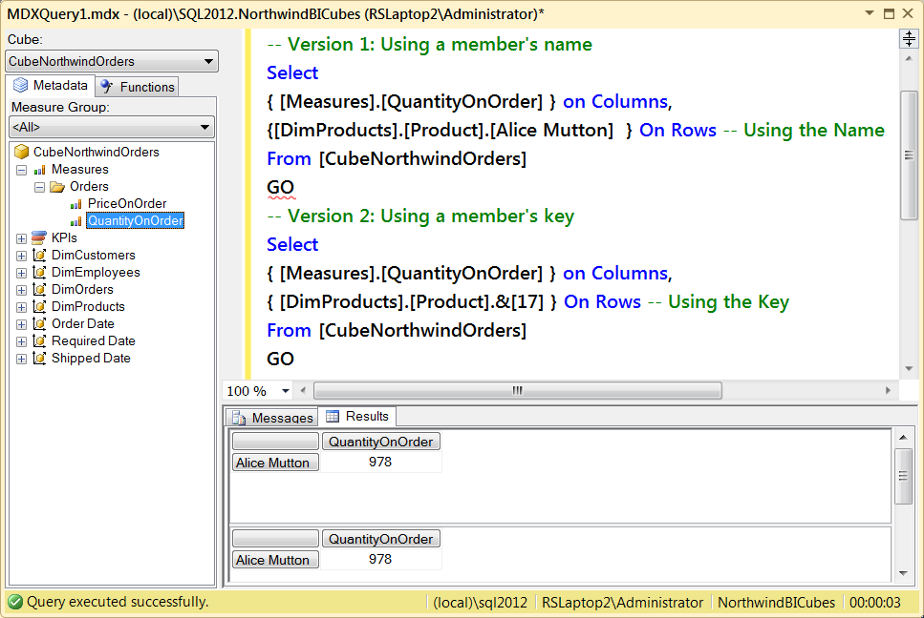
Figure 2. The results of Exercise 14-1

Exercise 14-2: Returning Multiple Tuples
In this exercise, you write a query that shows the number of QuantityOnOrders and PriceOnOrder for all customers, all order IDs, and all products.
- With a connection to the SSAS server established, click the New Query button to create a new MDX coding window.
- When the new Query window opens, type in the MDX code shown in Listing 2.
Listing 2. Code for the Learn By Doing Exercise 14-2
SELECT
Non Empty{
([Measures].[QuantityOnOrder])
, ([Measures].[PriceOnOrder])
} ON COLUMNS,
Non Empty{
(
[DimCustomers].[Customer].[Customer].ALLMEMBERS
*
[DimOrders].[OrderID].[OrderID].ALLMEMBERS
*
[DimProducts].[Product].[Product].ALLMEMBERS
)
} ON ROWS
FROM [CubeNorthwindOrders]
- Highlight the select statement from the code you entered, right-click the code, and choose Execute. Alternately, you can run the query by clicking the “! Execute” button on the toolbar.
- Verify that your results match the results shown in Figure 3.
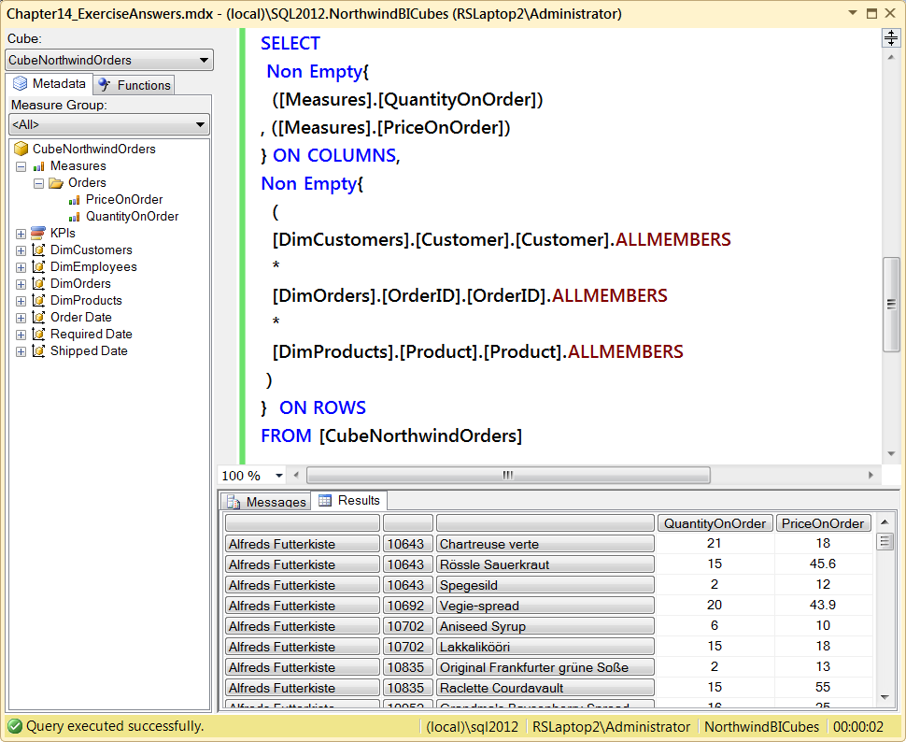
Figure 3. The results of Exercise 14-2
In this exercise, you wrote and executed an MDX query that returned four tuples. Let’s continue our coverage of the MDX language by looking at various aspects of dimensional members and levels.

Exercise 14-3: Creating MDX with the Cube Browser
In this exercise, you generate MDX code using the cube browser that comes with SSAS 2012. You then copy the code to a new MDX code window, review the code, and remove nonuseful clauses and properties.
Opening the Cube Browser
- With a connection to the SSAS server established, use the Object Explorer window to locate the CubeNorthwindOrders cube (Figure 14-34).
- Right-click the cube’s icon, and select Browse from the context menu (Figure 14-34). This will launch the cube browser.
- When the browser displays, create a query result that shows the number of QuantityOnOrders and PriceOnOrder for all customers, all order IDs, and all products, but for only the customer "Alfreds Futterkiste" (Figure 4).
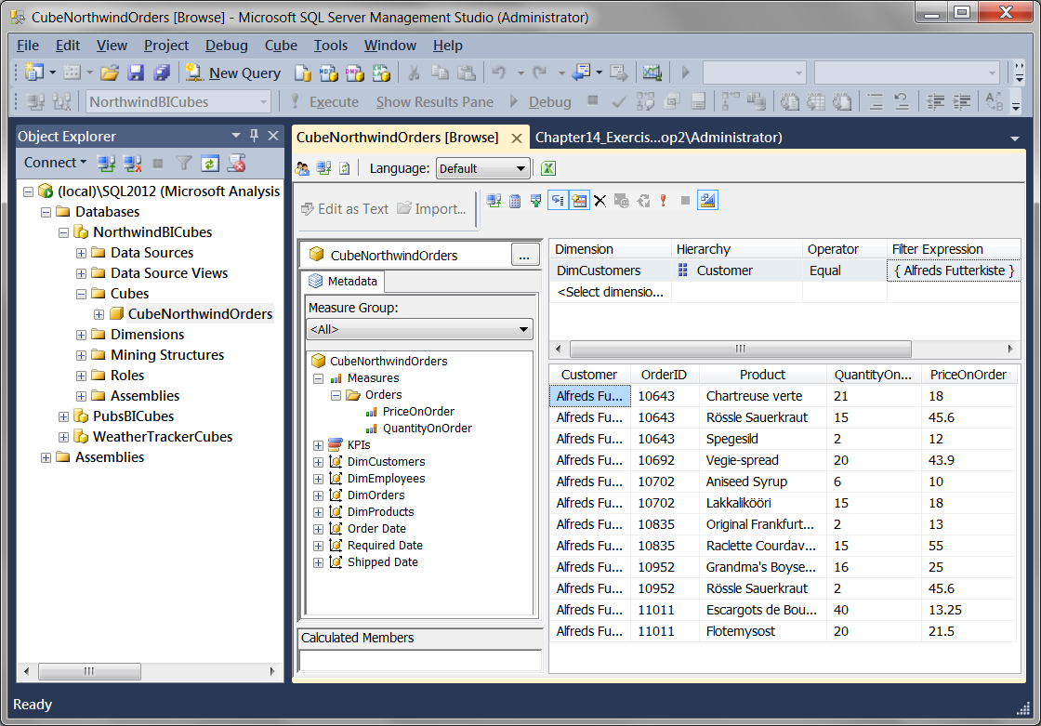
Figure 4. Using the cube browser from SSMS
Reviewing the New Code
As you drag and drop measures into the results pane, MDX code is being written for you. It is not necessarily good MDX code, but it is code you did not have to write yourself. Let's see what the new MDX code looks like.
- Click the Design Mode button to reveal the MDX code the cube browser has generated (Figure 5). To make the code easier to see, we’ve displayed it in Listing 3 as well.
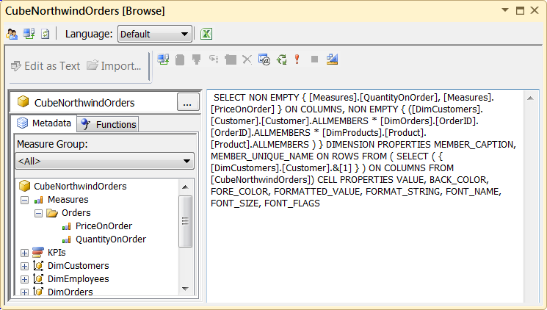
Figure 5. MDX code automatically generated by the cube browser
Listing 3. The Automatically Generated MDX Code
SELECT NON EMPTY { [Measures].[QuantityOnOrder], [Measures].[PriceOnOrder] } ON COLUMNS, NON EMPTY { ([DimCustomers].[Customer].[Customer].ALLMEMBERS * [DimOrders].[OrderID].[OrderID].ALLMEMBERS * [DimProducts].[Product].[Product].ALLMEMBERS ) } DIMENSION PROPERTIES MEMBER_CAPTION, MEMBER_UNIQUE_NAME ON ROWS FROM ( SELECT ( { [DimCustomers].[Customer].&[1] } ) ON COLUMNS FROM [CubeNorthwindOrders]) CELL PROPERTIES VALUE, BACK_COLOR, FORE_COLOR, FORMATTED_VALUE, FORMAT_STRING, FONT_NAME, FONT_SIZE, FONT_FLAGS
Reusing the Code
As you can see, the code needs a little work before we would want to use it as our own MDX code. Let’s clean it up and test it in a regular MDX query window.
- Highlight all of the MDX code in the designer window, right-click, and select Copy from the context window.
- Click the New Query button to create a new MDX coding window, as circled in Figure 14-6. Paste the MDX code into the new MDX coding window that opens. The code will be presented on a single line, without any carriage returns.
- Add carriage returns to the MDX code so that it displays like the code shown in Listing 4.
Listing 4. Reformatting the Automatically Generated MDX Code
SELECT
NON EMPTY {
[Measures].[QuantityOnOrder]
, [Measures].[PriceOnOrder]
} ON COLUMNS,
NON EMPTY {
(
[DimCustomers].[Customer].[Customer].ALLMEMBERS
*
[DimOrders].[OrderID].[OrderID].ALLMEMBERS
*
[DimProducts].[Product].[Product].ALLMEMBERS
)
} DIMENSION PROPERTIES MEMBER_CAPTION
, MEMBER_UNIQUE_NAME
ON ROWS
FROM (
SELECT ( { [DimCustomers].[Customer].&[1] } ) ON COLUMNS
FROM [CubeNorthwindOrders])
CELL PROPERTIES VALUE
, BACK_COLOR
, FORE_COLOR
, FORMATTED_VALUE
, FORMAT_STRING
, FONT_NAME
, FONT_SIZE
, FONT_FLAGS
- Highlight the select statement within your reformatted code, right-click, and select the Execute option. Alternately, you can run the query by clicking the “! Execute” button on the toolbar.
- Verify that your results match the results shown in Figure 6.
Final Code Cleanup
As you can see, the code works as expected. But it contains a lot of extra, unnecessary code. This extra code, such as the foreground color, specifies settings to be used in client applications. Standard Microsoft client applications ignore these settings. Therefore, they are not necessary if you are using your MDX code to create reports in SSRS or Excel.
- Reformat the code to exclude all client properties added by the designer. Your new code should look like Listing 5.
Listing 5. Reformatting the Automatically Generated MDX Code
SELECT
NON EMPTY {
[Measures].[QuantityOnOrder]
, [Measures].[PriceOnOrder]
} ON COLUMNS,
NON EMPTY {
(
[DimCustomers].[Customer].[Customer].ALLMEMBERS
*
[DimOrders].[OrderID].[OrderID].ALLMEMBERS
*
[DimProducts].[Product].[Product].ALLMEMBERS
)
} ON ROWS
FROM (
SELECT (
{ [DimCustomers].[Customer].&[1] }
) ON COLUMNS
FROM [CubeNorthwindOrders])
- Highlight the select statement within your reformatted code and execute the query.
- Verify that your results still match the results shown in Figure 6.
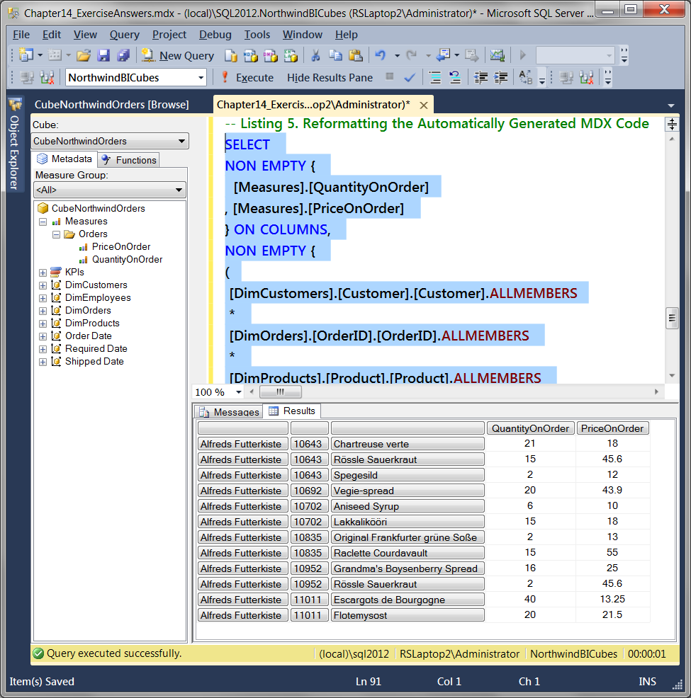
Figure 6. The Results of Code Listing 5.

