Read Me

_BookFiles\_LearnByDoing\Chapter15Files
This folder contains listing code and the files needed for the Learn By Doing exercises in Chapter 15.

Outlined Instructions
Please use the following instructions to complete each exercise. Remember that the instructions are intentionally brief and that you may need to refer to the Pro SQL 2012 BI Solutions book for examples of how to perform these tasks.

Exercise 15-1. Creating a SQL View Report
Use the steps within this chapter to connect to the data warehouse and build a report that looks like the one shown in Figure 15-11.
Creating the SQL Views
Before we make the Excel report, let’s make sure that all of the views and stored procedures needed for this chapter are present in the database.
- With Management Studio open, choose the Connect to the Database Engine option in the Server Type dropdown box. Then click Connect.
- Use the File -> Open -> File menu option to open the file that contains all the SQL code needed to create the views and stored procedures for this chapter, called C:\_BookFiles\_LearnByDoing\Chapter15Files\ViewsAndStoredProceduresForChapter15.sql.
- When the file opens in SQL Server Management Studio, execute the code using the “! Execute” button on the toolbar.
- Close SQL Server Management Studio. We will no longer need it for this chapter.
Creating the Excel Report
- Open Excel. You can do so by clicking the Start button and selecting All Programs a Microsoft Office -> Microsoft Excel 2010.
- Go to the Data tab, as shown in Figure 15-2.
- Create a new data source using the From SQL Server option (Figure 15-2).
- Specify the name of your SQL Server in the Data Connection Wizard (Figure 15-4).
- Select the DWNorthwindOrders database from the dropdown box shown in Figure 15-5.
- Select the view called vQuantitiesByCustomerAndDate.
- Select a pivot table report (Figure 15-8). An empty pivot table will be created.
- Using the PivotTable Field List window, drag and drop or select the checkboxes to make your report look like Figure 1.
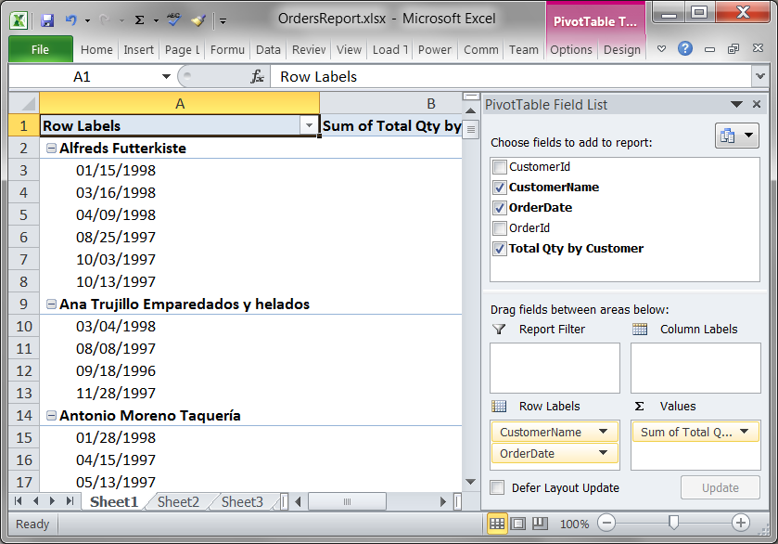
Figure 1. The report for Exercise 15-1
Save Your Report
You have created you first report for the Publications Industries BI solution. It is time to save your work in a subfolder within the Publications Industries Visual Studio solution folder.
- Save your report using Excel’s File -> Save As menu item. When you do, a dialog window appears similar to Figure 2.
- Navigate to the C:\_BISolutions\NorthwindFoods folder (Figure 2).
- Click the “New folder” button at the top of the Save As dialog window to create a new folder named ExcelReports (Figure 2).
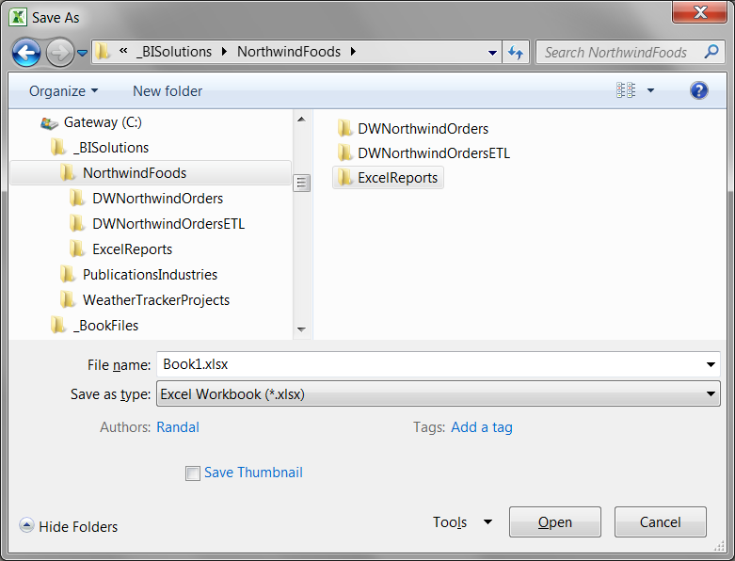
Figure 2. The Excel Save As dialog window
- Select the ExcelReports folder and save the Excel report file as OrdersReport.xlsx.

Exercise 15-2. Creating a Cube-Based Report
In this exercise, you create your own report by connecting the SSAS cube and building a report that looks like the one shown in Figure 15-25.
- With Excel open to the workbook you created in Exercise 15-1, navigate to Sheet2 by clicking the tab at the bottom of the screen.
- Go to the Data tab of the Ribbon, as shown in Figure 15-19, and create a new data source for SSAS.
- When the Connect to Database Server dialog window appears, specify your SSAS server’s name (Figure 15-20).
- When the Select Database and Table dialog window appears, select the NorthwindBICubes database and the cube called CubeNorthwindOrders.
- When the Data Connection File and Finish dialog appears, accept the default settings and click Finish. This launches the Import Data dialog window.
- When the Import Data dialog window appears, select the Pivot Table Report option.
- Create a report table that looks like Figure 3, just as you did in the previous exercise.
- Save your report using Excel’s File -> Save menu item.
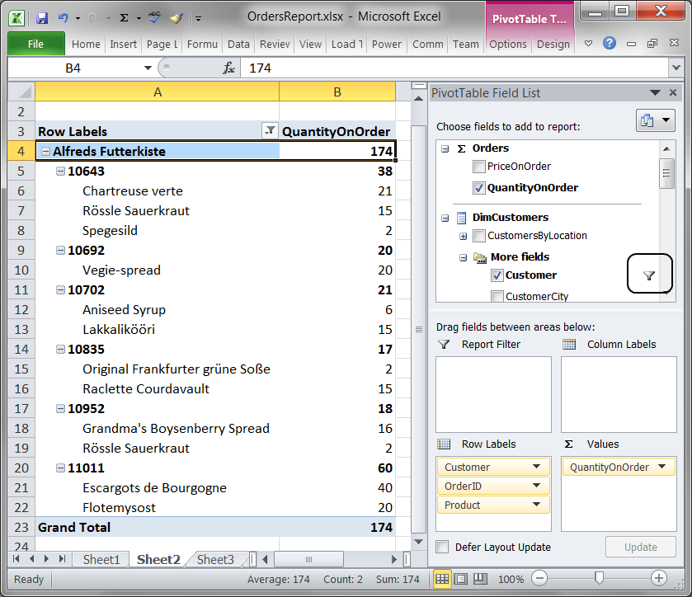
Figure 3. The report for Exercise 15-2
Adding the Solution Documents
- Add a new solution folder to your Visual Studio.
- Rename the new folder as ExcelReports.
- Right-click the new ExcelReports folder and select Add an Existing Items from the context menu, as shown in Figure 3-28.
- Add the OrdersReport.xlsx file to the folder. Visual Studio will try to open the file; let it do so, and then close it afterwards.
- Verify that the Treeview of Solution Explore looks like the one in Figure 4.

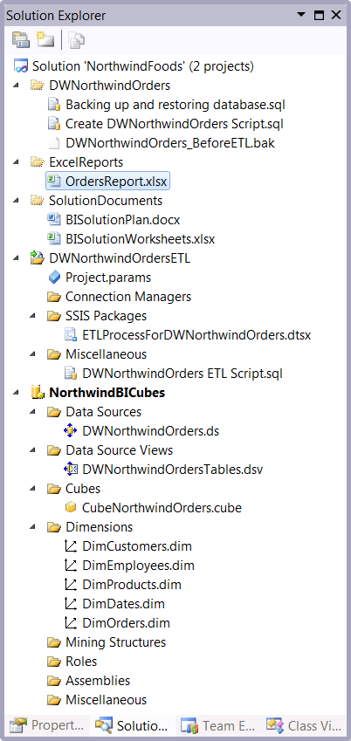
Figure 4. Solution Explorer at the end of Chapter 15's Learn By Doing exercises.

Exercise 15-3. CREATING A PIVOTTABLE CHART REPORT
There is no Learn By Doing exercise associated with Exercise 15-3.

Exercise 15-4. Saving as a PDF File
There is no Learn By Doing exercise associated with Exercise 15-4.

