Read Me

_BookFiles\_LearnByDoing\Chapter16Files
This folder contains listing code and the files needed for the Learn By Doing exercises in Chapter 16.

Outlined Instructions
Please use the following instructions to complete each exercise. Remember that the instructions are intentionally brief and that you may need to refer to the Pro SQL 2012 BI Solutions book for examples of how to perform these tasks.

Exercise 16-1. Creating a Report
In this exercise, you add an SSRS project to your existing Northwind Foods solution. You then create a shared data source, a shared dataset, and a basic report.
Add a Project to the Current Solution
- Open the Northwind Foods solution and add a new project to the solution by selecting File -> Add -> New Project from the main menu at the top of Visual Studio. An Add New Project dialog window appears (Figure 16-15).
- Select the Business Intelligence -> Reporting Services template category on the left of the dialog window. Then select the Reporting Server Project option from the center of the dialog window (Figure 16-15).
- Name the project NorthwindBIReports at the bottom of the dialog window and click OK to add the new project to your current solution (Figure 16-15).
Create a Shared Data Source
- Add a new shared data source by right-clicking the Shared Data Sources folder and selecting the Add New Data Source option in the context menu (Figure 16-16).
- When the Shared Data Source Properties dialog window appears (Figure 16-17), type DataSourceDWNorthwindOrders in the Name textbox and select Microsoft SQL Server.
- Click the Edit button next to the Connection String textbox and type in the name of your SQL Server and select the DWNorthwindOrders database (Figure 16-17).
- Close both dialog windows by clicking the OK buttons to complete the creation of the shared data source.
Create a Shared Dataset
- Right-click the Shared Datasets folder in Solution Explorer and choose the Add New Dataset option from the context menu (Figure 16-18).
- When the Shared Properties dialog window appears, type DataSetvQuantitiesByCustomerAndDate into the Name textbox.
- Use the Data Source dropdown box to select the DataSourceDWPubsSales Data Source (Figure 16-19).
- Type the SQL code found in Listing 1 in the Query textbox.
Listing 1. SQL Code for the DatasetvQuantitiesByTitleAndDateDataset
SELECT
[CustomerId]
,[CustomerName]
,[OrderId]
,[OrderDate]
,[Total Qty by Customer]
FROM [vQuantitiesByCustomerAndDate]
- Close the dialog window by clicking OK to complete the creation of the shared dataset.
Important: The view that the SQL code uses was created in Chapter 13 learn by doing exercises, but if you do not have it already in your database, you can open the SQL script file C:\_BookFiles\Chapter16Files\ViewAndStoredProcedureForChapter16.sql and execute its code to create it.
Create a Basic Report
- Add a new report to the project by right-clicking the Reports folder in Solution Explorer and selecting New Item from the context menu (Figure 16-20).
- When the Add New Item dialog window appears, select the Report icon, as shown in Figure 16-21.
- Configure the Name textbox with the filename of CustomerOrders.rdl Then click the Add button to add a new report to the project.
- Once the Report Designer window appears, use the View menu to display both the Report Data and Toolbox windows (Figure 16-22).
- In the Report Data window, right-click the Datasets folder and select Add Dataset from the context menu.
- When the dataset Properties window appears, name the dataset DataSetCustomerOrdersByDates, select the “Use a shared dataset” radio button, and select DataSetvQuantitiesByTitleAndDate, as shown in Figure 16-23. Finally, click OK to close the dialog window.
- Add a table to your report by clicking the Table icon in the Toolbox and dragging it to the Report Designer surface (Figure 16-24).
- Create a report that looks like Figure 1.

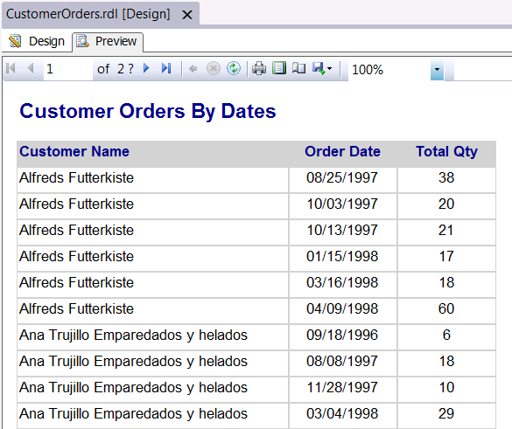
Figure 1. The completed report for the chapter 16 Learn By Doing exercise.

