Read Me

_BookFiles\_LearnByDoing\Chapter17Files
This folder contains listing code and the files needed for the Learn By Doing exercises in Chapter 17.

Outlined Instructions
Please use the following instructions to complete each exercise. Remember that the instructions are intentionally brief and that you may need to refer to the Pro SQL 2012 BI Solutions book for examples of how to perform these tasks.

Exercise 17-1: Starting a Report Template
In this exercise, you start the process of creating a report template.
Create a New Report
- Open the Northwind Foods solution you have been working on.
- Add a new report to the Reporting Server NorthwindBIReports project you created in Chapter 16.
- When the Add New Item dialog window appears, select the Report option, name the report RDL file NorthwindBIReportTemplate.rdl.
- When the new report displays in the design window, click the report background, and then access the Visual Studio Report menu item. Select and set the Add Page Header and Add Page Footer menu options, as shown in Figure 17-3
- Using what you learned in Chapter 17, create a report that looks like Figure 1.
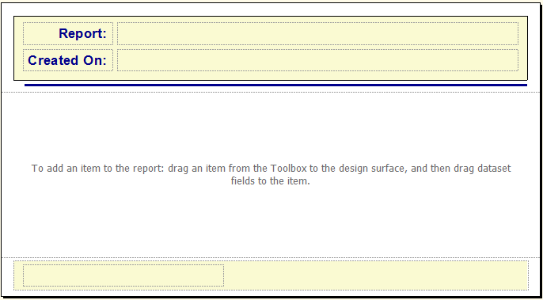
Figure 1. The report tempate at the end of Exercise 1.
- Save your work by either clicking Save (the file floppy disk symbol on the toolbar) or using the File -> Save option in Visual Studio.

Exercise 17-2: Completing a Report Template
In this exercise, you finish configuring the report template that we worked on in Exercise 17-1. In addition, you configure different options within the template such as renaming the report items, creating report variables, configuring expressions, configuring placeholders, and configuring the footer.
Renaming the Report Items
- Rename all the objects as shown in Figure 2.
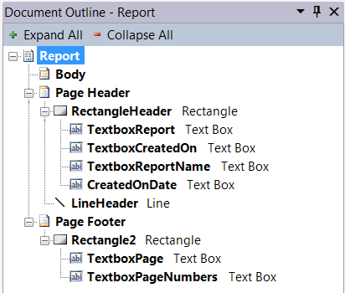
Figure 2. The current report items renamed.
Creating Report Variables
- Add a variable as indicated in Table 1.
Table 1. Report Variable Settings
Name | Value
ReportName | Add the Report Name

Configuring Expressions
With the variables in place, we can now use them as well as our expressions. Follow the next few steps to create the various expressions used within the report header and footer.
- Configure the value propertie of the textboxes as indicated in Table 17-2.
Table 17-2. Expression Code for Report Items
Textbox Item | Expression
TextboxReportName | = Variables!ReportName.Value
TextboxCreatedOnDate | = FormatDateTime(Today, DateFormat.LongDate)
TextboxPageNumbers | = "Page Number: "  & Globals!PageNumber  & " of "  & Globals!TotalPages

Configuring Placeholders
Next we include placeholders over the top of each text box value.
- Right-click each of the textboxes and configure the placeholders, as shown in Table 17-3.
(For an example of how to access the placeholder properties, see Figure 17-20. For an example of how the Placeholder Properties dialog window appears, see Figure 17-21.)
Table 17-3. Placeholder Code for Report Items
Textbox Item | Placeholder
TextboxReportLabel | Ex. Sales Report
TextboxCreatedOnLabel | Ex. Monday, January 01, 2012
TextboxPageNumber | Page Number
- Verify that the report works as expected by using the Preview tab.
- Save the changes to the new template and leave it open for use in the next exercise.

Exercise 17-3: Using a Report Template
In this exercise, copy the finished template from your Visual Studio project into Microsoft’s predefined ReportProject folder on your local computer, and configure the report variables that control the data displayed in the header. Then, use the template you created in this exercise to create a new version of the customer orders report.
Adding the Template to the ReportProject Folder
- Copy of the the NorthwindBIReportTemplate.rdl file file to the ReportProject folder using Windows Explorer (Figure 17-29).
The path to this location may vary; however, on a Windows (64-bit) operating system, the path should be as follows:
C:\Program Files (x86)\Microsoft Visual Studio 10.0\Common7\IDE\PrivateAssemblies\ProjectItems\ReportProject
On a Windows (32-bit) operating system, the path should be as follows:
C:\Program Files\Microsoft Visual Studio 10.0\Common7\IDE\PrivateAssemblies\ProjectItems\ReportProject
Tip: If you are using a different Windows operating system and are unable to find the location on your own, you may have to search the Internet to find the appropriate path for your computer.
- Once you have located the proper folder, paste the file into the ReportProject folder and close Windows Explorer (Figure 17-29).
Creating a New Report Using the NorthwindBIReport Template
- Now that you have the file in the proper location, use it to create a new report.
- When the Add New Item dialog window appears, select the NorthwindBIReportTemplate icon from the center of the dialog window, as shown in Figure 17-30.
- In the Name textbox, name the new report CustomerOrdersV1.rdl and click Add (Figure 17-30). This opens the new report in the Report Designer.
Configure the Header
- Now you have a new report based on the custom report template, but the header data needs to be configured.Use the Report Properties dialog window, access the Variables page and configure the value of the ReportName variable to Customer Orders by Dates.
Re-create the CustomerOrders Report
- Next we add content to the report within the report body. We use the same steps from Chapter 16. Once you have completed your formatting, take a look at the report using the Preview tab. Continue adjusting it until you are satisfied with the look of your report. It should look similar to Figure 3.
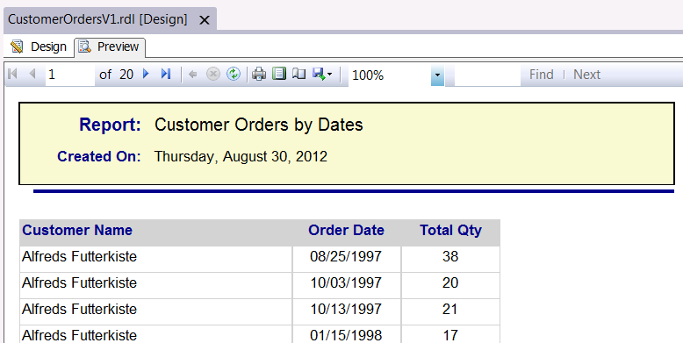
Figure 3. The new report after the authors’ formatting

