Purpose (Heading 1)
The following sections illustrate various possibilities in ODF Text

A simple series of paragraphs (Heading 2)
This section contains a series of paragraphs.
This is a second paragraph.
And a third paragraph.

A section with lists (Heading 2)
Elements to illustrate:
- hyperlinks
- italics and bold text
- lists (ordered and unordered)
How to figure out ODF
- work out the content.xml tags
- work styles into the mix
- figure out how to apply what we learned to spreadsheets and presentations
The URL for Flickr is http://www.flickr.com. The API page is http://www.flickr.com/services/api

A Table (Heading 1)
Website | Description | URL
Flickr | A social photo sharing site | http://www.flickr.com
Google Maps | An online map | http://maps.google.com

Footnotes (Heading 1)
This sentence has an accompanying footnote. Where does the text after a footnote go?

An Image
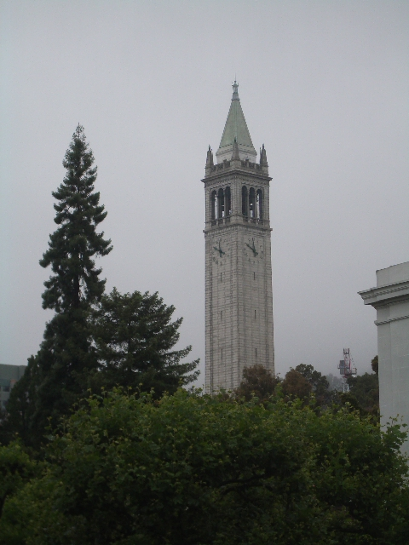

You are reading a footnote.

