Creating the Visual Studio .NET application for Chapter 6

- Open Visual Studio .NET
- Click File, New, Project to create a new project. The New Project dialog will display.
- In the Project Types pane of the New Project dialog, click Visual Basic Projects.
- In the Templates pane of the New Project dialog, click ASP.NET Web Application.
- In the Location box of the New Project dialog, type http://localhost/BuyDirect
- Click the OK button. Visual Studio .NET will create the project under your C:\Inetpub\wwwroot directory (assuming you installed Windows on Drive C).
- Copy the contents of the BuyDirect directory under Chapter6/Project directory to C:\Inetpub\wwwroot\BuyDirect.
- In the Visual Studio .NET, click Add Existing Item from the Project menu. If you copied the files to the right directory, you should see three directories and a number of .vb files. Select all of them, excluding WebForm1.aspx.resx and WebForm1.aspx.vb (See Figure 1)

Figure 1

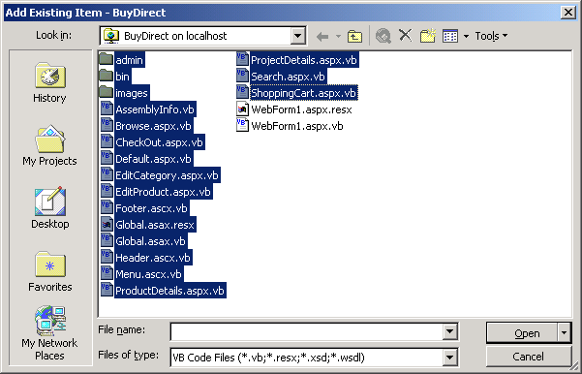

- Click Open.
- Now, add the two files (DbObject.vb and ShoppingItem.vb) in the bin directory. Click Add Existing Item from the Project menu again, and select the two files from the bin directory.
- Edit the web.config file as in the Readme.txt file for Chapter 6. You can open the file by double-clicking the file from the Solution Explorer.
- Right-click the Default.aspx page in the Solution Explorer, and select Set As Start Page.
- Click F5 to run the application. VS. NET will launch your browser and the URL will be http://localhost/BuyDirect/Default.aspx. In the beta version of VS.NET 2003, you cannot change the start page. In this case, when running the application, the WebForm1.aspx will be invoked. Just change the URL in the browser to http://localhost/BuyDirect/Default.aspx.
- The URL to invoke the admin section is http://localhost/BuyDirect/admin/Admin.aspx. The username is ken and password is blackcomb.

