Chapter 6 - Apress LightSwitch 2015

In Chapter 6, I show you how to write data access code Part of this content includes how to enlist data operations in transactions.
To demonstrate this technique, I show you how to add audit records to an external data source. The code that performs the auditing works inside a transaction. If the auditing fails, LightSwitch rolls back the changes that have been made in the intrinsic data source.

To run this example, make sure that you attach the AuditData data source. To do this:
- Right click “AuditDataSource > Update Datasource”
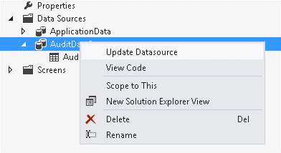
- When the “Attach Data Source Wizard” dialog opens, click the “Previous” button
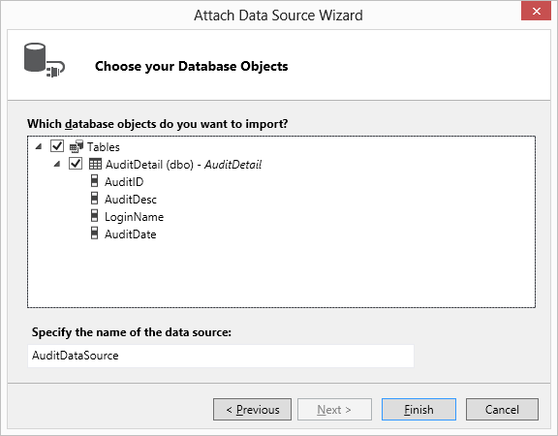
- After you click the “Previous” button, Visual Studio opens the “Connection Properties” window. Enter the correct path into the “Attach a database file” textbox. You’ll find the database file in the folder \Bin\Data\HelpDeskAudit.mdf. Next, click the “Test Connection” button to test that your connection works.
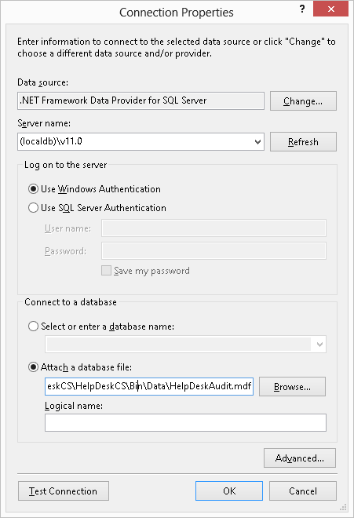

If the test connection succeeds, you’ll be able to run the examples in this project.
For distributed transactions to work, you’ll need to start the ‘Distributed Transaction Coordinator’ service on your computer. To do this, go to Control Panel > Services, and start the service as shown in the diagram beneath.
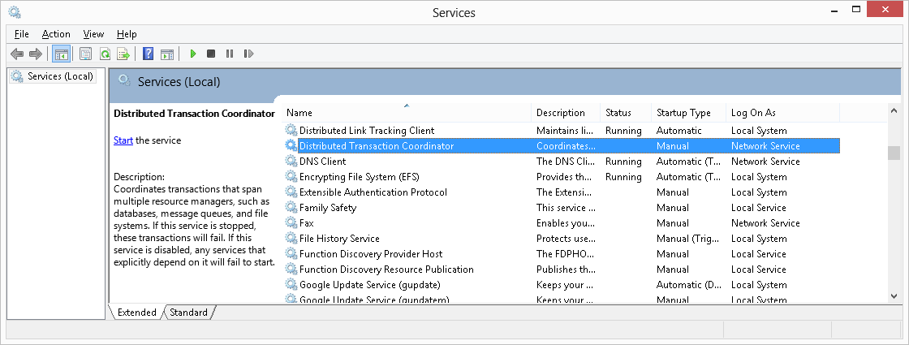

Tim Leung

