Apress LightSwitch 2015 (Tim Leung) – Chapter 14

This chapter includes a demonstration that shows you how to make your application run faster by accessing your Intrinsic database through a RIA service data source.
To run this example, you need to set the RIA Service database connection string so that it points to the correct database. To do this, open the HelpDeskVB or HelpDeskCS project.
- Right click “EngineerData > Update Datasource”
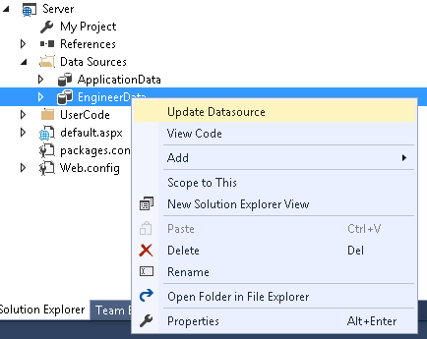
- Here’s the dialog that opens when you click the Update Datasource link.
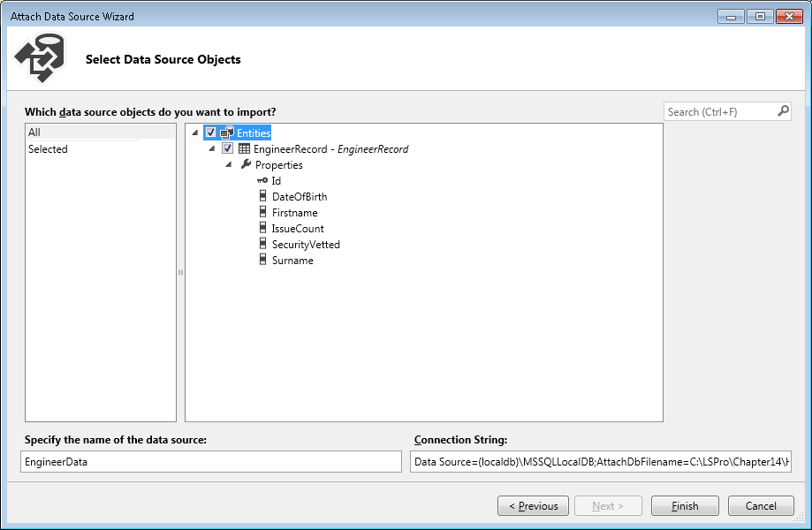
- Modify the value in the Connection String textbox so that it points to your Intrinsic (ApplicationDatabase.mdf) database file. The part that you should modify is highlighted below.
Data Source=(localdb)\MSSQLLocalDB;AttachDbFilename=C:\LSPro\Chapter14\HelpDeskVB\HelpDeskVB\bin\Data\ApplicationDatabase.mdf;Integrated Security=True

Once you’ve made these changes, your project should run. Note that if you extract the contents of the chapter 14 ZIP file into the folder C:\LSPro\Chapter14, you won’t need to make any of these modifications.
Tim Leung

