Apress LightSwitch 2015 (Tim Leung) – Chapter 15

This chapter includes a demonstration on how to access LightSwitch data through an ASP.NET website. The purpose of this demo is to show how use OData.
Here are the steps to run this example.
- Start the LightSwitch application and run the application by selecting the Start without debugging option.
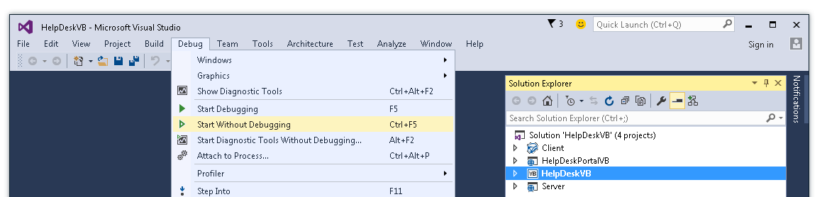
- With the LightSwitch application open, start the HelpDeskPortal website. To run the HelpDeskPortal website, select the right-click Debug > Start new instance option from Solution Explorer. You can use this website to view and add records to your LightSwitch application.
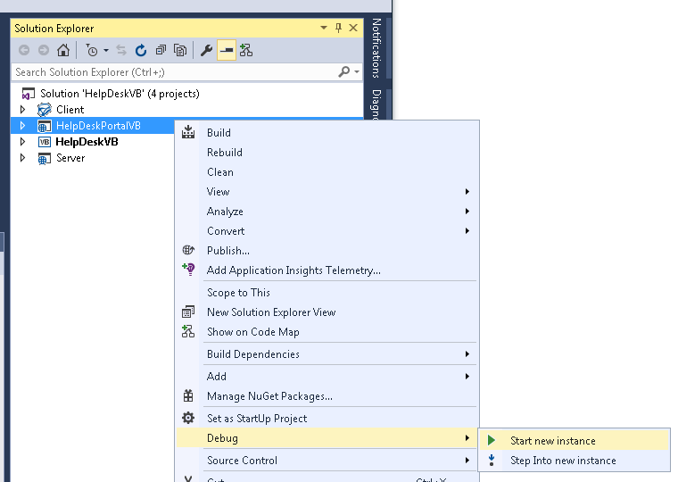
Tim Leung

