

Lab Report
实验报告

Course: | Class Libraries and Data Structures
Semester: | 1st semester of the academic year 2024-2025
Major: | Software Engineering
Class: | 2023
Student Name: | 唐浩玮
Student ID: | 222023321062106
Teacher: | ZHAO, Hengjun (赵恒军)

School of Computer and Information Science

在西南大学，考虑到20个定点构成的无向图
- Objective & Requirements（实验目的）
  - Grasp the adjacency matrix and adjacency list representation method for graph structure
掌握图数据结构的邻接矩阵和邻接链表表示法
  - Grasp the basic operations on graph structure
掌握图数据结构的基本操作
  - Understand classical algorithms on graphs, such as minimum spanning tree, shortest path, etc.
理解图上常见算法如最小生成树、最短路等的基本原理
  - Grasp the implementation of Dijkstra’s algorithm for solving the shortest path problem on graphs.
掌握图上Dijkstra最短路算法的C++实现
  - Learn how to use Dijkstra’s algorithm for solving shortest path problems in real applications, for example, path planning on maps.
学习使用最短路算法解决现实应用中的路径规划问题

- Experimental environment (platform and software)（实验环境）
Windows 7 (or higher versions) + Visual Studio 2010 (or higher versions)

- Experimental content and design (Main Content, Procedure, Codes and Results)（此部分应包含每一个实验内容的详细设计，含实验思路、详细实验步骤、核心代码说明等）
Task 1
- For this task, you are provided with a template container class for graphs. Some basic definitions and operations have already been defined in the class. Try to read and comprehend the codes.
阅读并理解所提供代码对Graph类的实现，特别是其中的邻接链表存储方式。
- Based on your understanding of the code, implement the missing method for getting the shortest path from a used provided source vertex v1 and destination vertex v2. The method should return a pair consisting of the vertices on the shortest path, and a double value indicating the path length (in case that there is not a path from v1 to v2, the path is an empty list and the path length is -1.0).
据a), 实现Dijkstra算法，用以求出用户指定的出发点和目的地之间的最短路径以及路径的长度，如果路径不存在，则返回空路径和-1.0.
Hint: it is recommended that a priority queue structure used in the implementation of the get_shortest_path() method. Reference:
- https://learn.microsoft.com/en-us/cpp/standard-library/priority-queue-class?view=msvc-170
- https://en.cppreference.com/w/cpp/container/priority_queue
- https://cplusplus.com/reference/queue/priority_queue/
提示：建议在最短路算法中使用优先级队列这种数据结构，可参考上述链接。
Task 2
- Using the graph class in Task 1, build a map for SWU campus. The map should consist of at least 20 vertices representing the places on campus that you would visit most often.
使用Task1中的Graph类，创建SWU的校园地图，要求包括至少20个校园地点，地点可参考

The distances between each pair of vertices can be obtained through the measurement service provided by https://map.baidu.com/
距离的测量可通过百度地图完成。
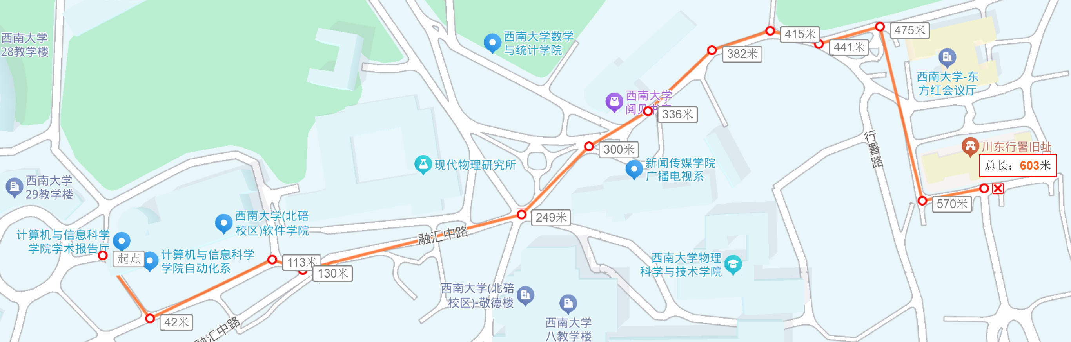
- Input any two places on the campus map and compute the shortest path between them.
通过SWU校园地图和百度地图测试你对Dijkstra算法的实现。

- Result analysis and discussion（Analysis of experimental results and summing up the harvest and the existing problems）（此部分应包含实验结果，对实验结果的分析，实验收获的总结，实验中存在问题的讨论等；另外，需要回应一下如下思考题：
1) 理论上，Dijkstra算法不能应用于带有负权边的图，为什么？
2) 本次实验所提供代码实现了一个网络类，即带权的有向图，而校园地图通常是无向图，怎么实现用该网络类存储一个无向图？
)

Name |  | Shortest Path Problem on Graphs  图上的最短路径
Date |  | Dec，2024 | Type |  | Confirmatory （验证确认型）  Design（设计型）  Comprehensive（综合型）
Comments & Evaluation | Content & Design (A-E)
Comments & Evaluation | Procedure & Codes (A-E)
Comments & Evaluation | Results (A-E)
Comments & Evaluation | Analysis & Discussion (A-E)
Comments & Evaluation | Score (A-E):  Feedback comments:

