Lab5: Observing Flow Table Overflows

# Objectives

* Fully understand the operation of OpenFlow and observe the operations.
* Learn basic skill of configuring an OpenFlow Switch.
* Trigger and observe the behavior of flow table overflow.
* Learn to manage flows based on limited network resources

# Equipment Needs

* Computer/Laptop/VM (Linux highly recommended)

# Experiments

## Preparation

1. Choose one controller stack from below to complete the rest of this lab

Ryu OpenFlow tutorial:

<https://osrg.github.io/ryu-book/en/html/>

Beacon OpenFlow tutorial <http://archive.openflow.org/wk/index.php/OpenFlow_Tutorial#Create_Learning_Switch>

OpenDaylight controller developing wiki:

* Note: this controller stack is quite complicated. As a starter at programming, I do not suggest you use it. But anyone realizing this project using ODL controller gets bonus points.

<http://www.projectfloodlight.org/getting-started/>

## Observing the table overflow in OVS

1. Use mininet to create the topology shown below.

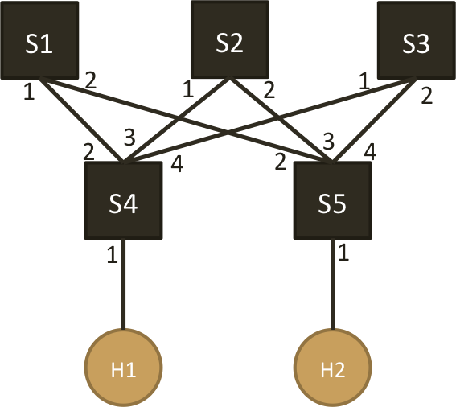

1. Set the flow table size of S1, S2 and S3 to 100
2. Provide a controller that
   1. upon receiving a new TCP flow, the switch (S4 or S5) forwards the first packet to the controller
   2. controller installs a path S4-S1-S5 for this TCP flow on both directions (2 rules per flow)
3. Use hping3 to send 100 TCP flows with varied destination ports from H1 to H2 and observe flow table overflow
4. Modify your controller so that
   1. 1/3 of TCP flows follow path S4-S1-S5
   2. 1/3 of TCP flows follow path S4-S2-S5
   3. 1/3 of TCP flows follow path S4-S3-S5
5. Observe the flow table to see if overflow still happens

**4. Lab Reports**

1. What is the command for setting the flow-table size in Open vSwitch. Please explain the meaning of each option.

2. Submit the screenshot(s) showing that the flow tables of S1 & S2 & S3 are configured to a required size.

3. Submit the screenshot(s) showing flow table overflow message(s) sent by the controller.

4. Submit the screenshot(s) showing there is no flow table overflow after modifying the controller.

5. Submit your controller code, both single path and 33%-33%-33% multipath. Add comments to clarify the logic if necessary.

5. Consider the implementation of flow table memory in Open vSwitch. What will happen if the table size is not set while millions of flow entries are inserted into the vSwitch?

6. Name at least 3 consequences when flow table gets overflowed.