Lab5: Observing Flow Table Overflows

# Xinmei Jin, NetID: xj573

# Zhaoxi Chen, NetID: zc1134

# Objectives

* Fully understand the operation of OpenFlow and observe the operations.
* Learn basic skill of configuring an OpenFlow Switch.
* Trigger and observe the behavior of flow table overflow.
* Learn to manage flows based on limited network resources

# Equipment Needs

* Computer/Laptop/VM (Linux highly recommended)

# Experiments

## Preparation

1. Choose one controller stack from below to complete the rest of this lab

Ryu OpenFlow tutorial:

<https://osrg.github.io/ryu-book/en/html/>

Beacon OpenFlow tutorial <http://archive.openflow.org/wk/index.php/OpenFlow_Tutorial#Create_Learning_Switch>

OpenDaylight controller developing wiki:

* Note: this controller stack is quite complicated. As a starter at programming, I do not suggest you use it. But anyone realizing this project using ODL controller gets bonus points.

<http://www.projectfloodlight.org/getting-started/>

## Observing the table overflow in OVS

1. Use mininet to create the topology shown below.

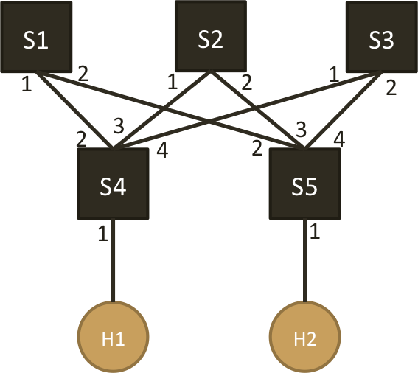

1. Set the flow table size of S1, S2 and S3 to 100
2. Provide a controller that
   1. upon receiving a new TCP flow, the switch (S4 or S5) forwards the first packet to the controller
   2. controller installs a path S4-S1-S5 for this TCP flow on both directions (2 rules per flow)
3. Use hping3 to send 100 TCP flows with varied destination ports from H1 to H2 and observe flow table overflow
4. Modify your controller so that
   1. 1/3 of TCP flows follow path S4-S1-S5
   2. 1/3 of TCP flows follow path S4-S2-S5
   3. 1/3 of TCP flows follow path S4-S3-S5
5. Observe the flow table to see if overflow still happens

**4. Lab Reports**

**1. What is the command for setting the flow-table size in Open vSwitch. Please explain the meaning of each option.**

The command for setting the flow-table size is

**sh ovs-vsctl add Bridge s1 flow_tables 0=@cathy -- --id=@cathy create flow_table flow_limit=100**

**ovs-vsctl:** The ovs-vsctl program configures ovs-virture switchd by providing a high-level interface to its configuration database

**add Bridge s1:** add switch S1

**flow_tables 0=@cathy-- --id=@cathy create flow_table:** Create flow table as 0.

**flow_limit=100: s**et flow table size to 100

**2. Submit the screenshot(s) showing that the flow tables of S1 & S2 & S3 are configured to a required size.**

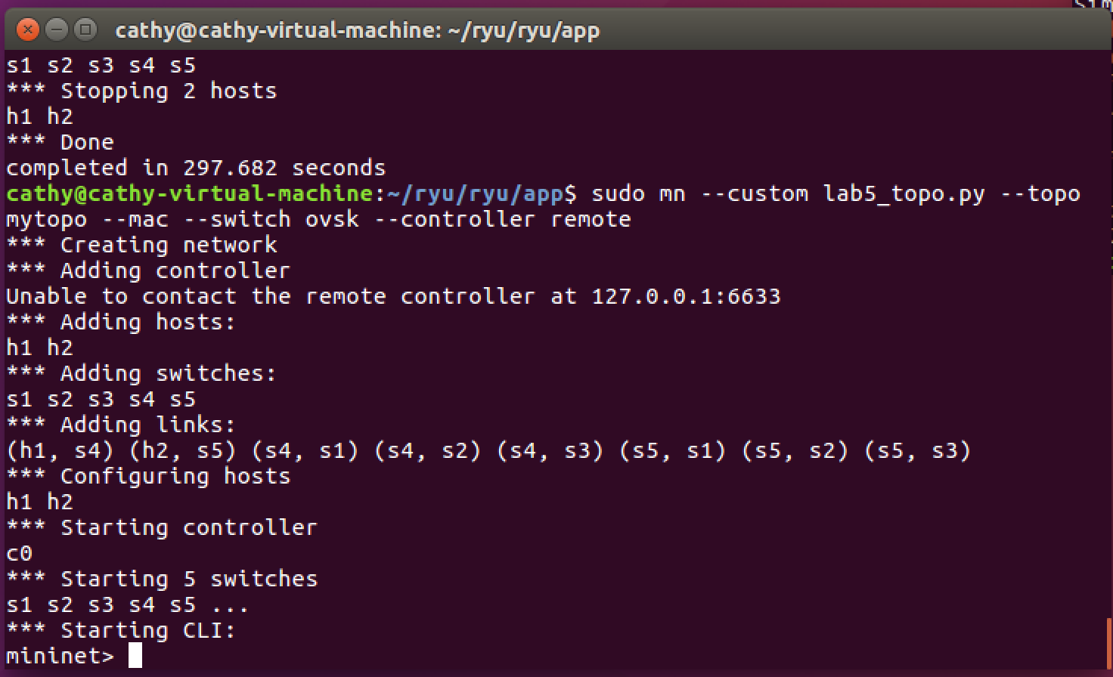

**set flow table size to 100:**

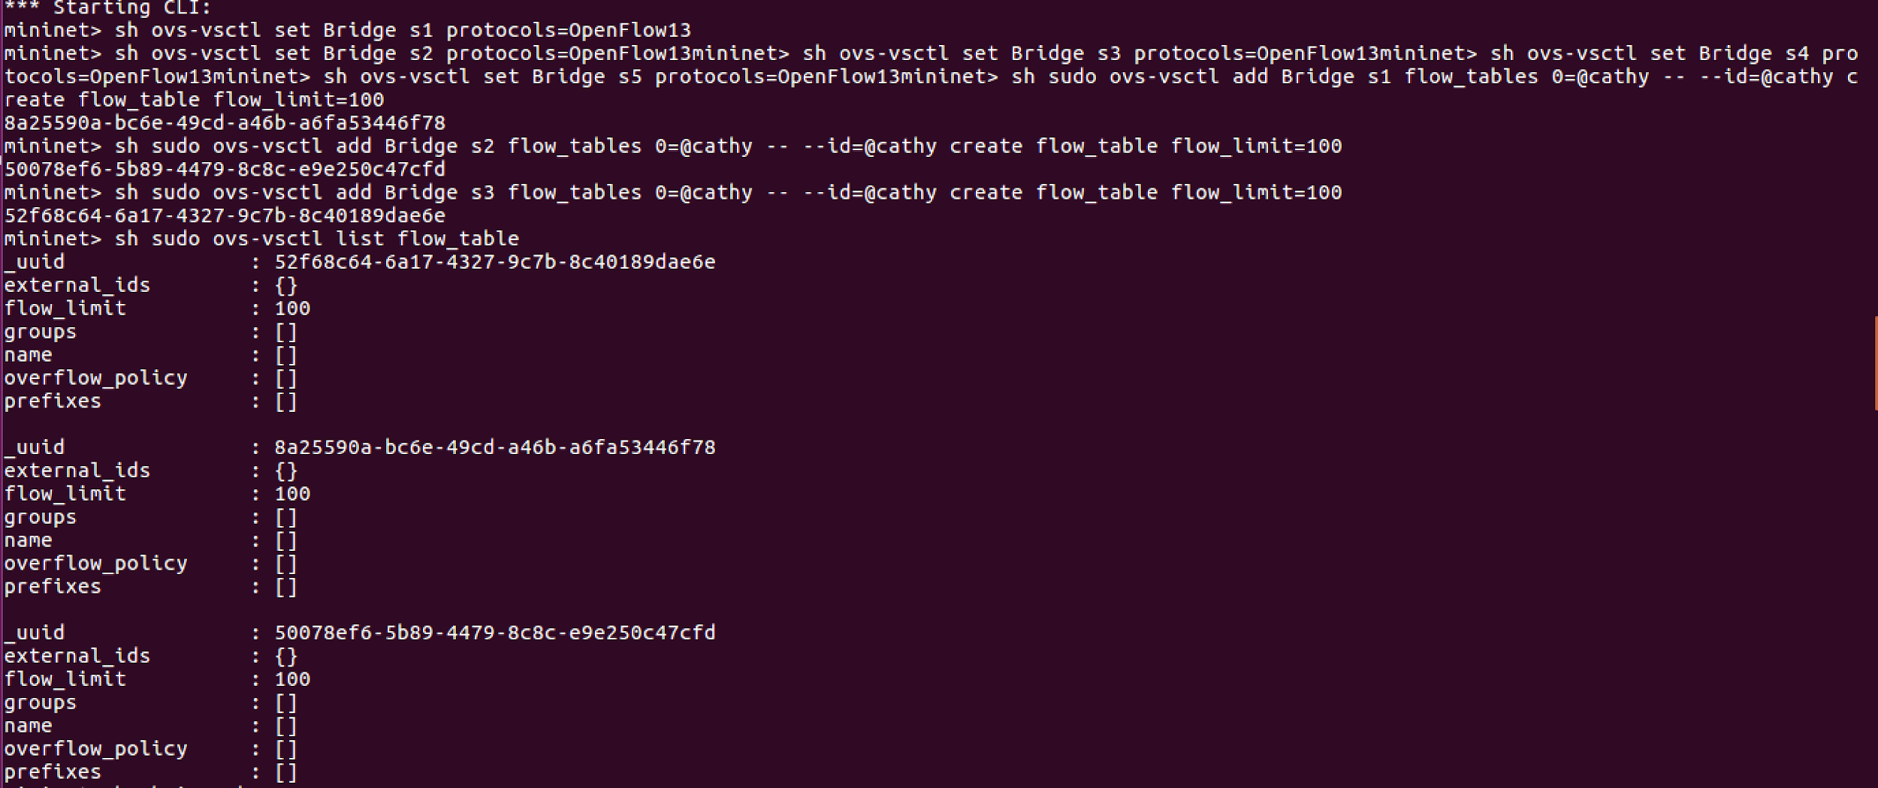

**3. Submit the screenshot(s) showing flow table overflow message(s) sent by the controller.**

After ryu-manager:

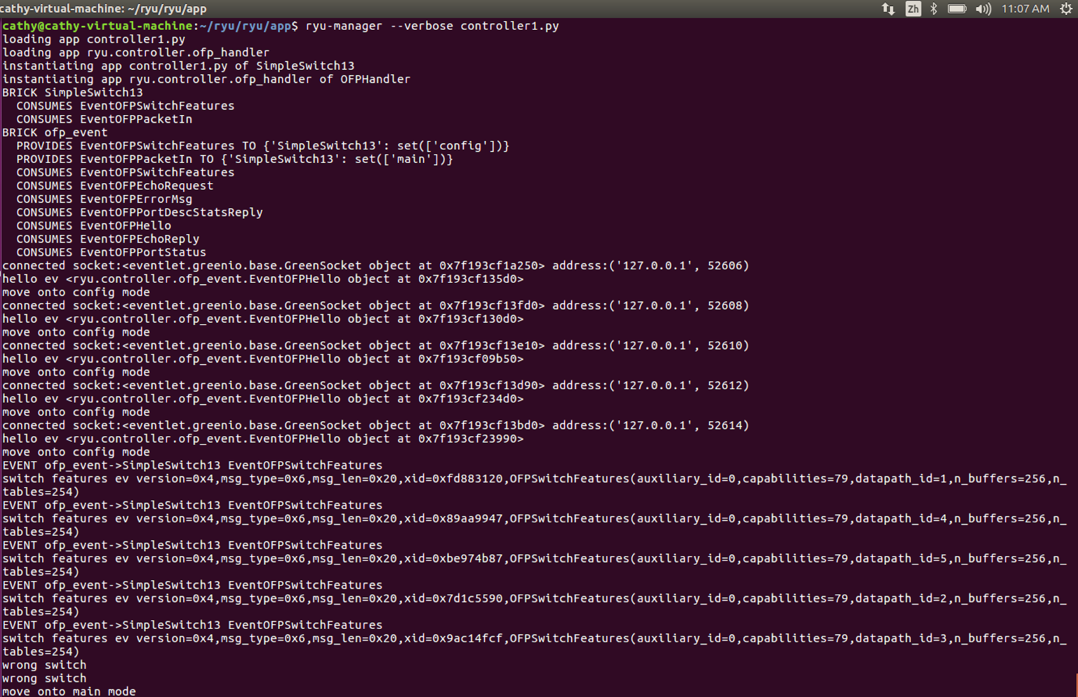

**when mininet> h1 hping3 –c 60 –p ++3000 –i u50000 h2 overflow:**

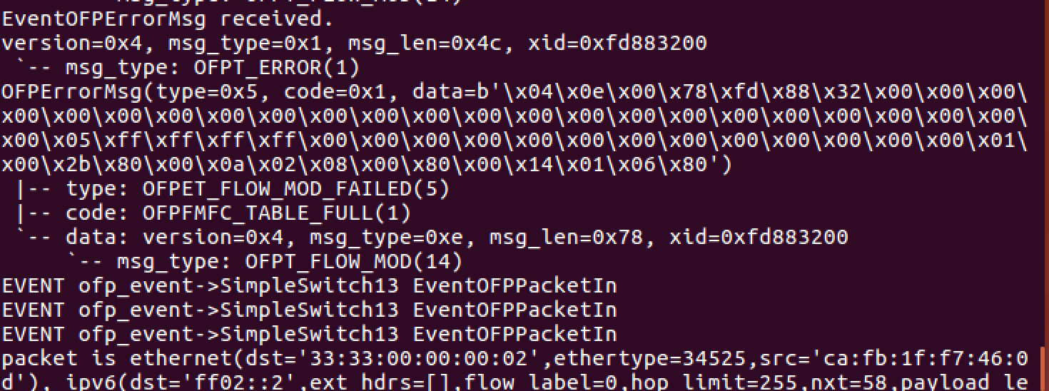

h1 hping3 h2:

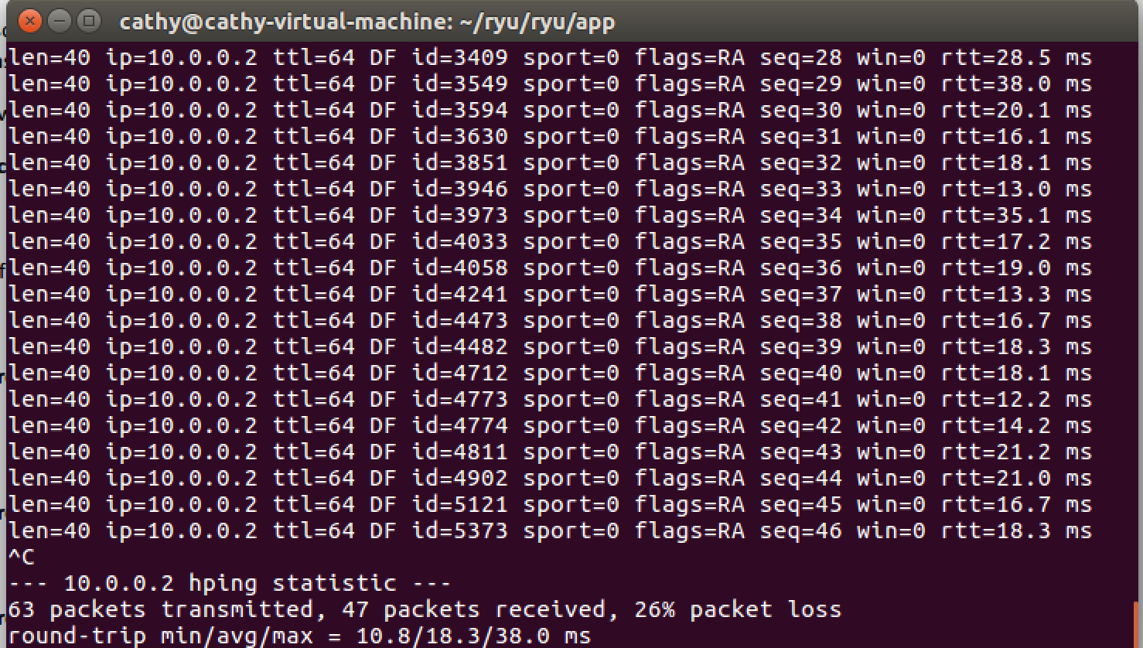

**4. Submit the screenshot(s) showing there is no flow table overflow after modifying the controller.**

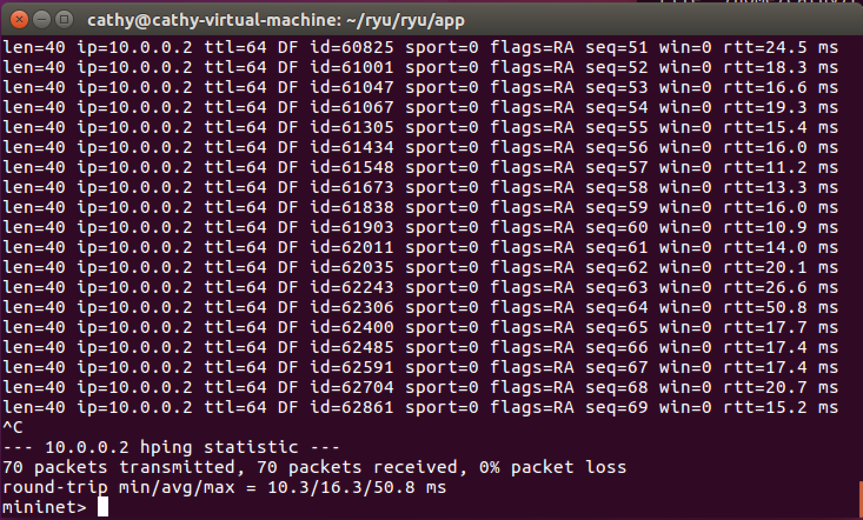

**5. Submit your controller code, both single path and 33%-33%-33% multipath. Add comments to clarify the logic if necessary.**

See in attachments:

controller1.py for single path, and controller2.py for 33%-33%-33% multipath.

For multipath, we separate the flow from different port to go to different path. The controller2 modules port by 3. If the residue is 0, flow take path s4-s1-s5. If the residue is 1, flow take path s4-s2-s5. If the residue is 2, flow take path s4-s3-s5.

**5. Consider the implementation of flow table memory in Open vSwitch. What will happen if the table size is not set while millions of flow entries are inserted into the vSwitch?**

Even if the flow table size is not set, the switch still has its maximum memory size. So, the flow table will be

overflowed while millions of flow entries are inserted into vSwitch. In addition, even flow table is so big

that it can keep all the entries, switch might need a long time to find the match.

**6. Name at least 3 consequences when flow table gets overflowed.**

(1) Controller will keep inserting new table entries but keep receiving error message from switch. Because the controller which will continuously attempt to add new flow entries and overflow the switch's flow table.

(2) Even controller can insert the entries into switch, the switch must delete some old entries. Then next time the flow of this old entries has to ask controller to insert the entry into switch again. In short, the switch has to keep swapping the flow entries.

(3) If flow table gets over owed and controller cannot insert the new entries, the packets of this flow will be dropped.