* 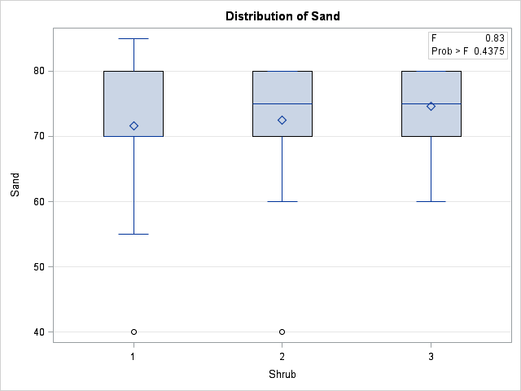**Maximum Sand Percentage**

|  |  |  |  |  |  |
| --- | --- | --- | --- | --- | --- |
| **Source** | **DF** | **Sum of Squares** | **Mean Square** | **F Value** | **Pr > F** |
| **Model** | 2 | 111.349206 | 55.674603 | 0.83 | 0.4375 |
| **Error** | 95 | 6342.650794 | 66.764745 |  |  |
| **Corrected Total** | 97 | 6454.000000 |  |  |  |

|  |  |  |  |
| --- | --- | --- | --- |
| **Level of Shrub** | **N** | **Max Sand** | |
| **Mean** | **Std Dev** |
| **1** | **63** | 71.6507937 | 8.17580761 |
| **2** | **20** | 72.5000000 | 9.38924357 |
| **3** | **15** | 74.6666667 | 6.11399643 |

|  |  |  |  |  |  |
| --- | --- | --- | --- | --- | --- |
| **Source** | **DF** | **Sum of Squares** | **Mean Square** | **F Value** | **Pr > F** |
| **Model** | 2 | 13.85204 | 6.92602 | 0.05 | 0.9501 |
| **Error** | 95 | 12839.46429 | 135.15226 |  |  |
| **Corrected Total** | 97 | 12853.31633 |  |  |  |

* **Minimum Sand Percentage**

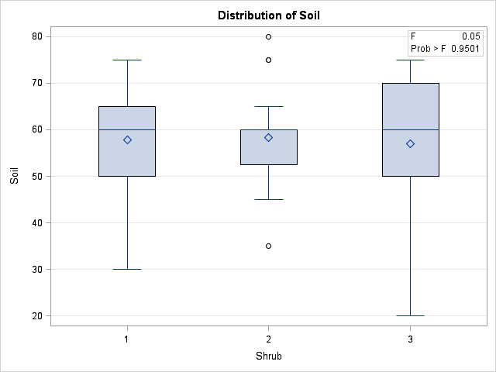

|  |  |  |  |
| --- | --- | --- | --- |
| **Level of Shrub** | **N** | **Min Sand** | |
| **Mean** | **Std Dev** |
| **1** | **63** | 57.8571429 | 11.2060714 |
| **2** | **20** | 58.2500000 | 10.6715312 |
| **3** | **15** | 57.0000000 | 14.3676223 |

* **Elevation**

|  |  |  |  |  |  |
| --- | --- | --- | --- | --- | --- |
| **Source** | **DF** | **Sum of Squares** | **Mean Square** | **F Value** | **ElevationBoxPlot.pngPr > F** |
| **Model** | 2 | 188.406880 | 94.203440 | 0.99 | 0.3769 |
| **Error** | 95 | 9077.919304 | 95.557045 |  |  |
| **Corrected Total** | 97 | 9266.326184 |  |  |  |

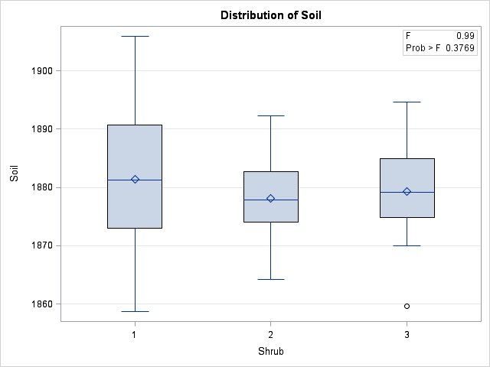

|  |  |  |  |
| --- | --- | --- | --- |
| **Level of Shrub** | **N** | **Elevation** | |
| **Mean** | **Std Dev** |
| **1** | **63** | 1881.45652 | 10.6116301 |
| **2** | **20** | 1878.15472 | 7.1791840 |
| **3** | **15** | 1879.31805 | 8.9324103 |

* 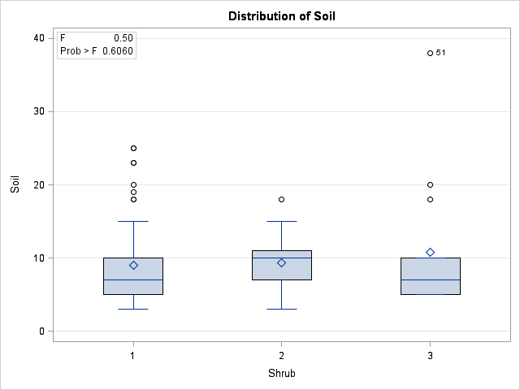**Maximum Clay Percentage**

|  |  |  |  |  |  |
| --- | --- | --- | --- | --- | --- |
| **Source** | **DF** | **Sum of Squares** | **Mean Square** | **F Value** | **Pr > F** |
| **Model** | 2 | 34.435034 | 17.217517 | 0.50 | 0.6060 |
| **Error** | 95 | 3248.340476 | 34.193058 |  |  |
| **Corrected Total** | 97 | 3282.775510 |  |  |  |

|  |  |  |  |
| --- | --- | --- | --- |
| **Level of Shrub** | **N** | **Max Clay** | |
| **Mean** | **Std Dev** |
| **1** | **63** | 9.0476190 | 5.53122681 |
| **2** | **20** | 9.3500000 | 3.74552364 |
| **3** | **15** | 10.7333333 | 8.80313797 |

* 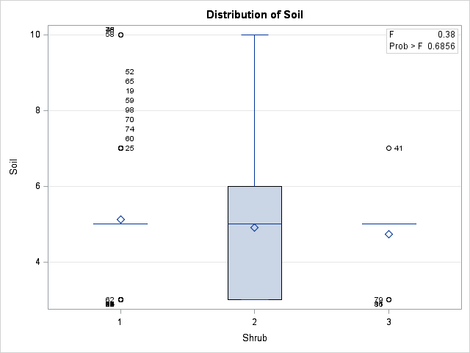**Minimum Clay Percentage**

|  |  |  |  |  |  |
| --- | --- | --- | --- | --- | --- |
| **Source** | **DF** | **Sum of Squares** | **Mean Square** | **F Value** | **Pr > F** |
| **Model** | 2 | 2.0342404 | 1.0171202 | 0.38 | 0.6856 |
| **Error** | 95 | 254.9555556 | 2.6837427 |  |  |
| **Corrected Total** | 97 | 256.9897959 |  |  |  |

|  |  |  |  |
| --- | --- | --- | --- |
| **Level of Shrub** | **N** | **Min Clay** | |
| **Mean** | **Std Dev** |
| **1** | **63** | 5.11111111 | 1.61755601 |
| **2** | **20** | 4.90000000 | 2.02354561 |
| **3** | **15** | 4.73333333 | 1.03279556 |

* 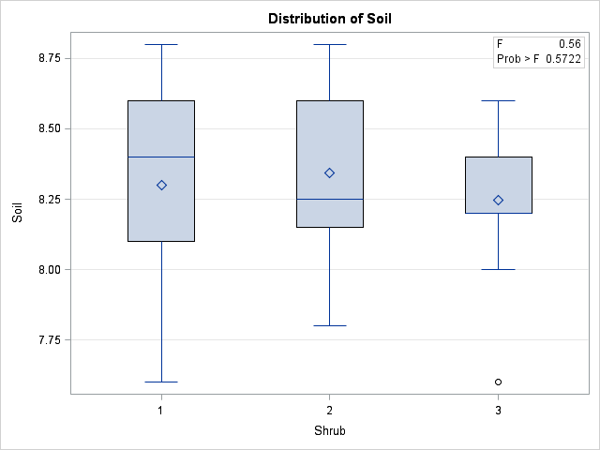**Maximum pH**

|  |  |  |  |  |  |
| --- | --- | --- | --- | --- | --- |
| **Source** | **DF** | **Sum of Squares** | **Mean Square** | **F Value** | **Pr > F** |
| **Model** | 2 | 0.08306463 | 0.04153231 | 0.56 | 0.5722 |
| **Error** | 95 | 7.02683333 | 0.07396667 |  |  |
| **Corrected Total** | 97 | 7.10989796 |  |  |  |

|  |  |  |  |
| --- | --- | --- | --- |
| **Level of Shrub** | **N** | **Max pH** | |
| **Mean** | **Std Dev** |
| **1** | **63** | 8.30000000 | 0.28055245 |
| **2** | **20** | 8.34500000 | 0.26847523 |
| **3** | **15** | 8.24666667 | 0.23563491 |

* 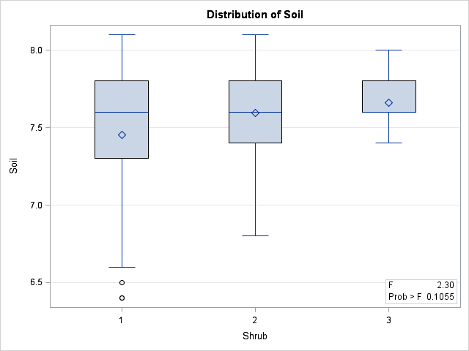**Minimum pH**

|  |  |  |  |  |  |
| --- | --- | --- | --- | --- | --- |
| **Source** | **DF** | **Sum of Squares** | **Mean Square** | **F Value** | **Pr > F** |
| **Model** | 2 | 0.67799206 | 0.33899603 | 2.30 | 0.1055 |
| **Error** | 95 | 13.98200794 | 0.14717903 |  |  |
| **Corrected Total** | 97 | 14.66000000 |  |  |  |

|  |  |  |  |
| --- | --- | --- | --- |
| **Level of Shrub** | **N** | **Min pH** | |
| **Mean** | **Std Dev** |
| **1** | **63** | 7.45396825 | 0.43914337 |
| **2** | **20** | 7.59500000 | 0.29285348 |
| **3** | **15** | 7.66000000 | 0.16818357 |

* 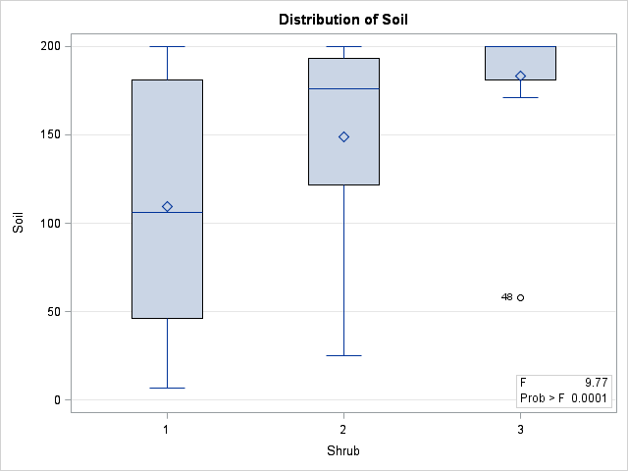**Maximum Depth**

|  |  |  |  |  |  |
| --- | --- | --- | --- | --- | --- |
| **Source** | **DF** | **Sum of Squares** | **Mean Square** | **F Value** | **Pr > F** |
| **Model** | 2 | 76192.0898 | 38096.0449 | 9.77 | 0.0001 |
| **Error** | 95 | 370433.8286 | 3899.3035 |  |  |
| **Corrected Total** | 97 | 446625.9184 |  |  |  |

|  |  |  |  |
| --- | --- | --- | --- |
| **Level of Shrub** | **N** | **Max Depth** | |
| **Mean** | **Std Dev** |
| **1** | **63** | 109.428571 | 68.0589674 |
| **2** | **20** | 149.000000 | 58.5113574 |
| **3** | **15** | 183.200000 | 36.0559090 |

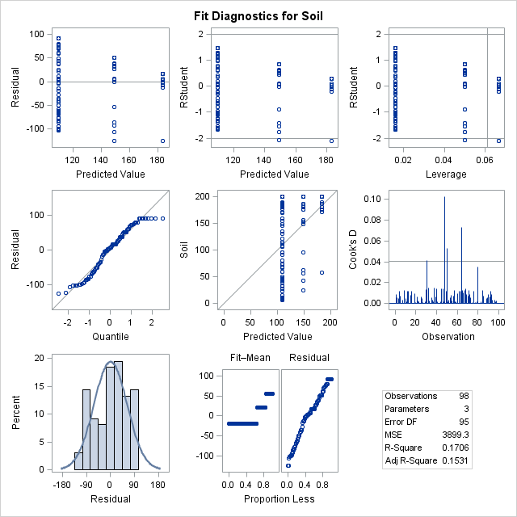

When I ran proc transreg to get BoxCox lambda was 1

* 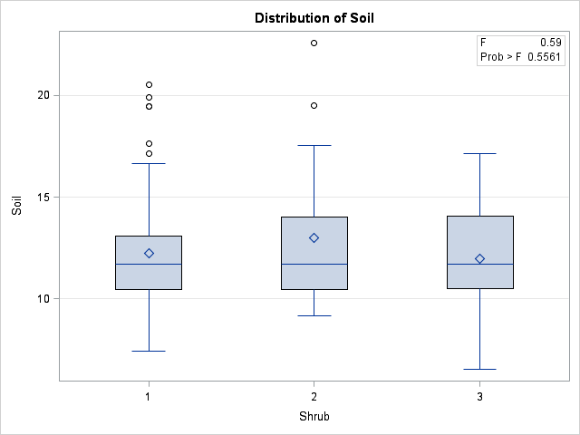**Max AWC (Available Water Holding Capacity)**

|  |  |  |  |  |  |
| --- | --- | --- | --- | --- | --- |
| **Source** | **DF** | **Sum of Squares** | **Mean Square** | **F Value** | **Pr > F** |
| **Model** | 2 | 11.6478040 | 5.8239020 | 0.59 | 0.5561 |
| **Error** | 95 | 937.0884633 | 9.8640891 |  |  |
| **Corrected Total** | 97 | 948.7362673 |  |  |  |

|  |  |  |  |
| --- | --- | --- | --- |
| **Level of Shrub** | **N** | **Max AWC** | |
| **Mean** | **Std Dev** |
| **1** | **63** | 12.2235714 | 3.08654724 |
| **2** | **20** | 12.9960500 | 3.58504200 |
| **3** | **15** | 11.9582667 | 2.70225415 |

|  |  |  |  |  |  |
| --- | --- | --- | --- | --- | --- |
| **Source** | **DF** | **Sum of Squares** | **Mean Square** | **F Value** | **TotalAWCBoxPlot.pngPr > F** |
| **Model** | 2 | 600.06340 | 300.03170 | 0.86 | 0.4279 |
| **Error** | 95 | 33274.69408 | 350.25994 |  |  |
| **Corrected Total** | 97 | 33874.75748 |  |  |  |

* **Total AWC**

|  |  |  |  |
| --- | --- | --- | --- |
| **Level of Shrub** | **N** | **Total AWC** | |
| **Mean** | **Std Dev** |
| **1** | **63** | 41.1219048 | 16.4384146 |
| **2** | **20** | 45.5058000 | 27.0449905 |
| **3** | **15** | 37.2519333 | 13.6898397 |

|  |  |  |  |  |  |
| --- | --- | --- | --- | --- | --- |
| **Levene's Test for Homogeneity of Soil Variance ANOVA of Squared Deviations from Group Means** | | | | | |
| **Source** | **DF** | **Sum of Squares** | **Mean Square** | **F Value** | **Pr > F** |
| **Shrub** | 2 | 3272894 | 1636447 | 5.00 | 0.0086 |
| **Error** | 95 | 31079417 | 327152 |  |  |

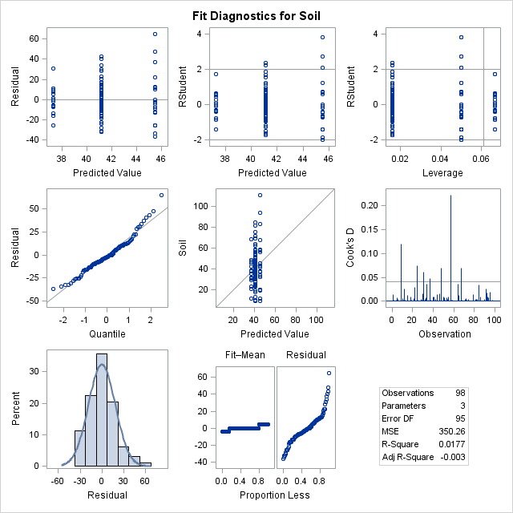

|  |  |  |  |  |  |
| --- | --- | --- | --- | --- | --- |
| **Source** | **DF** | **Sum of Squares** | **Mean Square** | **F Value** | **Pr > F** |
| **Model** | 2 | 1.8274410 | 0.9137205 | 0.42 | 0.6567 |
| **Error** | 95 | 205.5358574 | 2.1635353 |  |  |
| **Corrected Total** | 97 | 207.3632985 |  |  |  |

* **AWC 25**

|  |  |  |  |  |  |
| --- | --- | --- | --- | --- | --- |
| **Source** | **DF** | **Sum of Squares** | **Mean Square** | **F Value** | **Pr > F** |
| **Model** | 2 | 29.2561363 | 14.6280681 | 1.89 | 0.1566 |
| **Error** | 95 | 735.0427911 | 7.7372925 |  |  |
| **Corrected Total** | 97 | 764.2989274 |  |  |  |

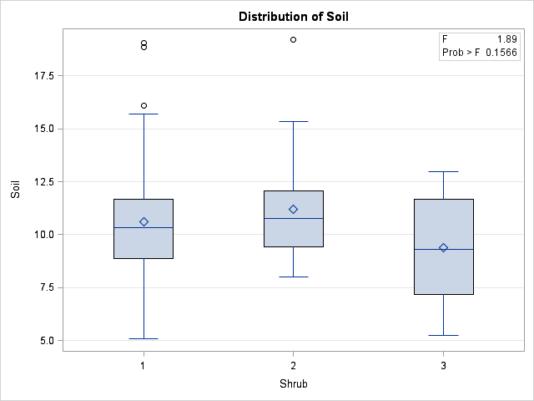

|  |  |  |  |
| --- | --- | --- | --- |
| **Level of Shrub** | **N** | **Soil** | |
| **Mean** | **Std Dev** |
| **1** | **63** | 10.6174777 | 2.87757353 |
| **2** | **20** | 11.1956720 | 2.64827768 |
| **3** | **15** | 9.3771600 | 2.51285335 |

* 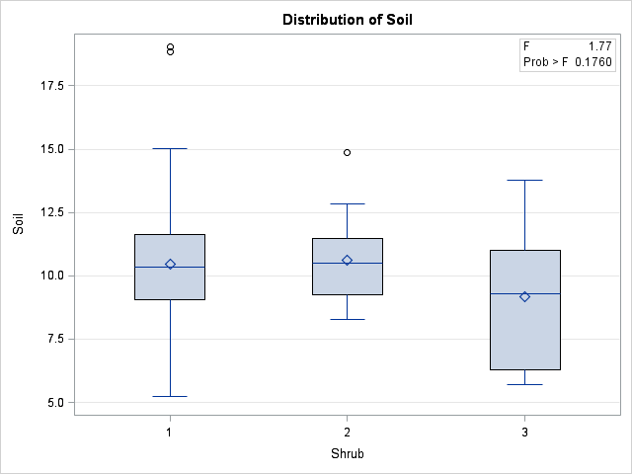**AWC 50**

|  |  |  |  |  |  |
| --- | --- | --- | --- | --- | --- |
| **Source** | **DF** | **Sum of Squares** | **Mean Square** | **F Value** | **Pr > F** |
| **Model** | 2 | 22.2871070 | 11.1435535 | 1.77 | 0.1760 |
| **Error** | 95 | 598.2500695 | 6.2973692 |  |  |
| **Corrected Total** | 97 | 620.5371765 |  |  |  |

|  |  |  |  |
| --- | --- | --- | --- |
| **Level of Shrub** | **N** | **Soil** | |
| **Mean** | **Std Dev** |
| **1** | **63** | 10.4493482 | 2.70367745 |
| **2** | **20** | 10.6199448 | 1.62595148 |
| **3** | **15** | 9.1791398 | 2.60229807 |

|  |  |  |  |  |  |
| --- | --- | --- | --- | --- | --- |
| **Source** | **DF** | **Sum of Squares** | **Mean Square** | **F Value** | **Pr > F** |
| **Model** | 2 | 16.4642275 | 8.2321137 | 1.34 | 0.2664 |
| **Error** | 95 | 583.0574380 | 6.1374467 |  |  |
| **Corrected Total** | 97 | 599.5216655 |  |  |  |

* **AWC100**

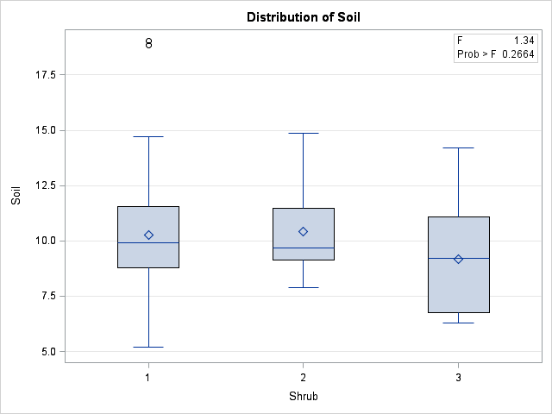

|  |  |  |  |
| --- | --- | --- | --- |
| **Level of Shrub** | **N** | **Soil** | |
| **Mean** | **Std Dev** |
| **1** | **63** | 10.2573706 | 2.65058426 |
| **2** | **20** | 10.4365928 | 1.92064364 |
| **3** | **15** | 9.1791304 | 2.35101593 |