**Sagebrush decline on the Colorado Plateau: A look at sagebrush and soils.**

**Introduction**

Sagebrush ecosystems are important habitat for mule deer, greater sage grouse, and over 350 different flora and fauna (Wisdom and Rowland 2007). They are also important rangeland for the western livestock industry, an icon of the American West, key components of many watersheds, and considered by many to be vital recreation areas (McIver et al. 2010). However, these ecosystems are also in decline due to overgrazing, fire suppression, woodland expansion, fragmentation, and many more natural and anthropogenic causes (Wisdom and Rowland 2007). Growing concern for this problem has led to a great many studies on the dynamics of sagebrush ecosystems and their obligate species. It has also led to the formation of nonprofit organizations such as Saving the Sagebrush Sea, and programs such as SageSTEP.

Much of this restoration attention is focused in the Great Basin, but very little is known about how sagebrush responds on the Colorado Plateau which has drier and monsoonal climatic conditions as well as different soils and vegetation (Monsen et al. 2004). This is problematic because there is little to suggest that restoration successes in well studied areas will be successful on the Colorado Plateau.

**Study Site**

This study is located in Beef Basin which is roughly in the center of the Colorado Plateau and is located on BLM land just south of Canyonlands National Park and north of the Abajo Mountains in San Juan County, Utah (Figures 1, 2, and 3). This area of southern Utah is known for recreation, cattle grazing, and deer hunting. However, these activities are threatened because sagebrush habitat has degraded to such an extent that it is more accurately described as grassland. Figure 4 shows an area of Beef Basin which was covered in shrubs (predominantly sagebrush) in 1975, and by 2011 there are very few shrubs left. Records show that in the late 1980’s there was between 40% and 100% die off of sagebrush (USDI BLM 2011).

**Objectives and Study Design**

The objectives of this study are 1to better understand the vegetation communities that define this area and 2to determine which soil characteristics are influencing the presence of sagebrush on the landscape. To this end Sites were randomly selected in ARC Map from two of the BLM’s proposed treatment polygons based on NDVI values that had been split into 4 quartiles, and within one of the three dominant soil types (Begay, Ignacio/Leanto, and Mido) for a total of 12 plot types (NDVI by soil) with 6 to 10 sites sampled at each plot type for a total of 99 plots sampled (Table 1). At each plot 5 transects 30m long were set up 7m apart. Data collected included Line Point Intercept (collected on all 5 transects), Shrub Density (collected on transects 1, 3, and 5), and Soil (2m auger, sampled 2m down from line 3) (Figure 5).

**Multivariate Analysis**

Multivariate analyses conducted on this data are classification trees and random forests. Line Point Intercept data used in these analyses includes the relative cover of four vegetation classes: tree, shrub, forb, and grass. Shrub density data used is presence/absence of sagebrush. Soil data includes horizon depth, maximum Munsell moist value and chroma, maximum Munsell dry value and chroma, maximum sand percent, minimum sand percent, maximum clay percent, minimum clay percent, maximum pH, minimum pH, elevation, carbonate stage, and biotic crust class. Other soil factors were removed from the following analysis but are anticipated to be useful in future analysis. They were removed because I have not yet found a meaningful way to reduce categorical data represented as characters which have several observations per plot to one observation per plot (multiple horizons in a single soil profile). The predictor variables are the Line Point Intercept and soils variables, the response variables are the shrub density sagebrush presence/ absence data.

**Results and Discussion**

Classification trees and random forests were performed on this data. Classification trees found a cp value of .064 which corresponded to a tree with 8 terminal nodes (Figure 6). After applying the cp value the resulting tree demonstrated that sagebrush prefer sites with soil depths less than ~150cm (Figure 7). Baring this, they then prefer elevations less than 6206 feet and forb cover roughly between 1 and 3 percent. A few sagebrush sites also occur at sites greater than 6216 feet. This tree also showed that sites with a soil depth greater than ~150cm, elevation less than 1216 feet, and a maximum pH less than 8.2 had the greatest concentration of absences (no sagebrush present). The second greatest focus of absences is sites with soil depth greater than ~150cm, elevation less than 6216 feet, max pH greater than 8.2, elevation greater than 6206 feet, and less than 1% forb cover. I found it interesting that the elevation range is only about 10 feet.

A notable problem with these results is the error rates. Prior to cross validation this data had an overall error rate of approximately 11 percent. After cross validation the overall error rate jumped up to between 30 and 40 percent (Table 2). This indicates that my predictor variables do not describe the data well. I anticipate that the addition of the afore mentioned character categorical data will mitigate this problem.

Random Forests were also carried out on this data will similarly lackluster results. The cross validated overall error rate for all of the variables is ~37% (Table 3). After creating a variable importance plot results show that maxDepth, minDryChroma, BioticCrustClass, minClay, minMoistChroma, maxpH, Elevation, and Tree are important variables (Figure 8). However, the cross validated overall error rate is ~ 36% (Table 4).

Despite these unacceptable error rates partial dependence plots were created for the important variables. Some interesting results include plots for maxDepth and Elevation which support the findings from the above classification tree. The partial dependence plot for maxDepth shows that sagebrush presence drops significantly at depths greater than 150cm (Figure 9). The partial dependence plot for Elevation shows that sagebrush occur most often at higher elevations, occur somewhat at lower elevations, but the mid elevation range has the least incidence of sagebrush (Figure 10).

**Conclusions**

Classification trees and random forests both found similar results, but also had similarly high error rates. The error rates are currently so high that the results are not useful. These two methods for multivariate analysis are valuable tools that can be used for this data set, but the data set itself needs to be refined. These results show a pressing need to use all collected variables in this analysis, and once all variables are available for analysis it is anticipated that the error rates will drop to reasonable levels.

Additional analysis to be done with this data set include looking at the presence and absence of sagebrush carcasses (dead sagebrush), as well as looking at the live and dead sagebrush together.

The results of this analysis (after it has been adjusted) will be used to inform land managers, particularly the BLM and USGS, and further restoration efforts.

**Works Cited**

Wisdom, Michael, and Mary Rowland. "Sagebrush in Western North America: Habitats and

Species in Jeopardy." USFS *Science Findings* 91 (2007): 1-6.

<http://www.fs.fed.us/pnw/sciencef/scifi91.pdf>.

McIver, J.D., M. Brunson, S. Bunting, J. Chambers, N. Devoe, P. Doescher, J. Grace, D. Johnson, S. Knick, R. Miller, M. Pellant, F. Pierson, D. Pyke, K. Rollins, B. Roundy, E.W. Schupp, R. Tausch, D. Turner. 2010. The Sagebrush Steppe Treatment Evaluation Project (SageSTEP): a test of state-and-transition theory. RMRS-GTR-237. USDA Forest Service General Technical Report, Rocky Mountain Research Station, Ft. Collins, CO.

Monsen, S.B., R. Stevens, N.L. Shaw, eds. 2004. Restoring western ranges and wildlands, Vol. I – III. RMRS-GTR-136. USDA Forest Service General Technical Report, Rocky Mountain Research Station, Ft. Collins, CO.

United States Department of the Interior Bureau of Land Management Environmental

Assessment UT-Y020-2011-0047-EA. Beef Basin/Dark Canyon Plateau Sagebrush

Restoration. December 2011. <https://www.blm.gov/ut/enbb/files/Beef_Basin_EA.pdf>

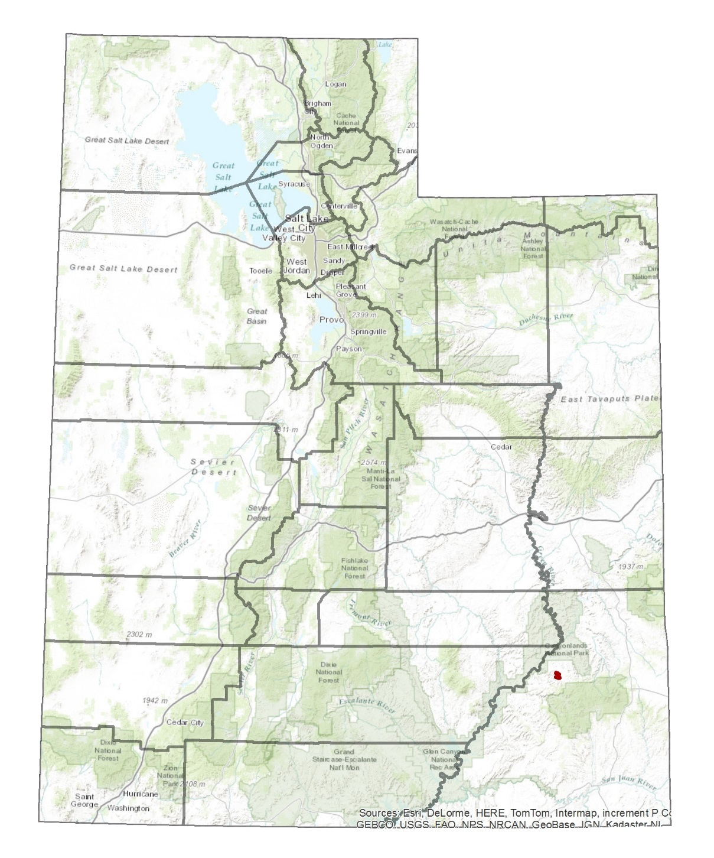**Figures, Tables, and Graphs**

Figure : Beef Basin (Overview)

Beef Basin, Utah (red dot) is located in San Juan County Utah. It is south of Canyonlands National Park and north of the Manti-La-Sal National Forest.

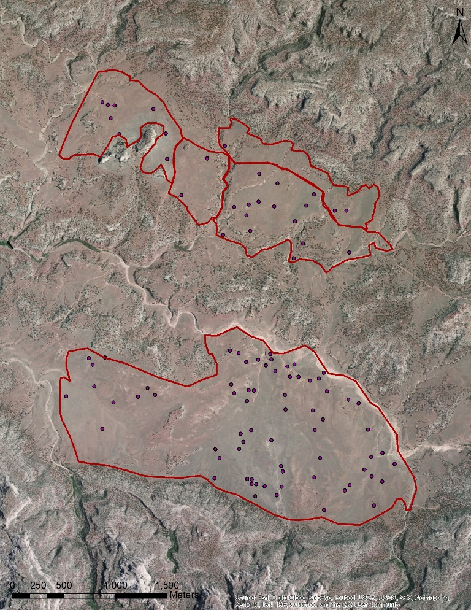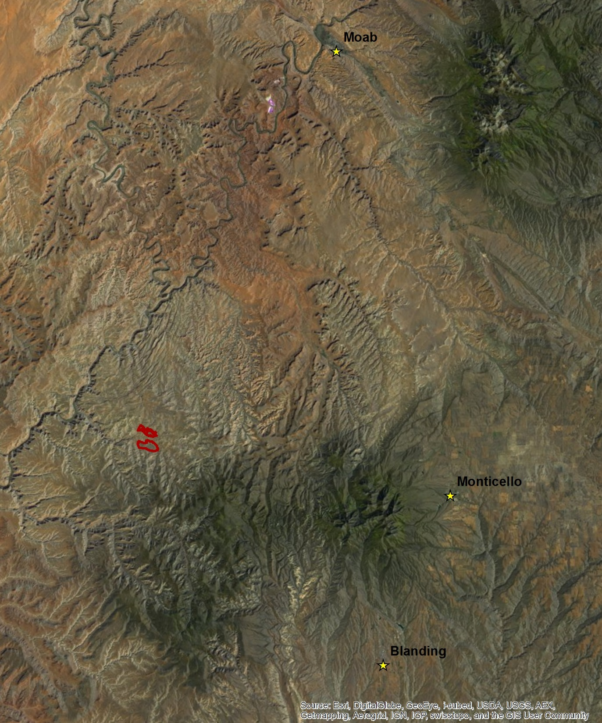

Figure 2: Beef Basin (What is nearby?)

Beef Basin, Utah can be seen above. The two sample polygons are outlined in red. Moab, Montecello, and Blanding are nearby cities. Dark reddish orange is Canyonlands National Park; dark green patch below polygons is the Manti-La-Sal National Forest.

Figure 3: Beef Basin (Study Sites)

The two basin polygons studied in Beef Basin are North Plain and South Plain outlined in red above. Purple dots are the 99 sites sampled.

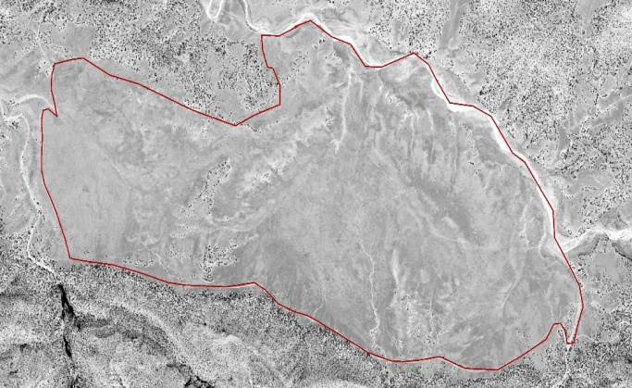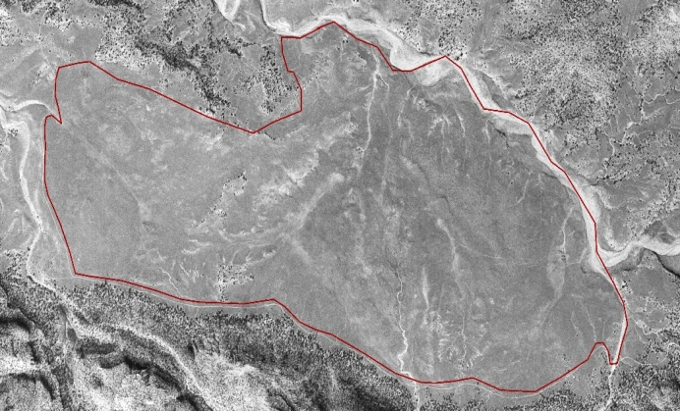

Figure 4: A Look Through Time

South Plain, Beef Basin. Aerial photograph from 1975 (left) shows that the area was dominated by shrubs (dark grey). NDVI from 2011 (right) shows most of this shrub cover has been replaced by grassland (light grey).

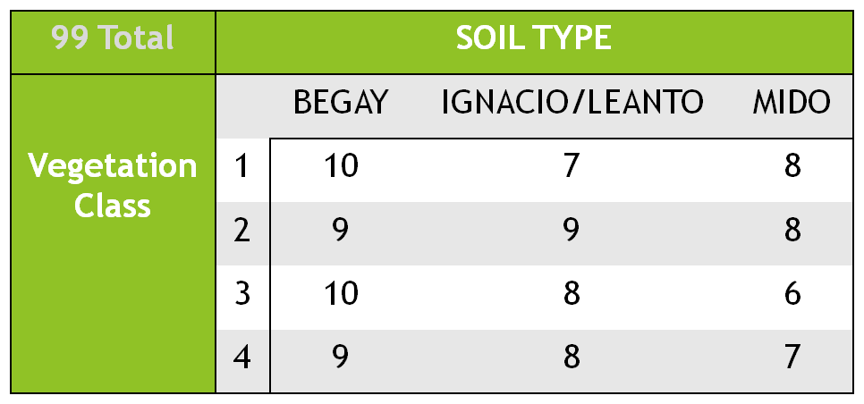Table : Study Design

Sites were stratified based on the three dominant soil types and 4 vegetation classes. Between 6 and 10 sites were selected for each combination for a total of 99 sites.

Figure 5: Site Design

5 transects were sampled per site, 30 meters long and 7 meters apart. Line Point intercept was taken on all 5 lines. Shrub density was taken on lines 2, 3, and 4. A soil pit was dug 15 meters in and 2 meters down from transect 3.

Figure 6: CP Plot

The cp plot indicated a cp of 0.064 or a tree size of 8.

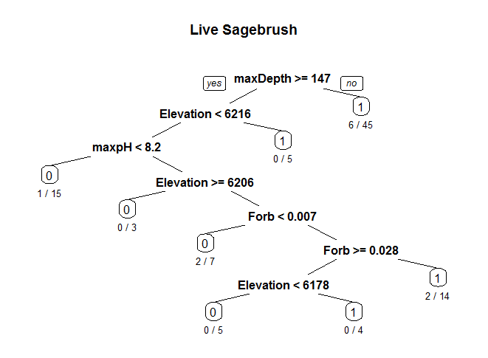



Figure 7: Classification Tree

This tree has 8 nodes. It shows that sagebrush prefer sites with soil depths less than ~150cm. Baring this, they then prefer elevations less than 6206 feet and forb cover roughly between 1 and 3 percent. A few sagebrush sites also occur at sites greater than 6216 feet.

|  |  |  |
| --- | --- | --- |
| **Live Sagebrush** | | |
|  | **0** | **1** |
| **0** | 16 | 19 |
| **1** | 17 | 46 |

|  |  |  |  |  |  |
| --- | --- | --- | --- | --- | --- |
| Overall Error Rate | PCC | Specificity | Sensitivity | Kappa | AUC |
| 36.73469 | 63.270 | 45.710 | 73.020 | 0.190 | 0.594 |

Classification Tree

Table : Classification Tree

Prior to cross validation the overall error rate was ~11%, after cross validation it jumped to between 30% and 40%.

|  |  |  |
| --- | --- | --- |
| **Live Sagebrush** | | |
|  | **0** | **1** |
| **0** | 12 | 23 |
| **1** | 9 | 54 |

|  |  |  |  |  |  |
| --- | --- | --- | --- | --- | --- |
| Overall Error Rate | PCC | Specificity | Sensitivity | Kappa | AUC |
| 37.35714 | 67.350 | 34.290 | 85.710 | 0.220 | 0.695 |

Random Forest: All Variables

Table 3: Random Forest for All Variables

Cross validated error rate for all of the variables is nearly 40%.

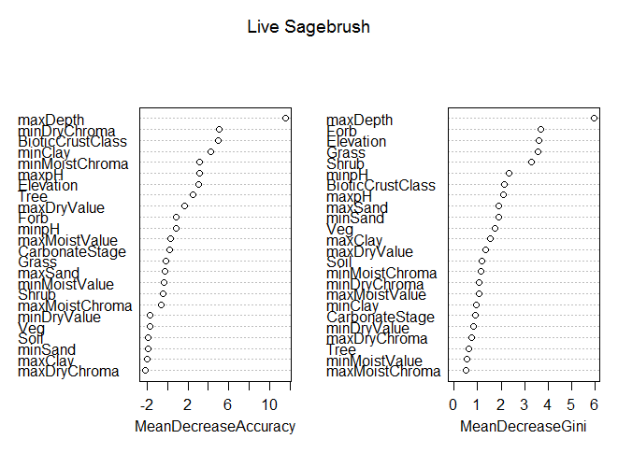 Figure 8: Variable Importance Plot

maxDepth, minDryChroma, BioticCrustClass, minClay, minMoistChroma, maxpH, Elevation, and Tree are identified as important variables.

|  |  |  |
| --- | --- | --- |
| **Live Sagebrush** | | |
|  | **0** | **1** |
| **0** | 18 | 17 |
| **1** | 11 | 52 |

|  |  |  |  |  |  |
| --- | --- | --- | --- | --- | --- |
| Overall Error Rate | PCC | Specificity | Sensitivity | Kappa | AUC |
| 36.88776 | 71.430 | 51.430 | 82.540 | 0.353 | 0.799 |

Random Forest: Important Variables Only

Table 4: Random Forest for Important Variables

Cross validated error rate for only the important variables (determined by variable importance plot) is between 30% and 40%.

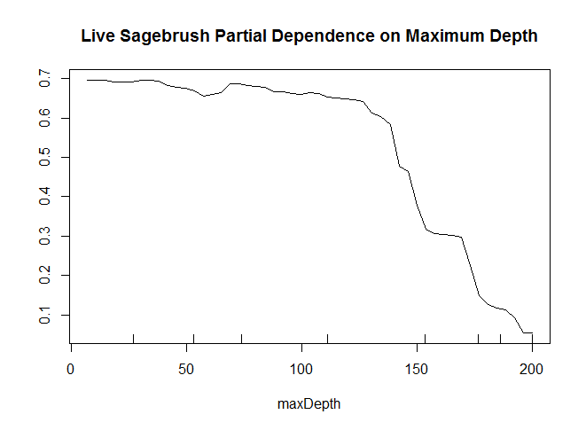

Figure 9: Partial Dependence on Maximum Depth

This plot shows that sagebrush prefer sites with depths >150cm.

Figure 10: Partial Dependence on Elevation

This plot shows that sagebrush prefer higher elevation sites, some will persist at the lowest elevation end. The middle elevation sees a dramatic drop in sagebrush presence.

