RAMOS, JENNYLYN ANNE O. BSIT 3A LinuxExer2

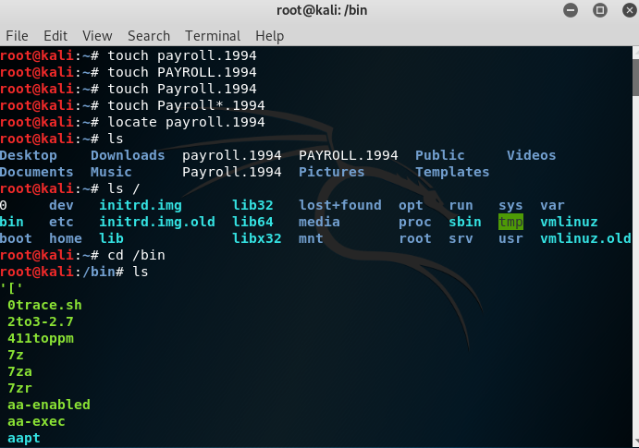
LINUX FILE AND DIRECTORY NAMING CONVENTIONS


LINUX FILE SYSTEM

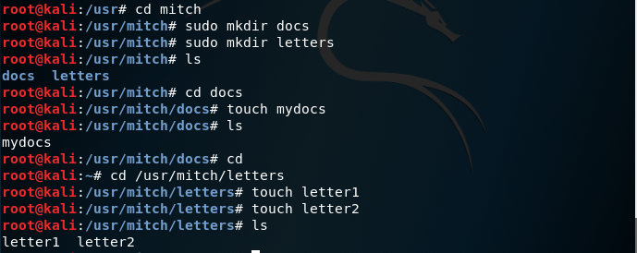

PATHS




FILE / DIRECTORY COMMANDS


CD COMMANDS
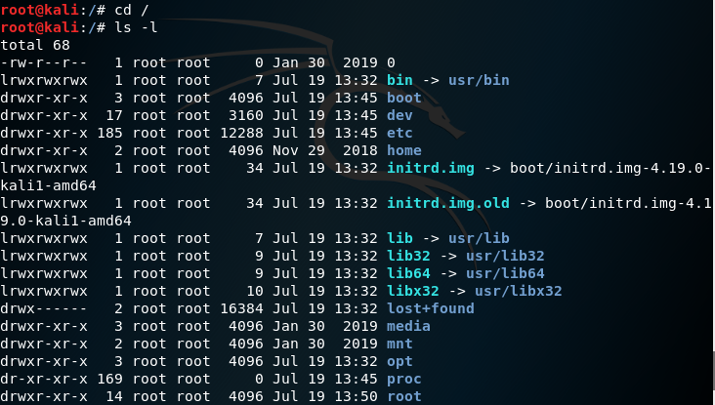

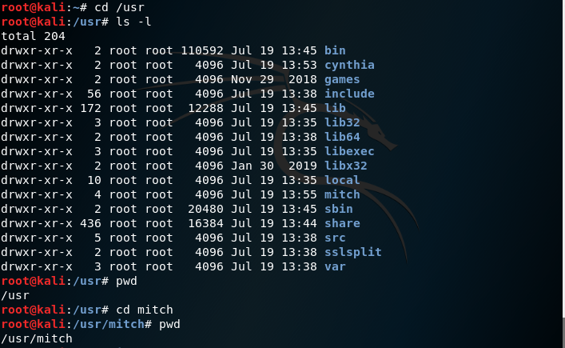

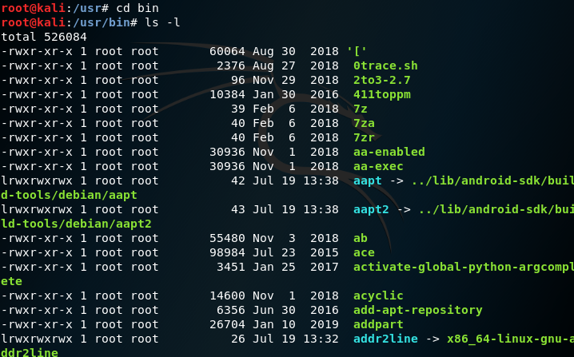

MKDIR COMMAND
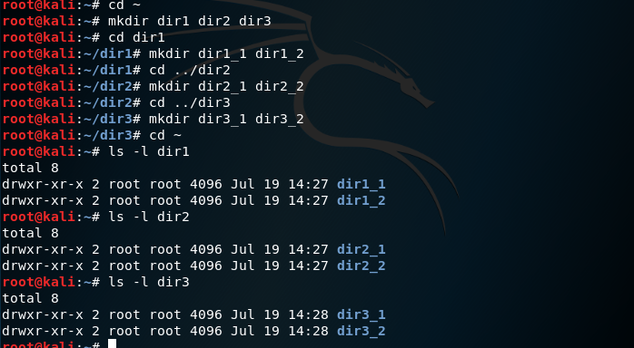
RMDIR COMMAND
Use the rmdir command to delete dir2_2 and dir3_2.
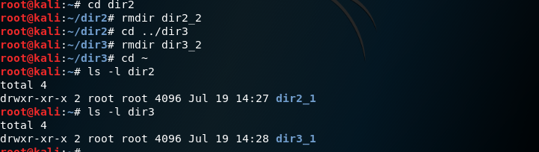

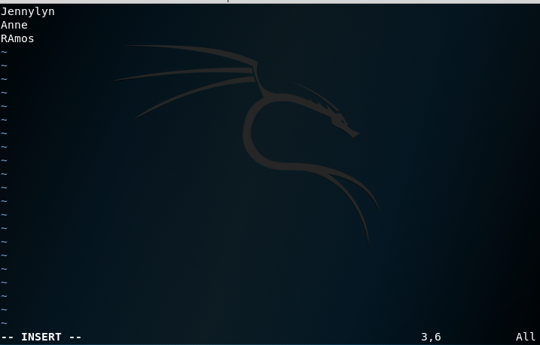
VI FILE EDITOR


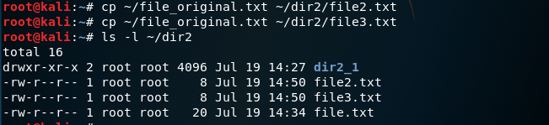

MV COMMAND
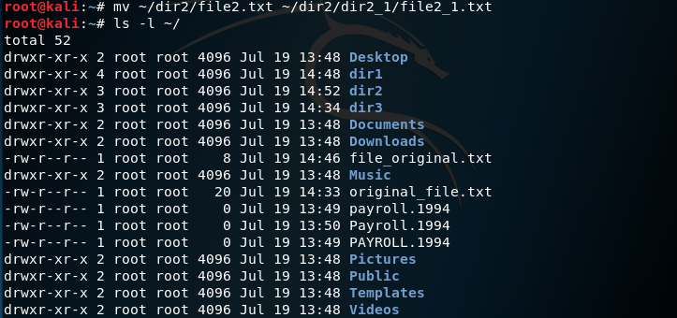

RM COMMAND
