
MARIE LENNY CANUA OBIS
Address: 60 Sitio Cadena De Amor Sanjose Sta Cruz, Laguna
Mobile No. 09944803075
Email: marielennycanuaobis@gmail.com

OBJECTIVE:
To obtain a position that would best fit my qualifications and develop further my talents and skills for continuous career development.
PERSONAL INFORMATION
Date of Birth : November 24, 2000 Civil Status : Single
Age : 23 years old Religion : Roman Catholic
Place of Birth : Sta Cruz, Laguna Gender : Female
Nickname : Lenny Nationality : Filipino
EDUCATIONAL BACKGROUND
SENIOR HIGH Felicisimo T. San Luis Memorial National High School
7C43+XX5 RECS Village, Santa Cruz, Laguna
Batch 2016 - 2018
Graduated
SECONDARY Felicisimo T. San Luis Memorial National High School
7C43+XX5 RECS Village, Santa Cruz, Laguna
Batch 2012 - 2016
Graduated
ELEMENTARY San Jose Elementary School
Brgy. San Jose Sta Cruz, Laguna
Batch 2006 - 2012
Graduated
SKILLS
- Communication skills
- Hardworking
- Willingness to learn
- Time Management

WORK EXPERIENCE

Seller : Food Vendor
Term : October 5, 2019 – May 1, 2024

Character Reference:
Darwin Uesereña
Brgy. Captain
Erica Estrada
Proven Vendor
I hereby certify that the above information is true and correct to the best of my knowledge and belief.

Marie Lenny C. Obis
(Applicant)

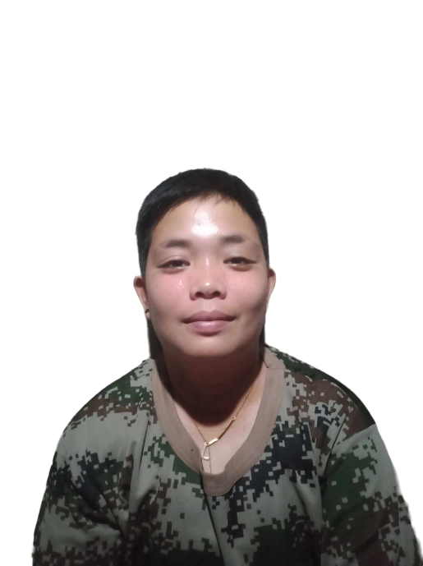
Ann Charish Canta Custodio
Address: Sitio 6 Brgy. Oogong Sta Cruz, Laguna
Mobile No. 09535315786
Email: cjcanta@gmail.com

OBJECTIVE:
Seeking a challenging role where I can utilize my skills and experience to contribute to the company's success while fostering my professional growth and continuous development.
PERSONAL INFORMATION
Date of Birth : December 7, 1997 Civil Status : Single
Age : 25 years old Religion : Roman Catholic
Place of Birth : Sta Cruz, Laguna Gender : Female
Nickname : CJ Nationality : Filipino
EDUCATIONAL BACKGROUND
SENIOR HIGH Santa Cruz Integrated National High School
Oogong Santa Cruz, Laguna
Under Graduate
SECONDARY Pedro Guevara Memorial National High School
7CH8+7GC, Pedro Guevara Ave, Santa Cruz, Laguna
Batch 2014 - 2015
Graduated
ELEMENTARY Santisima Cruz Elementary School
Luna St, Santa Cruz, Laguna
Batch 2010 - 2011
Graduated

SKILLS
- Communication skills
- Hardworking
- Willingness to learn
- Time Management

WORK EXPERIENCE

Seller : Food Vendor
Term : October 5, 2019 – May 1, 2024

Character Reference:
Patriciona Kalaw
Brgy. Kapitana
Catherine Daracan
Proven Vendor
I hereby certify that the above information is true and correct to the best of my knowledge and belief.

Ann Charish C. Custodio
(Applicant)

